EADS NA Defense Test & Services

Software Design Document

ATXML to CBTS driver for the Bus Carrier
AtXmlDriver – AtXmlCBTS.dll

SDD- AtXmlCBTS
Version 0.00
26 June 2006

This document and the information contained herein are proprietary to EADS NA Defense and may not be disclosed in whole or in part to any parties without the expressed written consent of EADS NA Defense.

© EADS NA Defense Test & Services
1222 Lucas Ave. Suite 200
St. Louis MO 63103
phone (314) 727 1337
fax (314) 727 6750

Software Design Document

Version 0.00

History of changes
0,00 Initial Version
Change Table

Change | Date | Paragraph

1 Scope 5
1.1 Identification 5
1.2 System Overview 5
1.3 Document Overview 5
2 Reference Documents 5
3 System-Wide Design Overview 5
3.1 Assumptions and Dependencies 5
3.2 General Constraints 6
3.3 Goals and Guidelines. 6
3.4 Safety and Security Considerations 6
3.5 Development Methods 6
4 System Architectural Design 6
4.1 System Components 7
4.2 Interface design 7
4.2.1 Common Interface (AtXmlCBTS.cpp) 7
4.2.2 Per Instrument Instance (AtXmlCBTS_T.cpp) 9
5 Detailed Design 10
5.1 Classification 10
5.2 XML Attribute Definition 10
5.3 Instrument IDs 10
5.4 Generic Measurement Definition 10
5.5 CBTS Programming Specifications 11
5.5.1 Programming Resolution 11
5.5.2 Programming Accuracy 11
5.6 Processing 11
6 Notes 11
6.1 IEEE1641 XML / Instrument Control Examples 11
6.1.1 CBTS Transmit Message 11
6.1.2 CBTS Receive Message 12

Scope

Identification
The software configuration component AtXmlCBTS.dll provides the software routines necessary to control the TETS Bus Carrier the CBTS.

System Overview
The TETS CICL provides a TE Interface to permit the TPS/TE to send XML signal descriptions to the test system instruments. Each instrument manufacturer provides an IVI/PnP API to control the instrument. The module defined herein provides the control of the CBTS by processing the XML signal descriptions into manufacturer API calls. The AtXmlCBTS.dll accepts the TETS CICL TE Interface XML signal descriptions that describes the action and signal modifiers described in IEEE1641 XML Test Signal Framework (TSF) Library and Basic Signal Component (BCS) layer descriptions. The TSF signal descriptions are mapped to the BSC component layer via the TSF Library as per the IEEEE1641 specification. The resultant BSC component descriptions are processed to control the instrument via the IVI/PnP API. In addition to the standard BSC sensor functionality, the standard provides for the use of “Generic Measurements”.

In addition to the XML interface, several standard TETS CICL interface functions are also provided for status, station calibration data (e.g. Path Loss Compensation (PLC)), and low level control.

Document Overview
This document defines the detailed software design for the TETS XML driver for the CBTS. The value ranges of all the IEEE1641 BSC attributes and how they are used to control the CBTS are also specified within. This document provides a detailed definition of the “Generic Measurements” implemented. This document provides a detailed description of the standard TETS CICL functions

Reference Documents
- DEFCOT&S-3560-SDD-001 CICL Software for TETS Software Detailed Design

System-Wide Design Overview
The TETS CICL provides a TE Interface that supports XML signal descriptions (i.e. IEEE1641 TSF/BSC). These signal descriptions are passed directly to this XML to IVI processor. In addition the TETS CICL requires direct access to status, calibration data, and low level control features of the instrument.

Assumptions and Dependencies
The following assumptions and dependencies are made:

- The TETS signal descriptions will conform to the IEEE1641 standard TSF/BSC definitions.
- When “Generic Measurements” are used, the TETS signal descriptions will only use “Generic Measurements” specified in this document.
- The full instrument range will be implemented when they exceed the ranges in the system requirements specification.
- The full functionality of the instrument will be implemented to the extent possible where the XML mapping can be defined. (Detailed below).

General Constraints
The sections below will detail which of the IEEE 1641 BSC attributes are used and how they are used to control the CBTS. The sections below will detail which “Generic Measurements” are allowed and details of how the measurement is taken.

Goals and Guidelines.
- Implement the full range and functionality as can be supported by the TETS XML signal description.

Safety and Security Considerations
No safety or security considerations for this module.

Development Methods
As described in the “TETS XML Driver Software Development Style Guide”

System Architectural Design
The TETS XML Driver provides an TETS specific common interface for each instrument. A common set of interfaces are provided to provide the instrument’s operation within the TETS Architeture. (See the “EADS XML Driver Software Development Style Guide” for details). The essence of the XML driver is defined as a class CCBTS. When multiple instruments (CBTSs) are available in the station, an instance of the CCBTS class will be instantiated. Therefore, the member variables and methods need only control a single instrument.
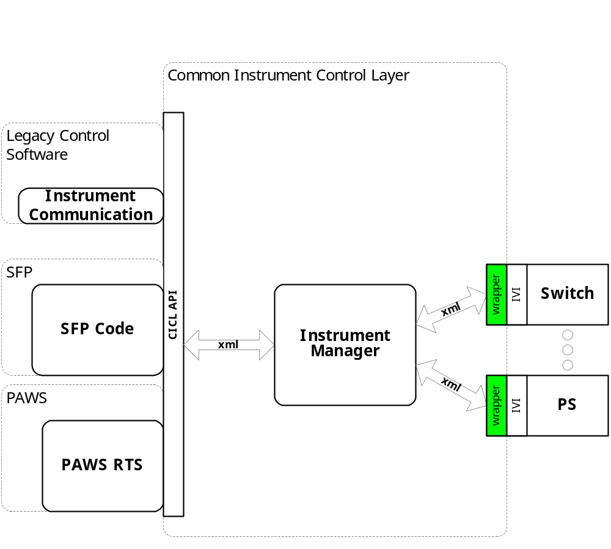
Figure 4.0 XML Driver Function Relationships

System Components
The XML driver will consist of:

- A Microsoft Visual C++ project to build the .dll
  - TETS XML standard interface functions
    - AtXmlCBTS.cpp
  - Configuration Information
  - AtXmlCBTS.rc
  - resource.h
  - The instrument specific driver file AtXmlCBTS_T.cpp

Interface design

Common Interface (AtXmlCBTS.cpp)

Function | Purpose
Initialize(int instno, char* instid, bool sim, int dbglvl, int prime_addr, int second_addr, int sub_mod_addr, CICL_XML_String* Response, int BufferSize) | This function is used to initialize the instrument, register the system assigned “instno” to the “Instid” (InstDrvrComponentID), obtain instrument availability status, and establish the device is in simulation mode and / or debug. This call may be issued multiple times to clear the instrument interface and alter the simulation mode or debug level.
Close(void) | This function shuts down the instrument and releases the device from active use status.
IssueSignal(int instno, CICL_XML_Snippet* SignalDescription, CICL_XML_String* Response, int BufferSize) | This function accepts the XML signal description, processes it, and returns a response
IssueNativeCmds(CICL_XML_String* InstrumentCommands, CICL_XML_String* Response, int BufferSize) | This function accepts the XML string that contains an instno, and a native instrument command string. It processes it, and returns a response
IssueDriverFunctionCall(int instno, CICL_XML_String* DriverFunction, CICL_XML_String* Response, int BufferSize) | This function accepts the XML string that contains a native instrument driver function call, processes it, and returns a response
Status(int instno, CICL_XML_String* Response, int BufferSize) | This function queries the instrument for status and returns the status and any errors to the SC
RegCal(int instno, CICL_XML_String* CalData) | This function registers the provided calibration data (e.g. PLC data) for use by the instrument driver
RegisterTSF(CICL_XML_Filename* TSFSignalDefinition, CICL_XML_Filename* TSFLibrary, CICL_XML_Filename* STDTSF, CICL_XML_Filename* STDBSC) | This function registers the TSF library data for this device
Reset(int instno, CICL_XML_String* Response, int BufferSize) | This function is responsible for resetting the instrument. The “instno” 0 will be reserved for a RESETALL action and shall reset all the instrument instances initialized.
Ist(int instno, int Level, CICL_XML_String* Response, int BufferSize) | This function is responsible for performing the instrument built in self test. It returns the instrument status. Where Level:  CICL_IST_LVL_CNF  CICL_IST_LVL_IST  CICL_IST_LVL_BIT1 - …BIT5

Per Instrument Instance (XXX_T.cpp)
Each hardware device in the Carrier Bus has an instrument instance and a class. The XXX above and below is replaced by one of the following: C212SysCDDI, IcPCIDM, CAN, or MIC

Function | Purpose
CXXX(bool sim, int dbglvl, int prime_addr, int second_addr) | This function is used to initialize the instrument, obtain instrument availability status, and establish if the device is in simulation mode and / or debug.
~CXXX(void) | This function shuts down the instrument and releases the device from active use status.
SetupXXX(CICL_XML_Snippet* SignalDescription, CICL_XML_String* Response, int BufferSize) | This function is the entry point for the setup action. The Signal Description is the BSC XML produced by expanding the TSF Library definitions
StatusXXX(CICL_XML_Snippet* SignalDescription, CICL_XML_String* Response, int BufferSize) | This function is the entry point for the status action. The Signal Description is the BSC XML produced by expanding the TSF Library definitions
FetchXXX(CICL_XML_Snippet* SignalDescription, CICL_XML_String* Response, int BufferSize) | This function is the entry point for the fetch action. The Signal Description is the BSC XML produced by expanding the TSF Library definitions
InitiateXXX(CICL_XML_Snippet* SignalDescription, CICL_XML_String* Response, int BufferSize) | This function is the entry point for the initiate action. The Signal Description is the BSC XML produced by expanding the TSF Library definitions
ResetXXX(CICL_XML_Snippet* SignalDescription, CICL_XML_String* Response, int BufferSize) | This function is the entry point for the reset action. The Signal Description is the BSC XML produced by expanding the TSF Library definitions.
CloseXXX(CICL_XML_Snippet* SignalDescription, CICL_XML_String* Response, int BufferSize) | This function is the entry point for the close action. The Signal Description is the BSC XML produced by expanding the TSF Library definitions.
OpenXXX(CICL_XML_Snippet* SignalDescription, CICL_XML_String* Response, int BufferSize) | This function is the entry point for the open action. The Signal Description is the BSC XML produced by expanding the TSF Library definitions.
SendNativeCmds(CICL_XML_String* InstrumentCommands, CICL_XML_String* Response, int BufferSize) | This function accepts the XML string that contains a native instrument command string, processes it, and returns a response
DoDriverFunctionCall(CICL_XML_String* DriverFunction, CICL_XML_String* Response, int BufferSize) | This function accepts the XML string that contains a native instrument driver function call, processes it, and returns a response

Detailed Design

Classification
This module is unclassified.

XML Attribute Definition
The following tables specify the IEEE 1641 BSC attributes used to control the CBTS:
CDDI
Attribute | Dim | Value Range | Default | Misc
localIP |  | #.#.#.# |  | # can be a value from 0 to 255
localSubnetMask |  | #.#.#.# |  | # can be a valid mask number from 0 to 255
localGatway |  | #.#.#.# |  | # can be a value from 0 to 255
remoteIP |  | #.#.#.# |  | # can be a value from 0 to 255
data_bits |  |  |  | Note 1
maxTime | s
Notes:
- Specified as an ASCII string. The following escape sequences are recognized: \n, \t, \\

AFAPD, IDL, MTS, TACFIRE
Attribute | Dim | Value Range | Default | Misc
localIP |  | #.#.#.# |  | # can be a value from 0 to 255
localSubnetMask |  | #.#.#.# |  | # can be a valid mask number from 0 to 255
localGatway |  | #.#.#.# |  | # can be a value from 0 to 255
remoteIP |  | #.#.#.# |  | # can be a value from 0 to 255
data_bits |  |  |  | Note 1
maxTime | s
Notes:
- Specified as an ASCII string. The following escape sequences are recognized: \n, \t, \\

MIC
Attribute | Dim | Value Range | Default | Misc
busTimeout | s | 0 to 65535
noCommandTimeout | s | 0 to 65535
noResponseTimeout | s | 0 to 1023
interruptAckTimeout | s | 0 to 1023
baseVector |  | 0 to 255
addressReg |  | 0 to 63
channel |  | 1 or 2
data_bits |  |  |  | Note 1
command |  |  |  | Note 2
maxTime | s
Notes:
- Specified as an ASCII string. The following escape sequences are recognized: \n, \t, \\
- The command word is to be specified as a 17 bit word. Each bit in the word will represent a boolean value for a certain device setting. If a 1 is specified, the setting is enabled. Each settings bit location is defined below with bit 16 being the MSB.

BIT Setting
16 ResetStandby
15 SetinStandbyMode
14 SelectModuleAddressRegister
13 ReceiveMultipleWords
12 DisableReceiving
11 ReceiveBufferControl
10 DisableTimeouts
9 InterruptonModuleAddressOnly
8 InterruptonResponsesOnly
7 eiveMultipleResponses
6 ClearBuffers
5 MonitorMode
4 BroadcastTransmit
3 SoftReset
2 DisableBusB
1 DisableBusA
0 Transmit

CAN
Attribute | Dim | Value Range | Default | Misc
timingValue | Hz | 6144 to 65535
threeSamples |  | 0 to 1
singleFilter |  | 0 to 1
acceptanceCode |  | 0x00000000 to 0xFFFFFFFF |  | Note 2
acceptanceMask |  | 0x00000000 to 0xFFFFFFFF |  | Note 2
channel |  | 1 or 2
data_bits |  |  |  | Note 1
maxTime | s
Notes:
- Specified as an ASCII string. The following escape sequences are recognized: \n, \t, \\
- Specified the same way as 1641 Serial Data. Each bit is represented by a H or L

Instrument IDs
The following list defines the accepted Instrument IDs for the CBTS:

Generic Measurement Definition
The following table specifies the IEEE 1641 Generic Measurement attributes used to control the CBTS:

Modifier | Dim | Value Range | Default | Description
data
config |  |  |  | Returns any configuration data. See note 1.
Notes:
- All data is returned with the same attribute name that is allowable. One extra attribute, called “spec”, is added to return the bus type. Returned types are CDDI, TACFIRE, MTS, IDL, AFAPD, MIC, and CAN.

CBTS Programming Specifications

Programming Resolution
TBD

Programming Accuracy
TBD

Processing
There are no special processing requirements other than normal IEEE 1641 to instrument programming.

Notes

IEEE1641 XML / Instrument Control Examples

CDDI Transmit Message
XML Signal Description:

<AtXmlSignalDescription>
<SignalAction>Apply</SignalAction>
<SignalResourceName>CBTS_1</SignalResourceName>
<SignalSnippit>
<Signal Name="CBTS_SIGNAL" Out="exchange">
<CDDI name="exchange" data_bits="THIS IS MY TEST MESSAGE" maxTime="20s" localIP="192.168.0.1" localSubnetMask="255.255.255.0" localGateway="192.168.0.2" remoteIP="192.168.0.2" />
</Signal>
</SignalSnippit>
</AtXmlSignalDescription>

Sends message specifed in data_bit using the CBTS protocol.

<AtXmlSignalDescription>
<SignalAction>Remove</SignalAction>
<SignalResourceName>CBTS_1</SignalResourceName>
<SignalSnippit>
<Signal Name="CBTS_SIGNAL" Out="exchange">
<CDDI name="exchange" data_bits="THIS IS MY TEST MESSAGE" maxTime="20s" localIP="192.168.0.1" localSubnetMask="255.255.255.0" localGateway="192.168.0.2" remoteIP="192.168.0.2" />
</Signal>
</SignalSnippit>
</AtXmlSignalDescription>

Disables and Resets the CBTS module.

CDDI Receive Message
XML Signal Description:

<AtXmlSignalDescription>
<SignalAction>Apply</SignalAction>
<SignalResourceName>CBTS_1</SignalResourceName>
<SignalSnippit>
<Signal Name="CBTS_SIGNAL" Out="exchange">
<CDDI name="exchange" maxTime="5s" localIP="192.168.0.1" localSubnetMask="255.255.255.0" localGateway="192.168.0.2" remoteIP="192.168.0.2" />
</Signal>
</SignalSnippit>
</AtXmlSignalDescription>

Makes the CBTS module ready to receive data using the CDDI protocol.

<AtXmlSignalDescription>
<SignalAction>Fetch</SignalAction>
<SignalResourceName>CBTS_1</SignalResourceName>
<SignalSnippit>
<Signal Name="CBTS_SIGNAL" Out="exchange">
<CDDI name="exchange" maxTime="5s" localIP="192.168.0.1" localSubnetMask="255.255.255.0" localGateway="192.168.0.2" remoteIP="192.168.0.2" attribute="data" />
</Signal>
</SignalSnippit>
</AtXmlSignalDescription>

Fetches the received data.

<AtXmlSignalDescription>
<SignalAction>Remove</SignalAction>
<SignalResourceName>CBTS_1</SignalResourceName>
<SignalSnippit>
<Signal Name="CBTS_SIGNAL" Out="exchange">
<CDDI name="exchange" maxTime="5s" localIP="192.168.0.1" localSubnetMask="255.255.255.0" localGateway="192.168.0.2" remoteIP="192.168.0.2" />
</Signal>
</SignalSnippit>
</AtXmlSignalDescription>

Disables and Resets the CBTS module.

