EADS NA Defense Test & Services

Software Design Document

Digital Multi-meter ATXML to IVI driver for the Racal 4152A
AtXmlDriver – AtXmlRi4152A.dll

SDD- AtXmlRi4152A
Version 0.00
9 December 2005

This document and the information contained herein are proprietary to EADS NA Defense and may not be disclosed in whole or in part to any parties without the expressed written consent of EADS NA Defense.

© EADS NA Defense Test & Services
1222 Lucas Ave. Suite 200
St. Louis MO 63103
phone (314) 727 1337
fax (314) 727 6750

Software Design Document

Version 0.00

History of changes
0,00 Initial Version
Change Table

Change | Date | Paragraph

1 Scope 5
1.1 Identification 5
1.2 System Overview 5
1.3 Document Overview 5
2 Reference Documents 5
3 System-Wide Design Overview 5
3.1 Assumptions and Dependencies 5
3.2 General Constraints 6
3.3 Goals and Guidelines. 6
3.4 Safety and Security Considerations 6
3.5 Development Methods 6
4 System Architectural Design 6
4.1 System Components 7
4.2 Interface design 7
4.2.1 Common Interface (AtXmlRi4152A.cpp) 7
4.2.2 Per Instrument Instance (AtXmlRi4152A_T.cpp) 9
5 Detailed Design 10
5.1 Classification 10
5.2 XML Attribute Definition 10
5.3 Instrument IDs 17
5.4 Generic Measurement Definition 17
5.5 Digital Multimeter Programming Specifications 18
5.5.1 Programming Resolution 18
5.5.2 Programming Accuracy 18
5.6 Processing 18
6 Notes 18
6.1 IEEE1641 XML / Instrument Control Examples 18
6.1.1 DC Signal Voltage Measurement 18

Scope

Identification
The software configuration component AtXmlRi4152A.dll provides the software routines necessary to control the TETS Analog System DMM/Digitizer the Ri4152A.

System Overview
The TETS CICL provides a TE Interface to permit the TPS/TE to send XML signal descriptions to the test system instruments. Each instrument manufacturer provides an IVI/PnP API to control the instrument. The module defined herein provides the control of the Ri4152A by processing the XML signal descriptions into manufacturer API calls. The AtXmlRi4152A.dll accepts the TETS CICL TE Interface XML signal descriptions that describes the action and signal modifiers described in IEEE1641 XML Test Signal Framework (TSF) Library and Basic Signal Component (BCS) layer descriptions. The TSF signal descriptions are mapped to the BSC component layer via the TSF Library as per the IEEEE1641 specification. The resultant BSC component descriptions are processed to control the instrument via the IVI/PnP API. In addition to the standard BSC sensor functionality, the standard provides for the use of “Generic Measurements”.

In addition to the XML interface, several standard TETS CICL interface functions are also provided for status, station calibration data (e.g. Path Loss Compensation (PLC)), and low level control.

Document Overview
This document defines the detailed software design for the TETS XML driver for the Ri4152A. The value ranges of all the IEEE1641 BSC attributes and how they are used to control the Ri4152A are also specified within. This document provides a detailed definition of the “Generic Measurements” implemented. This document provides a detailed description of the standard TETS CICL functions

Reference Documents
- DEFCOT&S-3560-SDD-001 CICL Software for TETS Software Detailed Design

System-Wide Design Overview
The TETS CICL provides a TE Interface that supports XML signal descriptions (i.e. IEEE1641 TSF/BSC). These signal descriptions are passed directly to this XML to IVI processor. In addition the TETS CICL requires direct access to status, calibration data, and low level control features of the instrument.

Assumptions and Dependencies
The following assumptions and dependencies are made:

- The TETS signal descriptions will conform to the IEEE1641 standard TSF/BSC definitions.
- When “Generic Measurements” are used, the TETS signal descriptions will only use “Generic Measurements” specified in this document.
- The full instrument range will be implemented when they exceed the ranges in the system requirements specification.
- The full functionality of the instrument will be implemented to the extent possible where the XML mapping can be defined. (Detailed below).

General Constraints
The sections below will detail which of the IEEE 1641 BSC attributes are used and how they are used to control the Ri4152A. The sections below will detail which “Generic Measurements” are allowed and details of how the measurement is taken.

Goals and Guidelines.
- Implement the full range and functionality as can be supported by the TETS XML signal description.

Safety and Security Considerations
No safety or security considerations for this module.

Development Methods
As described in the “TETS XML Driver Software Development Style Guide”

System Architectural Design
The TETS XML Driver provides an TETS specific common interface for each instrument. A common set of interfaces are provided to provide the instrument’s operation within the TETS Architeture. (See the “EADS XML Driver Software Development Style Guide” for details). The essence of the XML driver is defined as a class CRi4152A. When multiple instruments (Ri4152As) are available in the station, an instance of the CRi4152A class will be instantiated. Therefore, the member variables and methods need only control a single instrument.
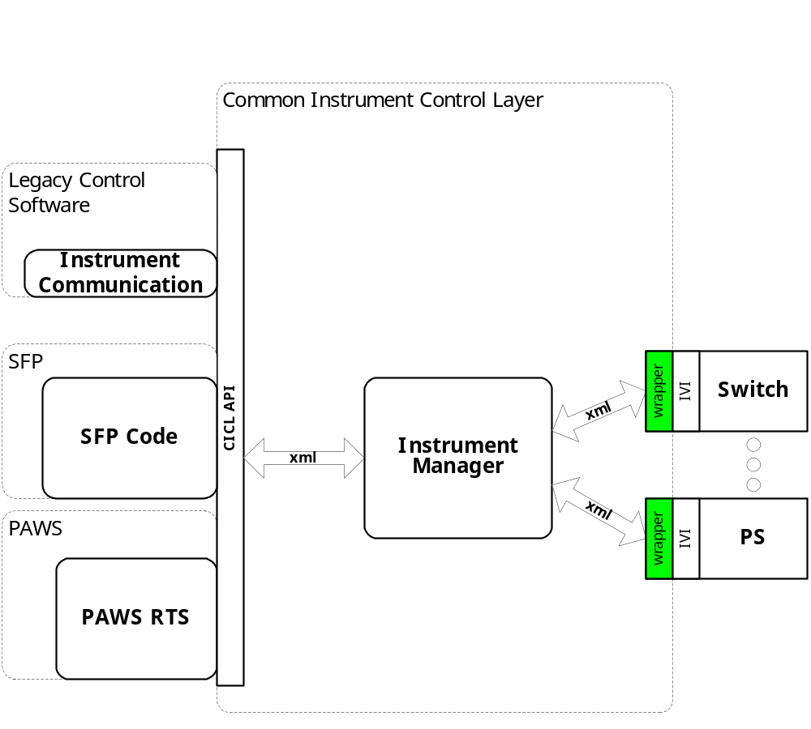
Figure 4.0 XML Driver Function Relationships

System Components
The XML driver will consist of:

- A Microsoft Visual C++ project to build the .dll
  - TETS XML standard interface functions
    - AtXmlRi4152A.cpp
  - Configuration Information
  - AtXmlRi4152A.rc
  - resource.h
  - The instrument specific driver file AtXmlRi4152A_T.cpp

Interface design

Common Interface (AtXmlRi4152A.cpp)

Function | Purpose
Initialize(int instno, char* instid, bool sim, int dbglvl, int prime_addr, int second_addr, int sub_mod_addr, CICL_XML_String* Response, int BufferSize) | This function is used to initialize the instrument, register the system assigned “instno” to the “Instid” (InstDrvrComponentID), obtain instrument availability status, and establish the device is in simulation mode and / or debug. This call may be issued multiple times to clear the instrument interface and alter the simulation mode or debug level.
Close(void) | This function shuts down the instrument and releases the device from active use status.
IssueSignal(int instno, CICL_XML_Snippet* SignalDescription, CICL_XML_String* Response, int BufferSize) | This function accepts the XML signal description, processes it, and returns a response
IssueNativeCmds(CICL_XML_String* InstrumentCommands, CICL_XML_String* Response, int BufferSize) | This function accepts the XML string that contains an instno, and a native instrument command string. It processes it, and returns a response
IssueDriverFunctionCall(int instno, CICL_XML_String* DriverFunction, CICL_XML_String* Response, int BufferSize) | This function accepts the XML string that contains a native instrument driver function call, processes it, and returns a response
Status(int instno, CICL_XML_String* Response, int BufferSize) | This function queries the instrument for status and returns the status and any errors to the SC
RegCal(int instno, CICL_XML_String* CalData) | This function registers the provided calibration data (e.g. PLC data) for use by the instrument driver
RegisterTSF(CICL_XML_Filename* TSFSignalDefinition, CICL_XML_Filename* TSFLibrary, CICL_XML_Filename* STDTSF, CICL_XML_Filename* STDBSC) | This function registers the TSF library data for this device
Reset(int instno, CICL_XML_String* Response, int BufferSize) | This function is responsible for resetting the instrument. The “instno” 0 will be reserved for a RESETALL action and shall reset all the instrument instances initialized.
Ist(int instno, int Level, CICL_XML_String* Response, int BufferSize) | This function is responsible for performing the instrument built in self test. It returns the instrument status. Where Level:  CICL_IST_LVL_CNF  CICL_IST_LVL_IST  CICL_IST_LVL_BIT1 - …BIT5

Per Instrument Instance (AtXmlRi4152A_T.cpp)

Function | Purpose
CRI4152A(bool sim, int dbglvl, int prime_addr, int second_addr) | This function is used to initialize the instrument, obtain instrument availability status, and establish if the device is in simulation mode and / or debug.
~CRI4152A(void) | This function shuts down the instrument and releases the device from active use status.
SetupRI4152A(CICL_XML_Snippet* SignalDescription, CICL_XML_String* Response, int BufferSize) | This function is the entry point for the setup action. The Signal Description is the BSC XML produced by expanding the TSF Library definitions
StatusRI4152A(CICL_XML_Snippet* SignalDescription, CICL_XML_String* Response, int BufferSize) | This function is the entry point for the status action. The Signal Description is the BSC XML produced by expanding the TSF Library definitions
FetchRI4152A(CICL_XML_Snippet* SignalDescription, CICL_XML_String* Response, int BufferSize) | This function is the entry point for the fetch action. The Signal Description is the BSC XML produced by expanding the TSF Library definitions
InitiateRI4152A(CICL_XML_Snippet* SignalDescription, CICL_XML_String* Response, int BufferSize) | This function is the entry point for the initiate action. The Signal Description is the BSC XML produced by expanding the TSF Library definitions
ResetRI4152A(CICL_XML_Snippet* SignalDescription, CICL_XML_String* Response, int BufferSize) | This function is the entry point for the reset action. The Signal Description is the BSC XML produced by expanding the TSF Library definitions.
CloseRI4152A(CICL_XML_Snippet* SignalDescription, CICL_XML_String* Response, int BufferSize) | This function is the entry point for the close action. The Signal Description is the BSC XML produced by expanding the TSF Library definitions.
OpenRI4152A(CICL_XML_Snippet* SignalDescription, CICL_XML_String* Response, int BufferSize) | This function is the entry point for the open action. The Signal Description is the BSC XML produced by expanding the TSF Library definitions.
SendNativeCmds(CICL_XML_String* InstrumentCommands, CICL_XML_String* Response, int BufferSize) | This function accepts the XML string that contains a native instrument command string, processes it, and returns a response
DoDriverFunctionCall(CICL_XML_String* DriverFunction, CICL_XML_String* Response, int BufferSize) | This function accepts the XML string that contains a native instrument driver function call, processes it, and returns a response

Detailed Design

Classification
This module is unclassified.

Instrument IDs
The following list defines the accepted Instrument IDs for the Ri4152A:

- DMM_Ri452A – Digital Multi-Meter functionality

Generic Measurement Definition
The following table specifies the IEEE 1641 Generic Measurement attributes used to control the Ri4152A:

Modifier | Dim | Value Range | Default | Description
ac_ampl | V | 0 to 300 V |  | AC rms value
ac_ampl_av | V | 0 to 300 V |  | AC amplitude from average of multiple amplitude readings
ac_ampl_p | V | 0 to 424 V |  | AC peak value
ac_ampl_pp | V | 0 to 848 V |  | AC peak to peak value
ac_dc_offset | V | 0 to +/- 300 V |  | DC offset of AC signal
ac_current | A | 0 to 3.0 A |  | AC current measurement
ac_current_av | A | 0 to 3.0 A |  | Current from average of multiple current readings
ac_freq | Hz | 0 to 300000 Hz |  | AC Frequency measurement
ac_period | Sec | .00000333 to .333 Sec |  | AC Period measurement
dc_ac_comp | V | 0 to 300 V |  | AC component amplitude of DC signal
dc_ac_comp_f | Hz | 3 to 300000 Hz |  | AC component frequency of DC signal
dc_ampl | V | -300 to 300 V |  | DC amplitude
dc_ampl_av | V | -300 to 300 V |  | DC amplitude from average of multiple amplitude readings
dc_ratio | V | 0 - 1000 |  | Ratio of HI-LO / SHI-SLO
dc_current | A | 0 to +/-3.0 A |  | Current measurement
dc_current_av | A | 0 to +/-3.0 A |  | Current from average of multiple current readings
resistance |  | 1 to 100,000,000 |  | Impedance measurment
sq_ampl | V | 0 to 300 V |  | Square wave rms value
sq_ampl_p | V | 0 to 300 V |  | Square wave peak value
sq_ampl_pp | V | 0 to 600 V |  | Square wave peak to peak value
sq_freq | Hz | 3 to 300000 Hz |  | Square wave frequency value
sq_period | Sec | .00000333 to .333 Sec |  | Square wave period value
tr_ampl | V | 0 to 300 V |  | Triangle wave rms value
tr_ampl_p | V | 0 to 519 V |  | Triangle wave peak value
tr_ampl_pp | V | 0 to 1039 V |  | Triangle wave peak to peak value
tr_freq | Hz | 3 to 300000 Hz |  | Triangle wave frequency value
tr_period | Sec | .00000333 to .333 Sec |  | Triangle wave period value
Notes:
- Resistance Modes: 2-wire or 4-wire measurements

Digital Multimeter Programming Specifications

Programming Resolution
TBD

Programming Accuracy
TBD

Processing
There are no special processing requirements other than normal IEEE 1641 to instrument programming.

Notes

IEEE1641 XML / Instrument Control Examples

DC Signal Voltage Measurement
XML Signal Description:

AC Signal – Voltage Measurement
<Signal Name="DMM_SIGNAL" Out="Measure">
<Sinusoid name="AC_COMP" amplitude="424.264V" />
<Constant name="DC_COMP" amplitude="2.000V" />
<Sum name="Signal" In="AC_COMP DC_COMP" />
<HighPass name="Filter" cutoff="3Hz" In="Signal" />
<Measure name="Measure" As="Filter" refVolt="2.000V" Attribute="ac_ampl" />
</Signal>

DC Signal – Current Measurement
<Signal Name="DMM_SIGNAL" Out="Measure">
<Constant name="DC_COMP" amplitude="1.000A" />
<Sinusoid name="AC_COMP" />
<Sum name="Signal" In="AC_COMP DC_COMP" />
<HighPass name="Filter" cutoff="20Hz" In="Signal" />
<Measure name="Measure" As="Filter" Attribute="dc_current" />
</Signal>

Impedance
<Signal Name="DMM_SIGNAL" Out="Measure">
<Load name="Impedance" resistance=" 10000.000Ohm" />
<Measure name="Measure" As="Impedance" samples="50" Attribute="resistance" />
</Signal>

Square Wave – Frequency Measurement
<Signal Name="DMM_SIGNAL" Out="Measure">
<Squarewave name="AC_COMP" amplitude="1.768V" />
<Constant name="DC_COMP" amplitude="8.000V" />
<Sum name="Signal" In="AC_COMP DC_COMP" />
<HighPass name="Filter" cutoff="20Hz" In="Signal" />
<Measure name="Measure" As="Filter" Attribute="sq_freq" />
</Signal>

Triangle Wave – Period Measurement
<Signal Name="DMM_SIGNAL" Out="Measure">
<Triangle name="AC_COMP" amplitude="3.062V" period=" 0.33s" />
<Constant name="DC_COMP" amplitude="8.000V" />
<Sum name="Signal" In="AC_COMP DC_COMP" />
<HighPass name="Filter" cutoff="20Hz" In="Signal" />
<Measure name="Measure" As="Filter" Attribute="tr_period" />
</Signal>

