EADS NA Defense Test & Services

Software Design Document

Waveform Generator Functionality

WCEM Driver - WcemArb.dll

SDD-WcemArb
Version 0.00
06/15/05

This document and the information contained herein are proprietary to EADS NA Defense and may not be disclosed in whole or in part to any parties without the expressed written consent of EADS NA Defense.

PAWS is a registered trademark of the TYX Corporation.

© EADS NA Defense Test & Services
1222 Lucas Ave. Suite 200
St. Louis MO 63103
phone (314) 727 1337
fax (314) 727 6750

Software Design Document

Version 0.00

History of changes
0: Initial Release

Change Table

Change | Date | Paragraph

1 Scope 5
1.1 Identification 5
1.2 System Overview 5
1.3 Document Overview 5
2 Reference Documents 5
3 System-Wide Design Overview 5
3.1 Assumptions and Dependencies 5
3.2 General Constraints 6
3.3 Goals and Guidelines 6
3.4 Safety and Security Considerations 6
3.5 Development Methods 6
4 System Architectural Design 6
4.1 System Components 7
4.2 Interface design 8
5 Detailed Design 9
5.1 Classification 9
5.2 ATLAS Modifier Definition 9
5.3 Port Names 13
5.4 Processing 13
6 Requirements traceability. 13
7 Notes 13
7.1 ATLAS Examples 13
7.1.1 Apply AC Signal 13
7.1.2 Apply Square Wave 14
7.1.3 Apply Waveform 14
8 Appendix A – Mathematical Equations 14

Scope

Identification
The software configuration component WcemArb.dll provides the software routines necessary to control the Waveform Generator.

System Overview
The PAWS system provides several methods of interfacing the compiled ATLAS object code with the test system instruments. The method used by this module is the Windows CIIL Emulation Module (WCEM). This mode of instrument control, the PAWS WRTS calls the WcemArb.dll via ATLAS single action verb related functions. The WcemArb.dll queries the WRTS for modifier values and other parameters and sends the necessary commands to the instrument.

Document Overview
The document defines the detailed software design for the PAWS WCEM driver for the Waveform Generator. This document specifies the value ranges of all the ATLAS modifiers and modifier value ranges and how they are used to control the Waveform Generator.

Reference Documents
- ARC PAWS WCEM Software Development Style Guide (ARCSTL-DSG-000)
- Software Requirements Specification for Third Echelon Test Set DEFCOT&S-3536-SRS-001
- PERFORMANCE SPECIFICATION FOR THE THIRD ECHELON TEST SET (TETS) MARCORSYSCOM-PD-02-001 12/1/2003
- Computer Programming Manual (CPM) for the Third Echelon Test System (TETS) REV. E P/N 93006A0026
- IEEE std. 716-1989 C/ATLAS Test Language
- General Notes for ATLAS Implementation Doc # 7992052 Rev.01 Aug 10 2005

System-Wide Design Overview
The PAWS development system provides the ability to code a test program in an extended / subset of the IEEE std. 716-1989 C/ATLAS Test Language. The PAWS development system provides the ability to modify the ATLAS subset with special nouns and modifiers (primarily analog) to meet special requirements.

Assumptions and Dependencies
The following assumptions and dependencies are made:

- The TETS ATLAS subset will contain the common ATLAS extensions found in most extended subsets of ATLAS (e.g. TRIG-SOURCE, TRIG-SLOPE, etc.)
- The TETS ATLAS subset will contain all required legacy ATLAS extensions that are not replaceable with the standard or common ATLAS extensions.
- The full instrument range will be implemented when they exceed the ranges in the system requirements specification.
- The full functionality of the instrument will be implemented to the extent possible where the ATLAS mapping can be defined. (Detailed below).

General Constraints
The sections below will detail which of the ATLAS modifiers are used and how they are used to control the Waveform Generator.

Goals and Guidelines
- To the extent possible, map the ATLAS modifiers to instrument controls in a common sense manner.
- Implement the full range and functionality as can be supported by the extended subset of ATLAS.

Safety and Security Considerations
No safety or security considerations for this instrument.

Development Methods
As described in the “ARC PAWS WCEM Software Development Style Guide”.

System Architectural Design
The PAWS WCEM driver is invoked on TPS load, TPS Unload, WRTS “Reset” / ATLAS “REMOVE, ALL”, and the derived “Single Action” ATLAS actions. The following diagram shows the major functions called from the WRTS through tables created by the WCEM Wizard in Wrapper.cpp. (See the “ARC PAWS WCEM Software Development Style Guide” for details). The essence of the WCEM driver is defined as a class CArb. When multiple instruments (Arb’s) are available in the station, an instance of the CArb class will be instantiated. Therefore, the member variables and methods need only control a single instrument.
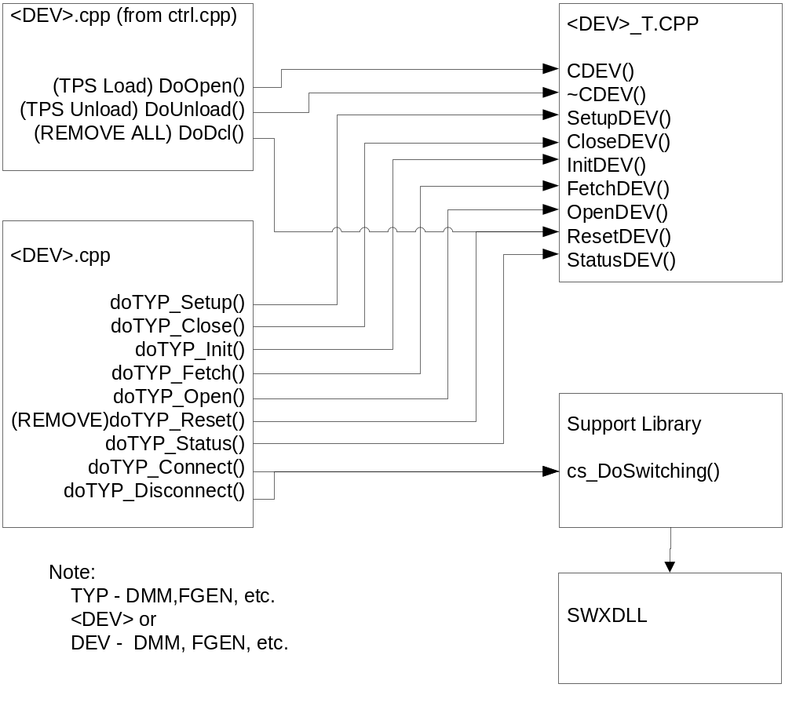
Figure 4.0 WCEM Function Relationships

System Components
The WCEM driver will consist of:

- A Microsoft Visual C++ project to build the WCEM
  - WCEM Wizard generated interface files
    - Wrapper.cpp
    - error.cpp
    - key.h
  - Configuration Information
  - Arb.rc
  - resource.h
  - Updated Template File
    - Arb.cpp
  - The programmer generated driver files
- Arb_T.cpp

- A PAWS Developer’s Studio project file for the benchmark Arb.PAW
  - An ATLAS program or programs to test the driver (Benchmark)
  - A Device Database static Description

Interface design

Function | Purpose
CArb(bool sim, int dbglvl, int addr) | This function is used to initialize the instrument, obtain a handle from VISA or other controller software, and establish if the device is in simulation mode and / or debug.
~CArb(void) | This function shuts down the instrument and releases the device handle.
SetupArb(int fnc) | This function is the entry point for the setup action. The argument is the FNC number from the DeviceDB Static Description.
StatusArb(void) | This function queries the instrument for status and reports any errors to the RTS via the error handling mechanisms
FetchArb(int fnc) | This function is responsible for retrieving measured values from the instrument and returns them to the RTS via the fetch API in WCEM or other support libraries
InitiateArb(int fnc) | This function controls the ATLAS INITIATE actions and is responsible for enabling or triggering a signal
ResetArb(int fnc) | This function is responsible for resetting the instrument. The argument 0 will be reserved for a RESETALL action and shall reset the instrument regardless of the current state of the device. Arguments > 0 may use a state variable to determine if the device is currently reset.
CloseArb(int fnc) | This function is responsible for the ATLAS CLOSE verb and shall close any internal relays within the instrument and will enable the output or input to the device.
OpenArb(int fnc) | This function is responsible for the ATLAS OPEN verb and will disable the output or input of the instrument.

Detailed Design

Classification
This module is unclassified.

ATLAS Modifier Definition
The following table specifies the Nouns / Measured Characteristics / Modifiers used to control the Arb:

Modifier | Dimension | Value Range | Default | Xml | Misc
AC SIGNAL
VOLTAGE-PP | V | Low Z:  .32374 V to 10.2375 V  High Z:  .64748 V to 20.475 V | 0V
VOLTAGE-P | V | Low Z:  .16187 V to 5.11875 V  High Z:  .32374 V to 10.2375 V
VOLTAGE | V | Low Z:  .11448 V to 3.62005 V  High Z:  .22895 V to 7.24010 V
DC-OFFSET | V | Range:  Low Z:  -5 V to 5 V  High Z:  -10 V to 10 V
FREQ | Hz | .01 Hz to 10,737,418.24 Hz
PERIOD | SEC | 93.132 nsec-100 sec
BURST | CYCLES | 1 cycles to 65535 cycles |  |  | Number of bursts output on each arm/trigger.
FREQ-WINDOW | Hz | .01 Hz to 10,737,418.24 Hz |  |  | Used only for measuring harmonics, noise, etc.; ATLAS 17-22
BANDWIDTH | Hz | 250 kHz, 10 MHz
AGE-RATE | Hz/sec | Range: 1 Hz/sec to 3350 Hz/sec |  |  | Sweep rate
RAMP SIGNAL
VOLTAGE-PP | V | Low Z:  .32374 V to 10.2375 V  High Z:  .64748 V to 20.475 V | 0V |  | Verify Range
VOLTAGE-P | V | Low Z:  .16187 V to 5.11875 V  High Z:  .32374 V to 10.2375 V |  |  | Verify Range
DC-OFFSET | V | Range:  Low Z:  -5 V to 5 V  High Z:  -10 V to 10 V
FREQ | Hz | Range: .002 Hz to 5,368,709.12 Hz
PERIOD | SEC | .8163 usec – 500 sec
BANDWIDTH | Hz | 250 kHz, 10 MHz
BURST | CYCLES | 1 cycles to 65535 cycles
BURST-REP-RATE | Hz | 0 Hz to 10500000 Hz
SQUARE WAVE
VOLTAGE-PP | V | Low Z:  .32374 V to 10.2375 V  High Z:  .64748 V to 20.475 V | 0V
VOLTAGE-P | V | Low Z:  .16187 V to 5.11875 V  High Z:  .32374 V to 10.2375 V
DC-OFFSET | V | Range:  Low Z:  -5 V to 5 V  High Z:  -10 V to 10 V
FREQ | Hz | Range: .0025 Hz to 5,368,709.12 Hz
PERIOD | SEC | .8163 usec – 400 sec
BANDWIDTH | Hz | 250 kHz, 10 MHz
BURST | CYCLES | 1 cycles to 65535 cycles
BURST-REP-RATE | Hz | 0 Hz to 2.6 MHz
TRIANGULAR WAVE SIGNAL
VOLTAGE-PP | V | Low Z:  .32374 V to 10.2375 V  High Z:  .64748 V to 20.475 V | 0V
VOLTAGE-P | V | Low Z:  .01619 V to 5.11874 V  High Z:  .03238 V to 1023748 V
DC-OFFSET | V | Range:  Low Z:  -5 V to 5 V  High Z:  -10 V to 10 V
FREQ | Hz | Range: .002 Hz to 5,368,709.12 Hz
PERIOD | SEC | .8163 usec – 500 sec
BANDWIDTH | Hz | 250 kHz, 10 MHz
BURST | CYCLES | 1 cycles to 65535 cycles
BURST-REP-RATE | Hz | 0 Hz to 2.6 MHz
WAVEFORM
VOLTAGE | V | Range:  Low Z:  -5 V to 5 V  High Z:  -10 V to 10 V |  |  | Verify Range
DC-OFFSET | V | Range:  Low Z:  -5 V to 5 V  High Z:  -10 V to 10 V
STIM |  | 4 to 262,144
SAMPLE-SPACING | sec | 47 ns to 100 sec
BANDWIDTH | Hz | 250 kHz, 10 MHz
EVENT-SYNC
DC SIGNAL
VOLTAGE | V | Low Z:  -5.12 V to 5.11875 V  High Z:  -10.24 V to 10.2375 V
COMMON MODIFIERS
MAX-TIME |  | 0 sec to 1000 sec
TEST-EQUIP-IMP | OHM | 50, 75, 1E6 OHM |  |  | 50 and 75 OHM available in the low voltage range and 1E6 OHM in the high voltage range
EVENT-OUT
EVENT-DELAY | SEC
EVENT-SLOPE |  | POS, NEG
EVENT-SYNC
EVENT-EACH-OCCURRENCES
EVENT-GATED-BY
Notes:

Port Names
The Port Names in the table below provide the naming convention utilized in the Switch Data Base and Model for interface control and management along with the connection field mnemonics to be used by ATLAS programs.

CNX Field | Port Name | Instrument
HI | ARB_x-StopTrigFsk | External trigger
EVENT-OUT | ARB_x-EvArm
VIA | ARB_x-Out | Main output
DIV7-OUT | ARB_x-Out/7 | Divide by 7 output
EVENT-SYNC | ARB_x-EvArm
EVENT-GATED-BY | ARB_x-EvArm

Processing
There are no special processing requirements other than normal ATLAS interpretation of the keywords.

Requirements traceability.

This WCEM driver provides the requirements stated in Paragraph 3.4.8 of the PERFORMANCE SPECIFICATION FOR THE THIRD ECHELON TEST SET (TETS) MARCORSYSCOM-PD-02-001 12/1/2003 and General Notes for ATLAS Implementation Doc # 7992052 Rev.01 Aug 10 2005.

Notes

ATLAS Examples

Apply AC Signal
APPLY, AC SIGNAL, VOLTAGE-PP 5V, FREQ 1 MHZ, DC-OFFSET 1V, TEST-EQUIP-IMP 50 OHMS, CNX VIA J1-1 $

Apply Square Wave
APPLY, SQUARE WAVE, VOLTAGE-PP 2V, FREQ 1 MHZ, CNX VIA J1-1 $

Apply Waveform
APPLY, WAVEFORM, STIM ‘VOLTS’ (1 THRU 200), SAMPLE-SPACING 200 NSEC, BANDWIDTH 10 MHZ, CNX VIA J1-1 $

Appendix A – Mathematical Equations
AC Signal

1. Voltage to Voltage-PK
Voltage-PK value = voltage_value * RMS_PK

2. Voltage-PK to Voltage
Voltage value = voltage-pk_value / RMS_PK

3. Voltage to Voltage-PP
Voltage-PP value = voltage_value * RMS_PP

4. Voltage-PP to Voltage
Voltage value = voltage-pp_value / RMS_PP

5. Voltage to Watt
Watt value = (voltage_value)² / impedance value

6. Watt to Voltage
Voltage value = sqrt(watt value) * impedance value

7. Voltage to dBm
For a 50 ohm test equipment impedance
dBm value = 20 log (voltage_value / DBM_50_OHM)

For a 600 ohm test equipment impedance
dBm value = 20 log(voltage_value / DBM_600_OHM)

8. dBm to Voltage
For a 50 ohm test equipment impedance
Voltage value = 10^{dBm_value / 20} * DBM_50_OHM
For a 600 ohm test equipment impedance
Voltage value = 10^{dBm_value / 20} * DBM_600_OHM

9. Watt to dBm
dBm value = 10 log (watt_value / .001)

10. dBm to Watt
Watt value = 10^{dBm_value / 10} * .001

Square Wave Signal - This is for a 50% Duty Cycle only and can only be done for this Duty Cycle. Any other Duty Cycle not allowed.

1. Voltage to Voltage-PP
Voltage-PP value = voltage_value * 2

2. Voltage-PP to Voltage
Voltage value = voltage-pp_value / 2

3. Voltage to Voltage-PK
Voltage-Pk value = voltage_value

4. Voltage-PK to Voltage
Voltage value = voltage-pk_value

Triangular Wave Signal - This is for symmetrical Triangular wave signal. Any other symmetry for this wave is not allowed.

1. Voltage to Voltage-PK
Voltage-PK value = voltage_value * RMS_TRI_PK

2. Voltage-PK to Voltage
Voltage value = voltage-pk_value / RMS_TRI_PK

3. Voltage to Voltage-PP
Voltage-PP value = voltage_value * RMS_TRI_PP

4. Voltage-PP to Voltage
Voltage value = voltage-pp_value / RMS_TRI_PP

Constants used for Mathematical Equations

RMS_PK = sqrt(2) = 1.414213562373 rounded to 12 decimal place.

RMS_PP = RMS_PK * 2

RMS_TRI_PK = sqrt(3) = 1.73205080808 rounded to 11 decimal place

RMS_TRI_PP = RMS_TRI_PK * 2

DBM_50_OHM = .22360679775 rounded to 11 decimal place
1mw = E²/50 equals sqrt(.05)

DBM_600_OHM = .7745966692414 rounded to 13 decimal place
1mw = E²/600 equals sqrt(.6)

