EADS NA Defense Test & Services

Software Design Document

Gigabit Ethernet Bus
WCEM Driver – WcemGigabit.dll

SDD-WcemGigabit
Version 0.00
06/20/05

This document and the information contained herein are proprietary to EADS NA Defense and may not be disclosed in whole or in part to any parties without the expressed written consent of EADS NA Defense.

PAWS is a registered trademark of the TYX Corporation.

© EADS NA Defense Test & Services
1222 Lucas Ave. Suite 200
St. Louis MO 63103
phone (314) 727 1337
fax (314) 727 6750

Software Design Document

Version 0.00

History of changes
0: Initial Release

Change Table

Change | Date | Paragraph

1 Scope 5
1.1 Identification 5
1.2 System Overview 5
1.3 Document Overview 5
2 Reference Documents 5
3 System-Wide Design Overview 5
3.1 Assumptions and Dependencies 5
3.2 General Constraints 5
3.3 Goals and Guidelines 6
3.4 Safety and Security Considerations 6
3.5 Development Methods 6
4 System Architectural Design 6
4.1 System Components 7
4.2 Interface design 7
5 Detailed Design 8
5.1 Classification 8
5.2 ATLAS Modifier Definition 8
Note 1: The command word is to be specified as an array of strings with the following format: 9
5.3 Port Names 9
5.4 Gigabit Ethernet Specifications 10
5.4.1 Programming Resolution 10
5.4.2 Programming Accuracy 10
5.5 Processing 10
6 Notes 10
6.1 ATLAS Examples 10
6.1.1 UDP Signal 10
6.1.2 TCP Receiver 10
7 Requirements traceability 11
8 Appendix 11

Scope

Identification
The software configuration component WcemGigabit.dll provides the software routines necessary to control the Gigabit Ethernet Bus.

System Overview
The PAWS system provides several methods of interfacing the compiled ATLAS object code with the test system instruments. The method used by this module is the Windows CIIL Emulation Module (WCEM). This mode of instrument control, the PAWS WRTS calls the WcemGigabit.dll via ATLAS single action verb related functions. The WcemGigabit.dll queries the WRTS for modifier values and other parameters and sends the necessary commands to the instrument.

Document Overview
The document defines the detailed software design for the PAWS WCEM driver for the Gigabit. This document specifies the value ranges of all the ATLAS modifiers and modifier value ranges and how they are used to control the Gigabit Ethernet Bus.

Reference Documents
- ARC PAWS WCEM Software Development Style Guide (ARCSTL-DSG-000)
- Software Requirements Specification for Third Echelon Test Set DEFCOT&S-3536-SRS-001
- PERFORMANCE SPECIFICATION FOR THE THIRD ECHELON TEST SET (TETS) MARCORSYSCOM-PD-02-001 12/1/2003
- Computer Programming Manual (CPM) for the Third Echelon Test System (TETS) REV. E P/N 93006A0026
- IEEE std. 716-1989 C/ATLAS Test Language

System-Wide Design Overview
The PAWS development system provides the ability to code a test program in an extended / subset of the IEEE std. 716-1989 C/ATLAS Test Language. The PAWS development system provides the ability to modify the ATLAS subset with special nouns and modifiers (primarily analog) to meet special requirements.

Assumptions and Dependencies
The following assumptions and dependencies are made:

- The TETS ATLAS subset will contain the common ATLAS extensions found in most extended subsets of ATLAS (e.g. TRIG-SOURCE, TRIG-SLOPE, etc.)
- The TETS ATLAS subset will contain all required legacy ATLAS extensions that are not replaceable with the standard or common ATLAS extensions.
- The full instrument range will be implemented when they exceed the ranges in the system requirements specification.
- The full functionality of the instrument will be implemented to the extent possible where the ATLAS mapping can be defined. (Detailed below).

General Constraints
The sections below will detail which of the ATLAS modifiers are used and how they are used to control the Gigabit.

Goals and Guidelines
- To the extent possible, map the ATLAS modifiers to instrument controls in a common sense manner.
- Implement the full range and functionality as can be supported by the extended subset of ATLAS.

Safety and Security Considerations
No safety or security considerations for this instrument.

Development Methods
As described in the “ARC PAWS WCEM Software Development Style Guide”

System Architectural Design
The PAWS WCEM driver is invoked on TPS load, TPS Unload, WRTS “Reset” / ATLAS “REMOVE, ALL”, and the derived “Single Action” ATLAS actions. The following diagram shows the major functions called from the WRTS through tables created by the WCEM Wizard in Wrapper.cpp. (See the “ARC PAWS WCEM Software Development Style Guide” for details). The essence of the WCEM driver is defined as a class CGIGABIT. When multiple instruments (GIGABITs) are available in the station, an instance of the CGIGABIT class will be instantiated. Therefore, the member variables and methods need only control a single instrument.
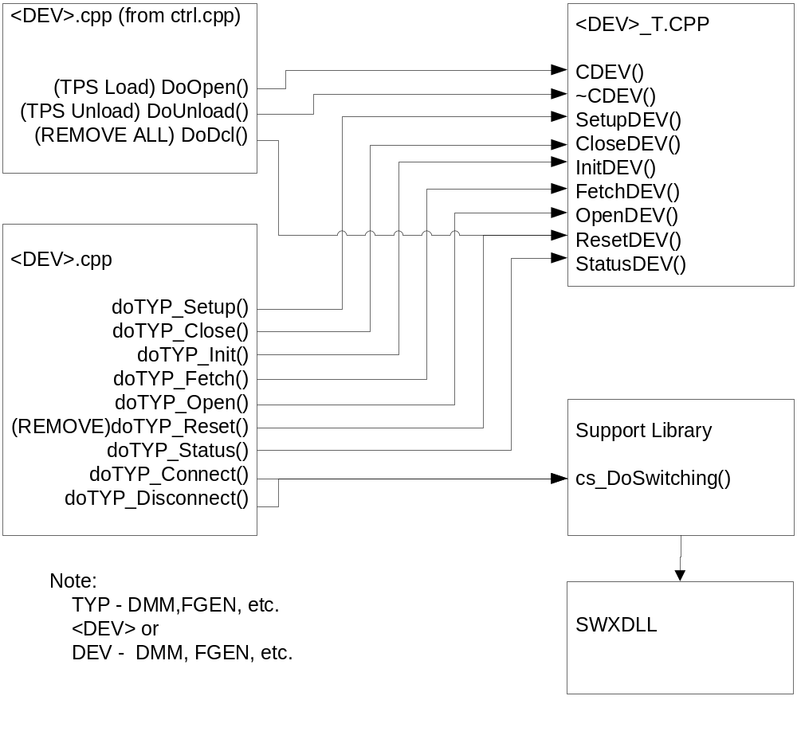
Figure 4.0 WCEM Function Relationships

System Components
The WCEM driver will consist of:

- A Microsoft Visual C++ project to build the WCEM
  - WCEM Wizard generated interface files
    - Wrapper.cpp
    - error.cpp
    - key.h
  - Configuration Information
  - GIGABIT.rc
  - resource.h
  - Updated Template File
    - GIGABIT.cpp
  - The programmer generated driver file GIGABIT_T.cpp

- A PAWS Developer’s Studio project file for the benchmark GIGABIT.PAW
  - An ATLAS program or programs to test the driver (Benchmark)
  - A Device Database static Description

Interface design

Function | Purpose
CGIGABIT(bool sim, int dbglvl, int addr) | This function is used to initialize the instrument, obtain a handle from VISA or other controller software, and establish if the device is in simulation mode and / or debug.
~CGIGABIT(void) | This function shuts down the instrument and releases the device handle.
SetupGIGABIT(int fnc) | This function is the entry point for the setup action. The argument is the FNC number from the DeviceDB Static Description.
StatusGIGABIT(void) | This function queries the instrument for status and reports any errors to the RTS via the error handling mechanisms
FetchGIGABIT(int fnc) | This function is responsible for retrieving measured values from the instrument and returns them to the RTS via the fetch API in WCEM or other support libraries
InitiateGIGABIT(int fnc) | This function controls the ATLAS INITIATE actions and is responsible for enabling or triggering a signal
ResetGIGABIT(int fnc) | This function is responsible for resetting the instrument. The argument 0 will be reserved for a RESETALL action and shall reset the instrument regardless of the current state of the device. Arguments > 0 may use a state variable to determine if the device is currently reset.
CloseGIGABIT(int fnc) | This function is responsible for the ATLAS CLOSE verb and shall close any internal relays within the instrument and will enable the output or input to the device.
OpenGIGABIT(int fnc) | This function is responsible for the ATLAS OPEN verb and will disable the output or input of the instrument.

Detailed Design

Classification
This module is unclassified.

ATLAS Modifier Definition
The following table specifies the Nouns / Measured Characteristics / Modifiers used to control the Model:

Modifier | Dim | Value Range | Default | XML | Misc
ESTABLISH
BUS PROTOCOL |  |  |  |  | <Protocol Name>
SPEC, , STANDARD PRIMARY BUS
ETHERNET | BUS |  | (type) STANDARD

Modifier | Dim | Value Range | Default | XML | Misc
BUS-PARAMETER <bus-parameter>
TCP |  |  |  |  | Specify either TCP or UDP
UDP
PROTOCOL PARAMETER <protocol parameter>
Not Legal
DEFINE EXCHANGE
EXCHANGE |  |  |  |  | <protocol name>
BUS MODE
TALKER-LISTENER | N/a
TALKER | UUT, TEST-EQUIP |  | TEST-EQUIP
LISTENER | UUT, TEST-EQUIP |  | UUT
COMMAND | <data store> |  |  |  | See Note 1
DATA | <data store> |  |  |  | Specified as a string. If data is supplied, it is assumed the test equipment is sending data.
Modifier | Dim | Value Range | Default | XML | Misc
DO EXCHANGE
EXCHANGE |  |  |  |  | <protocol name>
TEST-EQUIP-MONITOR
DATA | <data store> |  |  |  | Returned as a string
PROCEED
WAIT
MAX-TIME | Sec

Note 1: The command word is to be specified as an array of strings with the following format:
Word 1: RemoteIP:Port
Word 2: LocalIP
Word 3: LocalSubnetMask
Word 4: LocalDefaultGateway

Port Names
The Port Names in the table below provide the naming convention utilized in the Switch Data Base and Model for interface control and management along with the connection field mnemonics to be used by ATLAS programs.

CNX Field | Port Name | Instrument
HI | ICGIGPORTx

Gigabit Ethernet Specifications

Programming Resolution
TBD

Programming Accuracy
TBD

Processing
There are no special processing requirements other than normal ATLAS interpretation of the keywords.

Notes

6.1 ATLAS Examples

6.1.1 UDP Signal
Example of programming the Gigabit-:

000001 BEGIN, ATLAS PROGRAM 'bustst' $
001010 ESTABLISH, BUS PROTOCOL 'INTEL100Card1',
SPEC 'ETHERNET',
STANDARD PRIMARY BUS,
BUS-PARAMETER UDP,
CNX HI INTEL100-1-HI $

C$
002110 DECLARE, TYPE, 'ADDRESS' IS STRING(20) OF CHAR $
20 DECLARE, VARIABLE, 'CMD WORDS' IS ARRAY(1 THRU 4) OF 'ADDRESS' $
30 DECLARE, VARIABLE, 'DATA WORDS' IS STRING(100) OF CHAR $
C$
003110 DEFINE, 'TEST', EXCHANGE, PROTOCOL 'INTEL100Card1',
BUS-MODE TALKER-LISTENER,
TALKER TEST-EQUIP,
LISTENER 'UUT',
DATA 'DATA WORDS',
COMMAND 'CMD WORDS'(1 THRU 4) $
CALCULATE, 'DATA WORDS' = C'THIS IS MY TEST MESSAGE',
'CMD WORDS'(1) = C'192.168.0.2:21',
'CMD WORDS'(2) = C'192.168.0.1',
'CMD WORDS'(3) = C'255.255.255.0',
'CMD WORDS'(4) = C'192.168.0.2' $
011000 DO, EXCHANGE,
EXCHANGE 'TEST',
WAIT, MAX-TIME 'MAX-T' RANGE 0 SEC TO 20 SEC $
TERMINATE, ATLAS PROGRAM 'bustst' $

6.1.2 TCP Receiver
Example of programming the Gigabit-:

000001 BEGIN, ATLAS PROGRAM 'bustst' $
001010 ESTABLISH, BUS PROTOCOL 'INTEL100Card1',
SPEC 'ETHERNET',
STANDARD PRIMARY BUS,
BUS-PARAMETER TCP,
CNX HI INTEL100-1-HI $

C$
002110 DECLARE, TYPE, 'ADDRESS' IS STRING(20) OF CHAR $
20 DECLARE, VARIABLE, 'CMD WORDS' IS ARRAY(1 THRU 4) OF 'ADDRESS' $
30 DECLARE, VARIABLE, 'DATA WORDS' IS STRING(100) OF CHAR $
C$
003110 DEFINE, 'TEST', EXCHANGE, PROTOCOL 'INTEL100Card1',
BUS-MODE TALKER-LISTENER,
TALKER 'UUT',
LISTENER TEST-EQUIP,
COMMAND 'CMD WORDS'(1 THRU 4) $
CALCULATE, 'DATA WORDS' = C' ',
'CMD WORDS'(1) = C'192.168.0.2:21',
'CMD WORDS'(2) = C'192.168.0.1',
'CMD WORDS'(3) = C'255.255.255.0',
'CMD WORDS'(4) = C'192.168.0.2' $
011000 DO, EXCHANGE,
EXCHANGE 'TEST',
TEST-EQUIP-MONITOR DATA 'DATA WORDS',
WAIT, MAX-TIME 'MAX-T' RANGE 0 SEC TO 20 SEC $
TERMINATE, ATLAS PROGRAM 'bustst' $

Requirements traceability
This WCEM driver provides the requirements stated in Paragraph 3.4.16.5 of the PERFORMANCE SPECIFICATION FOR THE THIRD ECHELON TEST SET (TETS) MARCORSYSCOM-PD-02-001 12/1/2003

Appendix
None.

