EADS NA Defense Test & Services

Software Design Document

EADS NA Defense Instrument Model M9 Digital Test Instruments
WCEM Driver – WcemTerM9.dll

SDD-WcemTerM9
Version 0.00
07/18/05

This document and the information contained herein are proprietary to EADS NA Defense and may not be disclosed in whole or in part to any parties without the expressed written consent of EADS NA Defense.

PAWS is a registered trademark of the TYX Corporation.

© EADS NA Defense Test & Services
1222 Lucas Ave. Suite 200
St. Louis MO 63103
phone (314) 727 1337
fax (314) 727 6750
Software Design Document

Version 0.00

History of changes
0: Initial Release
Change Table

Change | Date | Paragraph

1 Scope 5
1.1 Identification 5
1.2 System Overview 5
1.3 Document Overview 5
2 Reference Documents 5
3 System-Wide Design Overview 5
3.1 Assumptions and Dependencies 5
3.2 General Constraints 6
3.3 Goals and Guidelines 6
3.4 Safety and Security Considerations 6
3.5 Development Methods 6
4 System Architectural Design 6
4.1 System Components 7
4.2 Interface design 8
5 Detailed Design 9
5.1 Classification 9
5.2 ATLAS Modifier Definition 9
5.3 Port Names 12
5.4 M9 Digital Test Instrument Programming Specifications 12
5.4.1 Programming Resolution 12
5.4.2 Programming Accuracy 12
5.5 Processing 12
6 Notes 13
6.1 ATLAS Examples 13
6.1.1 Static Test Example 13
6.1.2 Dynamic Test Example 1 13
6.1.3 Dynamic Test Example 2 13
7 Requirements Traceability 13
8 Appendix 14

Scope

Identification
The software configuration component WcemTerM9.dll provides the software routines necessary to control Teradyne's Digital Test Instrument.

System Overview
The PAWS system provides several methods of interfacing the compiled ATLAS object code with the test system instruments. The method used by this module is the Windows CIIL Emulation Module (WCEM). This mode of instrument control, the PAWS WRTS calls the WcemTerM9.dll via ATLAS single action verb related functions. The WcemTerM9.dll queries the WRTS for modifier values and other parameters and sends the necessary commands to the instrument.

Document Overview
The document defines the detailed software design for the PAWS WCEM driver for Teradyne's Digital Test Instrument M9. This document specifies the value ranges of all the ATLAS modifiers and modifier value ranges and how they are used to control the Model M9 Digital Interfaces.

Reference Documents
- ARC PAWS WCEM Software Development Style Guide (ARCSTL-DSG-000)
- M9 series Digital Test Instrument V5.0 with users manual.
- Software Requirements Specification for Third Echelon Test Set DEFCOT&S-3536-SRS-001
- PERFORMANCE SPECIFICATION FOR THE THIRD ECHELON TEST SET (TETS) MARCORSYSCOM-PD-02-001 12/1/2003
- Computer Programming Manual (CPM) for the Third Echelon Test System (TETS) REV. E P/N 93006A0026
- IEEE std. 716-1989 C/ATLAS Test Language

System-Wide Design Overview
The PAWS development system provides the ability to code a test program in an extended / subset of the IEEE std. 716-1989 C/ATLAS Test Language. The PAWS development system provides the ability to modify the ATLAS subset with special nouns and modifiers (primarily analog) to meet special requirements.

Assumptions and Dependencies
The following assumptions and dependencies are made:

- The TETS ATLAS subset will contain the common ATLAS extensions found in most extended subsets of ATLAS (e.g. TRIG-SOURCE, TRIG-SLOPE, etc.)
- The TETS ATLAS subset will contain all required legacy ATLAS extensions that are not replaceable with the standard or common ATLAS extensions.
- The full instrument range will be implemented when they exceed the ranges in the system requirements specification.
- The full functionality of the instrument will be implemented to the extent possible where the ATLAS mapping can be defined. (Detailed below).

General Constraints
The sections below will detail which of the ATLAS modifiers are used and how they are used to control Teradyne's M9 Digital Test Interface.

Goals and Guidelines
- To the extent possible, map the ATLAS modifiers to instrument controls in a common sense manner.
- Implement the full range and functionality as can be supported by the extended subset of ATLAS.

Safety and Security Considerations
No safety or security considerations for this instrument.

Development Methods
As described in the “ARC PAWS WCEM Software Development Style Guide”.

System Architectural Design
The PAWS WCEM driver is invoked on TPS load, TPS Unload, WRTS “Reset” / ATLAS “REMOVE, ALL”, and the derived “Single Action” ATLAS actions. The following diagram shows the major functions called from the WRTS through tables created by the WCEM Wizard in Wrapper.cpp. (See the “ARC PAWS WCEM Software Development Style Guide” for details). The essence of the WCEM driver is defined as a class CTerM9. When multiple instruments (TerM9’s) are available in the station, an instance of the CTerM9 class will be instantiated. Therefore, the member variables and methods need only control a single instrument.
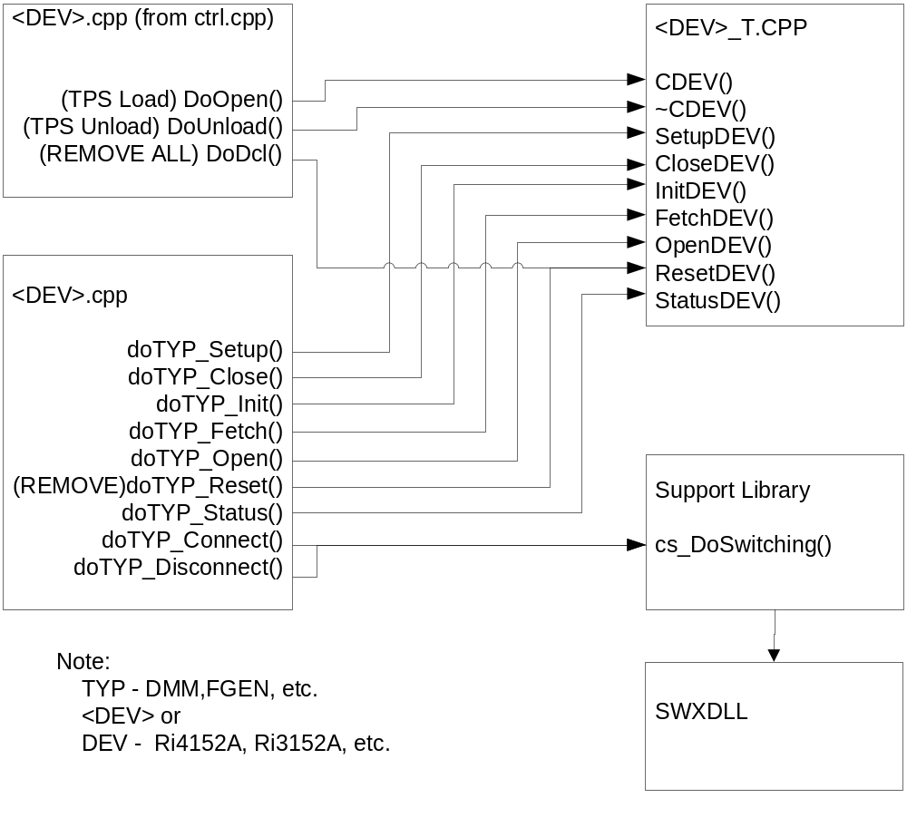
Figure 4.0 WCEM Function Relationships

System Components
The WCEM driver will consist of:

- A Microsoft Visual C++ project to build the WCEM
  - WCEM Wizard generated interface files
    - Wrapper.cpp
    - error.cpp
    - key.h
  - Configuration Information
  - TerM9.rc
  - resource.h
  - Updated Template File
    - TerM9.cpp
  - The programmer generated driver file TerM9_T.cpp

- A PAWS Developer’s Studio project file for the benchmark TerM9.PAW
  - An ATLAS program or programs to test the driver (Benchmark)
  - A Device Database static Description

Interface design

Function | Purpose
CTerM9(bool sim, int dbglvl, int addr) | This function is used to initialize the instrument, obtain a handle from VISA or other controller software, and establish if the device is in simulation mode and / or debug.
~CTerM9(void) | This function shuts down the instrument and releases the device handle.
SetupTerM9(int fnc) | This function is the entry point for the setup action. The argument is the FNC number from the DeviceDB Static Description.
SetupPinElecTerM9(int fnc) | This function, associated with the SETUP verb, establishes the in electronics settings.
StatusTerM9(void) | This function queries the instrument for status and reports any errors to the RTS via the error handling mechanisms
FetchTerM9(int fnc) | This function is responsible for retrieving measured values from the instrument and returns them to the RTS via the fetch API in WCEM or other support libraries
InitiateTerM9(int fnc) | This function controls the ATLAS INITIATE actions and is responsible for enabling or triggering a signal
ResetTerM9(int fnc) | This function is responsible for resetting the instrument. The argument 0 will be reserved for a RESETALL action and shall reset the instrument regardless of the current state of the device. Arguments > 0 may use a state variable to determine if the device is currently reset.
CloseTerM9(int fnc) | This function is responsible for the ATLAS CLOSE verb and shall close any internal relays within the instrument and will enable the output or input to the device.
OpenTerM9(int fnc) | This function is responsible for the ATLAS OPEN verb and will disable the output or input of the instrument.

Detailed Design

Classification
This module is unclassified.

ATLAS Modifier Definition
The following table specifies the Nouns / Stimulus and Measure Characteristics / Modifiers used to control the M9 Digital Test Instruments.:

The m9 DTI operates at amplitudes of –2V to 5V. The m9 functions are labeled in the Misc column as “Low Voltage Digital".

Modifier |  | Dim |  | Value Range | Default |  |  |  |  |  | XML |  |  |  |  |  |  | Misc
DEFINE DIGITAL CONFIGURATION
DIGITAL CONFIGURATION |  |  |  |  |  |  |  |  |  |  |  |  |  |  |  |  |  | <configuration>
DEFINE DIGITAL SOURCE
LOGIC DATA |  |  |  |  |  |  |  |  |  |  |  |  |  |  |  |  |  |  |  | noun extension
SAME AS |  |  |  |  |  |  |  |  |  |  |  |  |  |  |  |  |  |  |  | previously defined <configuration>
TYPE |  |  | PARALLEL |  |  |  | PARALLEL |  |  |  |  |  |  |  |  |  |  |  |  | optional
VOLTAGE-ONE | V |  | -2V to 5 V
VOLTAGE-ZERO | V |  | -2 to +5V |  |  |  |  |  |  |  |  |  |  |  |  |  |  |  |  | Low Voltage Digital
VOLTAGE-QUIES | V |  | -2 to +5V |  |  |  |  |  |  |  |  |  |  |  |  |  |  |  |  | Low Voltage Digital
CURRENT-ONE | A |  | -10mA to 10mA
CURRENT-ZERO | A |  | -10mA to 10mA
ILLEGAL-STATE-INDICATOR
ILLEGAL-STATE- INDICATOR |  |  | TRUE,FALSE |  |  |  | TRUE
LEVEL-LOGIC-ONE VOLTAGE | V |  | -2 to +5V |  |  |  |  |  |  |  |  |  |  |  |  |  |  |  | Low Voltage Digital
LEVEL-LOGIC-ZERO VOLTAGE | V |  | -2 to +5V |  |  |  |  |  |  |  |  |  |  |  |  |  |  |  | Low Voltage Digital
RISE –TIME | SEC |  | 0 sec to 1 sec
FALL-TIME | SEC |  | 0 sec to 1 sec
DEFINE DIGITAL SENSOR
LOGIC DATA |  |  |  |  |  |  |  |  |  |  |  |  |  |  |  |  |  |  | noun extension
SAME AS |  |  |  |  |  |  |  |  |  |  |  |  |  |  |  |  |  |  | previously defined <configuration>
TYPE |  |  | PARALLEL |  |  |  |  |  |  | PARALLEL |  |  |  |  |  |  |  |  | optional
VOLTAGE-ONE | V |  | -2V to 5V
VOLTAGE-ZERO | V |  | -2 to +5V |  |  |  |  |  |  |  |  |  |  |  |  |  |  |  | Low Voltage Digital
VOLTAGE-ZERO | V |  | -2 to +5V |  |  |  |  |  |  |  |  |  |  |  |  |  |  |  | Low Voltage Digital
VOLTAGE-QUIES | V |  | -2 to +5V |  |  |  |  |  |  |  |  |  |  |  |  |  |  |  | Low Voltage Digital
CURRENT-ONE MAX | A |  | -10mA to 10mA
CURRENT-ZERO MAX | A |  | -10mA to 10mA
CONNECT
LOGIC DATA, VALUE
LOGIC DATA, VALUE
(VALUE), LOGIC DATA,
DISCONNECT
LOGIC DATA, VALUE
LOGIC DATA, VALUE
(VALUE), LOGIC DATA,
DEFINE, <digital timing>, DIGITAL TIMING,
STIM-EVENT |  |  |  |  |  |  |  |  |  |  |  |  |  |  |  |  |  |  | <event>
SENSE-EVENT |  |  |  |  |  |  |  |  |  |  |  |  |  |  |  |  |  |  | <event>
IDENTIFY
EVENT |  |  |  |  |  |  |  |  |  |  |  |  |  |  |  |  |  |  | <event>
AS (VOLTAGE) SQUAREWAVE, EQ | V |  | -2 to +5V
PERIOD RANGE <> TO<> | SECS
MAX-TIME | SEC |  | 0 to 100 seconds |  |  |  |  |  |  |  |  |  |  |  |  |  |  |  | The max time for patterns to be sent and/or recevied, processed.
STIMULATE
REPEAT |  |  |  |  |  |  |  |  |  |  |  |  |  |  |  |  | Optional
HIZ
ZERO
ONE
ON
SENSE
VALUE or HIZ
INTO
ON
PROVE
VALUE or HIZ
INTO
REF
MASK-ONE or MASK-ZERO |  |  |  |  |  |  |  |  |  |  |  |  |  |  |  | Optional
SAVE-COMP |  |  |  |  |  |  |  |  |  |  |  |  |  |  |  | Optional
ERROR |  |  |  |  |  |  |  |  |  |  |  |  |  |  |  | Optional
ERROR-INDEX |  |  |  |  |  |  |  |  |  |  |  |  |  |  |  | Optional
FAULT-COUNT |  |  |  |  |  |  |  |  |  |  |  |  |  |  |  | Optional
ON
ZERO , ON
ONE, ON
HIZ, ON
APPLY, LOGIC DATA, VALUE
VOLTAGE-ONE |  |  | -2 V to 5 V
VOLTAGE-ZERO |  |  | -2V to 5 V
MEASURE, (VALUE INTO
LOGIC DATA,
VOLTAGE-ONE |  |  | -2 V to 5 V
VOLTAGE-ZERO |  |  | -2V to 5 V
DO, TIMED DIGITAL
STIM-RATE |  |  | word/sec
STIM-EVENT
SENSE-DELAY |  |  | Sec
SENSE-EVENT
SENSE-RATE |  |  | word/sec
ITERATE |  |  | times |  |  |  |  |  |  |  |  |  |  |  |  | Optional
MAX-TIME |  |  |  |  |  |  |  |  |  |  |  |  |  |  |  | Optional
ENABLE
EVENT,
DISABLE
EVENT,

Port Names
The Port Names in the table below provide the naming convention utilized in the Switch Data Base and Model for interface control and management along with the connection field mnemonics to be used by ATLAS programs.

CNX Field | Port Name | Instrument
HI |  | Bidirectional
EVENT-SENSE
EVENT-STIM
EVENT-OUT
EVENT-DELAY
Notes:

1. Single Ended channels are assigned by that number for the HI connections.

M9 Digital Test Instrument Programming Specifications

Programming Resolution
TBD

Programming Accuracy
TBD

Processing
There are no special processing requirements other than normal ATLAS interpretation of the keywords.

Notes

ATLAS Examples

Static Test Example
000100 DEFINE, 'CT831 Static Configuration', DIGITAL CONFIGURATION $
55 DEFINE, 'ADBUS Sense', DIGITAL SENSOR, (VALUE), LOGIC DATA,
VOLTAGE-ONE 2.0V,
VOLTAGE-ZERO 0.8V,
CNX HI J1-9 J1-10 $
99 END, 'CT831 Static Configuration' $

100000 ENABLE, DIGITAL CONFIGURATION 'CT831 Static Configuration' $
35 SENSE, (VALUE INTO 'Result'), ON 'ADBUS Sense' $
40 CALCULATE, 'Expect' = DIG(BNR,'Dat',8,0) $
41 COMPARE, 'Result', EQ 'Expect' $

999900 DISABLE, DIGITAL CONFIGURATION 'CT831 Static Configuration' $

Dynamic Test Example 1
000100 DEFINE, 'CT831 Dynamic Configuration', DIGITAL CONFIGURATION $
55 DEFINE, 'ADBUS Drive', DIGITAL SOURCE, (VALUE), LOGIC DATA,
VOLTAGE-ONE 2.0V,
VOLTAGE-ZERO 0.8V,
CNX HI J1-9 J1-10 $
99 END, 'CT831 Dynamic Configuration' $

100000 ENABLE, DIGITAL CONFIGURATION 'CT831 Dynamic Configuration' $
35 ENABLE, EVENT '50 NRET' $
36 DO, TIMED DIGITAL,
37 STIM-RATE 1 MWORDS/SEC $
39 STIMULATE, B'1', ON CNX 'J1-9' $
40 STIMULATE, B’10’, ON 'ADBUS Drive' $
41 END, DO $

999900 DISABLE, DIGITAL CONFIGURATION 'CT831 Dynamic Configuration' $

Dynamic Test Example 2
STIMULATE on P1, P2, P3, P4, P5, P6 for 3 patterns
SENSE on P8, P9, P10, P11, P12 for 3 patterns
STIMULATE on P1, P2, P3 for 1 pattern
PROVE on P9, P10, P11 for 1 pattern
STIMULATE on P1, P2, P3, P4, P5, P6, P7 for 4 patterns
STIMULATE on P1, P2, P3, P4, P5, P6, P7 for 2 patterns
PROVE on P8, P9, P10, P11, P12 for 2 patterns
SENSE on P8, P9, P10, P11 for 2 patterns

Requirements Traceability
This WCEM driver provides the requirements stated in Paragraph 3.4.10 of the PERFORMANCE SPECIFICATION FOR THE THIRD ECHELON TEST SET (TETS) MARCORSYSCOM-PD-02-001 12/1/2003

Appendix
None.

