EADS NA Defense

Software Design Document

Switch Functionality for the TETS Switch Subsystem
WCEM Driver – WcemSwitch.dll

SDD-WcemSwitch
Version 0.00
01/10/06

This document and the information contained herein are proprietary to EADS NA Defense and may not be disclosed in whole or in part to any parties without the expressed written consent of EADS NA Defense.

PAWS is a registered trademark of the TYX Corporation.

© EADS NA Defense
1222 Lucas Ave. Suite 200
St. Louis MO 63103
phone (314) 727 1337
fax (314) 727 6750

Software Design Document

Version 0.00

History of changes
1/10/06 Preliminary
Change Table

Change | Date | Paragraph

1 Scope 5
1.1 Identification 5
1.2 System Overview 5
1.3 Document Overview 5
2 Reference Documents 5
3 System-Wide Design Overview 5
3.1 Assumptions and Dependencies 5
3.2 General Constraints 5
3.3 Goals and Guidelines 6
3.4 Safety and Security Considerations 6
3.5 Development Methods 6
4 System Architectural Design 6
4.1 System Components 7
4.2 Interface design Error! Bookmark not defined.
5 Detailed Design 10
5.1 Classification Error! Bookmark not defined.
5.2 ATLAS Modifier Definition Error! Bookmark not defined.
5.3 Port Names Error! Bookmark not defined.
5.4 Digital Multimeter Programming Specifications Error! Bookmark not defined.
5.4.1 Programming Resolution Error! Bookmark not defined.
5.4.2 Programming Accuracy Error! Bookmark not defined.
5.5 Processing Error! Bookmark not defined.
6 Notes Error! Bookmark not defined.
6.1 ATLAS / ATML Output Examples Error! Bookmark not defined.
6.1.1 DC Signal using Digital Multimeter Error! Bookmark not defined.
6.1.2 AC Signal using Digital Multimeter Error! Bookmark not defined.
6.1.3 Four-Wire Resistance Measurement using Digital Multimeter Error! Bookmark not defined.
7 Requirements traceability. Error! Bookmark not defined.
8 Appendix A –TETS IEEE 1641 TSF Definitions 17
8.1 TSF .XSD Signal Description Error! Bookmark not defined.
8.1.1 Switch_DCSIGNAL Error! Bookmark not defined.
8.1.2 Switch_ACSIGNAL Error! Bookmark not defined.
8.1.3 Switch_IMPEDANCE Error! Bookmark not defined.
8.2 TSF .XML Signal IEEE 1641 TSF Library Error! Bookmark not defined.
8.2.1 Switch_DCSIGNAL Error! Bookmark not defined.
8.2.2 Switch_ACSIGNAL Error! Bookmark not defined.

Scope

Identification
The software configuration component WcemSwitch.dll provides the software routines necessary to control the TETS Switch.

System Overview
The PAWS system provides several methods of interfacing the compiled ATLAS object code with the test system instruments. The method used by this module is ATML. The Windows CIIL Emulation Module (WCEM) is used to convert ATLAS to ATML. In this mode of instrument control, the PAWS WRTS calls the WcemSwitch.dll via ATLAS single action verb related functions. The WcemSwitch.dll queries the WRTS for ATLAS modifier values and other parameters and builds an ATML signal description that describes the action and signal modifiers to be sent to the TETS Station Controller. Appendix A describes the IEEE1641 TSF library schema to be used to generate the ATML/1641 signal description portion of the ATML signal description.

Document Overview
This document defines the detailed software design for the PAWS WCEM driver for the Switch. This document specifies the SwitchDB path values and ATLAS pin descriptors for all ATLAS accessible interface connections.

Reference Documents
- EADS PAWS WCEM Software Development Style Guide
- Software Requirements Specification for Third Echelon Test Set DEFCOT&S-3536-SRS-001
- Series 1260 VXI Switching Cards Users Manual, (Racal Instruments Inc. 980673-999 Release February 24, 2003)
- Computer Programming Manual (CPM) for the Third Echelon Test System (TETS) REV. E P/N 93006A0026
- IEEE std. 716-1989 C/ATLAS Test Language
- General Notes for ATLAS Implementation Doc # 7992052 Rev.01 Aug 10 2005

System-Wide Design Overview
The PAWS development system provides the ability to code a test program in an extended subset of the ATLAS Test Language. The PAWS development system provides the ability to modify the ATLAS subset with special nouns and modifiers (primarily analog) to meet special requirements.

Assumptions and Dependencies
The following assumptions and dependencies are made:
- The TETS ATLAS subsets will contain the common ATLAS extensions found in most extended subsets of ATLAS (e.g. TRIG-SOURCE, TRIG-SLOPE, etc.)
- The TETS ATLAS subset will contain all required legacy ATLAS extensions that are not replaceable with the standard or common ATLAS extensions.
- The full instrument range will be implemented when they exceed the ranges in the system requirements specification.
- The full functionality of the instrument will be implemented to the extent possible where the ATLAS mapping can be defined. (Detailed below).

General Constraints
The sections below will detail which of the ATLAS modifiers are used and how they are used to control the Racal switch modules.

Goals and Guidelines
- To the extent possible, map the ATLAS modifiers to instrument controls in a common sense manner.
- Implement the full range and functionality as can be supported by the extended subset of ATLAS.

Safety and Security Considerations
No safety or security considerations for this instrument.

Development Methods
As described in the “EADS PAWS WCEM Software Development Style Guide”

System Architectural Design
The PAWS WCEM driver is invoked on TPS load, TPS Unload, WRTS “Reset” / ATLAS “REMOVE, ALL”, and the derived “Single Action” ATLAS actions. The following diagram shows the major functions called from the WRTS through tables created by the WCEM Wizard in Wrapper.cpp. (See the “EADS PAWS WCEM Software Development Style Guide” for details). The essence of the WCEM driver is defined as a class CSwitch. When multiple instruments (Switch’s) are available in the station, an instance of the CSwitch class will be instantiated. Therefore, the member variables and methods need only control a single instrument.
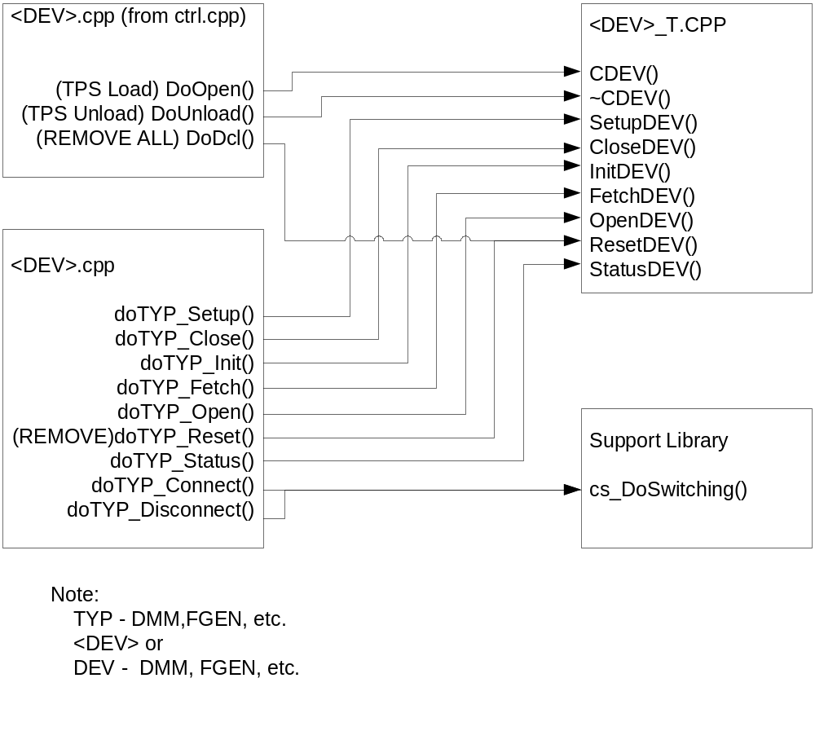
Figure 4.0 WCEM Function Relationships

System Components
The WCEM driver will consist of:
- A Microsoft Visual C++ project to build the WCEM
  - WCEM Wizard generated interface files
    - Wrapper.cpp
    - error.cpp
    - key.h
  - Configuration Information
  - Switch.rc
  - resource.h
  - Updated Template File
    - Switch.cpp
  - The programmer generated driver file Switch_T.cpp

- A PAWS Developer’s Studio project file for the benchmark Switch.PAW
  - An ATLAS program or programs to test the driver (Benchmark)
  - A Device Database static Description

Interface design

Test Program Interface

The ATLAS Program and UUT Pins
One of the preferred approaches of operation within the scope of the ATLAS Specification is the classification of signals as UUT Test Requirements. As such, the specification of the connection field in an ATLAS program should reflect the identity of the UUT Pins themselves.

For Example:

APPLY, DC SIGNAL,
VOLTAGE 5 V,
CNX HI J1-1 LO J1-2 $

This ATLAS Statement describes a requirement for 5 Volts at the UUT Pins
J1-1 and J1-2.

UUT to SAIF – The Interface Test Adapter (ItaDB)
To meet the criteria of the UUT Test Requirements, the TPS Engineer will design and develop an Interface Test Adapter, (ITA). The ITA is a hardware fixture that mates to both the UUT (via cables, connectors etc.) and the TETS Stand Alone Instrument Fixture (SAIF).

The TPS engineer will examine and have knowledge of the resources available per the definitions of the SAIF and create mappings between UUT Pins and points on the SAIF and, as needed, mappings between interface points on the SAIF, (SHORTS). These interface points on the SAIF are known as ‘Plug-pins’, and their relationship to the outside world is defined in the pinouts. A Hardware Fixture will be built to these definitions.

The Software side of these definitions is the Interface Test Adapter DataBase, (ItaDB). Each TPS will have an associated ItaDB. The ItaDB has a simple from – to format defined as:

from UUT-PIN to ‘Plug-Pin’;
from ‘Plug-Pin’ to ‘Plug-Pin’;

J-Connector Interface and Switch Model
The definition of the SAIF will be detailed for the PAWS Software Environment in the Switch Database, (SwitchDB). The SwitchDB is a static definition of how the SAIF relates to the outside world and to the instrumentation of the TETS Station. There are 3 items of information available to the system through the switch model that uniquely identify the switching connection required. These items are the block (BLK), module (MOD) and path (PTH) as defined in the switch database. In this way, the system can be modeled to the hardware modularity. The switch types of MATRIX and Switch identify the functionality of the switch being modeled. The purpose of the SwitchDB model is to assign a unique BLK-MOD-PTH or a unique combination of BLK-MOD-PTHs to specify a path from either <device port name> to ‘Plug-Pin’ or a ‘Plug-Pin’ to ‘Plug-Pin’ combination.

The BLK-MOD-PTH value assignments will be made such that they are algorithmic to the switch device commands.

Resource Allocation and the Switching
There is a step in the Compilation Process called Resource Allocation. During this phase, the UUT Test Requirements from the ATLAS Test Program are ‘assigned’ to resources as defined for the TETS ATS. As part of this process, the PATH between the UUT Pin – to the SAIF --- To the Station Resources is checked and assigned.

Data on this PATH is stored with the signal and when the ATLAS Signal is executed, the CONNECT and DISCONNECT Actions will call the appropriate DLL Functions as defined above.

These Resource and PATH assignments are done automatically and relieve the TPS engineer of the requirement to understand the station interconnect and switching resources to any great detail. The ‘Plug-Pin’, as defined above, is the focus of the test interconnections via the ITA that the TPS Engineer is required to focus. What resources are available where and does a valid path exist for each test.

WcemSwitch.dll Interface

Function | Purpose
DoOpen() | This function is used to initialize all switch controllers and cards, obtain a handle from VISA or other controller software, and establish if the device is in simulation mode and / or debug.
DoUnload() | This function shuts down all switch controllers and cards and releases the device handle.
doIfc () | This function resets all switches to their default state. (REMOVE, ALL)
doSwitch_Connect(Path) | This function is the entry point for establishing the connection PATH.
doSwitch_Disconnect(Path) | This function is the entry point for removing the connection PATH.

SwxSrvr.dll Interface

Function | Purpose
InitSwitch () | This function is used to initialize all switch controllers and cards, obtain a handle from VISA or other controller software, and establish if the device is in simulation mode and / or debug.
ReleaseSwitch () | This function shuts down all switch controllers and cards and releases the device handle.
ResetSwitch () | This function resets all switch controllers and cards.
CloseSwitches(PathData) | This function is the entry point for establishing the connection PATH.
OpenSwitches(PathData) | This function is the entry point for removing the connection PATH.
CheckUniqStationStatus(ErrMsg) | This function performs all unique station status parameters that require monitoring prior to setup of an instrument.
GetUniqCalCfg(DevName ExpTs, ErrMsg) | This function incorporates the station unique calibration and configuration table styles for the each instrument.
CloseUniqStationStatus() | This function closes any threads spawned to monitor station interrupts etc. and release any resources used for monitoring station status.

Detailed Design

Classification
This module is unclassified.

TETS Switch ATLAS Pin Descriptor (Plug-Pin) Definition

SAIF / Plug-Pin Overview
The TETS SAIF Pin Map is a J-Connector configuration.

The term used in the PAWS environment is ‘Plug-Pin’, where ‘Plug’ is the callout for the individual modules and the ‘Pins’ are defined for each plug.

The ‘Plug’ nomenclature will be:

For SAIF Interface: J<module>

Where <module> will be 1 through and including 23, which correspond to the module positions.

Example would be: J1 Which is the Module dealing with the DC Power Supplies.

Note: Drawing found in TETS Station CDR rev1 power point.

SAIF - Front View
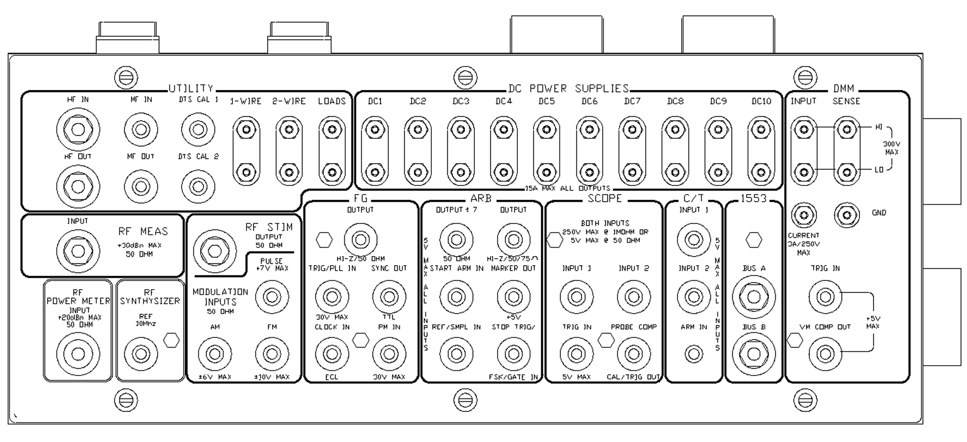
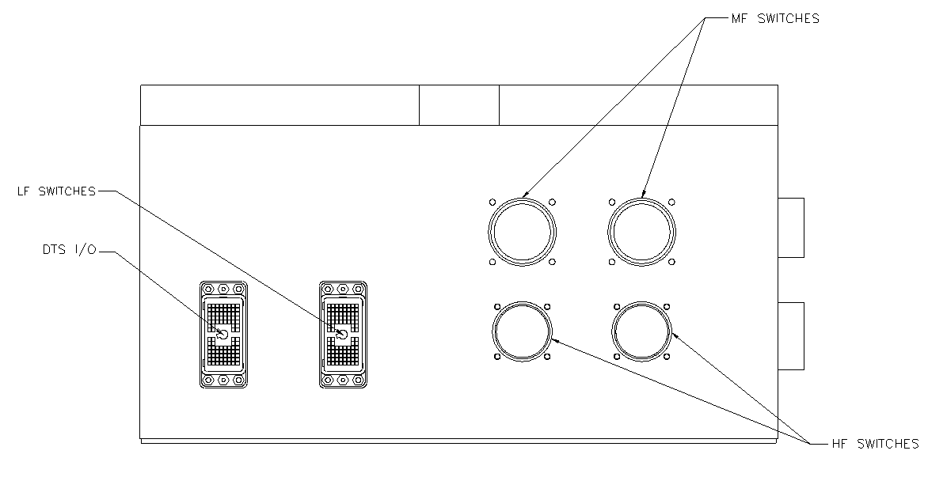
SAIF - Top View

SAIF – Side View
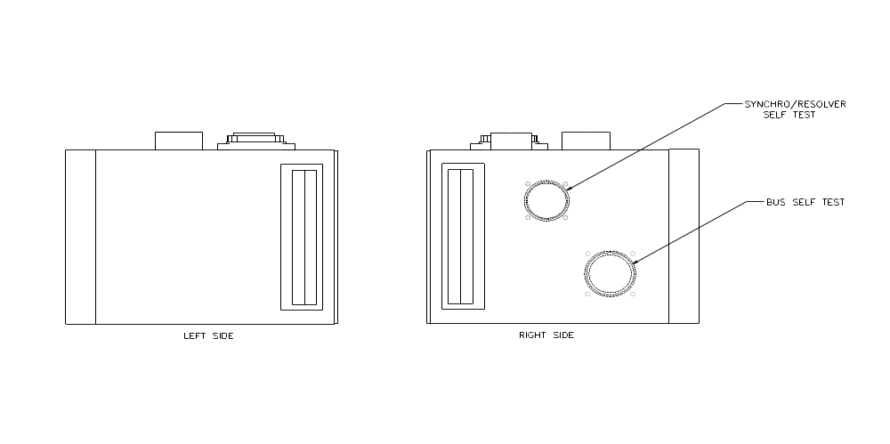

J1 Module DC Power Supply
The pins in this module are directly connected to the various resources. As such, the switch database will be used for allocation purposes only and no path triplets will be generated.

J2 – J9 Modules Digital Word Generators
The pins in this module are directly connected to the various resources. As such, the switch database will be used for allocation purposes only and no path triplets will be generated.

J10 Module 1x1, 1x4, 2x8, DPST and 1x2 General Purpose Switches – RI1260-39 Opt 001 Card 1
The Power relays are general purpose power relays which are controlled via the CONNECT and DISCONNECT actions of the ATLAS program. The path triplet assigned by the switch database will be assigned to aid in automatic generation of command strings for the device.

J11 Module 1x1, 1x4, 2x8, DPST and 1x2 General Purpose Switches – RI1260-39 Card 2
The Signal relays are general purpose signal relays which are controlled via the CONNECT and DISCONNECT actions of the ATLAS program. The path triplet assigned by the switch database will be assigned to aid in automatic generation of command strings for the device.

J12 and J13 Modules 1x8, 1x24, and 2x24 General Purpose Switches – RI1260-38T
The Coax relays are general purpose coax relays which are controlled via the CONNECT and DISCONNECT actions of the ATLAS program. The path triplet assigned by the switch database will be assigned to aid in automatic generation of command strings for the device.

J14 and J15 Modules 1x8 Coax General Purpose Switches – RI1260-58
The mux relays are general purpose relays which are controlled via the CONNECT and DISCONNECT actions of the ATLAS program. The path triplet assigned by the switch database will be assigned to aid in automatic generation of command strings for the device.

J17 and J17 Modules 1x6 Coax General Purpose Switches – RI1260-67A
The signal relays are general purpose relays which are controlled via the CONNECT and DISCONNECT actions of the ATLAS program. The path triplet assigned by the switch database will be assigned to aid in automatic generation of command strings for the device.

J18 and J19 Modules Analog Probe, RF Stimulus, RF Measurement, RF Power Meter, RF System, Digital Oscilloscope, Function Generator, and Counter Timer
The pins in this module are directly connected to the various DC power supplies. As such, the switch database will be used for allocation purposes only and no path triplets will be generated.

J20 and J21 Modules Digital Multi-Meter
The pins in this module are directly connected to the various resources. As such, the switch database will be used for allocation purposes only and no path triplets will be generated.

J22 and J23 Modules Arbitrary Waveform Generator
The pins in this module are directly connected to the various resources. As such, the switch database will be used for allocation purposes only and no path triplets will be generated.

SwxSrvr Processing
The switch server is the SwxSrvr_TETS.dll that contains most of the test system dependant functions. Most other instrument .dlls are independent of the test system in which they reside. The SwxSrvr_TETS.dll is the module which contains all the test system specific controls (e.g. switch controls, ICA interlock monitoring, Power Control Monitoring (PCM), Temperature monitoring, etc.).

InitSwitch(), ReleaseSwitch(),ResetSwitch(), CloseSwitches(), OpenSwitches()
The “Switch” functions convert the compiler generated “Block-Mod-Path” data into the commands that control operation of the various switch cards in the station as well as initializing and releasing the handles and resources required for the switch card processing.

Check/Clear/CloseUniqStationStatus
The “UniqStationStatus” functions perform the test station unique status monitoring functions. CheckUniqStationStatus is called from each WCEM instrument driver at the beginning of the DoSetup function to check the station status prior to programming the instrument. The initial call to the CheckUniqStationStatus function initializes the station monitoring thread. Calls to CheckUniqStationStatus enable the SAIF interlock checking and calls to ClearUniqStationStatus disable ICA interlock checking. CloseUniqStationStatus function is called from the switch WCEM DoUnload function to terminate any threads and close any handles and resources as the WRTS is closing.

Station Monitoring Thread
The station monitoring thread maintains the various status flags used/checked by the CheckUinqStationStatus calls from the instruments.

Requirements Traceability
This WCEM driver provides the requirements stated in Paragraph 3.4.4 of the PERFORMANCE SPECIFICATION FOR THE THIRD ECHELON TEST SET (TETS) MARCORSYSCOM-PD-02-001 12/1/2003 and General Notes for ATLAS Implementation Doc # 7992052 Rev.01 Aug 10 2005.

Notes
None.

Appendix

Appendix A

