EADS NA Defense Test & Services

Software Design Document

NAI 65CS4-A2210C0 Synchro/Resolver Functionality for TETS Analog Subsystem

WCEM Driver – WcemSRS.dll

SDD – WcemSRS
Version 0.00
03/31/2006

This document and the information contained herein are proprietary to EADS NA Defense and may not be disclosed in whole or in part to any parties without the expressed written consent of EADS NA Defense.

PAWS is a registered trademark of the TYX Corporation.

© EADS NA Defense Test & Services
1222 Lucas Ave. Suite 200
St. Louis MO 63103
phone (314) 727 1337
fax (314) 727 6750

Software Design Document

Version 0.00

History of changes
0: Initial Release

Change Table

Change | Date | Paragraph

1 Scope 5
1.1 Identification 5
1.2 System Overview 5
1.3 Document Overview 5
2 Reference Documents 5
3 System-Wide Design Overview 5
3.1 Assumptions and Dependencies 5
3.2 General Constraints 6
3.3 Goals and Guidelines 6
3.4 Safety and Security Considerations 6
3.5 Development Methods 6
4 System Architectural Design 6
4.1 System Components 7
4.2 Interface design 8
5 Detailed Design 8
5.1 Classification 8
5.2 ATLAS Modifier Definition 9
5.3 Port Names 9
5.4 Processing 10
6 Requirements traceability 10
7 Notes 10
7.1 ATLAS Examples 10
7.1.1 Synchro Stimulus 10
7.1.2 Resolver Stimulus 10
7.1.3 Synchro Measurement 10
7.1.4 Resolver Measurement 10
8 Appendix A – Mathematical Equations 10

Scope

Identification
The software configuration component WcemSRS.dll provides the software routines necessary to control the Synchro/Resolver.

System Overview
The PAWS system provides several methods of interfacing the compiled ATLAS object code with the test system instruments. The method used by this module is the Windows CIIL Emulation Module (WCEM). In this mode of instrument control, the PAWS WRTS calls the WcemSRS.dll via ATLAS single action verb related functions. The WcemSRS.dll queries the WRTS for modifier values and other parameters and sends the necessary commands to the instrument.

Document Overview
This document defines the detailed software design for the PAWS WCEM driver for the Synchro/Resolver. This document specifies the value ranges of all the ATLAS modifiers and modifier value ranges and how they are used to control the Synchro/Resolver.

Reference Documents
- ARC PAWS WCEM Software Development Style Guide (ARCSTL-DSG-000)
- Software Requirements Specification for Third Echelon Test Set DEFCOT&S-3536-SRS-001
- PERFORMANCE SPECIFICATION FOR THE THIRD ECHELON TEST SET (TETS) MARCORSYSCOM-PD-02-001 12/1/2003
- Computer Programming Manual (CPM) for the Third Echelon Test System (TETS) REV. E P/N 93006A0026
- IEEE std. 716-1989 C/ATLAS Test Language
- General Notes for ATLAS Implementation Doc # 7992052 Rev.01 Aug 10 2005

System-Wide Design Overview
The PAWS development system provides the ability to code a test program in an extended subset of the IEEE std. 716-1989 C/ATLAS Test Language. The PAWS development system provides the ability to modify the ATLAS subset with special nouns and modifiers (primarily analog) to meet special requirements.

Assumptions and Dependencies
The following assumptions and dependencies are made:

- The TETS ATLAS subset will contain the common ATLAS extensions found in most extended subsets of ATLAS (e.g. TRIG-SOURCE, TRIG-SLOPE, etc.).
- The TETS ATLAS subset will contain all required legacy ATLAS extensions that are not replaceable with the standard or common ATLAS extensions.
- The full instrument range will be implemented when they exceed the ranges in the system requirements specification.
- The full functionality of the instrument will be implemented to the extent possible where the ATLAS mapping can be defined. (Detailed below).

General Constraints
The sections below will detail which of the ATLAS modifiers are used and how they are used to control the Synchro/Resolver.

Goals and Guidelines
- To the extent possible, map the ATLAS modifiers to instrument controls in a common sense manner.
- Implement the full range and functionality as can be supported by the extended subset of ATLAS.

Safety and Security Considerations
No safety or security considerations for this instrument.

Development Methods
As described in the “ARC PAWS WCEM Software Development Style Guide.”

System Architectural Design
The PAWS WCEM driver is invoked on TPS load, TPS Unload, WRTS “Reset” / ATLAS “REMOVE, ALL”, and the derived “Single Action” ATLAS actions. The following diagram shows the major functions called from the WRTS through tables created by the WCEM Wizard in Wrapper.cpp. (See the “ARC PAWS WCEM Software Development Style Guide” for details). The essence of the WCEM driver is defined as a class CSRS. When multiple instruments (SRSs) are available in the station, an instance of the CSRS class will be instantiated. Therefore, the member variables and methods need only control a single instrument.
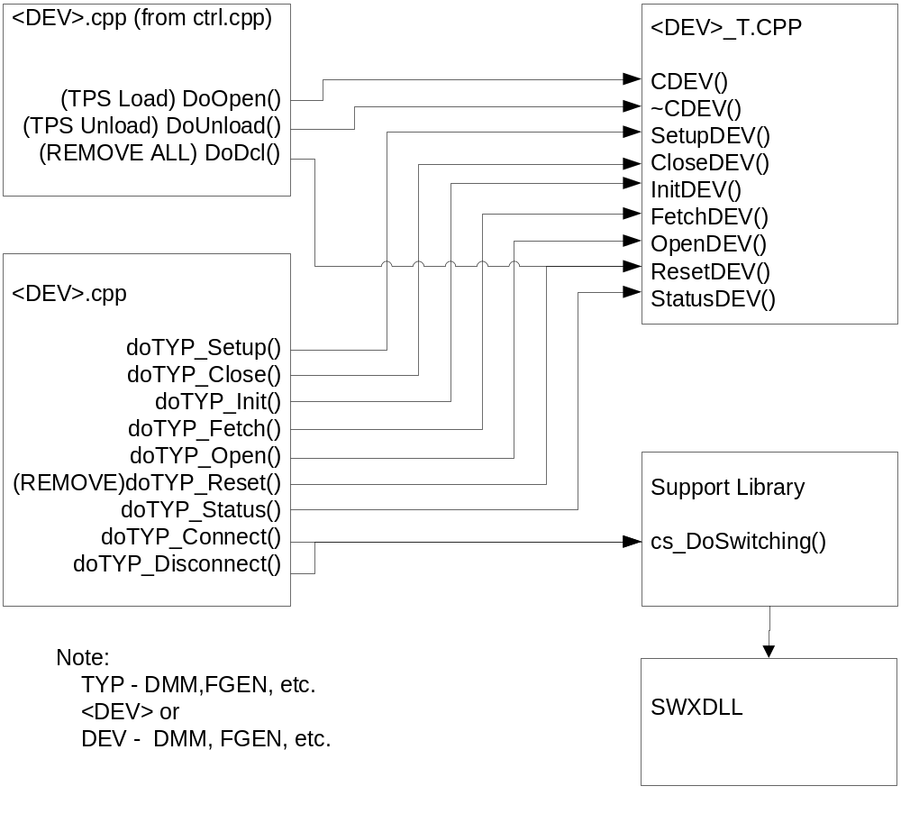
Figure 4.0 WCEM Function Relationships

System Components
The WCEM driver will consist of:

- A Microsoft Visual C++ project to build the WCEM
  - WCEM Wizard generated interface files
    - Wrapper.cpp
    - error.cpp
    - key.h
  - Configuration Information
  - SRS.rc
  - resource.h
  - Updated Template File
    - SRS.cpp
  - The programmer generated driver file SRS_T.cpp

- A PAWS Developer’s Studio project file for the benchmark SRS.PAW
  - An ATLAS program or programs to test the driver (Benchmark)
  - A Device Database static Description

Interface design

Function | Purpose
CSRS(bool sim, int dbglvl, int addr) | This function is used to initialize the instrument, obtain a handle from VISA or other controller software, and establish if the device is in simulation mode and / or debug.
~CSRS(void) | This function shuts down the instrument and releases the device handle.
SetupSRS(int fnc) | This function is the entry point for the setup action. The argument is the FNC number from the DeviceDB Static Description.
StatusSRS(void) | This function queries the instrument for status and reports any errors to the RTS via the error handling mechanisms
FetchSRS(int fnc) | This function is responsible for retrieving measured values from the instrument and returns them to the RTS via the fetch API in WCEM or other support libraries
InitiateSRS(int fnc) | This function controls the ATLAS INITIATE actions and is responsible for enabling or triggering a signal
ResetSRS(int fnc) | This function is responsible for resetting the instrument. The argument 0 will be reserved for a RESETALL action and shall reset the instrument regardless of the current state of the device. Arguments > 0 may use a state variable to determine if the device is currently reset.
CloseSRS(int fnc) | This function is responsible for the ATLAS CLOSE verb and shall close any internal relays within the instrument and will enable the output or input to the device.
OpenSRS(int fnc) | This function is responsible for the ATLAS OPEN verb and will disable the output or input of the instrument.

Detailed Design

Classification
This module is unclassified.

ATLAS Modifier Definition
The following table specifies the Nouns / Measured Characteristics / Modifiers used to control the SRS:

Modifier | Dimension | Value Range | Default | Misc
SYNCHRO
RESOLVER
ANGLE | Deg | 0 to 359.99 Deg
ANGLE-RATE | Deg/Sec | 0 to 4896 Deg/Sec |  | Rotation rate
VOLTAGE | Vrms | 1 V to 90 V |  | V_{L-L}, line-to-line output voltage
SYNC-TO-EVENT |  |  |  | Initiates rotation
(ANGLE) SYNCHRO, (ANGLE) RESOLVER, (ANGLE-RATE) SYNCHRO, (ANGLE-RATE) RESOLVER
ANGLE | Deg | 0 to 359.99 Deg
ANGLE-RATE | Deg/Sec | -32767 to +32767 Deg/Sec |  | Rotation rate
COMMON MODIFIERS
EVENT-SLOPE |  | NEG, POS
REF-SOURCE |  | INT, EXT | INT
VOLTAGE-REF | Vrms | 2 V to 115 V |  | Reference voltage
FREQ | Hz | 47 Hz to 2 kHz |  | Internal reference generator frequency
SPEED-RATIO |  | 1 to 255

Port Names
The Port Names in the table below provide the naming convention utilized in the Switch Data Base and Model for interface control and management along with the connection field mnemonics to be used by ATLAS programs.

CNX Field | Port Name | Instrument
X or S1 | SRS_x_y-DS-S1 | D/S Stim S1
Z or S2 | SRS_x_y-DS-S2 | D/S Stim S2
Y or S3 | SRS_x_y-DS-S3 | D/S Stim S3
S4 | SRS_x_y-DS-S4 | D/S Stim S4
REF HI | SRS_x_y-DS-RHI | D/S Stim Ref HI Input
REF LO | SRS_x_y-DS-RLO | D/S Stim Ref LO Input
S1 | SRS_x_y-SD-S1 | S/D Meas S1
S2 | SRS_x_y-SD-S2 | S/D Meas S2
S3 | SRS_x_y-SD-S3 | S/D Meas S3
S4 | SRS_x_y-SD-S4 | S/D Meas S4
REF HI | SRS_x_y-SD-RHI | S/D Meas Ref HI Input
REF LO | SRS_x_y-SD-RLO | S/D Meas Ref LO Input

Notes:
- Where ‘x’ is the number of devices in the test station and y is the number of channels each. There are 2 Digital/Synchro (D/S) stimulus channels and 2 Synchro/Digital (S/D) measurement channels for each module.

Processing
There are no special processing requirements other than normal ATLAS interpretation of the keywords.

Requirements traceability
This WCEM driver provides the requirements stated in Paragraph 3.4.17 of the PERFORMANCE SPECIFICATION FOR THE THIRD ECHELON TEST SET (TETS) MARCORSYSCOM-PD-02-001 12/1/2003 and General Notes for ATLAS Implementation Doc # 7992052 Rev.01 Aug 10 2005.

Notes

ATLAS Examples

Synchro Stimulus
APPLY, SYNCHRO, ANGLE 10 DEG, VOLTAGE 11.8V, FREQ 400 HZ, CNX X J1 Y J2 Z J3 $

Resolver Stimulus
APPLY, RESOLVER, ANGLE-RATE 100 DEG/SEC, VOLTAGE 11.8V, FREQ 400 HZ, CNX S1 J1 S2 J2 S3 J3 S4 J4 $

Synchro Measurement
MEASURE, (ANGLE-RATE INTO ‘ANG-RATE’), SYNCHRO, ANGLE-RATE MAX 1000 DEG/SEC, FREQ 400 HZ, CNX S1 J1-1 S2 J1-2 S3 J1-3 $

Resolver Measurement
MEASURE, (ANGLE INTO ‘ANG’), RESOLVER, ANGLE MAX 359.9 DEG, FREQ 400 HZ, VOLTAGE-REF 90 V, CNX S1 J1-1 S2 J1-2 S3 J1-3 S4 J1-4 $

Appendix A – Mathematical Equations
AC Signal

1. Voltage to Voltage-PK
Voltage-PK value = voltage_value * RMS_PK

2. Voltage-PK to Voltage
Voltage value = voltage-pk_value / RMS_PK

3. Voltage to Voltage-PP
Voltage-PP value = voltage_value * RMS_PP

4. Voltage-PP to Voltage
Voltage value = voltage-pp_value / RMS_PP

5. Voltage to Watt
Watt value = (voltage_value)² / impedance value

6. Watt to Voltage
Voltage value = sqrt(watt value) * impedance value

7. Voltage to dBm
For a 50 ohm test equipment impedance
dBm value = 20 log (voltage_value / DBM_50_OHM)

For a 600 ohm test equipment impedance
dBm value = 20 log(voltage_value / DBM_600_OHM)

8. dBm to Voltage
For a 50 ohm test equipment impedance
Voltage value = 10^{dBm_value / 20} * DBM_50_OHM
For a 600 ohm test equipment impedance
Voltage value = 10^{dBm_value / 20} * DBM_600_OHM

9. Watt to dBm
dBm value = 10 log (watt_value / .001)

10. dBm to Watt
Watt value = 10^{dBm_value / 10} * .001

Square Wave Signal - This is for a 50% Duty Cycle only and can only be done for this Duty Cycle. Any other Duty Cycle not allowed.

1. Voltage to Voltage-PP
Voltage-PP value = voltage_value * 2

2. Voltage-PP to Voltage
Voltage value = voltage-pp_value / 2

3. Voltage to Voltage-PK
Voltage-Pk value = voltage_value

4. Voltage-PK to Voltage
Voltage value = voltage-pk_value

Triangular Wave Signal - This is for symmetrical Triangular wave signal. Any other symmetry for this wave is not allowed.

1. Voltage to Voltage-PK
Voltage-PK value = voltage_value * RMS_TRI_PK

2. Voltage-PK to Voltage
Voltage value = voltage-pk_value / RMS_TRI_PK

3. Voltage to Voltage-PP
Voltage-PP value = voltage_value * RMS_TRI_PP

4. Voltage-PP to Voltage
Voltage value = voltage-pp_value / RMS_TRI_PP

Constants used for Mathematical Equations

RMS_PK = sqrt(2) = 1.414213562373 rounded to 12 decimal place.

RMS_PP = RMS_PK * 2

RMS_TRI_PK = sqrt(3) = 1.73205080808 rounded to 11 decimal place

RMS_TRI_PP = RMS_TRI_PK * 2

DBM_50_OHM = .22360679775 rounded to 11 decimal place
1mw = E²/50 equals sqrt(.05)

DBM_600_OHM = .7745966692414 rounded to 13 decimal place
1mw = E²/600 equals sqrt(.6)

