EADS NA Defense Test & Services

Software Design Document

AgE1445A Arbitrary Waveform Generator
SFP

SDD-SAIS AgE1445A
Version 0.00
08/22/05

This document and the information contained herein are proprietary to EADS NA Defense and may not be disclosed in whole or in part to any parties without the expressed written consent of EADS NA Defense.

PAWS is a registered trademark of the TYX Corporation.

© EADS NA Defense Test & Services
1222 Lucas Ave. Suite 200
St. Louis MO 63103
phone (314) 727 1337
fax (314) 727 6750

Software Design Document

Version 0.00

History of changes
0: Initial Release
Change Table

Change | Date | Paragraph

1 Scope 5
1.1 Identification 5
1.2 System Overview 5
1.3 Document Overview 5
2 Reference Documents 5
3 System-Wide Design Overview 5
3.1 Assumptions and Dependencies 5
3.2 General Constraints 5
3.3 Goals and Guidelines 5
3.4 Safety and Security Considerations 6
3.5 Development Methods 6
4 System Architectural Design 6
4.1 System Components 6
4.2 Interface design 7
5 Detailed Design 7
5.1 Classification 7
5.2 SFP GUI 7
5.3 ATLAS Generation 10
5.4 Function Definition 10
5.5 AgE1445A Arbitrary Waveform Generator Programming Specifications 14
5.6 Processing 14
6 Notes 14
6.1 ATLAS Code Examples 14
7 Requirements traceability 14
8 Appendix 14

Scope

Identification
The ARB Stand-Alone Instrument Software (SAIS) CSCI AgE1445A.exe provides the software routines necessary to control the AgE1445A Arbitrary Waveform Generator from a Soft Front Panel (SFP).

System Overview
The SAIS system provides a method of interfacing with the test system instruments. The method used by this module is utilizing the Common Interface Control Layer (CICL) calling Application Programming Interface (API) functions or SCPI commands.

Document Overview
The document defines the detailed software design for the SFP of the AgE1445A. This document specifies the functional capabilities and how they are used to control the AgE1445A Arbitrary Waveform Generator.

Reference Documents
- ARC PAWS WCEM Software Development Style Guide (ARCSTL-DSG-000)
- User Manual E1445A Waveform & Dual Output Pulse Generator (mE1445A.pdf)
- Software Requirements Specification for Third Echelon Test Set DEFCOT&S-3536-SRS-001
- PERFORMANCE SPECIFICATION FOR THE THIRD ECHELON TEST SET (TETS) MARCORSYSCOM-PD-02-001 12/1/2003
- Computer Programming Manual (CPM) for the Third Echelon Test System (TETS) REV. E P/N 93006A0026
- IEEE std. 716-1989 C/ATLAS Test Language
- General Notes for Virtual Instrumentation Doc # 7992051 Rev.01 Aug 10 2005

System-Wide Design Overview
The SAIS provides the ability to control the instrument in debug and local modes of operation. The SFP will provide the capability to generate ATLAS code supported by IEEE 716-89 C/ATLAS.

Assumptions and Dependencies
The following assumptions and dependencies are made:

- ATLAS shall conform to the ATLAS standard and not be extended
- Instruments are provided with APIs
- Direct programming to instrument via SCPI (or equivalent) is permitted for functions that are not supported via the API.
- No complex assumptions for ATLAS generation.

General Constraints
The sections below will detail which of the instrument functions and parameters are implemented to control the AgE1445A.

Goals and Guidelines
- To the extent possible, map functionality and parameters to instrument controls using the Common Interface Control Layer (CICL)
- Implement the functionality as defined in General Notes for Virtual Instrumentation Doc # 7992051 Rev.01 Aug 10 2005.

Safety and Security Considerations
No safety or security considerations for this instrument.

Development Methods
TBD

System Architectural Design
SFPs will be modified and or developed using Visual Basic 6.0 and executed using existing SAIS interface.
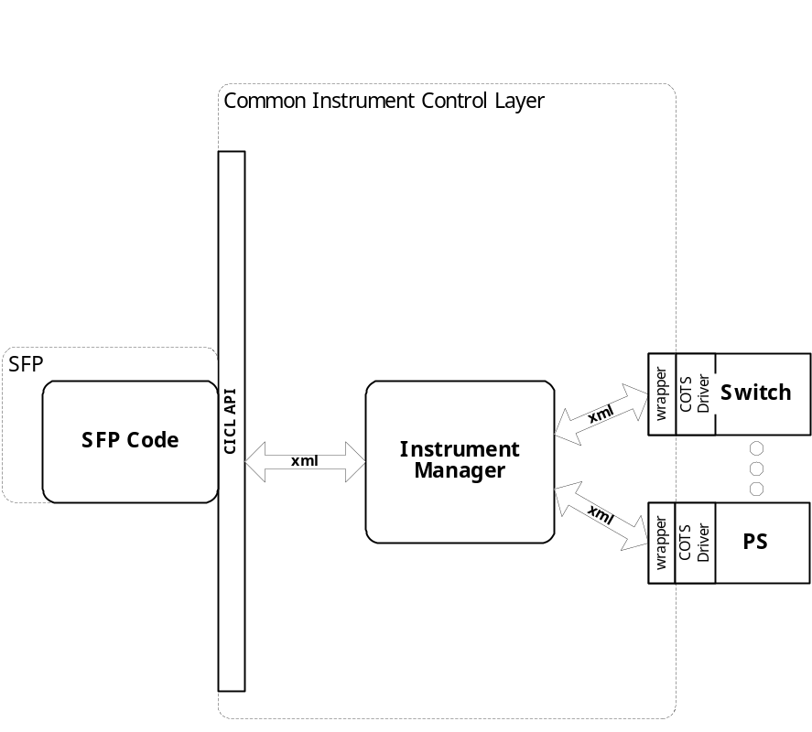

System Components
The SFP will consist of:

- A Visual Basic 6.0 project to build the SFP
  - Gui Files
    - About.frm
    - hpe1445a.frm
  - Basic Source Modules
  - Tetslib.bas
  - Visa32,bas
  - Programmer Generated hpe1445a Source File
  - Main.bas

Interface design

Communications with the instrument is through the CICL interface API.

Function | Purpose
(cicl_SD_Snippet* SignalDescription, SCTE_XML_String* cResponse, int BufferSize)

Detailed Design

Classification
This module is unclassified.

SFP GUI

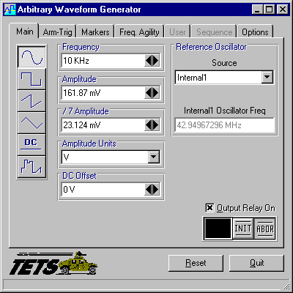

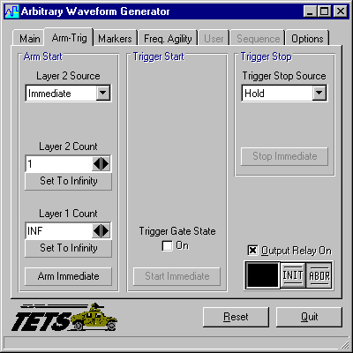

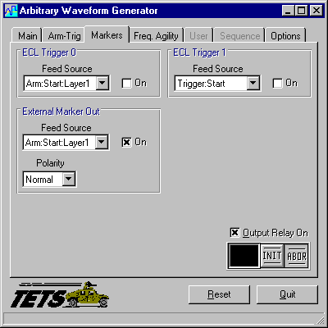

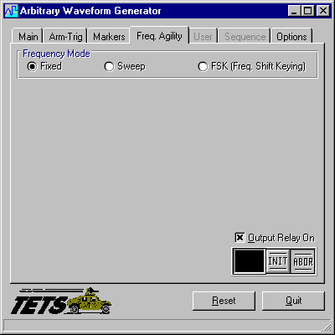

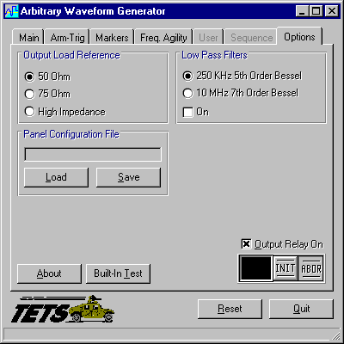

ATLAS Generation
When the ATLAS Generation button is pushed, an ATLAS statement representing the current GUI state will be generated. For this device, the verb shall be APPLY. No Test/Step number shall be created. The connection field shall be CNX HI LO (unless it is 4 wire ohm). No pins can be assigned through the GUI. The ATLAS column in the table below identifies the transform functions that will be supported. The statement shall be put into the system scratchpad for movement to the appropriate file.

Function Definition
The following table specifies the functions and parameters used to control the RI4152A:

Function | Value Range | Default |  | XML |  | Misc
Sine, Square, Triangle/Ramp
Frequency | 0Hz to 10.73741824MHz  0Hz to 2.68435456MHz  0Hz to 107.3741824KHz |  |  |  |  | Sine  Square  Triangle/Ramp
Amplitude | 161.87mV to 5.11875V |  |  |  |  | Can be specified in V, Vpk, Vpp, Vrms, W
/7 Amplitude | 23.124mV to 731.25mV
DC Offset | 0V to +/-999.93mV
(Reference Oscillator) Source | Clk 10, External, ECL0, ECL1, Internal1, Internal2
(Reference Oscillator)  Oscillator Frequency | 10MHz  1Hz to 40MHz  1Hz to 40MHz  1Hz to 40MHz  42.94967296MHz  40MHz |  |  |  |  | Clk 10  External  ECL0  ECL1  Internal1  Internal2
Waveform Polarity | Normal, Inverted |  |  |  |  | Square
Waveform Points | 4 to 262144 |  |  |  |  | Triangle/Ramp
DC
Amplitude | -5.24V to +5.11875V |  |  |  |  | Can be specified in V, Vpk, Vpp, Vrms, W
/7 Amplitude | -748.57mV to +731.25mV
Waveform
Frequency | 0Hz to 10.73741824MHz
Amplitude | 161.87mV to 5.11875V |  |  |  |  | Can be specified in V, Vpk, Vpp, Vrms, W
/7 Amplitude | 23.124mV to 731.25mV
DC Offset | 0V to +/-999.93mV
(Reference Oscillator) Source | Clk 10, External, ECL0, ECL1, Internal1, Internal2
(Reference Oscillator)  Oscillator Frequency | 10MHz  1Hz to 40MHz  1Hz to 40MHz  1Hz to 40MHz  42.94967296MHz  40MHz |  |  |  |  | Clk 10  External  ECL0  ECL1  Internal1  Internal2
Waveform Polarity | Normal, Inverted |  |  |  |  | Square
ARM-TRIG Parameters | Value Range | Default |  | XML |  | Misc
Arm Start
Layer 2 Source | Immediate,  TTL0-7
Layer 2 Start | 1 to 65535,  Set to Infinity
Layer 1 Count | 1 to 65535,  Set to Infinity
Arm Immediate
Trigger Start
Trigger Gate State | On, Off |  |  |  |  | When on, Trigger Gate Source and Trigger Gate Polarity may be specified
Trigger Gate Polarity | External, TTL0-7
Trigger Gate Source | Inverted, Normal
Trigger Stop Souce | Bus,  External,  Hold,  TTL0-7,  Start Immediate
Trigger Stop Slope | Positive,  Negative,  Stop Immediate
MARKERS Parameters | Value Range | Default |  | XML |  | Misc
ECL Trigger 0
Feed Source | Arm:Start Layer1 Arm:Start Layer2 Freq:Change Source:List1 PM:Dev:Change ROscillator Trigger:Start
On/OFF
ECL Trigger 1
Feed Source | Arm:Start Layer1 Arm:Start Layer2 Freq:Change Source:List1 PM:Dev:Change ROscillator Trigger:Start
On/OFF
External Marker Out
Feed Source | Arm:Start Layer1 Arm:Start Layer2 Freq:Change Source:List1 PM:Dev:Change ROscillator Trigger:Start
On/OFF
Polarity | Normal, Inverted
FREQ AGILITY Parameters | Value Range |  | Default | XML | Misc
Frequency Mode
Fixed
Sweep | Start Frequency  Stop Frequency  Sweep Duration  Direction  Number of Steps  Step Spacing  Sweep Arm Source  Step Adv. Source  Sweep Count
Start Frequency | 0Hz to 10.737MHz
Stop Frequency | 0Hz to 10.737MHz
Sweep Duration | .99875S to 3351.248696S
Direction | Up/Down
Number of Steps | 2 to 1073741824
Step Spacing | Linear/Logarithmic
Sweep Arm Source | Bus, Hold, Immediate, TTL0-7
Step Adv. Source | Bus, Hold, Link, TTL0-7
Sweep Count | 1 to 2147483647,  Set to Infinity
FSK
FSK Parameters | Source  Key High Freq  Key Low Freq
Source | External, TTL0-7
Key High Freq | 0Hz to 10.737Mhz
Key Low Freq | 0Hz to 10.737Mhz
Parameters | Value Range |  | Default | XML | Misc
User
Segment Name | Down Load, Load, Save
Points | 4 to 262144
Sample Frequency | 0Hz to 21.47483648MHz
Sequence
Downloaded Segments | Name/Length, Delete/Add to List
Sequence List Definition | Segment Name/ Dwell Count,  Remove/Up/Down
Available Memory | Segment/Sequence
Options
Output Load Reference | 50 Ohm, 75 Ohm, High Impedance
Low Pass Filters | 250KHz 5th Order Bessel  10MHz 7th Order Bessel  On/Off
Panel Configuration File | Load/Save
Built In Test
Output
RelayOn
INIT/ABOR

Notes:

AgE1445A Arbitrary Waveform Generator Programming Specifications
Not Applicable.

Processing
There are no special processing requirements.

Notes

ATLAS Code Examples
TBD

Requirements traceability
This SAIS provides the requirements stated in Paragraph 3.5.6 of the PERFORMANCE SPECIFICATION FOR THE THIRD ECHELON TEST SET (TETS) MARCORSYSCOM-PD-02-001 12/1/2003 and General Notes for Virtual Instrumentation Doc # 7992051 Rev.01 Aug 10 2005

Appendix
None.

