EADS NA Defense Test & Services

Software Design Document

SAIS Bus I/O Controller Soft Front Panel
SFP

SDD-SAIS BUS IO
Version 0.00
06/13/06

This document and the information contained herein are proprietary to EADS NA Defense and may not be disclosed in whole or in part to any parties without the expressed written consent of EADS NA Defense.

PAWS is a registered trademark of the TYX Corporation.

© EADS NA Defense Test & Services
1222 Lucas Ave. Suite 200
St. Louis MO 63103
phone (314) 727 1337
fax (314) 727 6750

Software Design Document

Version 0.00

History of changes
0: Initial Release
Change Table

Change | Date | Paragraph

1 Scope 5
1.1 Identification 5
1.2 System Overview 5
1.3 Document Overview 5
2 Reference Documents 5
3 System-Wide Design Overview 5
3.1 Assumptions and Dependencies 5
3.2 General Constraints 5
3.3 Goals and Guidelines 6
3.4 Safety and Security Considerations 6
3.5 Development Methods 6
4 System Architectural Design 6
4.1 System Components 6
4.2 Interface design 7
5 Detailed Design 7
5.1 Classification 7
5.2 SFP GUI 7
5.3 ATLAS Generation 10
5.4 Function Definition 10
5.4.1 Common Interface (AtXmlApi.dll) 10
5.4.2 Device Specific Functions (Main.bas) 11
5.5 Bus I/O Controller Programming Specifications 12
5.6 Processing 12
6 Notes 12
6.1 ATLAS Examples 12
7 Requirements traceability 12
8 Appendix 12

Scope

Identification
The Bus I/O Controller Stand-Alone Instrument Software (SAIS) Bus_IO.exe provides the software routines necessary to control communication ports from a Soft Front Panel (SFP). These ports include COM 1 (RS232), COM 2 (RS422), Ethernet (TCP and UDP), and PCI Serial (RS232, RS422, and RS485).

System Overview
The SAIS system provides a method of interfacing with the test system instruments. The method used by this module is utilizing the Common Interface Control Layer (CICL) calling Application Programming Interface (API) functions or SCPI commands.

Document Overview
The document defines the detailed software design for the SFP of the Bus I/O Controller. This document specifies the functional capabilities and how they are used to control the Bus I/O Controller.

Reference Documents
- ARC PAWS WCEM Software Development Style Guide (ARCSTL-DSG-000)
- TETS ATLAS and Protocol Programming Manual, Doc. No. NA-84-1110H
- IEEE Std. 716-1989 C/ATLAS Test Language
- General Notes for ATLAS Implementation Doc # 7992052 Rev.01 Aug 10 2005
- General Notes for Virtual Instrumentation Doc # 7992051 Rev.01 Aug 10 2005
- RS232/RS422 ATXML to serial driver for the Amrel COM ports, Doc. SDD- AtXmlAmCOM
- RS232/RS422/RS485 ATXML to IVI driver for the Sea Level Systems 5102, Doc. SDD- AtXmlSls5102
- TCP/UDP ATXML to Winsock driver for the SBS Gigabit Ethernet card, Doc. SDD- AtXmlSBSGigabit

System-Wide Design Overview
The SAIS provides the ability to control the instrument in debug and local modes of operation. The SFP will provide the capability to generate ATLAS code supported by IEEE 716-89 C/ATLAS.

Assumptions and Dependencies
The following assumptions and dependencies are made:

- ATLAS shall conform to the ATLAS standard and not be extended
- Instruments are provided with APIs
- Direct programming to instrument via SCPI (or equivalent) is permitted for functions that are not supported via the API.
- No complex assumptions for ATLAS generation

General Constraints
The sections below will detail which of the instrument functions and parameters are implemented to control the Bus I/O Controller.

Goals and Guidelines
- To the extent possible, map functionality and parameters to instrument controls using the Common Interface Control Layer (CICL)
- Implement the functionality as defined in General Notes for Virtual Instrumentation Doc # 7992051 Rev.01 Aug 10 2005.

Safety and Security Considerations
No safety or security considerations for this instrument.

Development Methods
TBD

System Architectural Design
SFPs will be modified and or developed using Visual Basic 6.0 and executed using existing SAIS interface.
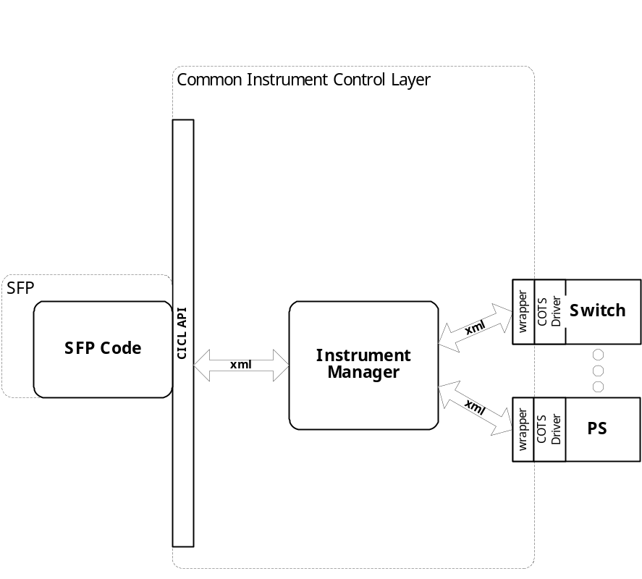

System Components
The SFP will consist of:

- A Visual Basic 6.0 project to build the SFP
  - Gui Files
    - Bus_IO.frm
    - About.frm
    - Panel.frm
    - DataTypes.frm
    - frmPCIDM.frm
  - Basic Source Modules
  - Tetslib.bas
  - Visa32.bas
  - Programmer Generated Panel Source File
  - Main.bas

Interface design

Communications with the instrument is through the CICL interface API.

Function | Purpose
(cicl_SD_Snippet* SignalDescription, SCTE_XML_String* cResponse, int BufferSize)

Detailed Design

Classification
This module is unclassified.

SFP GUI
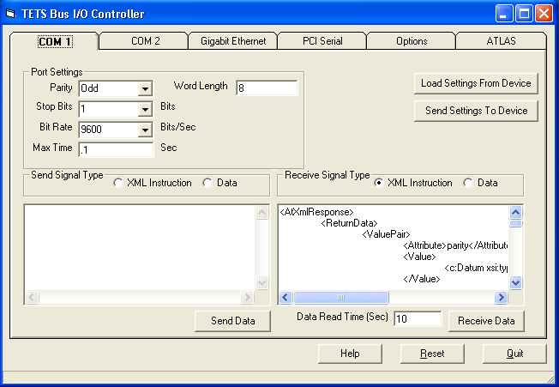

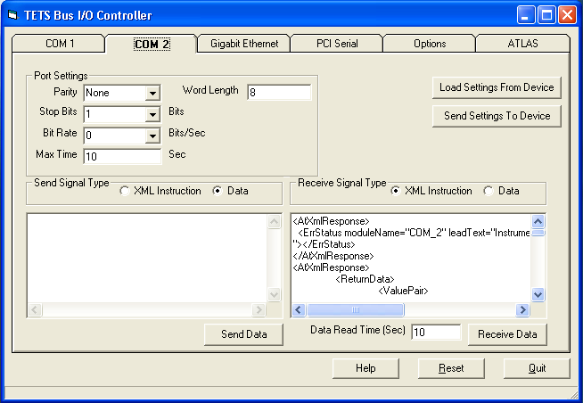

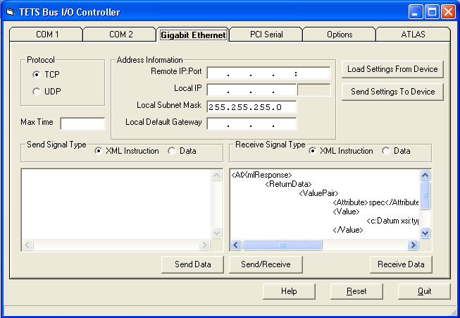

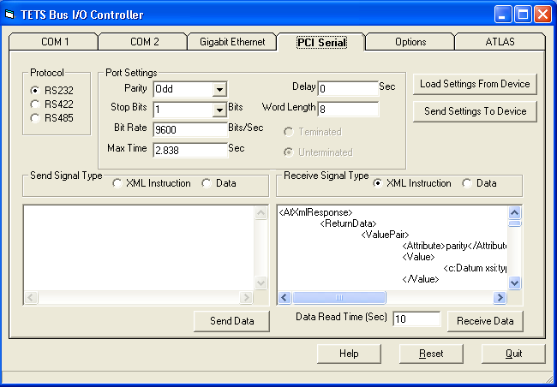

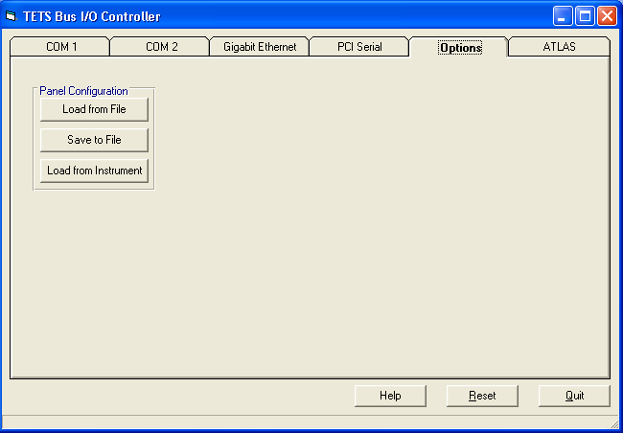

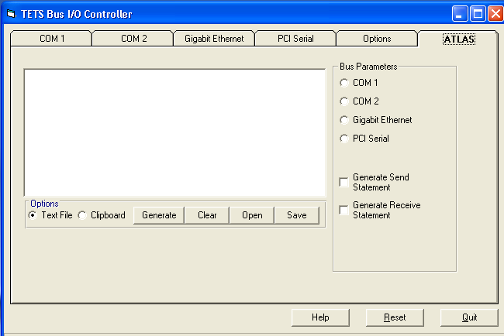

ATLAS Generation
TBD

Function Definition
The following table specifies the functions and parameters used to control communication ports:

Common Interface (AtXmlApi.dll)

Function | Purpose
atxml_Initialize(ByVal proctype As String, ByVal guid As String) As Long | This function is used to initialize the bus, register the bus driver with the CiclKernelC.exe, and obtain instrument availability status.
atxml_ValidateRequirements (ByVal TestRequirements As String, ByVal Allocation As String, ByVal Availability As String, ByVal BufferSize As Integer) As Long | This function is used to validate then allocation of used by the communication bus driver.
atxml_IssueSignal(ByVal SignalDescription As String, ByVal Response As String, ByVal BufferSize As Integer) As Long | This function is used to send an AtXml command to the bus driver and returns the response from the bus driver
atxml_GetSingleIntValue(ByVal Response As String, ByVal Attr As String, ByRef IntValue As Integer) As Long | This function is used to parse the response message for an integer data type attribute.
atxml_GetIntArrayValue(ByVal Response As String, ByVal Attr As String, ByVal IntArrayPtr As Integer, ByVal ArraySize As Integer) As Long | This function is used to parse the response message for an integer array data type attribute.
atxml_GetSingleDblValue(ByVal Response As String, ByVal Attr As String, ByRef DblValue As Double) As Long | This function is used to parse the response message for a double data type attribute.
atxml_GetDblArrayValue(ByVal Response As String, ByVal Attr As String, ByVal DblArrayPtr As Double, ByVal ArraySize As Integer) As Long | This function is used to parse the response message for a double array data type attribute.
atxml_GetStringValue(ByVal Response As String, ByVal Attr As String, ByVal StrPtr As String, ByVal BufferSize As Integer) As Long | This function is used to parse the response message for a string data type attribute.

Device Specific Functions (Main.bas)

Function | Purpose
getCom_1_settings(), getCom_2_settings(), getEthernet_settings(), or getSerial_settings() | These functions are used to retrieve the devices settings of the port.
ReceiveCom1Data(), ReceiveCom2Data(), ReceiveEtherData(), or ReceiveSerialData() | These functions are used to issue a fetch command to the port driver to receive the data sent to the port
RemoveCom1(), RemoveCom2(), RemoveEther(), or RemoveSerial() | These functions are used to issue a Remove command for the port.
ResetCom1(), ResetCom2(), ResetEther(), or ResetSerial() | These functions are used to issue a Reset command for the port.
SendCom1Data(), SendCom2Data(), SendEtherData(), or SendSerialData() | These functions are used to issue an Apply command to the port thus sending the user supplied data
SendCom1XML(), SendCom2XML(), SendEtherXML(), or SendSerialXML() | These functions are used to issue a user supplied xml snippet to the device.
SendCom1Settings(), SendCom2Settings(), SendEtherSettings(), or SendSerialSettings() | These functions are used to issue a Setup command to the port thus applying the user supplied settings to the port.

Notes:

Bus I/O Controller Programming Specifications
Not Applicable.

Processing
There are no special processing requirements.

Notes
TBD

ATLAS Examples

Requirements traceability
This SAIS provides the requirements stated in General Notes for Virtual Instrumentation Doc # 7992051 Rev.03 Nov 28 2005

Appendix
None.

