EADS NA Defense Test & Services

Software Design Document

AgE1420B Universal Counter/Timer
SFP

SDD-SAIS AgE1420B
Version 0.00
08/22/05

This document and the information contained herein are proprietary to EADS NA Defense and may not be disclosed in whole or in part to any parties without the expressed written consent of EADS NA Defense.

PAWS is a registered trademark of the TYX Corporation.

© EADS NA Defense Test & Services
1222 Lucas Ave. Suite 200
St. Louis MO 63103
phone (314) 727 1337
fax (314) 727 6750

Software Design Document

Version 0.00

History of changes
0: Initial Release
Change Table

Change | Date | Paragraph

1 Scope 5
1.1 Identification 5
1.2 System Overview 5
1.3 Document Overview 5
2 Reference Documents 5
3 System-Wide Design Overview 5
3.1 Assumptions and Dependencies 5
3.2 No complex assumptions for ATLAS generationGeneral Constraints 5
3.3 Goals and Guidelines 6
3.4 Safety and Security Considerations 6
3.5 Development Methods 6
4 System Architectural Design 6
4.1 System Components 6
4.2 Interface design 7
5 Detailed Design 7
5.1 Classification 7
5.2 SFP GUI 7
5.3 ATLAS Generation 9
5.4 Function Definition 9
5.5 AgE1420B Universal Timer/Counter Programming Specifications 11
5.6 Processing 11
6 Notes 11
6.1 ATLAS Examples 11
7 Requirements traceability 11
8 Appendix 11

Scope

Identification
The CNTR Stand-Alone Instrument Software (SAIS) CSCI AgE1420B.exe provides the software routines necessary to control the AgE1420B Universal Counter/Timer from a Soft Front Panel (SFP).

System Overview
The SAIS system provides a method of interfacing with the test system instruments. The method used by this module is utilizing the Common Interface Control Layer (CICL) calling Application Programming Interface (API) functions or SCPI commands.

Document Overview
The document defines the detailed software design for the SFP of the AgE1420B. This document specifies the functional capabilities and how they are used to control the AgE1420B Universal Counter/Timer.

Reference Documents
- E1420B Counter/Timer User’s Manual (E1420B Users Manual.pdf)
- ARC PAWS WCEM Software Development Style Guide (ARCSTL-DSG-000)
- Software Requirements Specification for Third Echelon Test Set DEFCOT&S-3536-SRS-001
- PERFORMANCE SPECIFICATION FOR THE THIRD ECHELON TEST SET (TETS) MARCORSYSCOM-PD-02-001 12/1/2003
- Computer Programming Manual (CPM) for the Third Echelon Test System (TETS) REV. E P/N 93006A0026
- IEEE std. 716-1989 C/ATLAS Test Language
- General Notes for ATLAS Implementation Doc # 7992052 Rev.01 Aug 10 2005
- General Notes for Virtual Instrumentation Doc # 7992051 Rev.01 Aug 10 2005

System-Wide Design Overview
The SAIS provides the ability to control the instrument in debug and local modes of operation. The SFP will provide the capability to generate ATLAS code supported by IEEE 716-89 C/ATLAS.

Assumptions and Dependencies
The following assumptions and dependencies are made:

- ATLAS shall conform to the ATLAS standard and not be extended
- Instruments are provided with APIs
- Direct programming to instrument via SCPI (or equivalent) is permitted for functions that are not supported via the API.
- No complex assumptions for ATLAS generation

No complex assumptions for ATLAS generationGeneral Constraints
The sections below will detail which of the instrument functions and parameters are implemented to control the AgE1420B.

Goals and Guidelines
- To the extent possible, map functionality and parameters to instrument controls using the Common Interface Control Layer (CICL)
- Implement the functionality as defined in General Notes for Virtual Instrumentation Doc # 7992051 Rev.01 Aug 10 2005.

Safety and Security Considerations
No safety or security considerations for this instrument.

Development Methods
TBD

System Architectural Design
SFPs will be modified and or developed using Visual Basic 6.0 and executed using existing SAIS interface.
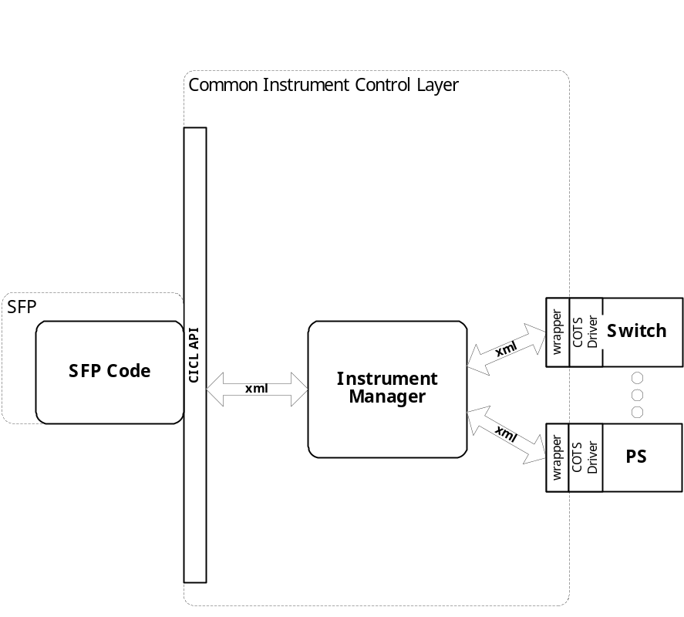

System Components
The SFP will consist of:

- A Visual Basic 6.0 project to build the SFP
  - Gui Files
    - About.frm
    - Hp1420b.frm
  - Basic Source Modules
  - Tetslib.bas
  - Visa32,bas
  - Programmer Generated Hp1420b Source File
  - Main.bas

Interface design
Communications with the instrument is through the CICL interface API.

Function | Purpose
(cicl_SD_Snippet* SignalDescription, SCTE_XML_String* cResponse, int BufferSize)

Detailed Design

Classification
This module is unclassified.

SFP GUI

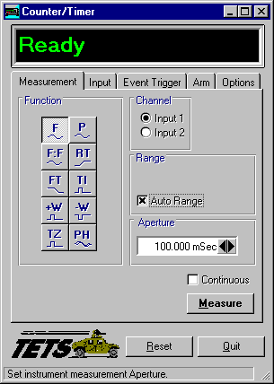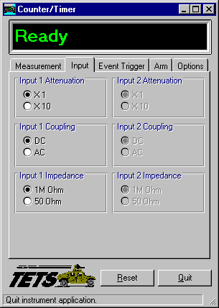

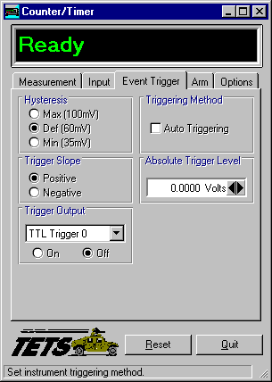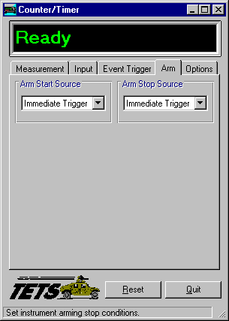

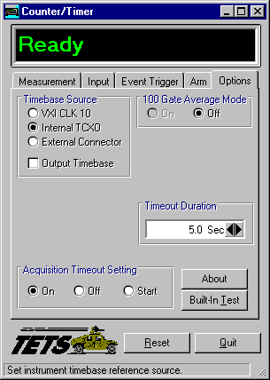

ATLAS Generation
When the ATLAS Generation button is pushed, an ATLAS statement representing the current GUI state will be generated. For this device, the verb shall be MEASURE. No Test/Step number shall be created. The connection field shall be CNX HI LO. No pins can be assigned through the GUI. The ATLAS column in the table below identifies the transform functions that will be supported. The statement shall be put into the system scratchpad for movement to the appropriate file.

Function Definition
The following table specifies the functions and parameters used to control the AGE1420B:

Function | Value Range | Default | XML | Misc
Measurement
Frequency | 1mHz to 200MHz  1mHz to 100MHz  100Hz to 200MHz  100Hz to 100MHz  Selected/Deselected |  |  | DC Coupled (Input 1)  Input 2  AC Coupled (Input 1)  Input 2  AutoRange
Period | 5 nSec to 1 KSec  10 nSec to 1 KSec
Frequency Ratio | 1 to 100G
Rise Time | 15nSec to 1000Sec  75nSec to 1000Sec |  |  | X1 Mode  X10 Mode
Fall Time | 15nSec to 1000Sec  75nSec to 1000Sec |  |  | X1 Mode  X10 Mode
Time Interval | 1nSec to 1KSec  1nSec to 10Sec
Pulse Width | 5nSec to 10mSec
Totalize
Phase
Parameters | Value Range | Default | XML | Misc
Aperture | 1mSec to 99.999Sec
Routing | Sep./Comm.
Measure | Single/Continuous
Input
Attenuation | X1/X10 |  |  | Input1/Input2
Coupling | DC/AC |  |  | Input1/Input2
Impedance | 1MOhm / 50Ohm |  |  | Input1/Input2
Event Trigger
Hysteresis | Max, Def, Min
Trigger Method | Auto Trigger |  |  | Selected/Deselected
Trigger Slope | Positive/Negative
Trigger Level | 0V to 10.2375V
Trigger Output | On/Off, TTL0-7
Arm
Start Source | TTL0-7,  Not Available,  VXI Bus Trigger,  External Trigger,  Immediate Trigger
Stop Source | TTL0-7,  Not Available,  VXI Bus Trigger,  External Trigger,  Immediate Trigger
Options
Timebase Source | VXI CLK 10  Internal TCXO  External Connector  Output Timebase
100 Gate Average Mode | On/Off
Timeout Duration | 100mSec to1500Sec
Acquisition Timeout Setting | On/Off/Start
Built In Test

Notes:

AgE1420B Universal Timer/Counter Programming Specifications
Not Applicable.

Processing
There are no special processing requirements other.

Notes

ATLAS Examples
TBD

Requirements traceability
This SAIS provides the requirements stated in Paragraph 3.5.6 of the PERFORMANCE SPECIFICATION FOR THE THIRD ECHELON TEST SET (TETS) MARCORSYSCOM-PD-02-001 12/1/2003 and General Notes for Virtual Instrumentation Doc # 7992051 Rev.01 Aug 10 2005

Appendix
None.

