EADS NA Defense Test & Services

Software Design Document

ZT1248VXI Digital Scope
SFP

SDD-SAIS ZT1248
Version 0.00
08/22/05

This document and the information contained herein are proprietary to EADS NA Defense and may not be disclosed in whole or in part to any parties without the expressed written consent of EADS NA Defense.

PAWS is a registered trademark of the TYX Corporation.

© EADS NA Defense Test & Services
1222 Lucas Ave. Suite 200
St. Louis MO 63103
phone (314) 727 1337
fax (314) 727 6750

Software Design Document

Version 0.00

History of changes
0: Initial Release
Change Table

Change | Date | Paragraph

1 Scope 5
1.1 Identification 5
1.2 System Overview 5
1.3 Document Overview 5
2 Reference Documents 5
3 System-Wide Design Overview 5
3.1 Assumptions and Dependencies 5
3.2 General Constraints 5
3.3 Goals and Guidelines 5
3.4 Safety and Security Considerations 6
3.5 Development Methods 6
4 System Architectural Design 6
4.1 System Components 6
4.2 Interface design 7
5 Detailed Design 7
5.1 Classification 7
5.2 SFP GUI 7
5.3 ATLAS Generation 10
5.4 Function Definition 10
5.5 Zt1248 Digital Scope Programming Specifications 12
5.6 Processing 12
6 Notes 12
6.1 ATLAS Examples 12
7 Requirements traceability 12
8 Appendix 13

Scope

Identification
The DSO Stand-Alone Instrument Software (SAIS) CSCI ZT1248.exe provides the software routines necessary to control the ZT1248VXI Digital Scope from a Soft Front Panel (SFP).

System Overview
The SAIS system provides a method of interfacing with the test system instruments. The method used by this module is utilizing the Common Interface Control Layer (CICL) calling Application Programming Interface (API) functions or SCPI commands.

Document Overview
The document defines the detailed software design for the SFP of the ZT1248. This document specifies the functional capabilities and how they are used to control the ZT1248 Digital Scope.

Reference Documents
- ZT1248 80 MS/S 14-BIT Digitizer User’s Manual (ZT1248_304.pdf)
- ARC PAWS WCEM Software Development Style Guide (ARCSTL-DSG-000)
- Software Requirements Specification for Third Echelon Test Set DEFCOT&S-3536-SRS-001
- PERFORMANCE SPECIFICATION FOR THE THIRD ECHELON TEST SET (TETS) MARCORSYSCOM-PD-02-001 12/1/2003
- Computer Programming Manual (CPM) for the Third Echelon Test System (TETS) REV. E P/N 93006A0026
- IEEE std. 716-1989 C/ATLAS Test Language
- General Notes for Virtual Instrumentation Doc # 7992051 Rev.01 Aug 10 2005

System-Wide Design Overview
The SAIS provides the ability to control the instrument in debug and local modes of operation. The SFP will provide the capability to generate ATLAS code supported by IEEE 716-89 C/ATLAS.

Assumptions and Dependencies
The following assumptions and dependencies are made:

- ATLAS shall conform to the ATLAS standard and not be extended
- Instruments are provided with APIs
- Direct programming to instrument via SCPI (or equivalent) is permitted for functions that are not supported via the API.
- No complex assumptions for ATLAS generation

General Constraints
The sections below will detail which of the instrument functions and parameters are implemented to control the ZT1248.

Goals and Guidelines
- To the extent possible, map functionality and parameters to instrument controls using the Common Interface Control Layer (CICL)
- Implement the functionality as defined in General Notes for Virtual Instrumentation Doc # 7992051 Rev.01 Aug 10 2005.

Safety and Security Considerations
No safety or security considerations for this instrument.

Development Methods
TBD

System Architectural Design
SFPs will be modified and or developed using Visual Basic 6.0 and executed using existing SAIS interface.
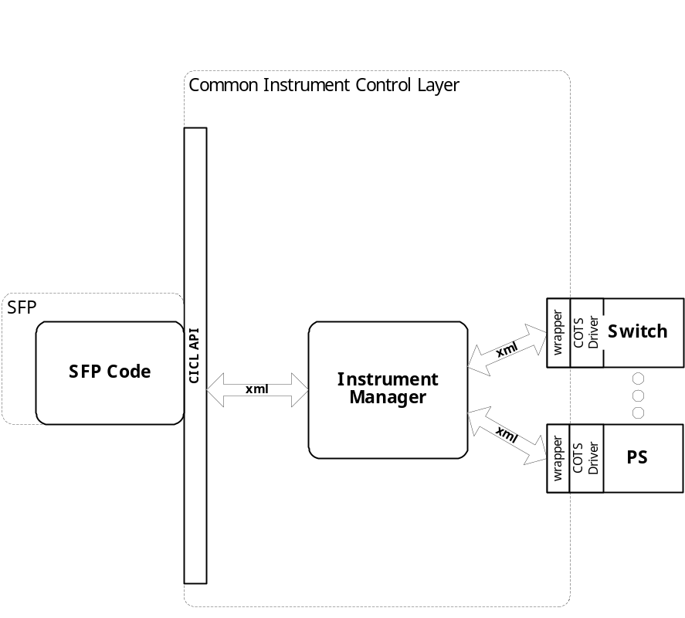

System Components
The SFP will consist of:

- A Visual Basic 6.0 project to build the SFP
  - Gui Files
    - About.frm
    - HP1428a.Frm
  - Basic Source Modules
  - Tetslib.bas
  - Visa32.bas
  - Programmer Generated HP1428a Source File
  - Main.bas

Interface design

Communications with the instrument is through the CICL interface API.

Function | Purpose
(cicl_SD_Snippet* SignalDescription, SCTE_XML_String* cResponse, int BufferSize)

Detailed Design

Classification
This module is unclassified.

SFP GUI

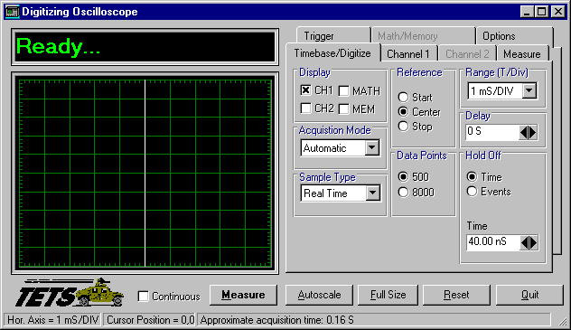

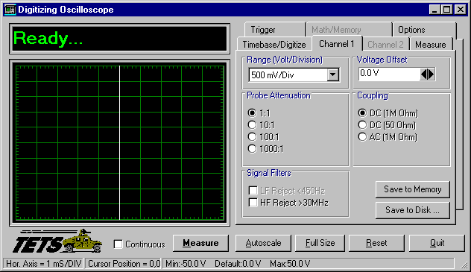

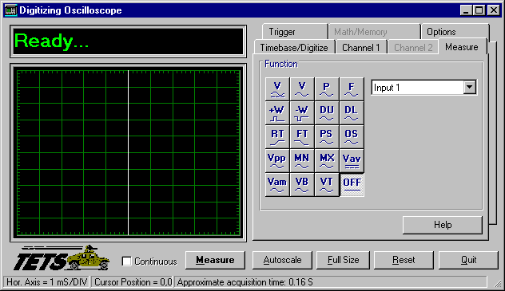

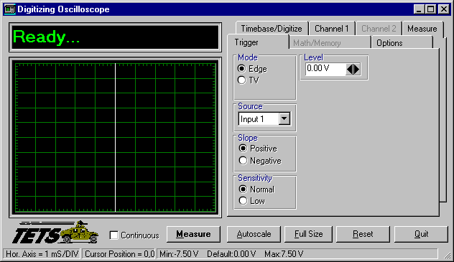

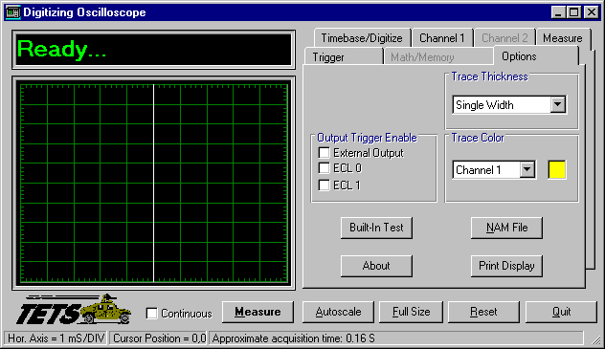

ATLAS Generation
When the ATLAS Generation button is pushed, an ATLAS statement representing the current GUI state will be generated. For this device, the verb shall be MEASURE. No Test/Step number shall be created. The connection field shall be CNX HI LO (unless it is 4 wire ohm). No pins can be assigned through the GUI. The ATLAS column in the table below identifies the transform functions that will be supported. The statement shall be put into the system scratchpad for movement to the appropriate file.

Function Definition
The following table specifies the functions and parameters used to control the ZT1248:

Function | Value Range | Default | XML | Misc
Measurement
DC Volts
Ac Volts
Period
Frequency
Pulse Width
Duty Cycle
Delay
Rise Time
Fall Time
Preshoot
Overshoot
Vpp
Vpk
Vmin
Vmax
Vavg
Vampl
Vbase
Vtop
Channel 1/Channel 2 Parameters | Value Range | Default | XML | Misc
Range | 800uV, 1mV, 2mV, 5mV, 10mV, 20mV, 50mV, 100mV, 200mV, 500mV, 1V, 2V, 4V
Probe Attenuation | 1:1, 10:1, 100:1, 1000:1
Coupling | DC (1MOhm)  DC (50Ohm)  AC (1MOhm)
Signal Filters | HF Reject, LF Reject
Save To Memory
Save To Disk
Parameters | Value Range | Default | XML | Misc
TIMEBASE/DIGITIZE
Display | CH1, CH2, MATH, MEM
Acquisition Mode | Automatic, Triggered
Sample Type | Real Time, Repetitive
Reference | Start, Center, Stop
Data Points | 500, 8000
Range | 1 nSec – 5 Sec
Delay | 0 Sec to  T/Div X 10 KSec
Hold Off | 40 nSec to 320 mSec  2 to 16 M events
TRIGGER
Mode | Edge, TV,
Delay | 300 nSec to 160 mSec  2 to 16 M events
Occurence | 1 to 1 K
Standard | US, Europe
Field | 1, 2
Lines | 1 to 263, 1 to 262  1 to 313, 314 to 625 |  |  | US  Europe
Source | Input1, Input2, ECL0, ECL1, EXT
Slope | Pos, Neg
Sensitivity | Normal, Low
MATH/MEMORY
Function | Add, Subtract, Multiply, Differentiate, Integrate, Invert
Source A | Channel 1, Channel 2, Memory
Source B | Channel 1, Channel 2, Memory
Range | 0V to 900GV,  1.000TV to 10.000TV
Data Points | 500, 8000
Save To Memory
Save To Disk

Load From Disk
OPTIONS
Output Trigger Enable | External Output, ECL0, ECL1
Probe Comp | On, Off
Trace Thickness | Single Width, Double Width, Triple Width
Trace Color | Channel 1, Channel 2, Math, Memory
Built In Test | NAM File
Measure | Single, Continuous
Autoscale
Full Size

Notes:

Zt1248 Digital Scope Programming Specifications
Not Applicable.

Processing
There are no special processing requirements.

Notes

ATLAS Examples
TBD

Requirements traceability
This SAIS provides the requirements stated in Paragraph 3.5.6 of the PERFORMANCE SPECIFICATION FOR THE THIRD ECHELON TEST SET (TETS) MARCORSYSCOM-PD-02-001 12/1/2003 and General Notes for Virtual Instrumentation Doc # 7992051 Rev.01 Aug 10 2005

Appendix
None.

