EADS NA Defense Test & Services

Software Design Document

Ri3152A Function Generator
SFP

SDD-SAIS Ri3152A
Version 0.00
08/22/05

This document and the information contained herein are proprietary to EADS NA Defense and may not be disclosed in whole or in part to any parties without the expressed written consent of EADS NA Defense.

PAWS is a registered trademark of the TYX Corporation.

© EADS NA Defense Test & Services
1222 Lucas Ave. Suite 200
St. Louis MO 63103
phone (314) 727 1337
fax (314) 727 6750

Software Design Document

Version 0.00

History of changes
0: Initial Release
Change Table

Change | Date | Paragraph

1 Scope 5
1.1 Identification 5
1.2 System Overview 5
1.3 Document Overview 5
2 Reference Documents 5
3 System-Wide Design Overview 5
3.1 Assumptions and Dependencies 5
3.2 General Constraints 5
3.3 Goals and Guidelines 5
3.4 Safety and Security Considerations 6
3.5 Development Methods 6
4 System Architectural Design 6
4.1 System Components 6
4.2 Interface design 7
5 Detailed Design 7
5.1 Classification 7
5.2 SFP GUI 7
5.3 ATLAS Generation 9
5.4 Function Definition 9
5.5 Ri3152A Function Generator Programming Specifications 11
5.6 Processing 11
6 Notes 11
6.1 ATLAS Examples 11
7 Requirements traceability. 11
8 Appendix 11

Scope

Identification
The FG Stand-Alone Instrument Software (SAIS) CSCI Ri3152A.exe provides the software routines necessary to control the Ri3152A Function Generator from a Soft Front Panel (SFP).

System Overview
The SAIS system provides a method of interfacing with the test system instruments. The method used by this module is utilizing the Common Interface Control Layer (CICL) calling Application Programming Interface (API) functions or SCPI commands.

Document Overview
The document defines the detailed software design for the SFP of the Ri3152A. This document specifies the functional capabilities and how they are used to control the Ri3152A Function Generator.

Reference Documents
- Software Requirements Specification for Third Echelon Test Set DEFCOT&S-3536-SRS-001
- PERFORMANCE SPECIFICATION FOR THE THIRD ECHELON TEST SET (TETS) MARCORSYSCOM-PD-02-001 12/1/2003
- Computer Programming Manual (CPM) for the Third Echelon Test System (TETS) REV. E P/N 93006A0026
- IEEE std. 716-1989 C/ATLAS Test Language
- General Notes for ATLAS Implementation Doc # 7992052 Rev.01 Aug 10 2005
- General Notes for Virtual Instrumentation Doc # 7992051 Rev.01 Aug 10 2005

System-Wide Design Overview
The SAIS provides the ability to control the instrument in debug and local modes of operation. The SFP will provide the capability to generate ATLAS code supported by IEEE 716-89 C/ATLAS.

Assumptions and Dependencies
The following assumptions and dependencies are made:

- ATLAS shall conform to the ATLAS standard and not be extended
- Instruments are provided with APIs
- Direct programming to instrument via SCPI (or equivalent) is permitted for functions that are not supported via the API.
- No complex assumptions for ATLAS generation

General Constraints
The sections below will detail which of the instrument functions and parameters are implemented to control the Ri3152A.

Goals and Guidelines
- To the extent possible, map functionality and parameters to instrument controls using the Common Interface Control Layer (CICL)
- Implement the functionality as defined in General Notes for Virtual Instrumentation Doc # 7992051 Rev.01 Aug 10 2005.

Safety and Security Considerations
No safety or security considerations for this instrument.

Development Methods
TBD

System Architectural Design
SFPs will be modified and or developed using Visual Basic 6.0 and executed using existing SAIS interface.
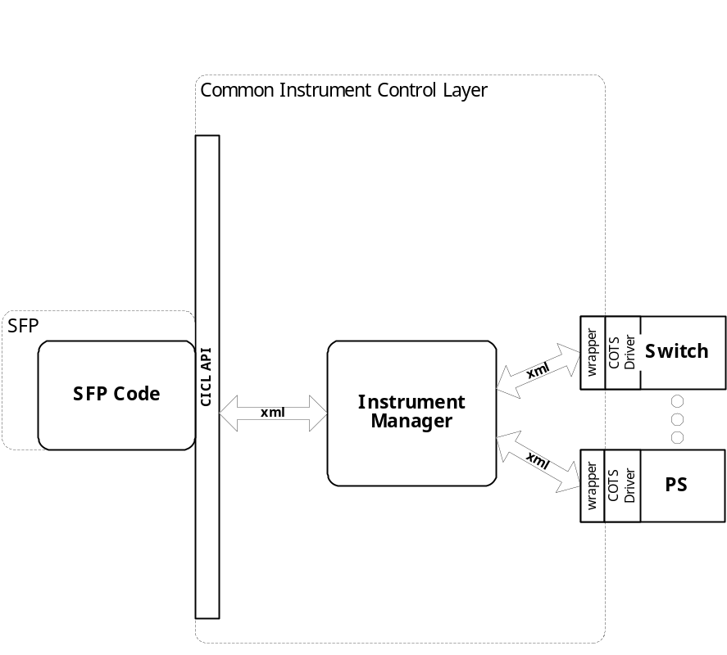

System Components
The SFP will consist of:

- A Visual Basic 6.0 project to build the SFP
  - Gui Files
    - About.frm
    - rac3152.frm
  - Basic Source Modules
  - Tetslib.bas
  - Visa32,bas
  - Programmer Generated rac3152 Source File
  - Main.bas

Interface design

Communications with the instrument is through the CICL interface API.

Function | Purpose
(cicl_SD_Snippet* SignalDescription, SCTE_XML_String* cResponse, int BufferSize)

Detailed Design

Classification
This module is unclassified.

SFP GUI

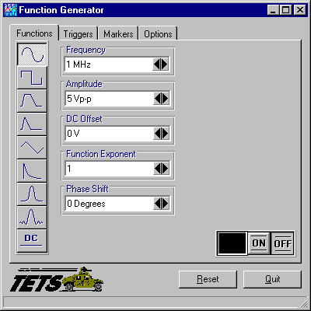

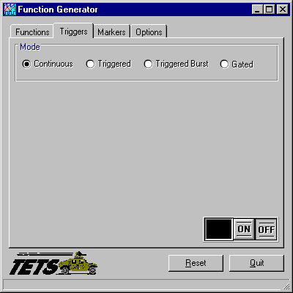

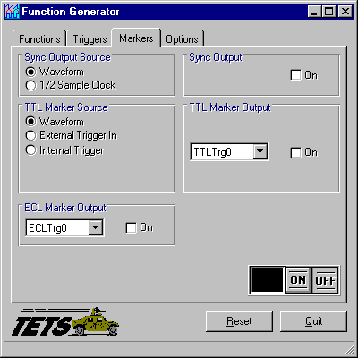

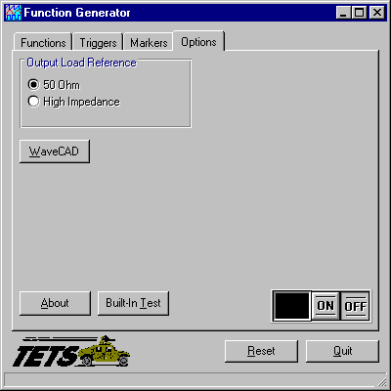

ATLAS Generation
When the ATLAS Generation button is pushed, an ATLAS statement representing the current GUI state will be generated. For this device, the verb shall be APPLY. No Test/Step number shall be created. The connection field shall be CNX HI LO (unless it is 4 wire ohm). No pins can be assigned through the GUI. The ATLAS column in the table below identifies the transform functions that will be supported. The statement shall be put into the system scratchpad for movement to the appropriate file.

Function Definition
The following table specifies the functions and parameters used to control the RI3152A:

Function | Value Range | Default | XML | Misc
Sine
Square
Pulse
Ramp
Triangle
Exponential Decay Pulse
Gaussian Pulse
Sinc Wave
DC
Parameters | Value Range | Default | XML | Misc
Frequency | 100 uHz to 50 MHz  100 uHz to 100 MHz |  |  | Sine, Square  All Others
Amplitude | -8 V to 8 V  10 mVpp to 16 Vpp
DC Offset | -7.19 V to 7.19 V
Function Exponent | 1 to 9  -10 to 200  1 to 200 |  |  | Sine, Triangle  Exponential Pulse  Gaussian Pulse
Phase Shift | 0 Deg to 360 Deg |  |  | Sine, Triangle
Sinc | 4 to 100 Cycles |  |  | Pulse, Ramp
Delay | 0% to 99% of Period
Pulse Width |  |  |  | Pulse, Ramp
Leading Edge | 0% to 99% of Period |  |  | Pulse, Ramp
Trailing Edge | 0% to 99% of Period |  |  | Pulse, Ramp
Duty Cycle | 1 % to 99 % |  |  | Square
Time Constant | -100 to 100  1 to 200 |  |  | Exponential Pulse  Gaussian Pulse
Cycles | 4 to 100 Cycles |  |  | Sinc
Triggers
Mode | Continous, Triggered, Triggered Burst, Gated
Source | External, Internal, TTL0-7 |  |  | Triggered,  Triggered Burst
Slope | Positive, Negative |  |  | Triggered,  Triggered Burst
Level | -10V to 10V |  |  | Triggered, Gated,  Triggered Burst
Burst Count | 1 to 1 M Cycles |  |  | Triggered Burst
Delay | 100 nSec to 20 mSec |  |  | Triggered,  Triggered Burst
Active Gate Level | Positive, Negative |  |  | Gated
Software Trig
Markers
Sync Output Source | WaveForm,  ½ Sample Clock
TTL Marker Source | Waveform, External Trigger In,  Internal Trigger |  |  | 15 uSec to 1 KSec
ECL Marker Output | ECL0, ECL1, On
Sync Ouput | On, Off
TTL Marker Output | TTL0-7, on
Options
Output Load Reference | 50 Ohm, High Impedance
WaveCAD
Built In Test
Output | On, Off

Notes:

Ri3152A Function Generator Programming Specifications
Not Applicable.

Processing
There are no special processing requirements.

Notes

ATLAS Examples
TBD

Requirements traceability
This SAIS provides the requirements stated in Paragraph 3.5.6 of the PERFORMANCE SPECIFICATION FOR THE THIRD ECHELON TEST SET (TETS) MARCORSYSCOM-PD-02-001 12/1/2003 and General Notes for Virtual Instrumentation Doc # 7992051 Rev.01 Aug 10 2005

Appendix
None.

