EADS NA Defense Test & Services

Software Design Document

NA65CS4 Synchro/Resolver
SFP

SDD-SAIS NA65CS4
Version 0.00
08/22/05

This document and the information contained herein are proprietary to EADS NA Defense and may not be disclosed in whole or in part to any parties without the expressed written consent of EADS NA Defense.

PAWS is a registered trademark of the TYX Corporation.

© EADS NA Defense Test & Services
1222 Lucas Ave. Suite 200
St. Louis MO 63103
phone (314) 727 1337
fax (314) 727 6750

Software Design Document

Version 0.00

History of changes
0: Initial Release
Change Table

Change | Date | Paragraph

1 Scope 5
1.1 Identification 5
1.2 System Overview 5
1.3 Document Overview 5
2 Reference Documents 5
3 System-Wide Design Overview 5
3.1 Assumptions and Dependencies 5
3.2 General Constraints 5
3.3 Goals and Guidelines 5
3.4 Safety and Security Considerations 6
3.5 Development Methods 6
4 System Architectural Design 6
4.1 System Components 6
4.2 Interface design 7
5 Detailed Design 7
5.1 Classification 7
5.2 SFP GUI 7
5.3 ATLAS Generation 9
5.4 Function Definition 9
5.5 NA65CS4 Synchro/Resolver Programming Specifications 11
5.6 Processing 11
6 Notes 11
6.1 ATLAS Examples 11
7 Requirements traceability 11
8 Appendix 11

Scope

Identification
The Synchro/Resolver Stand-Alone Instrument Software (SAIS) CSCI NA65CS4.exe provides the software routines necessary to control the NA65CS4 Synchro/Resolver from a Soft Front Panel (SFP).

System Overview
The SAIS system provides a method of interfacing with the test system instruments. The method used by this module is utilizing the Common Interface Control Layer (CICL) calling Application Programming Interface (API) functions or SCPI commands.

Document Overview
The document defines the detailed software design for the SFP of the NA65CS4. This document specifies the functional capabilities and how they are used to control the NA65CS4 Synchro/Resolver.

Reference Documents
- Operation/Maintenance Manual for the Model VXI 65CS4 Synchro/Resolver (NAI_65CS4.pdf)
- ARC PAWS WCEM Software Development Style Guide (ARCSTL-DSG-000)
- Software Requirements Specification for Third Echelon Test Set DEFCOT&S-3536-SRS-001
- PERFORMANCE SPECIFICATION FOR THE THIRD ECHELON TEST SET (TETS) MARCORSYSCOM-PD-02-001 12/1/2003
- Computer Programming Manual (CPM) for the Third Echelon Test System (TETS) REV. E P/N 93006A0026
- IEEE std. 716-1989 C/ATLAS Test Language
- General Notes for ATLAS Implementation Doc # 7992052 Rev.01 Aug 10 2005
- General Notes for Virtual Instrumentation Doc # 7992051 Rev.01 Aug 10 2005

System-Wide Design Overview
The SAIS provides the ability to control the instrument in debug and local modes of operation. The SFP will provide the capability to generate ATLAS code supported by IEEE 716-89 C/ATLAS.

Assumptions and Dependencies
The following assumptions and dependencies are made:

- ATLAS shall conform to the ATLAS standard and not be extended
- Instruments are provided with APIs
- Direct programming to instrument via SCPI (or equivalent) is permitted for functions that are not supported via the API.
- No complex assumptions for ATLAS generation

General Constraints
The sections below will detail which of the instrument functions and parameters are implemented to control the NA65CS4.

Goals and Guidelines
- To the extent possible, map functionality and parameters to instrument controls using the Common Interface Control Layer (CICL)
- Implement the functionality as defined in General Notes for Virtual Instrumentation Doc # 7992051 Rev.01 Aug 10 2005.

Safety and Security Considerations
No safety or security considerations for this instrument.

Development Methods
TBD

System Architectural Design
SFPs will be modified and or developed using Visual Basic 6.0 and executed using existing SAIS interface.
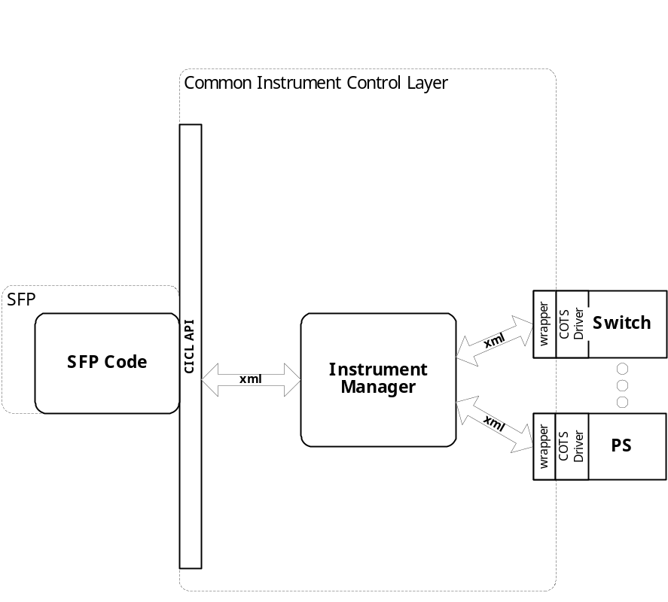

System Components
The SFP will consist of:

- A Visual Basic 6.0 project to build the SFP
  - Gui Files
    - About.frm
    - NA65CS4.frm
  - Basic Source Modules
  - Tetslib.bas
  - Visa32,bas
  - Programmer Generated NA65CS4 Source File
  - Main.bas

Interface design

Communications with the instrument is through the CICL interface API.

Function | Purpose
(cicl_SD_Snippet* SignalDescription, SCTE_XML_String* cResponse, int BufferSize)

Detailed Design

Classification
This module is unclassified.

SFP GUI
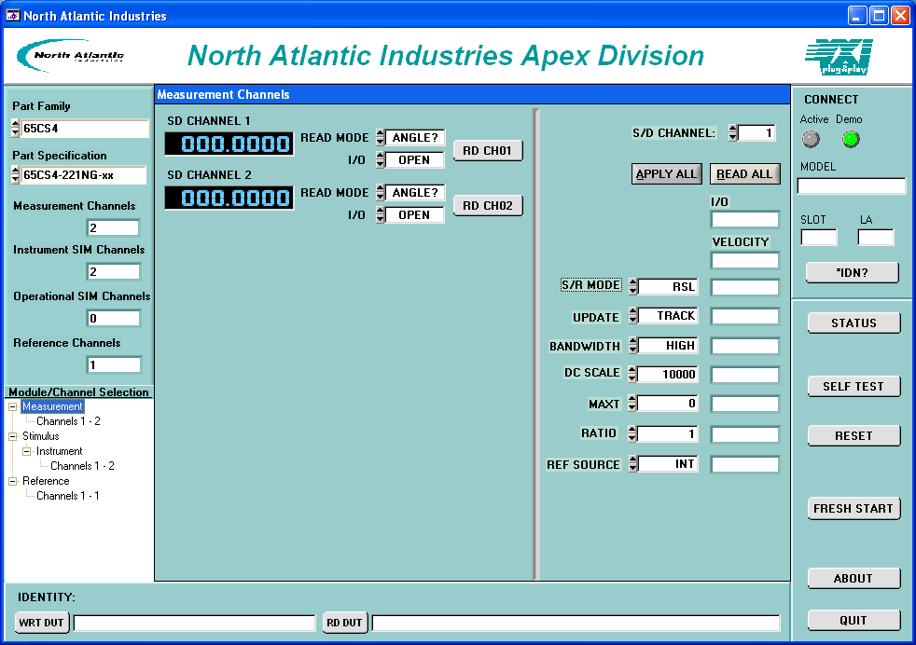
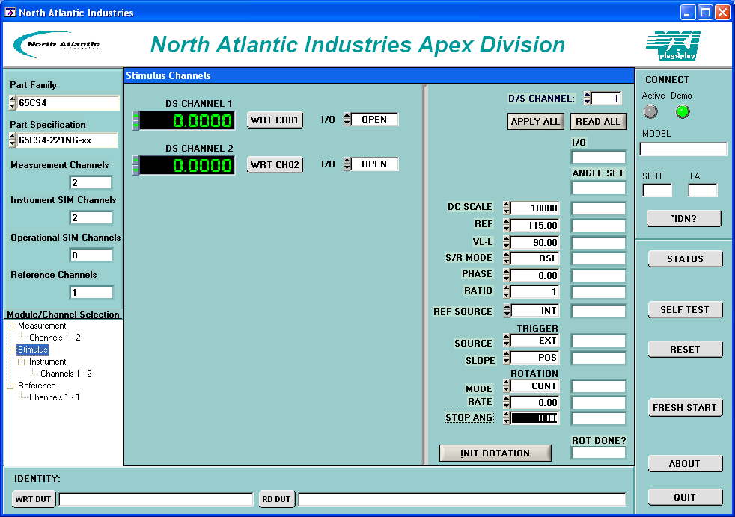

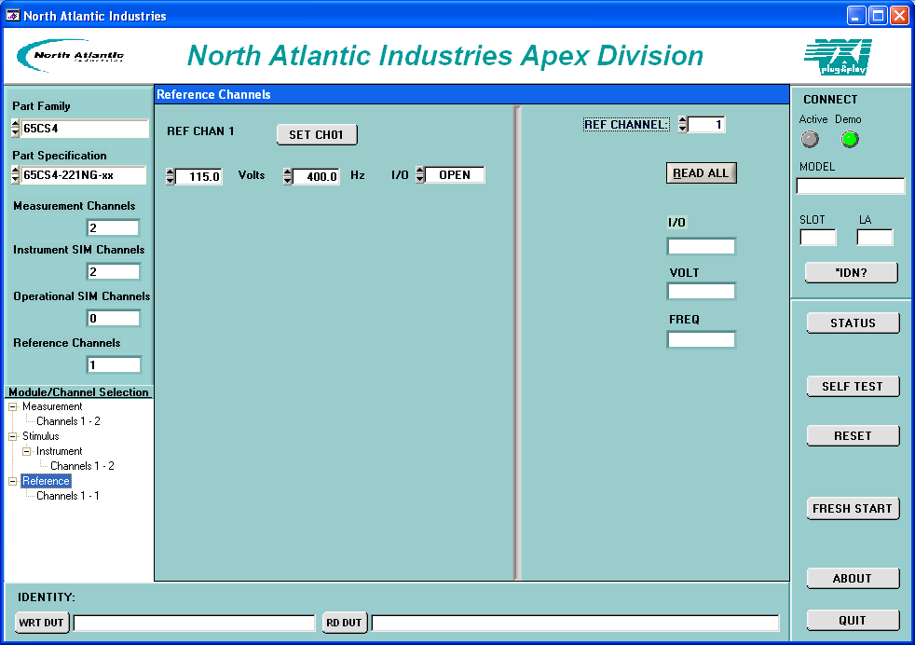

ATLAS Generation
When the ATLAS Generation button is pushed, an ATLAS statement representing the current GUI state will be generated. For this device, the verb shall be MEASURE or APPLY. No Test/Step number shall be created. The connection field shall be CNX HI LO (unless it is 4 wire ohm). No pins can be assigned through the GUI. The ATLAS column in the table below identifies the transform functions that will be supported. The statement shall be put into the system scratchpad for movement to the appropriate file.

Function Definition
The following table specifies the functions and parameters used to control the NA65CS4:

Function | Value Range | Default | XML | Misc
Part Family
Part Specification
Measurement Channels
Instrument SIM Channels
Operation SIM Channels
Reference Channels
Connect | Active/Demo
Model
Slot
LA
*IDN?
Status
Self Test
Reset
Fresh Start
About
Quit
WRT DUT
RD DUT
Measurement
Read Mode | Angle, Vel |  |  | SD Channel 1,  SD Channel 2
I/O | Open, Closed |  |  | SD Channel 1,  SD Channel 2
S/D Channel | 1, 2
Apply All
Read All
S/R Mode | SYN, RSL
Update | Track, Latch
Bandwidth | High, Low
DC Scale | 0 to 30000 |  | 10000
MaxT | 0 to 20 |  | 0
Ratio | 1 to 255 |  | 1
Ref Source | INT, EXT
Stimulus
DS Channel 1 | -360 to 360 |  | 0
DS Channel 2 | -360 to 360 |  | 0
Wrt Ch01
Wrt Ch02
I/O | OPEN, CLOSED |  |  | Ch01, Ch02
DS Channel | 1, 2
DC Scale | 0 to 30000 |  | 10000
Ref | 2 to 115 |  | 115
VL-L | 1 to 90 |  | 90
S/R Mode | RSL, SYN
Phase | 0 to 90 |  | 0
Ratio | 1 to 255 |  | 1
Ref Source | INT, EXT |  | INT
Source | EXT, INT, TTL0, TTL1, TTL2, TTL3, TTL4, TTL5, TTL6, TTL7, BUS |  | EXT
Slope | POS, NEG |  | POS
Mode | CONT, STEP |  | CONT
Rate | -1000 to 1000 |  | 0
Stop Ang | 0 to 360 |  | 0
Init Rotation
Reference
Set Ch01
Volts | 2 to 115 |  | 115
Hz | 47 to 10000 |  | 400
I/O | CLOSED, OPEN |  | CLOSED
Ref Channel | 1 |  | 1
Read All

Notes:

NA65CS4 Synchro/Resolver Programming Specifications
Not Applicable.

Processing
There are no special processing requirements.

Notes

ATLAS Examples

Requirements traceability
This SAIS provides the requirements stated in Paragraph 3.5.6 of the PERFORMANCE SPECIFICATION FOR THE THIRD ECHELON TEST SET (TETS) MARCORSYSCOM-PD-02-001 12/1/2003 and General Notes for Virtual Instrumentation Doc # 7992051 Rev.01 Aug 10 2005

Appendix
None.

