EADS NA Defense Test & Services

Software Design Document

Switch
SFP

SDD-SAIS Switch
Version 0.00
07/13/06

This document and the information contained herein are proprietary to EADS NA Defense and may not be disclosed in whole or in part to any parties without the expressed written consent of EADS NA Defense.

PAWS is a registered trademark of the TYX Corporation.

© EADS NA Defense Test & Services
1222 Lucas Ave. Suite 200
St. Louis MO 63103
phone (314) 727 1337
fax (314) 727 6750

Software Design Document

Version 0.00

History of changes
0: Initial Release
Change Table

Change | Date | Paragraph

1 Scope 5
1.1 Identification 5
1.2 System Overview 5
1.3 Document Overview 5
2 Reference Documents 5
3 System-Wide Design Overview 5
3.1 Assumptions and Dependencies 5
3.2 General Constraints 5
3.3 Goals and Guidelines 5
3.4 Safety and Security Considerations 6
3.5 Development Methods 6
4 System Architectural Design 6
4.1 System Components 6
4.2 Interface design 6
5 Detailed Design 7
5.1 Classification 7
5.2 SFP GUI 7
5.3 ATLAS Generation 11
5.4 Function Definition 11
5.5 Switch Programming Specifications 11
5.6 Processing 11
6 Notes 11
6.1 ATLAS Examples 11
7 Requirements traceability 11
8 Appendix 11

Scope

Identification
The SWITCH Stand-Alone Instrument Software (SAIS) Rac1260.exe provides the software routines necessary to control the Switch from a Soft Front Panel (SFP).

System Overview
The SAIS system provides a method of interfacing with the test system instruments. The method used by this module is utilizing the Common Interface Control Layer (CICL) calling Application Programming Interface (API) functions or SCPI commands.

Document Overview
The document defines the detailed software design for the SFP of the Switch. This document specifies the functional capabilities and how they are used to control the Switch.

Reference Documents
- User’s Manuals (m1260-38.pdf, m1260-39.pdf, m1260-58.pdf, m1260-66.pdf, m1260-67.pdf)
- ARC PAWS WCEM Software Development Style Guide (ARCSTL-DSG-000)
- Software Requirements Specification for Third Echelon Test Set DEFCOT&S-3536-SRS-001
- PERFORMANCE SPECIFICATION FOR THE THIRD ECHELON TEST SET (TETS) MARCORSYSCOM-PD-02-001 12/1/2003
- Computer Programming Manual (CPM) for the Third Echelon Test System (TETS) REV. E P/N 93006A0026
- IEEE std. 716-1989 C/ATLAS Test Language

System-Wide Design Overview
The SAIS provides the ability to control the instrument in debug and local modes of operation. The SFP will provide the capability to generate ATLAS code supported by IEEE 716-89 C/ATLAS.

Assumptions and Dependencies
The following assumptions and dependencies are made:

- ATLAS shall conform to the ATLAS standard and not be extended
- Instruments are provided with APIs
- Direct programming to instrument via SCPI (or equivalent) is permitted for functions that are not supported via the API.
- No complex assumptions for ATLAS generation

General Constraints
The sections below will detail which of the instrument functions and parameters are implemented to control the Switch.

Goals and Guidelines
- To the extent possible, map functionality and parameters to instrument controls using the Common Interface Control Layer (CICL)

Safety and Security Considerations
No safety or security considerations for this instrument.

Development Methods
TBD

System Architectural Design
SFPs will be modified and or developed using Visual Basic 6.0 and executed using existing SAIS interface.
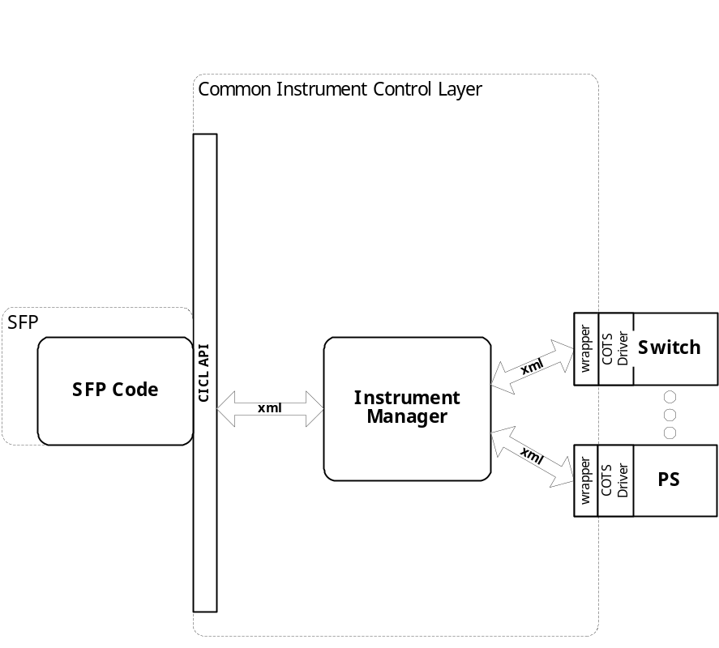

System Components
The SFP will consist of:

- A Visual Basic 6.0 project to build the SFP
  - Gui Files
    - About.frm
    - Rac1260.Frm
  - Programmer Generated Rac1260 Source File
  - Main.bas
  - RI1260.bas

Interface design

Communications with the instrument is through the CICL interface API.

Function | Purpose
(cicl_SD_Snippet* SignalDescription, SCTE_XML_String* cResponse, int BufferSize)

Detailed Design

Classification
This module is unclassified.

SFP GUI

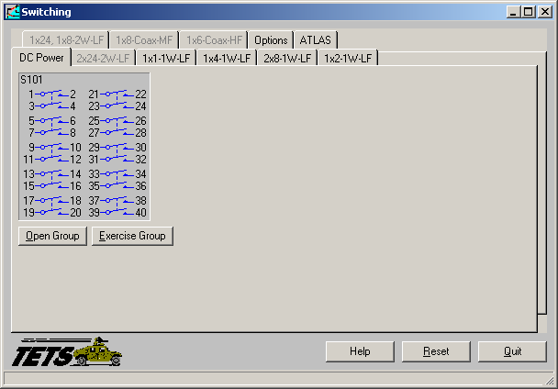

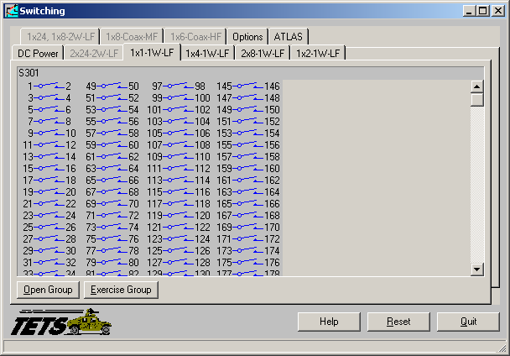

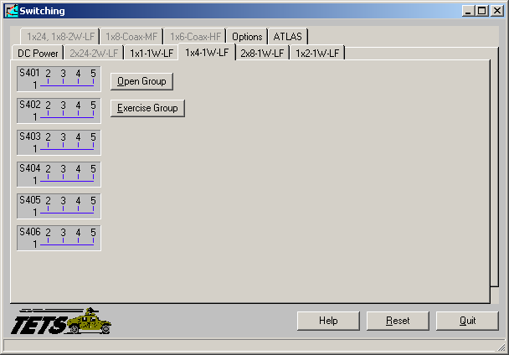

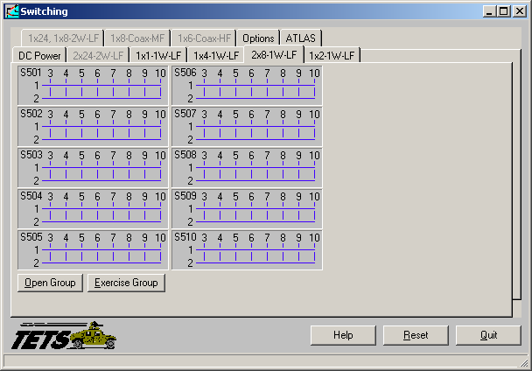

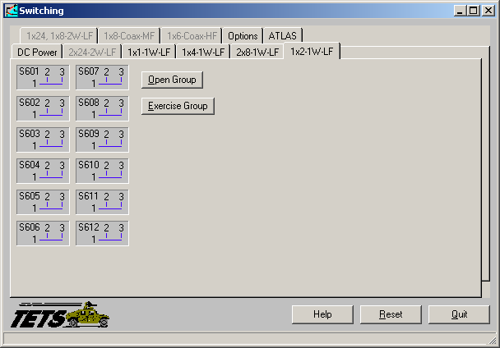
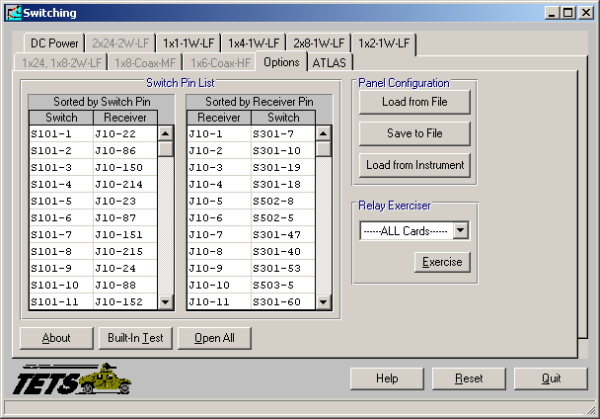

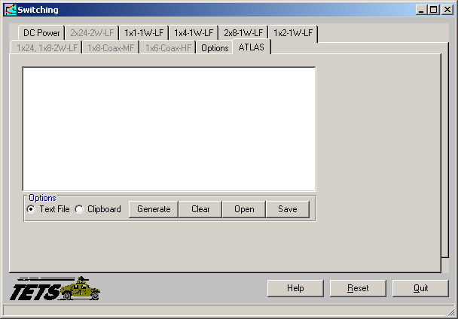

ATLAS Generation
When the ATLAS Generation button is pushed, an ATLAS statement representing the current GUI state will be generated. For this device, the verb shall be MEASURE. No Test/Step number shall be created. The connection field shall be CNX HI LO (unless it is 4 wire ohm). No pins can be assigned through the GUI. The ATLAS column in the table below identifies the transform functions that will be supported. The statement shall be put into the system scratchpad for movement to the appropriate file.

Function Definition
The following table specifies the functions and parameters used to control the Switch:

Function | Value Range | Default | XML | Misc
APPLY SHORT
REMOVE SHORT

Notes:

Switch Programming Specifications
Not Applicable.

Processing
There are no special processing requirements.

Notes

ATLAS Examples
TBD

Requirements traceability
This SAIS provides the requirements stated in Paragraph 3.4.11 of the PERFORMANCE SPECIFICATION FOR THE THIRD ECHELON TEST SET (TETS) MARCORSYSCOM-PD-02-001 12/1/2003 and General Notes for Virtual Instrumentation Doc # 7992051 Rev.01 Aug 10 2005

Appendix
None.

