Jossen Deer
2001616
Individual Assignment #2 (Arctic Flow)
Web Programming (CIT2011)
Tutorial : Thursdays @ 1PM

Repository Link: https://github.com/jossendeer/2001616_IA2_S1AY26
Hosting Link: https://jossendeer.github.io/2001616_IA2_S1AY26/Codes/

  - Wireframe & Sitemap.

- 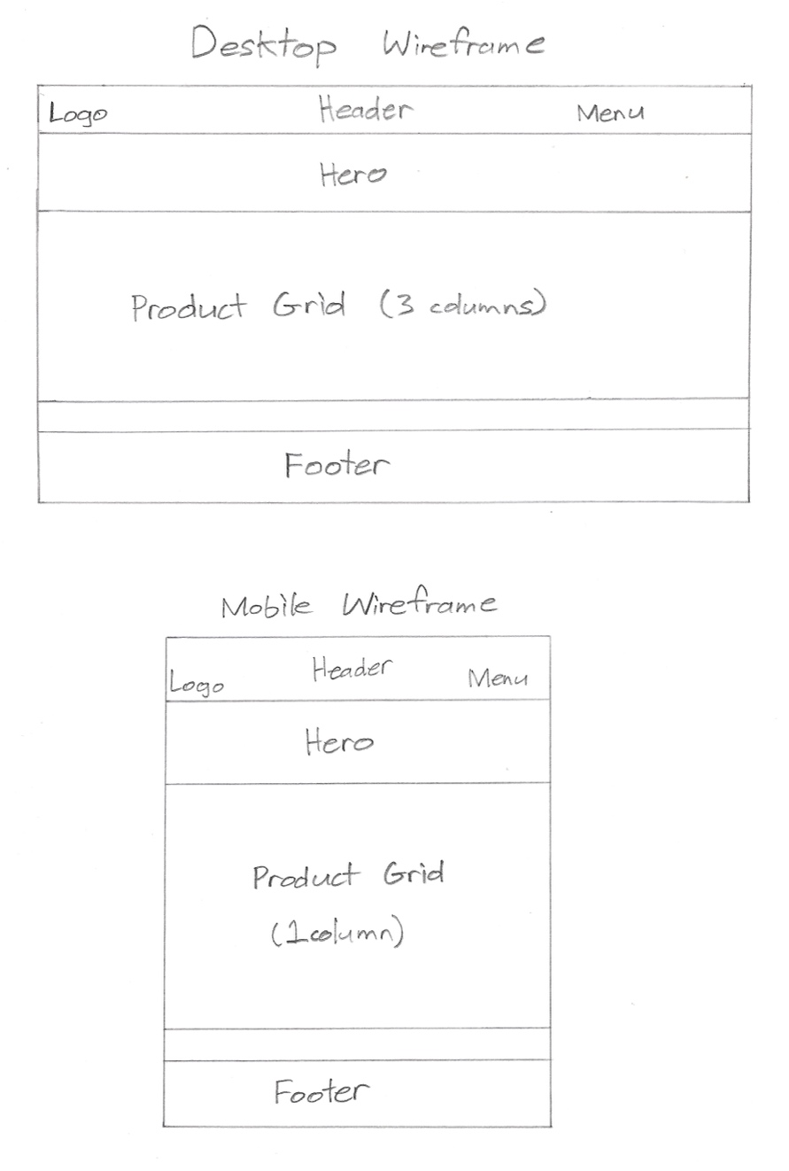

- Sitemap:

- Home
    - Product Details
  - About
  - Cart
    - Checkout
  - My Account
  - Login
    - Register

- Icons used:
    - Cart icon — 24×24px
    - User/account icon — 24×24px
    - Category icons — 32×32px

- Font-family: Inter, sans-serif
    - Root font-weight: 400 (regular)
    - Header weight: 600–700
    - Button weight: 600

- Arctic Blue
HEX: #2F80ED
RGB: (47, 128, 237)
- Eco Green
HEX: #27AE60
RGB: (39, 174, 96)
- Blue Light (Glacier Mist)
HEX: #EAF4FF
RGB: (234, 244, 255)
- Green Light (Mint Frost)
HEX: #E8F9F1
RGB: (232, 249, 241)
- Background Soft Blue
HEX: #F3FAFF
RGB: (243, 250, 255)
- Dark Text
HEX: #333333
RGB: (51, 51, 51)
- Muted Text
HEX: #777777
RGB: (119, 119, 119)
- Border Light
HEX: #DDDDDD
RGB: (221, 221, 221)

  - A description of your Business, Logo, Slogan, Mission Statement and Vision Statement.

- Business : My business is an e-commerce site that sells insulated food ware items that are also eco-riendly.
- Logo : My logo is just a simple image with the top showing half a snowflake and the bottom showing half of the sun as our way of showing that we can keep your food hot or cold.
- Slogan : “Adventure-Ready. Eco-Friendly”
- Mission Statement : To provide durable, eco-friendly insulated containers that keep food and drinks at the perfect temperature, while supporting a sustainable lifestyle for families, students, and adventurers.
- Vision Statement : “To inspire a sustainable lifestyle by creating durable, eco-friendly insulated products that empower people to enjoy the world while protecting it for future generations.”

  - Include a brief justification of the color palette you chose for your website, ie the psychology of color in web design and marketing. https://www.youtube.com/watch?v=8J0nbuunDXc

- I chose to use blue and green as they are calming and feel like they represent nature. They also provide a grounded sense of stability and control and that’s what I want my brand to be. I want my customers to be confident in our product and know it will keep their meals and beverages protected and warm/cold on the go.

  - Description of the intended audience for your website.

- My intended audience is mainly active adults/parents and students/kids. These products are excellent for keeping your food at the perfect temperature when you aren’t near somewhere to get ice or to reheat your food/beverage for a few hours.

References

Amazon.com: Insulated leakproof Food Container - 15.2 Oz, Stainless Steel Vacuum Insulated Food Jar with Folding Spoon, Leak Proof, Vacuum Insulated Thermo, Portable Food grade Bowl BPA Free (blue double layer): Home & Kitchen. (n.d.). https://www.amazon.com/Insulated-leakproof-Food-Container-Stainless/dp/B0DQ128ZR5

ARIA: aria-live attribute - ARIA | MDN. (n.d.). https://developer.mozilla.org/en-US/docs/Web/Accessibility/ARIA/Reference/Attributes/aria-live

ARIA live regions - ARIA | MDN. (n.d.). https://developer.mozilla.org/en-US/docs/Web/Accessibility/ARIA/Guides/Live_regions

Buy Kuber Industries Water Bottle | Vacuum Insulated Travel Bottle | Hot & Cold Water Bottle | Water Bottle with Carry Handle | Thermos Flask for Gym Bottle | MYZ-230805C | 550 ML | Blue Online at Low Prices in India - Amazon.in. (n.d.). https://www.amazon.in/Kuber-Industries-Insulated-Thermos-MYZ-230805C/dp/B0CS3CRC86?th=1

Dongguan Oumeng Houseware Products Co., Ltd. (n.d.). AOHEA Manufacturer Eco Friendly Lunch Box Stainless Steal 5 compartment bento box with food container jar. www.alibaba.com. https://www.alibaba.com/product-detail/Aohea-Manufacturer-Eco-Friendly-Lunch-Box_1600796416223.html

Grid | web.Dev. (n.d.). web.dev. https://web.dev/learn/css/grid
grid-template-columns - CSS | MDN. (n.d.). https://developer.mozilla.org/en-US/docs/Web/CSS/Reference/Properties/grid-template-columns

Hangzhou Hono Housewares Co., Ltd. (n.d.). 350ml Insulated Travel Coffee Mug Spill Proof With Lid Best Thermal Coffee Go Cups Reusable Small Coffee Thermos - Buy Mug Coffee Cup coffee Travel Cup coffee Thermos Product on Alibaba.com. www.alibaba.com. https://www.alibaba.com/product-detail/350ml-Insulated-Travel-Coffee-Mug-Spill_1601042476414.html

Initiative, W. W. A. (n.d.). WAI-ARIA Overview. Web Accessibility Initiative (WAI). https://www.w3.org/WAI/standards-guidelines/aria/

Kantor, I. (n.d.). Event delegation. https://javascript.info/event-delegation

New high-value unicorn astronaut pattern water cup with rope, direct drinking cup 700ML outdoor sports student kettle. (n.d.). https://www.aliexpress.com/item/1005008875583374.html

Rendle, R. (2020, July 1). object-fit | CSS-Tricks. CSS-Tricks. https://css-tricks.com/almanac/properties/o/object-fit/

Schroiff, F. (2025, March 11). The complete guide to ARIA Live Regions for developers. The A11Y Collective. https://www.a11y-collective.com/blog/aria-live/

Understanding shipping rates. (n.d.). Shopify. https://help.shopify.com/en/manual/fulfillment/setup/shipping-rates/understanding-shipping-rates?

Use ARIA to announce updates and messaging - Centre for Excellence in Universal Design. (n.d.). Centre for Excellence in Universal Design. https://universaldesign.ie/communications-digital/web-and-mobile-accessibility/web-accessibility-techniques/developers-introduction-and-index/use-aria-appropriately/use-aria-to-announce-updates-and-messaging?

Using CSS custom properties (variables) - CSS | MDN. (n.d.). https://developer.mozilla.org/en-US/docs/Web/CSS/Guides/Cascading_variables/Using_custom_properties

Using CSS gradients - CSS | MDN. (n.d.). https://developer.mozilla.org/en-US/docs/Web/CSS/Guides/Images/Using_gradients/

Using the Web Storage API - Web APIs | MDN. (n.d.). https://developer.mozilla.org/en-US/docs/Web/API/Web_Storage_API/Using_the_Web_Storage_API

Web Storage API - Web APIs | MDN. (n.d.). https://developer.mozilla.org/en-US/docs/Web/API/Web_Storage_API?

What is Color Theory? (2025, September 19). The Interaction Design Foundation. https://www.interaction-design.org/literature/topics/color-theory?srsltid=AfmBOopcGOnZ8z4OR9VaJQtw4YBjXWumR8puQTGdg6y7RO3RtlDIz8sK

Window: localStorage property - Web APIs | MDN. (n.d.). https://developer.mozilla.org/en-US/docs/Web/API/Window/localStorage

Zhejiang Lingqi Industry And Trade Co., Ltd. (n.d.). 2025 Custom Stainless Steel Vacuum Flask Wide Mouth thermal Bottle for 27/32/40oz capacity 12-24hr thermal insulation. www.alibaba.com. https://www.alibaba.com/product-detail/2025-Custom-Vacuum-Flask-Thermal-Bottle_1601368775581.html

