Cloud-Based Temperature Monitoring System
CSDA306 - Internet of Things
Aldrin Aype Joseph | MSc Computer Science (Data Analytics) | Semester 3

1. Objective
This project simulates an IoT temperature sensor, stores its readings in a cloud database, and visualizes them through a live web dashboard. It demonstrates the full data path of a real IoT deployment: a device generating data at the edge, a cloud data store, and a client application that consumes and presents that data, without requiring physical hardware.

2. System Architecture
The system is split into two independent components connected only through a shared cloud database table:
- Part A - Sensor Simulator: A standalone Python script generates a random temperature reading (20-40°C) every 5 seconds and inserts it into a Supabase table over HTTPS using Supabase's auto-generated REST API.
- Part B - Web Dashboard: A Flask application queries the same Supabase table and renders the results as a live-updating line chart and a data table in the browser.
Because the two components only communicate through the database, either can be stopped, restarted, or replaced independently. This mirrors how real IoT deployments decouple data-producing devices from the applications that consume that data.

3. Database Schema
Supabase (a hosted Postgres database with an auto-generated REST layer) stores all readings in a single table, temperature_readings:
Column | Type | Constraint | Purpose
id | bigint (identity) | Primary key | Unique row identifier, auto-incremented
temperature | numeric(5,2) | Not null | Simulated sensor reading in °C (20.0-40.0)
reading_date | date | Not null | Calendar date the reading was taken
reading_time | time | Not null | Clock time the reading was taken
created_at | timestamptz | Default now() | Server-side insert timestamp, used to order the chart
Row Level Security (RLS) is enabled on the table, with explicit policies permitting the anon API role to INSERT (used by the simulator) and SELECT (used by the dashboard), plus the corresponding Postgres-level GRANT statements required alongside RLS policies.

4. Implementation

4.1 Part A - Sensor Simulator (Python)
sensor_simulator.py runs an infinite loop that, every 5 seconds: generates a random float temperature between 20.0°C and 40.0°C using Python's random module, builds a JSON payload with the temperature plus the current date and time, and sends it as an HTTP POST request to Supabase's REST endpoint (/rest/v1/temperature_readings) using the requests library. Supabase credentials (project URL and API key) are kept out of source control in a .env file, loaded at runtime with python-dotenv. Each upload prints a console confirmation line, and the loop continues until manually stopped with Ctrl+C.

4.2 Part B - Web Application (Flask)
app.py exposes three routes:
- GET / - renders the dashboard page (index.html).
- GET /api/readings - queries Supabase for all rows ordered by timestamp and returns them as JSON; polled by the browser every 5 seconds.
- GET /export - streams all readings back as a downloadable CSV file (bonus feature).
On the frontend, Chart.js renders temperature against time as a line chart, and a JavaScript setInterval loop calls /api/readings every 5 seconds to refresh the chart, the table, and a "latest reading" panel without a full page reload. A manual "Reload now" button is also provided. Chart.js is bundled locally as a static file rather than loaded from a public CDN, to avoid depending on external network access at demo time.

5. Screenshot - Web Application
The dashboard below shows live data retrieved from Supabase while the simulator was running: the line chart plotting temperature over time, the latest-reading panel, and the auto-refreshing table.
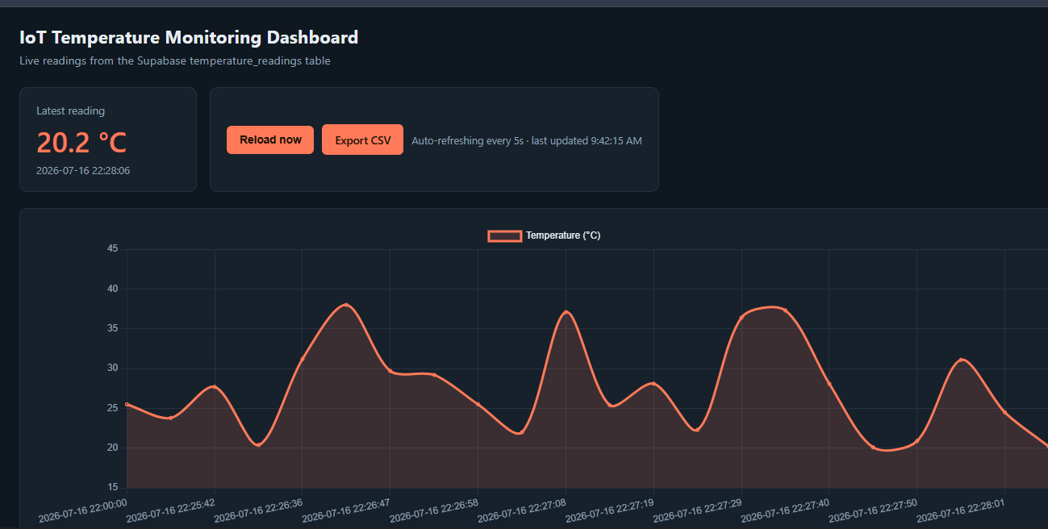

6. Challenges Faced and Resolutions
- Initial uploads failed with a 401 permission error even with RLS policies in place. Resolution: Supabase requires explicit Postgres-level GRANT statements (GRANT SELECT, INSERT ... TO anon) in addition to RLS policies; adding these resolved the issue.
- The dashboard's chart failed to render with a "Chart is not defined" error because the CDN-hosted Chart.js script did not load (network restrictions). Resolution: bundled Chart.js as a local static file served directly by Flask, removing the external dependency.
- A misconfigured .env value (the full REST path instead of the base project URL) caused 404 errors. Resolution: corrected SUPABASE_URL to the bare project URL, since the application code appends the REST path itself.

7. Conclusion
This project successfully demonstrates an end-to-end cloud-based IoT monitoring pipeline: simulated sensor data generation, cloud storage via Supabase, and a live web dashboard built with Flask and Chart.js. Beyond the core requirements, the implementation includes a live-updating chart without page reloads, a latest-reading display, and CSV export. The project's source code is version-controlled and available on GitHub, with incremental commits reflecting each stage of development.

