Yoseph Ayele Kebede

Dr. Mitachell

ENPM701 Assgnm #1

Moving Average

Assignment #2

Confirming initial setup and configuration of Raspberry Pi working

Question #1

To do checks

1. All packages properly imported in Python and sanitycheck.py working with no errors

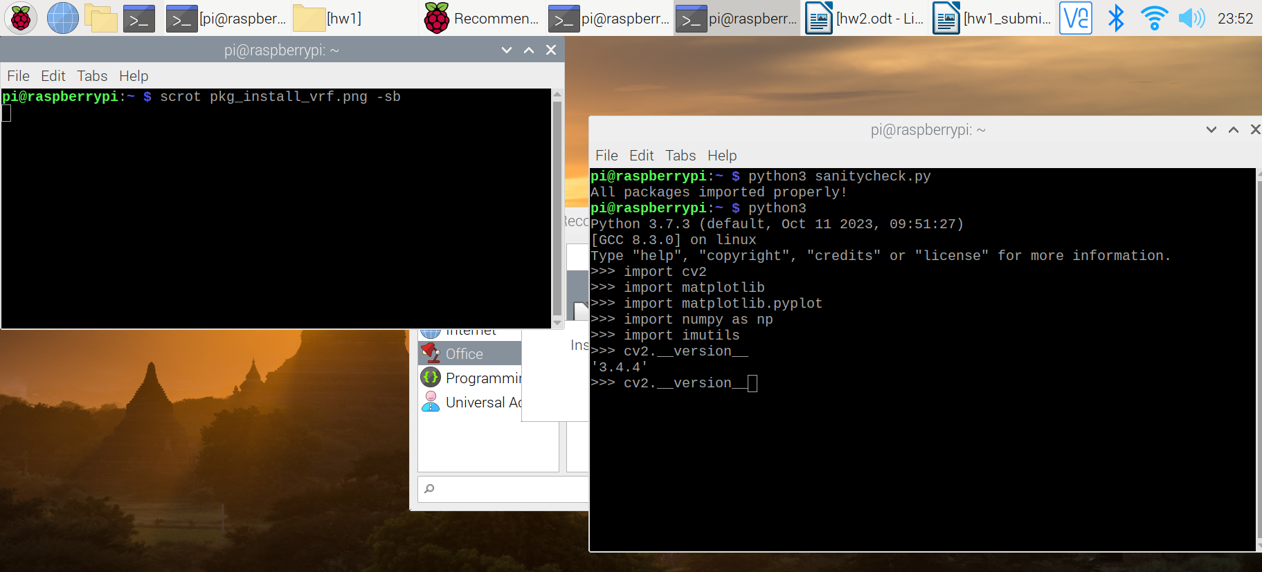
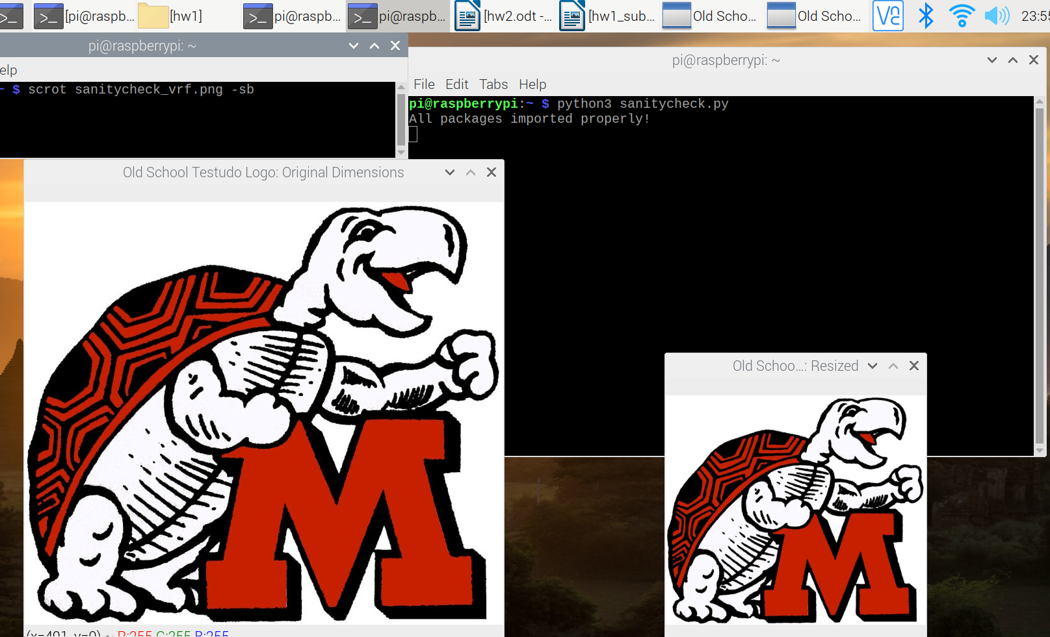
2. Wiireless connection to Pi: Putty/Terminal and VNC

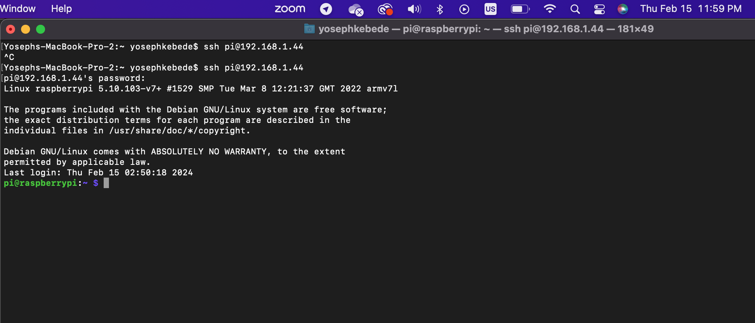
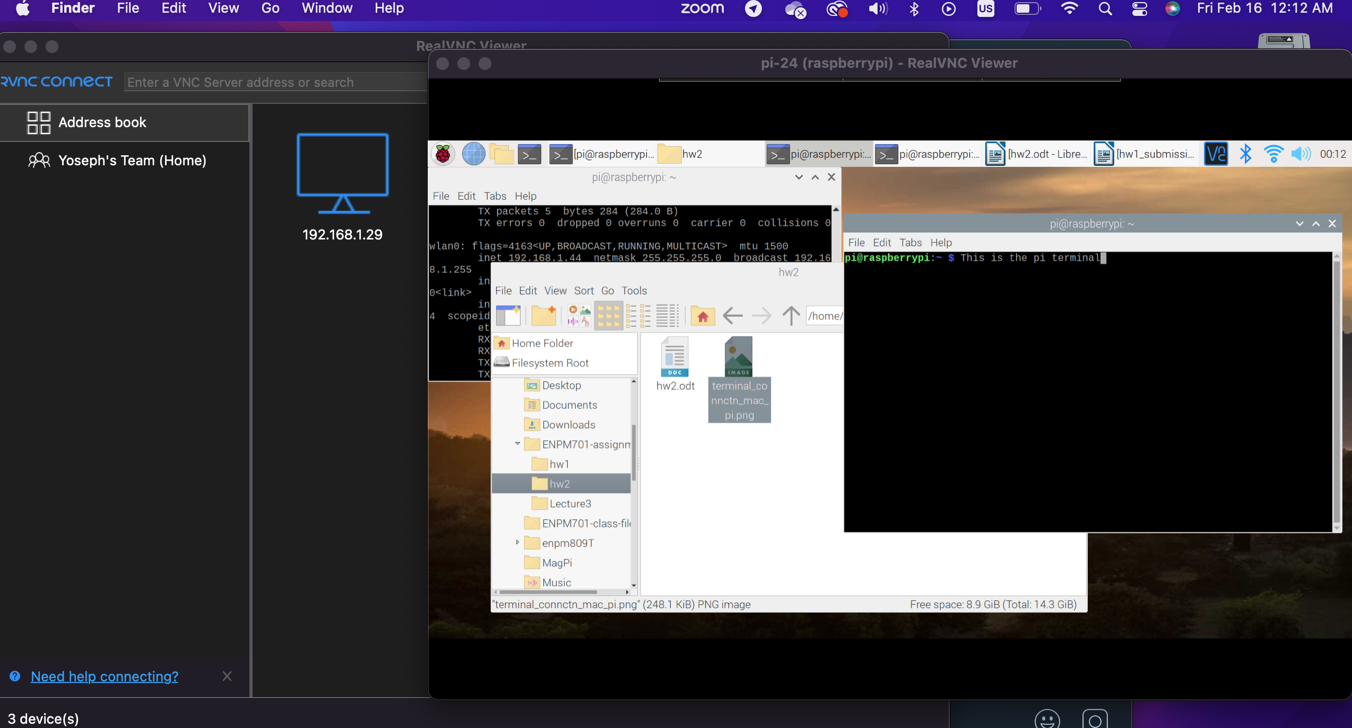
3. Transfer files between Raspberry Pi to laptop

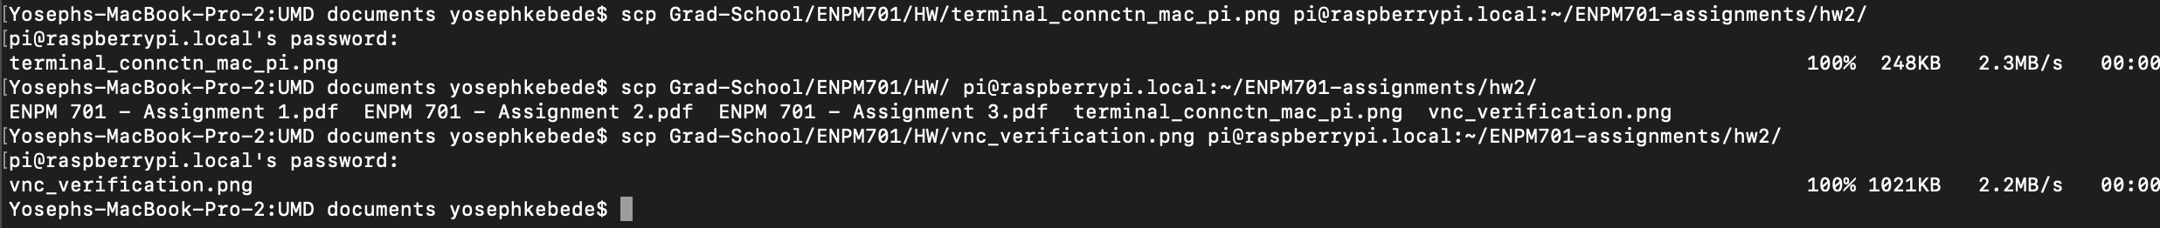
4. Raspistill and raspvid function correctly

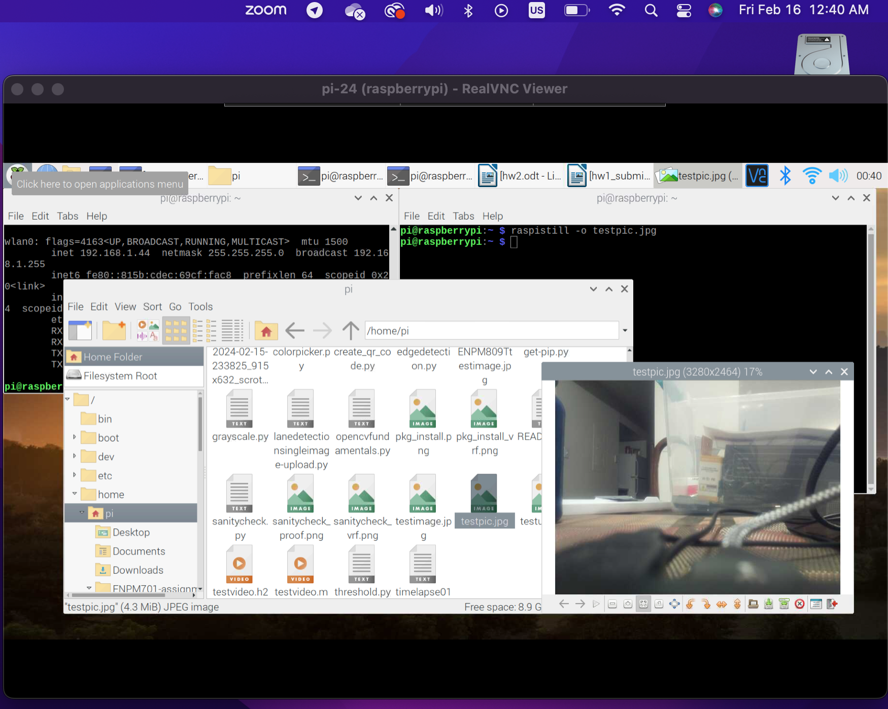
5. Picamera functons properly (39 secs video)

https://youtu.be/o4EgsfYXHYE

