Yoseph Kebede

Dr. Reza

ENPM662

Project 1

11/03/2022

Report on CAD Modeling and Gazebo Simulation

The project was started by creating the CAD files that are the building blocks for the robotic car. This was done by designing the chassis, followed by the wheel and the connectors. At first, the assembly was done without the connecting link, which was one issue that created a setback, since the Gazebo simulation was not properly rotating the wheels as the chassis was floating in the air, when the physics engine of Gazebo kicked in. As a result, I was forced to go back and create the connector link as shown in Figure 1. Then assigned materials to each component and reassembled the robot. The assembly was the exported as URDF and imported into ROS.

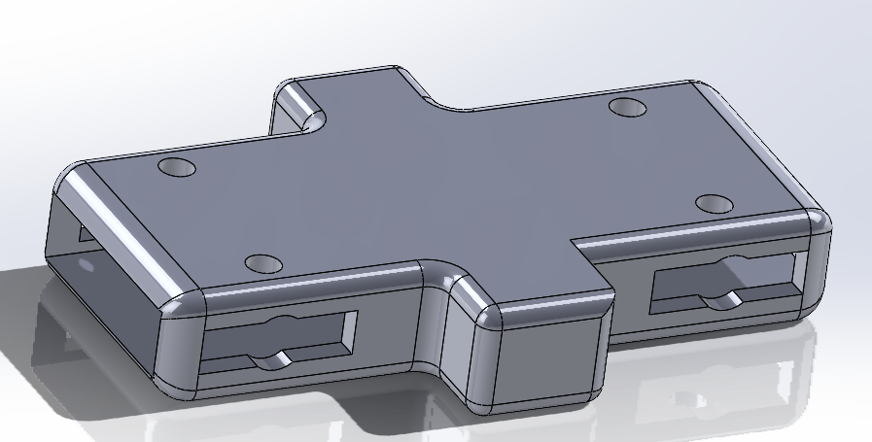

Figure 1. CAD of components and Assembly

Finally, after adjusting the proper launch files and attached lidar to robot, the robot was spawned in gazebo with laser shown on rviz as displayed in Figure 2.

There were numerous challenges on the second part of the project, i.e. converting the solidworks design to urdf and correctly spawning the robot with the joints, controllers, and rotations accurately so that it moves as expected. Debugging the vast issues it was facing at the same time increased the level of difficulty. First, the URDF was not exported with a connector, i.e. the wheels were constrained to move in the desired direction but was not connected with the chassis physically. Therefore, I had to go back and create another part that was able to rotate with a revolute joint, thereby steering the wheels independently. Hence, the time of adding this part to getting the joints correctly configured required redesigning and checking with gazebo numerous times, which was exhausting. Additionally, there were sporadic errors that happened seldom which meant that the PID variables needed tweaking. All in all, juggling between the urdf, xacro, config controller, template launch, teleop publisher files and more importantly the fact that gazebo restarting inconsistently which could be regarded to the core i3 processor laptop being used, all made this project challenging. At the end, thanks to Pavan and Adarsh’s selfless off OH time help, I was to both spawn the robot successfully and move it via teleop and simple publish/subscriber commands.

The Result, nevertheless, is a four wheeled two drive car able to steer 25 degrees in either direction with lidar mounted in the front of the Chassis so that it can detect obstacles approaching it.

Figure 2. Robot car in Gazeb (left) and Rviz (right)

Videos for teleop and talker – listener ROS publisher subscriber nodes are found below which enabled the vehicle to be controlled from a distant, as well as travel a preplanned path.

Teleop

<https://drive.google.com/file/d/1LwWLyoFtQ24kS-eLrMtJs1DSjOGrkQjC/view?usp=sharing>

Pub_Sub

<https://drive.google.com/file/d/1V9bImKPEgOOHhCZ89CkqQbaan47e8Yui/view?usp=sharing>