**Book Shelving Robotic Arm**

The Proposal

Submitted By: Yoseph Kebede

Submitted To: Dr. Reza Monfaredi

ENPM662 – Fall 2022

12/08/2022

Project 02: Proposal

**Outline**

* **Introduction**
* **Motivation**
* **What’s the Book Shelving Robotic Arm?**
* **Design Selection**
* **Scope of application**
* **Model Assumptions**
* **Approach to performing the task**
* **Milestones with timeline**
* **Validation Plan**

**Introduction**

It has been more than a decade since robots have become to be used extensively in our daily lives, besides their use in manufacturing and storages. In the global scope, while sectors ranging from self-driving cars to household items like Roomba are becoming casual ways of managing tasks, there are still places that have not been given enough focus compared to our frequent usage. One of these places are libraries. Although books have become digital now than ever before, people still enjoy going to libraries to either borrow hard copies or sit and read or do their work in the quiet and appealing space. Thus, except for few well-funded huge libraries that are beginning to try out a robotic system for sorting and retrieving books, most local libraries still rely on manpower to retrieve books from shelves, regardless of their height (The University of Chicago Library, n.d). Therefore, the objective of this project is to design a simple robotic arm stationed on one edge of a bookshelf that’s able to move to the various rows vertically, extend to the different books in a given row, have a reaching end effector that can extract the book and rotate to change the orientation of the book, and a rotating arm base with a joint and two links so that the robot can accommodate to different types of shelves with varied row dimensions.

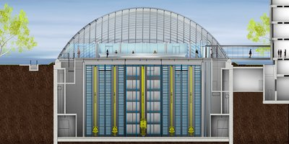 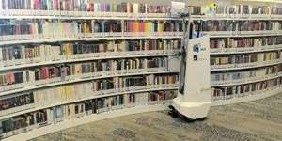

The University of Chicago Library, AuRoSS - Autonomous Robotic Shelf Scanning system

Joe and Rika Mansueto Library

**Organization**

The report is organized as shown in the outline above where the need for the robotic design’s application is first highlighted, followed by the description of the robot and various applications. Then, the details of the product design along with assumptions used will be explained. Finally, the specific plans on how to model and test concept will be laid out, with any recommendations into to anyone interested in pursuing this route in the future.

**Motivation**

Space, as in land that people dwell in, keeps on getting expensive as the years go by. For this reason, one solution has been to vertically tally items up so that one can efficiently provide service, live in, or utilize the part of land he or she owns to their desired needs. This comes with a cost, however, as shelving items higher and higher would mean that people need to device ways to bring those items down for access and return them to their storage location when done. To this end, apart from many sectors and services that usurp various solutions to address the storing and accessing challenge, due to lack of substantial financial resources and the comfort of using one task repeatedly for thousands of years, libraries – for the most part – have been using the basic way of accessing out of reach books, hence ladders. Besides the obvious safety risks and the number of books one can bring down at any given moment, the current ways of extracting books from tall shelves have been treated as an annoyance only librarians have to struggle with. It is important to note, however, just in 2017 alone, it’s been recorded that public libraries have been visited about 1.32 billion times, which comes out to have each American visiting a public library more than 4 times (Institute of Museum and Library Services, 2020).

Therefore, since, as engineers, solving the problems, removing the annoyances of the society and providing better solutions to help societies conduct their daily task is the professional obligation we abide by, providing an time saving, and cost effective solution would indeed simplify the lives of librarians serving the vast number of customers, as well as help bring back shelved books to access with more ease (National Society of Professional Engineers, n.d).

**What’s the Book Shelving Robotic Arm?**

To help address the challenge described in the previous section, the book shelving robotic arm (BSRAm) is proposed in this paper. As the naming suggests, apart from other areas where an assisting tool to help people access besides books is needed, for ease of implementation, and exigence in terms of current potential use as explained before, shelving robotic solution as been termed as such; hence, success in proper application can help spawn design to other needs as preferred. Nonetheless, as shown in Figure 1 below, the BSRAm is a robotic arm that has a prismatic and revolute base attached to a vertical bar, which itself is fixed at one edge of a bookshelf. Furthermore, its remaining links and joints are designed to reach to any row and column within that bookshelf, while also being able to access three rows within one fixture, which allows it to be freely placed in any rectangular bookshelf no matter the height of the rows. More importantly, Figure 1 only shows the core mechanical system performing the extraction, even though the design of the whole system includes a graphical interface for users to input the book row and column number (author last name and indexed column respective to the specific library implementing the device) which translates into cartesian coordinates that the BSRAm calculates in real time to provide actuation commands to its joints. Additionally, BSRAm would also consist of a revolute joint holding a plate, placed underneath joint 6 in Figure 1, that can temporarily hold the books retrieved by the robot as extracting orders from the customer. However, this paper covers on the actual task of extracting books, as designing end user interactions are trivial in comparison.

Figure 1. The BSRAm Rough Sketch

Here is a summary of the BASm’s sensors, joints, motors, and material.

Parts responsible for movement in 8 DOF system, with (X) as labeled in sketch:

* Vertical Bar (1, Prismatic joint attached) (1)– robot arm base uses to travel vertically
* Robot arm base (1, Prismatic joint attached) (2)– Extends from Bar to book column
* Link base (1, Revolute joint attached) (3) – rotates arm into or out of book shelf when presenting books to user at the end
* Robot bottom link (1, Revolute joint attached) (4)– Rotates bottom link to provide horizontal reach to the BASm
* Robot upper link (1, Revolute joint attached) (5)– Rotates from bottom link to reach more shelves both vertically and horizontally
* Book grapple base (1, Prismatic joint attached) (6)– Extends end effecter from upper link to get book gripper next to book.
* Book gripper base (1, Revolute joint attached) (7)– Picks up book and can also rotate along the grapple base axis to place book by the plate attached to bottom link
* Book gripper (1, crankshaft) (8)– Rotates two pinching plates to grapple or release book

Motors:

* Stepper motors, servos

Sensors:

* Cameras (to read bookshelf row and column number, to verify book capture), gyroscope (measure link angle), Lidar (to measure gripper proximity to book)

Materials:

* Aluminum (for the links), Steel (for the vertical bar), Rechargeable batteries for motors and sensors

**Design Selection**

This design was considered after assessing the present setup of most libraries, i.e. currently looking for ones in the US. As mentioned in the introduction, most designs out there in the market are either humungous systems with tunnels built into buildings like the Joe and Rika Manseuto Library or mobile autonomous robots – like the AuRoSS robot – currently utilized to work independently by reshelving books and other mundane librarian tasks (The University of Chicago Library, 2022)(Phys.org). Thus, current solutions are high cost, implemented offline, and not easily dispensable towards those libraries identified as target audiences. Therefore, in order to target the numerous customers accessing libraries daily, the BSRAm design conveniently allows the setup to be placed essentially on every shelf due to the minimal items needed to obtain and setup. Furthermore, for the task of retrieving books, the BSRAm can access more than one bookshelf row and book from one order. Moreover, it can coexist with traditional ways of extracting books, since it can get stationed on either edge of a shelf when not needed. Therefore, simplicity, efficiency, and cost effectiveness to say the least, make this design well suited for the task.

**Scope**

The Book Shelving Robotic Arm project includes, by the very least, these areas of study. To name a few: user interface for obtaining instructions from potential librarian or visitor, program for recording user entry and translating destination commands and actuation controls for the actuated joints, sensing and control feedback during motion, kinematics and dynamics involved in moving book gripper to desired destination as well as extracting book, verifying design via CAD and Gazebo plus RVIZ simulation, refining accuracy plus efficiency per book order, and finally maximizing scalability and mass production using lean six sigma and other mechanisms.

In this project, the focus will be on the CAD modeling and Gazebo plus RVIZ simulation area when moving the robotic gripper from its home state to the desired state; that is, the rotational and translational movements involved in every link and joint will be accounted for, materials selected, and finally the synergy of entire setup will be checked whether design hypothesis holds true as end effector is actuated in gazebo’s physics engine.

As working towards accomplishing this project, the basic goal aimed to achieve is to have user manually interact with the simulation via RVIZ, so that he/she can move the end effector to an arbitrarily chosen point in the simulation space, thereby proving the robot model in its entirety is a cohesive system able to achieve the task it’s intended to. If this goal is met in a timely manner, the project’s ambitious goal is to design a simple user interaction terminal whereby utilizing ROS’s Gazebo, one can enter a bookshelf row and column entry (both valid and invalid) which the program can take, process and simulate on the environment, which will have the additional book shelf CAD spawned and fixed in the gazebo world, so that the full implementation of the design from input to processing to output can be visualized. If, this can not be achieved in time, while the basic requirement is met, the ambitious goal will get predicated to either manually experiment with the BSRAm on a modeled bookshelf, or simply simulate the BSRAm alone in an empty world environment.

**Model Assumptions**

Below are listed the assumptions considered in designing and testing the Book Shelving Robotic Arm.

* The BSRAm is a stationary robot with links that protrude and rotate to accomplish task.
* The BSRAm is designed to be used on Earth, ie for Earth’s gravitational field
* The design assumes to have prismatic and revolute joints to be well lubricated, such that friction on joints is negligible.
* The BSRAm cannot retrieve more than 5 books at once, or until total mass of books on plate is 15lbs, whichever is satisfied first.
* If the bookshelf’s width extends 2.5meters, the BSRAm will need to have it’s prismatic Robotic arm base (2) connected with the rows on the bookshelf with a rail so that the link does not bend, break or shorten its life span.
* The actuators and sensors on the BSRAm are battery powered, to avoid entanglement with power cables.
* Homebase station will charge all motors and sensors, thus the BSRAm will assume efficient packing configuration to enable recharge of essential components
* The gripper, link holding plate and gripper base, cannot exceed turning out of the shelf by 90 degs
* The project assumes there are no human, or objects standing within 2.5ft proximity of bookshelf during operation
* The actuators, sensors, and joints can be purchased off the shelf. Links can also be bought as general rectangular or cylindrical bars with minimum machining to fit and assemble with joints. Thus, no new manufacturing needed for prototyping
* The project assumes all books have barcodes generated used in recognizing ordered books. Future iterations of project will have visual inspections on the gripper to detect more information besides barcode.
* ROS Melodic will be used to test gazebo simulation on Ubuntu 18.04 LTS OS.
* Python 2.7 will be used to perform automated simulation using ROS.
* Visual Studio Code interpreter will be used to work with ROS package, URDF files and meshes.

**Methodology**

Project started with designing and then completing the assembly using Solidworks from scratch by independently CADing 13 parts as well as assembling them all together as shown in Figure 2. Then, proper material, linkage and joint assignments were made after which the assembly’s URDF and meshes were exported as a package to a unix environment. Then, the respective controllers, transmissions, parent - child urdf linkages, and ROS launch files (publisher/subscriber nodes if time permits) were generated.

Figure 2. BSRAM in its base orientation

Finally, the BSRAm will be launched onto both Gazebo and RVIZ, where the 8 DOF system was tested in RVIZ by manually changing the dialer for every joint to verify correct design execution; Gazebo was used while the RVIZ check was being analyzed. Finally, the automation and similarity to the realistic environment as mentioned above in the motivation were attempted on one at a time, starting with adjusting the robot to place the end effecter at the location where books would be placed. Additionally, as a base link was connected to the BSRAm’s vertical bar furthermore tests for interference and verification of requirements met were conducted, followed by attempts to simulate one book extraction order.

Figure 3. Rviz on the left, and Gazebo on the right

Although robot was placed with easily uploaded into Rviz and Gazebo from CAD assembly, sending out both teleop commands to the end effector while utilizing inverse kinematics computations real time was challenging. This was attributed to URDF exporter tool in accuracy in sending joint information as well as combination of prismatic and revolute links assembled to achieve purpose. Therefore, previously mentioned plans of autonomous configuration and better designed user interface became ambitious.

The movement of the robotic assembly was performed using Inverse Kinematics where a velocity vector was commanded to a single end effector joint which was used as an input for evaluating the angular velocities of each movable link. Thus, first the coordinate frames along with the DH parameters of the robot were defined as shown in Figure 4 below. Therefore, the 13 part system was reduced to 8 DoF system, which after a second iteration of computation had one

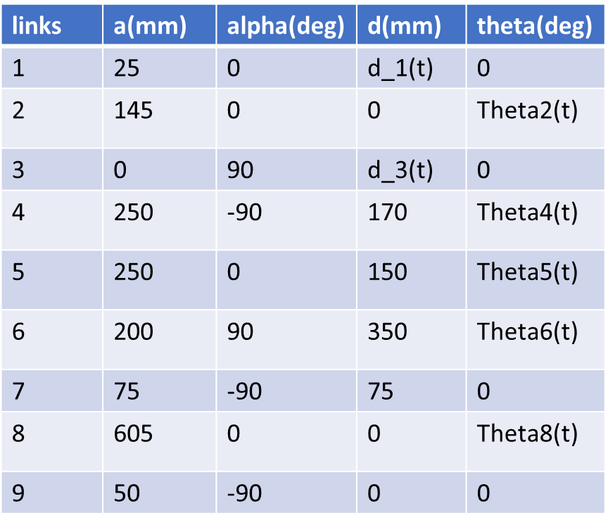

Figure 4. Coordinate frame definition (left) and DH parameters table (right)

frame fixed at the end to simplify the computation to 7 DoF in order to obtain demonstrable results. Then, using the first method to compute Jacobians, all transformations to the 8 frames, not counting base frame, were computed, followed by performing the cross product of the last column of rotation matrix of preceding frame with the translation matrix. Thus, after obtaining Jv (linear velocity Jacobian) and Jw (angular velocity Jabobian), the full 6 DoF Jacobian for a single link was found, and then for all defined links, summarized below.

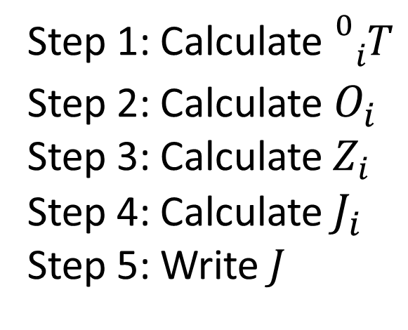

The full Jacobian of the robot was computed once and saved to be used when converting linear velocity of end effector to revolute and prismatic movements of the BRAm robot. Therefore, the inverse Jacobian was multiplied with linear vector input, which were saved and published to each joint in the robot. Steps are illustrated below.

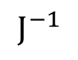

Input

Theta_dot

**Milestones with Timeline Reassessment**

Based on current standing, the below timeline has been updated to reflect status of tasks completed from the generated tasks need to track progress on project. (* and ** are must complete objectives). The simulation of inverse kinematics application in Rviz and Gazebo is where the project is currently hung. Future goal is to fix visualization and move on to adding capacities that make prototype realistic

1. Pre-proposal: due October 20, 2022 – completed
2. Proposal: due November 06, 2022 – completed

\***Currently here**\*: work on CAD prototype – completed

*Begin integration with ROS – completed

*Begin testing on RVIZ << first milestone achieved – completed

*Begin working on Presentation for minimum goal – completed

*Continue to next steps if testing is successful – **currently here with Rviz and Gazebo not moving robot as expected**

*Begin adding bookshelf and constraints – ambitious goal*

*Begin testing BSRAm with bookshelf << ambitious part 1*

*Begin coding to accept user input to control joints*

*Continue coding to control all joints*

*Finish programming and test full standalone simulation << ambitious goal*

**Finish and practice presentation, whichever goal gets completed – completed

1. Final Report: completed
2. Final Presentation (simulation): completed
3. Final Presentation submission: completed

**Results and Discussion**

With the limitation of allotted time for project, the successful creation of assembly, implementation of Inverse Kinematics validation internally by testing DH parameters for 8 DoF system, and realtime computation of Jacobian followed by converting end effector velocity to angular velocity for each link have been test successfully. This shows that for small DoF systems, upto 7, mediocre techniques of obtaining Jacobian and its inverse in moving joints prove to be working. However, when the DoF for robot increases, issues with singularity and assumptions in frame assignment and vector transformation between end effector and each of the links need robust algorithms, that were not discussed in class. Current results only uploaded results to simulation environment and need revision to move robot as desired

**Challenges**

Demonstrating use of Inverse kinematics concepts in Rviz and Gazebo were not successful. As discussed throughout this paper, URDF exporter tool issue with accurately transferring coordinate frame information, complexity of robot in having various moving parts, eminent collision between parts in assembly, and the hand off of data from teleop to listener and publisher of transformed matrices to each joint while listening to single topic accessed by another listening node, were few of the reasons attributed to the crashing and unrealistic simulation of robot movement.

**Future Work**

**Resume Validation Plan (Testing)**

To test the design, there will be a table of test cases that verify the proper functioning of all of the links constructed and spawned into simulation. Hence, by proving the proper functioning of each joint and with the end effector attaining the expected point in the simulated space, one can prove the hypothesis has correctly implemented the kinematics and dynamical laws for the robotic model thereby proving, although from a virtual ideation standpoint, the possibility of introducing solution to market. Table 1 is listed below as an example to show how the 8 DOF will be tested. Note (X) correspond to the joints as depicted in Figure 1.

|  |  |  |  |  |  |  |  |  |
| --- | --- | --- | --- | --- | --- | --- | --- | --- |
| **Point** | **(1) +z** | **(2) +x** | **(3) α** | **(4)φ** | **(5)ψ** | **(6) +y** | **(7) ϕ** | **(8) rot** |
| **A** | 5m | 2m | 450 | 200 | 50 | 2m | 00 | 3 turn |
| **B** | 0m | 1.5m | 00 | 150 | 150 | 1m | 300 | 0 turn |

Table 1. Testing table for attaining arbitrary points in space using BSRAm

Once the baseline goal is met, following successful testing, similar method is used to test for the next step of adding the bookshelf to simulation in which case only bounds to rotation of joint (3) will be added. Finally, if this portion is also completed in time, then the last testing method will be to verify the automation where user input in terminal window, gets translated by ROS publisher program to achieve precise movements of the 8 joints to achieve purpose. This part, however, is heavily user interface integration, thus ambitious to test in current scope.

**Conclusion**

This project demonstrated practical application of solution of daily problem in a simple manner as discussed in class. Even if simulation was not productive as expected, with correct computations, it proved that with the control of one joint, other joint in the robotic system can be controlled in real time. Therefore, with fewer points getting fed actual change in motion, this robot has promising potential to be rolled out in libraries and other venues with cost effective production.

**Reference**

*Code of ethics*. Code of Ethics | National Society of Professional Engineers. (n.d.). Retrieved November 7, 2022, from <https://www.nspe.org/resources/ethics/code-ethics>

*Free CAD designs, Files & 3D models: The grabcad community library*. Free CAD Designs, Files & 3D Models | The GrabCAD Community Library. (n.d.). Retrieved November 7, 2022, from https://grabcad.com/library

*People visited public libraries more than a billion times in one year*. Institute of Museum and Library Services. (2020, July 16). Retrieved November 7, 2022, from <http://www.imls.gov/news/people-visited-public-libraries-more-billion-times-one-year>

Phys.org (2016, June 2). *Automated robot that scans library shelves using laser mapping and radio tags can ensure no book is misplaced again*. Phys.org. Retrieved November 7, 2022, from <https://phys.org/news/2016-06-automated-robot-scans-library-shelves.html>

*The University of Chicago Library*. The Joe and Rika Mansueto Library - The University of Chicago Library. (n.d.). Retrieved November 7, 2022, from <https://www.lib.uchicago.edu/mansueto/tech/asrs/>