Design Of PI Controller for Speed Control Of Rotor Shaft in Wind Energy Conversion System Stability Studies
V.S.Shivram , Joseph Divyan Thomas, Kripa Kumaran, C. Subramani
Department Of Electrical & Electronics Engineering
SRM University
Chennai , India
shivram_subramanian@srmuniv.edu.in

Abstract— It can be widely accepted that inconsistency in wind speed causes stability issues in power generation of wind energy. This paper covers the modeling and designing of a PI controller to improve the efficiency of the wind turbine .The system has been simulated in a realistic wind profile with turbulence .The controller has been fine-tuned using trial and error method by simulating multiple cases with different control parameters. As per the concept of Direct Imposing Of Optimal Operating Point (OOP), maximum power can be extracted by performing a speed control of the high speed shaft, thereby improving overall efficiency of the wind energy conversion system. Adequate measures have been taken to ensure that electromagnetic torque limit is not violated. The best set of controller values have been identified in this paper and the results have been simulated for the same.
Keywords—maximum power; shaft speed; peak overshoot; damping ratio; natural frequency; proportional constant; maximum torque

Introduction
A typical wind energy consists of a rotor which rotates on interaction with the wind, a gear box which transmits rotor motion to the generator, and a generator which provides energy to the power grid. [1] It can be observed that by Direct Imposing Of Operating Point (OOP) Position Speed Control, maximum power can be extracted from the input wind. [2] As per OOP method of controller design, for each instantaneous value of input wind speed, there will be a corresponding value of Shaft Speed which can rotate the generator to supply maximum power to the grid. Stability issues arise when there is a continuous variation in the wind input.[3] The stability issues can lead to damage of machines or operation of the machine in abnormal characteristic regimes. This will result in poor efficiency of the Wind Turbine. Hence it is necessary to design a controller which can prevent the machine from exceeding its rated value and at the same time improve the efficiency of the wind turbine. Numerous control techniques have emerged for controller design of wind turbine, but at the same time there is an increase in the level of complexity of controller. The Controller discussed in this paper is a Proportional Integral (PI) controller. [4] Three parameters which are proportional gain, damping factor and natural frequency have been varied to obtain the desired results. By increasing the value of proportional gain, it is seen that the system reached the optimal speed at a faster rate. High value of proportional gain results in increased value of natural frequency. Increased natural frequency results in violation of torque limit and can cause the generator to reach positive values of torque values.[5] Taking into consideration all these parameters, a controller has been designed to extract maximum power from the input wind with a preset value of wind turbulence.

SYSTEM ANALYSIS

System Modelling
The system has been modeled by considering a closed loop feedback from the generator.[2] The gear train model has been derived after linearizing the corresponding equations[6] The relationship between the controller parameters has been established using pole placement procedure.[7] The vector control model[8] provides the appropriate voltage signal to Squirrel Cage Induction motor[9] and thereby rotates at the desired value of torque to control the shaft speed. The System considered in this paper is given in Appendix A.

System Parameters
The parameters which are varied, along with their corresponding limits has been defined in Appendix B. One must note that, Damping ratio of the system cannot exceed 0.75 due to design constraints. The Peak Overshoot should be less that 5% in order to obtain desired response. Settling time should be as low as possible so that the system reaches the desired speed faster, thereby ensuring maximum power output to the grid. The equation corresponding to maximum power is given below. Value Of Power Co-efficient depends on the value of angular speed.
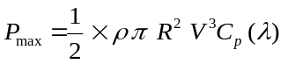 (1)
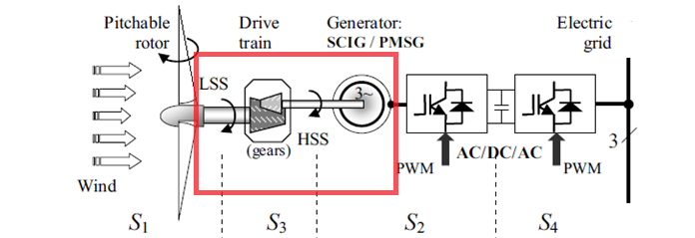
Figure 2.1 WECS system without controller
The figure shown above is that of a typical WECS system which converts input wind energy to power. In this paper, we are interested in placing the PI controller in between the rotor shaft and generator input as highlighted above.

SIMULATED RESULTS
To demonstrate the effectiveness of the proposed controller design, the following cases have been considered for simulation. The ideal power response of the system with the specified simulation parameters has been shown below.

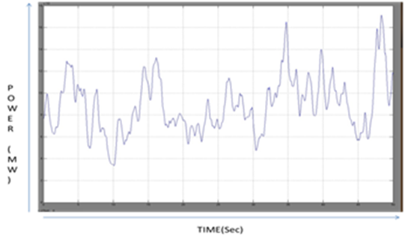
Figure 3.1 Ideal Power Response Of the system

Case 1: System Without Controller
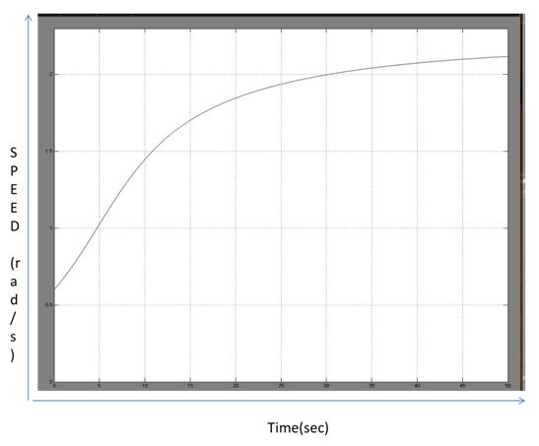
Figure 3.1 Step Response of Low Speed Shaft (L.S.S.)

As shown in the above figure, the angular speed of the low speed shaft continuously increases to 2.2 rad/sec whereas the ideal value should be 1.2444 rad/sec. Hence, we need a controller which can keep the angular speed at 1.2444 rad/sec.
The corresponding power response with turbulence in input is shown below.
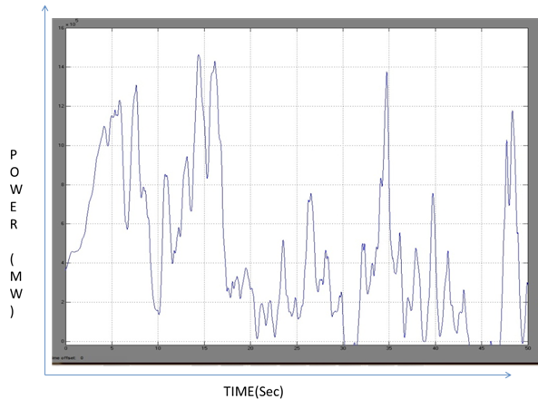
Figure 3.2 Power Response For system without controller

It is seen that average of the power output is less compared to the maximum average power which can be extracted from the wind.

Case 2: System With High value Of Proportional Gain

The controller has been designed by trial and error method where the parameters have been varied as per the data shown in Appendix C. It is observed that, power output increases with increase in the value of proportional gain. By increasing the value of proportional gain beyond a specific value, it is seen that electromagnetic torque reaches positive values as shown in figure 3.4
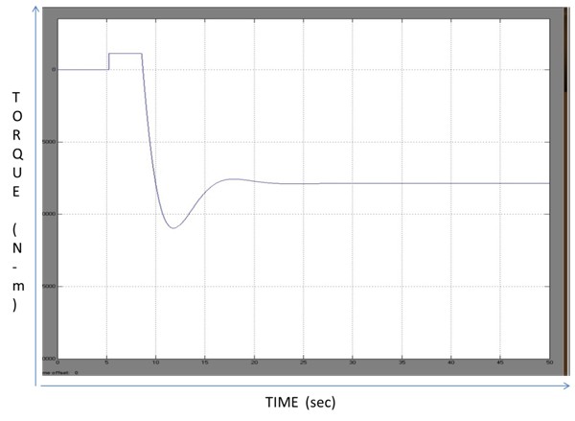
Figure 3.3 Torque Response For System with High value Of Proportional Gain [2]

The power response for the same is shown in Figure 3.5
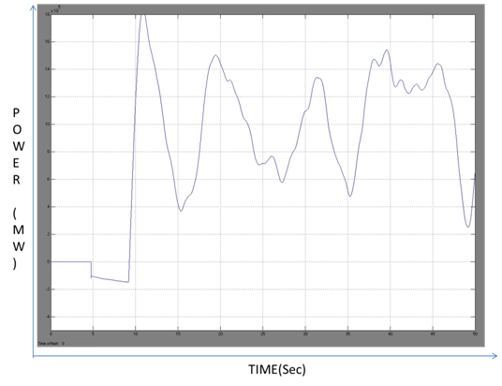

Figure 3.5 Power Response For System with High value of proportional Gain

The negative region of the Power response indicates that the generator consumes power for certain period of time, resulting in reduced power output. However we can see that the step response of the system is satisfactory as shown in Figure 3.6

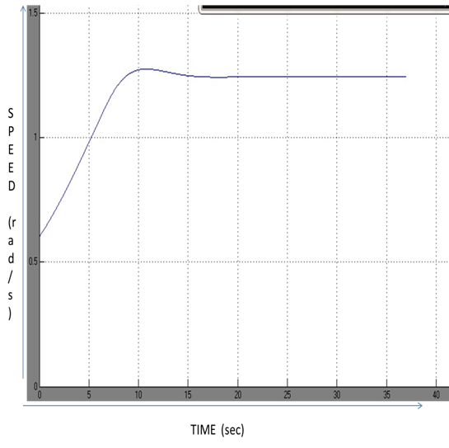
Figure 3.6 Step Response of LSS for high value of Gain

Case 3: System With proposed values Of Control Parameters
The data of the proposed controller has been shown in Appendix C. The following simulated output can be used to compare the results of the proposed controller and the previous controller.

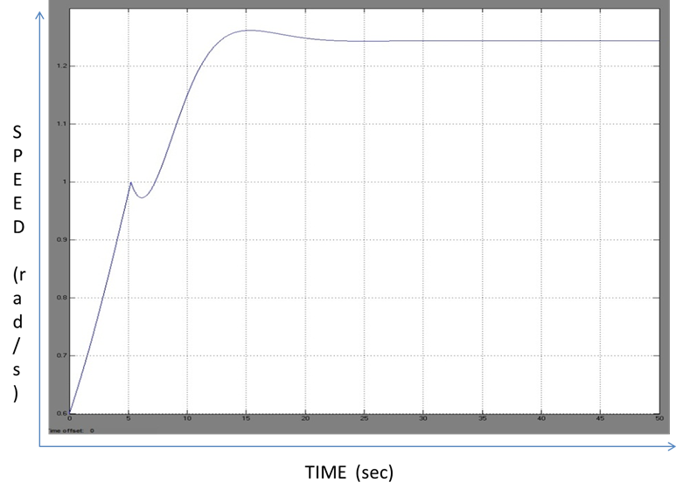
Figure 3.7 Step Response Of LSS for designed controller

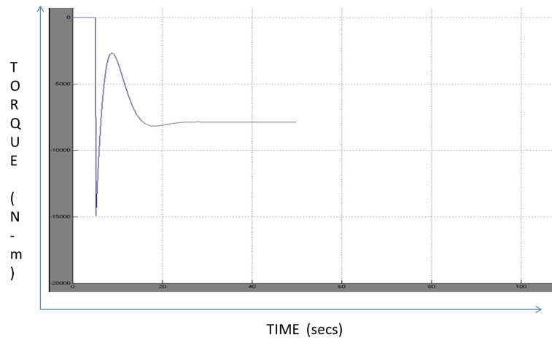
Figure 3.8 Torque Response Of System with Designed controller

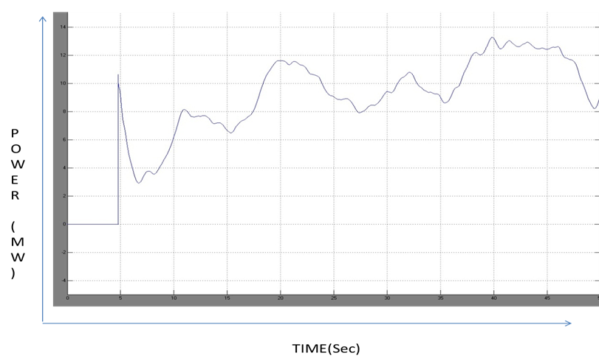
Figure 3.9 Power Response Of system with Designed Controller

simulation analysis

Table 1
CASE | Average Power (MW) | Max Theoretical Average Power  (MW) | Max Practical Average Power(MW) | Efficiency(%)
1 | 0.307 | 1.981 | 0.8915 | 15.49
2 | 0.8408 | 1.981 | 0.8915 | 42.4%
3 | 0.85458 | 1.981 | 0.8915 | 43.2%

Table 2
CASE | OUTPUT PARAMETERS
CASE | Time Taken to reach ideal speed(sec) | Time Taken to reach ideal torque (sec) | Presence Of instability in Torque characteristics
1 | N.A. | N.A. | Yes
2 | 29.10 | 38.35 | Yes
3 | 30.58 | 40.41 | No

On the basis of the data present in Table 2, it is seen that the controller with parameters defined in case 2 gives a better step response in comparison to the controller which has been proposed in this paper. However, the controller in case 2 will force the generator to operate at abnormal characteristic regimes, resulting in instability of the system for a brief moment of time. This makes the generator to operate as a motor for a brief period of time, thereby consuming power. This reduces the overall efficiency of the WECS. On the other hand, if the system uses the controller designed in this paper, it is observed that even though step response is not as good as that of case 2, there is a stable torque output from the generator. This results in smooth operation of the machine, thereby improving the performance of the WECS, The improvement in the overall efficiency of the WECS has been shown in Table 1.

conclusion
Based on the simulated results it can be concluded that the proposed controller is giving a better output efficiency of the WECS compared to the controller suggested in one of the reference papers. [2] The controller mentioned in the reference paper will give a better result than the proposed controller if the wind profile is simulated in with a negligible value of turbulence. However, in a practical WECS, the turbulence of the wind speed cannot be avoided. Considering the wind profile mentioned in Appendix A, the best of values has been discussed in this paper and the efficiency of the WECS has been improved by 0.8%. The performance has been validated using MATLAB.

REFERENCES
[1] Betz A (1926) Wind energy and its use by wind-mills (Wind-Energie und ihre Ausnutzung durch Windmühlen). Vandenhoek & Ruprecht, Göttingen

[2] Optimal Control Of Wind Energy Systems, Towards a global Approach,
Springer, 2008. 2nd Edition

[3] Akhmatov V (2003) Analysis of dynamic behaviour of electric power systems with large amount of wind power. Ph.D. Thesis, Technical University of Denmark, Denmark

[4] PID Controllers, Theory, Design and Tuning, K.Astrom and T. Hagglund,
2nd Edition

[5] Lubosny Z (2003) Wind turbine operation in electric power systems. Springer, Berlin Heidelberg New-York

[6] Hofmann W, Thieme A, Dietrich A, Stoev A (1997) Design and control of a wind power station with double fed induction generator. In: Proceedings of EPE ’97, pp 2723-2728

[7] Burton T, Sharpe D, Jenkins N, Bossanyi E (2001) Wind energy handbook. John Wiley & Sons, New-York

[8] Ekelund T (1997) Modeling and linear quadratic optimal control of wind turbines. Ph.D. Thesis, Chalmers University of Göteborg, Sweden

[9] Krause PC, Wasynczuk O, Sudhoff SD (2002) Analysis of electric machinery and drive systems, 2nd edition. Wiley-IEEE Press

APPENDIX
Appendix A
WECS Parameters:

Appendix B
Wind  Profile | Turbine  Rotor | Drive Train | SCIG
V =8m/sec  Turbulence=1.5m/sec | R = 45m  V_{n}=10.5m/sec | i = 100  J_{h}=990 | P=2,V_{s}=990V,L_{m}=5.09mH,L_{s}=5.25mH,Lr=5.25mH,  T_{max}=17e5Nm, R_{s}=4milliohm,R_{r}=4milliohm
Control Parameters Constraint
S.No | Parameter | Limit
1. | K_{p} | 200 - 700
2. |  | 0.4 – 0.75
3. | W_{n} | 0.1 rad/sec – 0.7 rad/sec
Appendix C
Parameter Value for Different Cases

Case | K_{p} |  | W_{n} (rad/s) | Peak Overshoot (%)
2 | 675 | 0.621 | 0.7 | 4.62
3 | 537.2 | 0.74 | 0.474 | 2.91

        

