Housing Dataset
Exploratory Data Analysis — Insight Summary Report
Prepared using Python (Pandas, NumPy, Matplotlib, Seaborn, scikit-learn) | July 2026
545  Records | 13  Features | 0  Missing Values | 0  Duplicate Rows

1. Overview
This report summarizes the exploratory data analysis (EDA) performed on the Housing dataset, which contains 545 property records across 13 features covering price, physical attributes (area, bedrooms, bathrooms, stories, parking), and amenities (main road access, guest room, basement, hot water heating, air conditioning, preferred area, and furnishing status).
The dataset arrived clean: no missing values and no duplicate records were found, so no imputation or de-duplication was required. Categorical yes/no fields were encoded numerically and furnishing status was one-hot encoded to support correlation and feature-importance analysis.

2. Univariate Analysis
Individual feature distributions were examined to understand the shape, spread, and typical values of each variable.
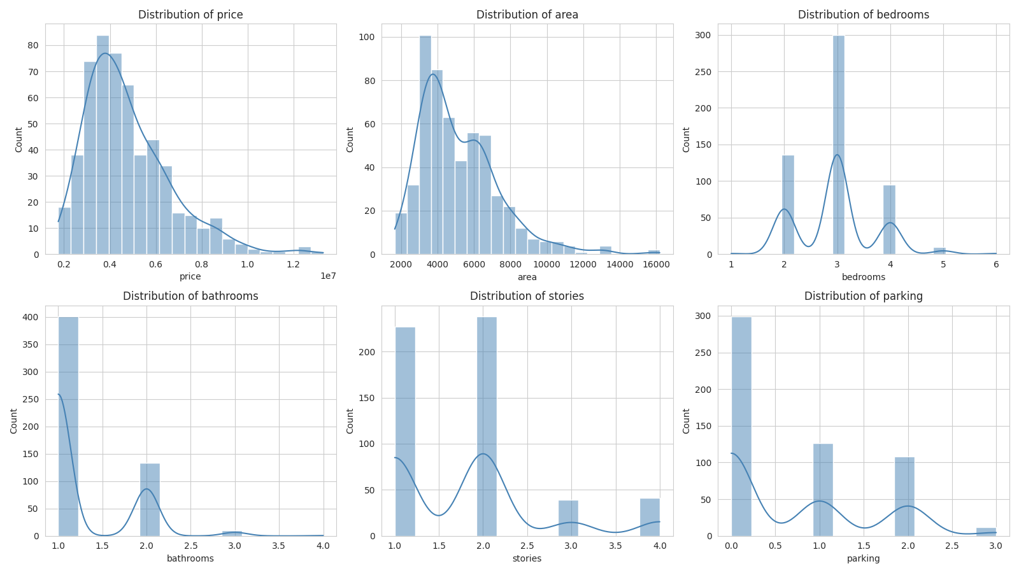
Figure 1 — Distribution of numeric features
- Price ranges from PKR 1.75M to 13.3M, with a median of ~4.34M; the distribution is right-skewed, driven by a small number of high-value properties.
- Area ranges from 1,650 to 16,200 sq ft (median ~4,600 sq ft) and is also right-skewed.
- Most homes have 2–3 bedrooms and 1 bathroom; 4+ bedroom or 2+ bathroom homes are comparatively rare.
- About 69% of listings have no dedicated parking space.
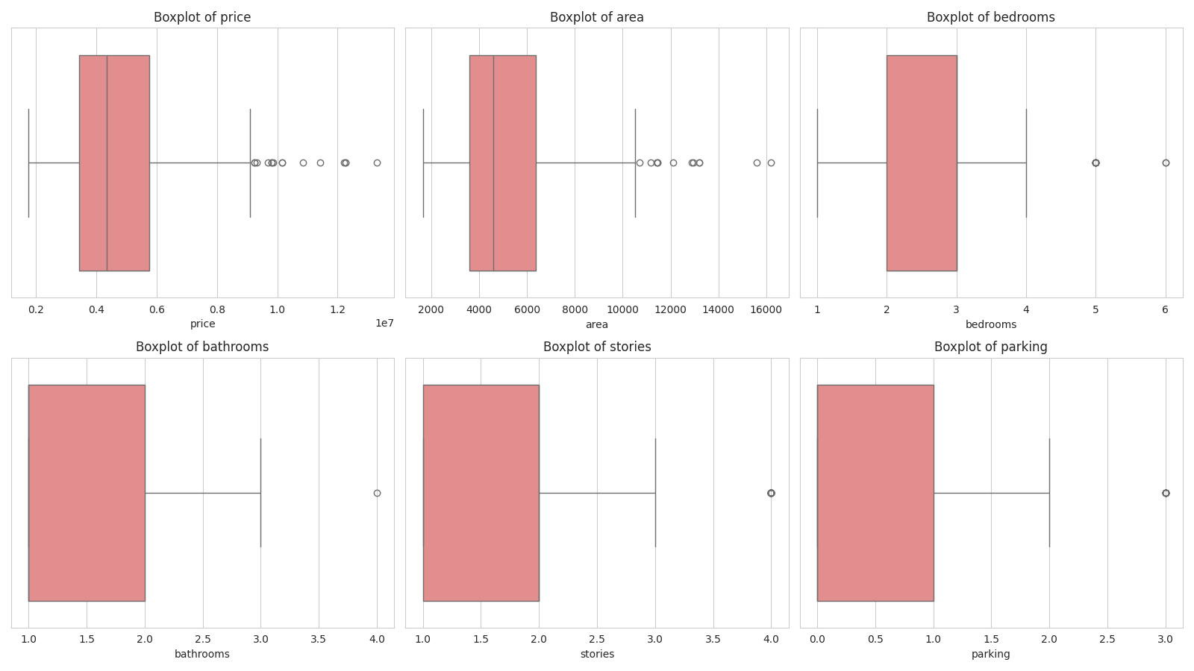
Figure 2 — Boxplots highlighting outliers in numeric features
Boxplots confirm that price and area contain the most pronounced high-end outliers, consistent with a market that includes a minority of large, premium properties.
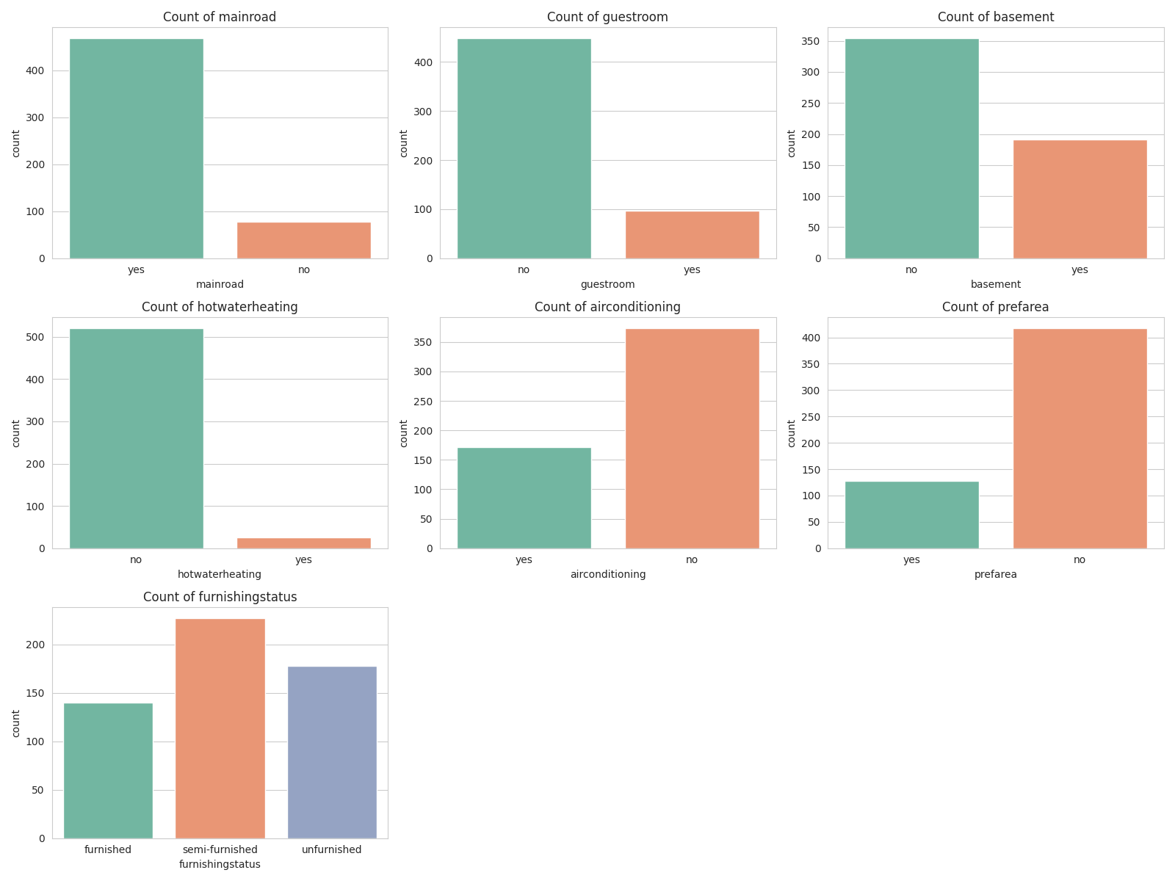
Figure 3 — Frequency counts across categorical / amenity features
- 86% of properties are on a main road; only 14% are not.
- Air conditioning is present in 32% of homes; hot water heating is rare, appearing in just 5%.
- Semi-furnished is the most common furnishing status (42%), followed by unfurnished (33%) and furnished (26%).
- Only 23% of properties sit in a “preferred area.”

3. Bivariate Analysis
Bivariate analysis explored how each feature relates to price, the target variable of interest.
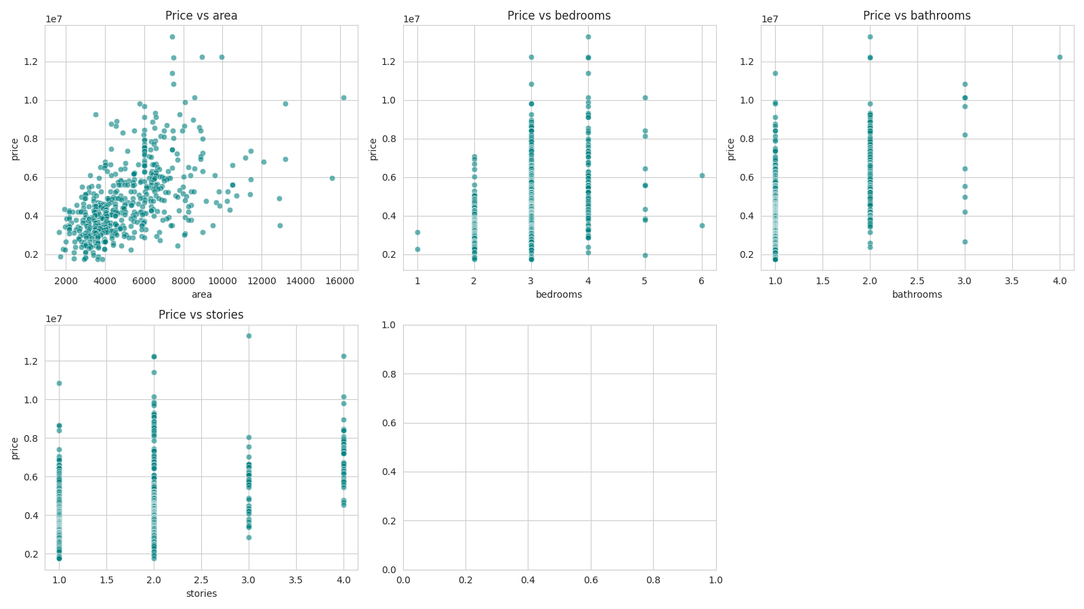
Figure 4 — Price vs. numeric features
- Area shows the clearest upward trend with price, though with meaningful scatter, indicating other factors also matter.
- Bathrooms and stories show a step-wise positive relationship: each additional bathroom or story is associated with a noticeably higher price band.
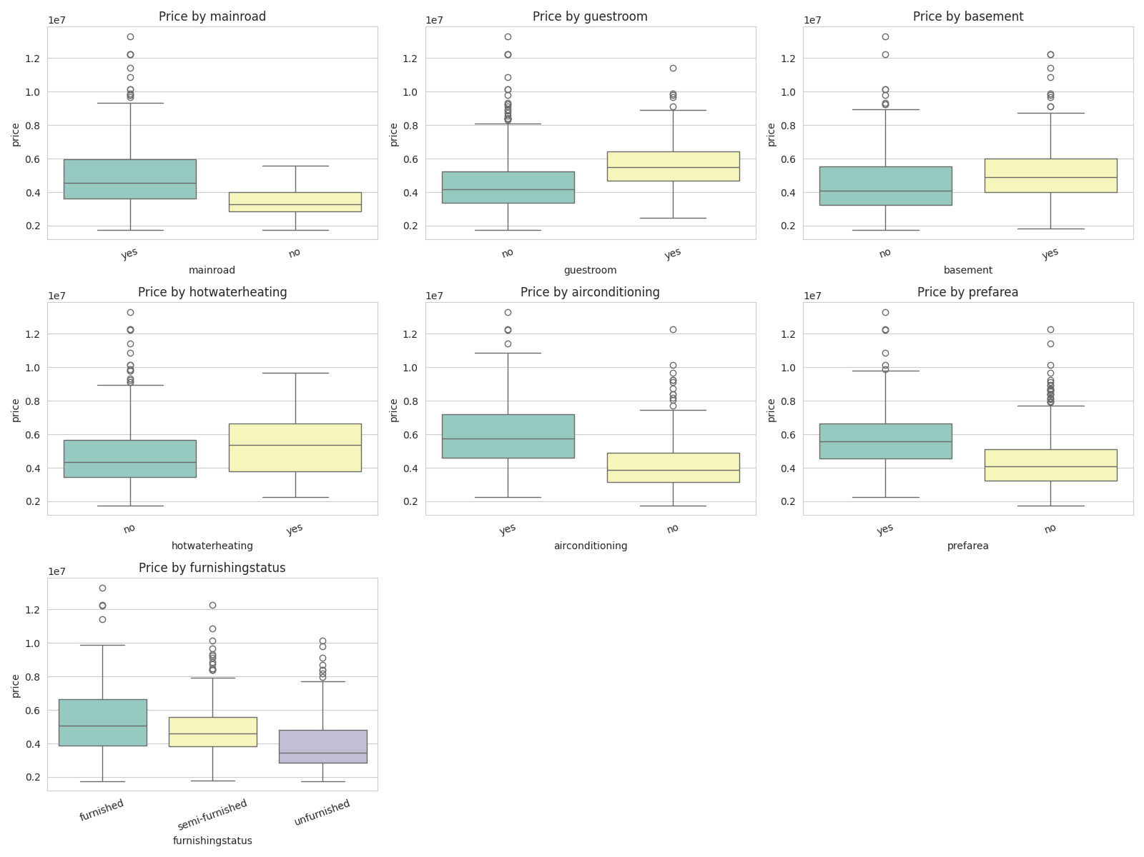
Figure 5 — Price distribution across categorical / amenity groups
- Homes with air conditioning, a basement, a guest room, or in a preferred area all show visibly higher median prices than homes without.
- Furnished homes command a modest premium over semi-furnished and unfurnished homes.
- Main road access is associated with higher prices, though the effect is less pronounced than for air conditioning or preferred area.

4. Correlation Analysis
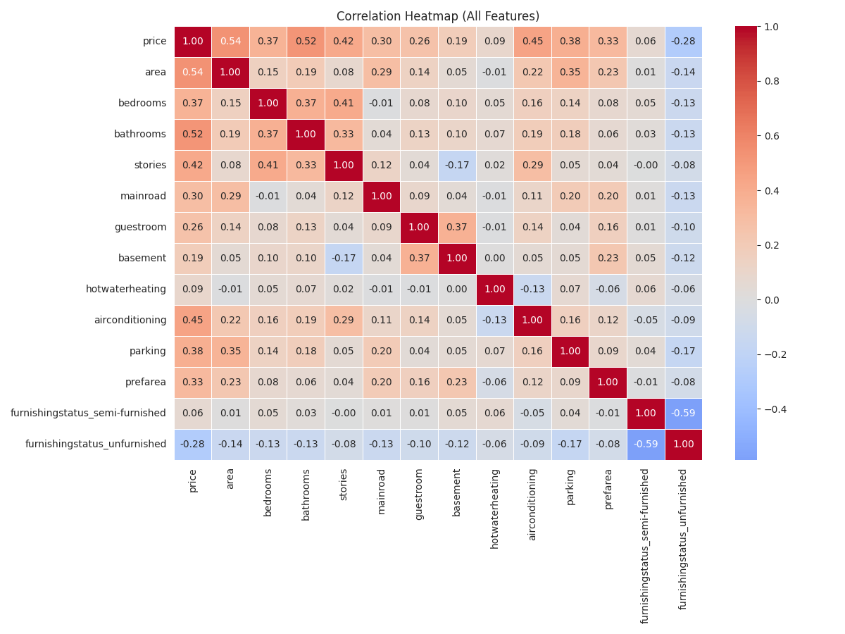
Figure 6 — Correlation heatmap across all encoded features
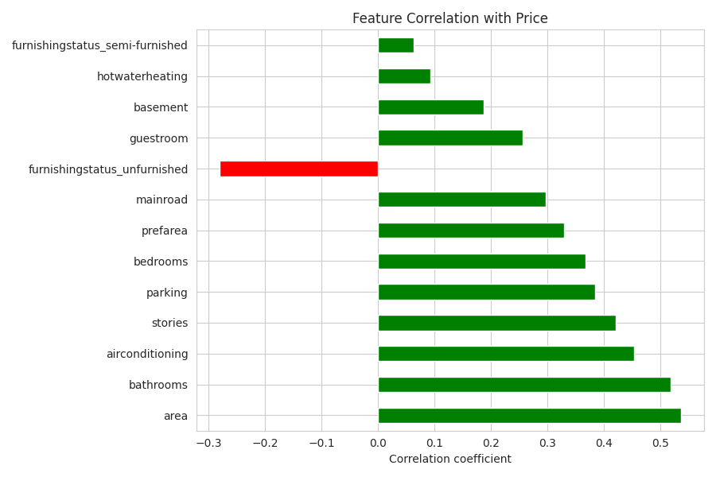
Figure 7 — Feature correlation strength with price
Correlation coefficients with price, ranked by strength:
Feature | Insight
Area | Strongest positive correlation (r ≈ 0.54) — larger properties command higher prices.
Bathrooms | Second-strongest driver (r ≈ 0.52); each extra bathroom aligns with a substantial price step-up.
Air Conditioning | Notable positive correlation (r ≈ 0.45) — a strong amenity-driven price signal.
Stories | Positive correlation (r ≈ 0.42); multi-story homes trend more expensive.
Parking | Positive correlation (r ≈ 0.38); more parking spaces align with higher prices.
Preferred Area | Positive correlation (r ≈ 0.33); location desirability adds a price premium.
Unfurnished status | Negative correlation (r ≈ -0.28) — unfurnished homes trend cheaper.
Hot Water Heating | Weak correlation (r ≈ 0.09) — minimal linear relationship with price.

5. Feature Importance
A Random Forest regressor was trained on the full feature set to rank features by their contribution to predicting price, capturing non-linear effects that correlation alone may miss.
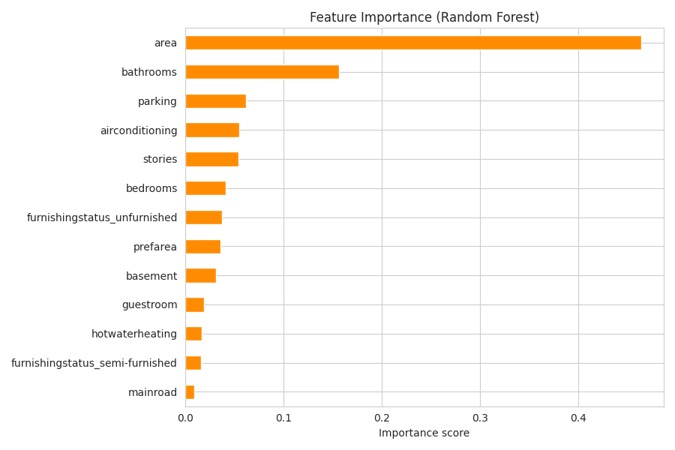
Figure 8 — Random Forest feature importance scores
- Area is by far the most influential feature (~46% of total importance), confirming its role as the primary price driver.
- Bathrooms ranks second (~16%), reinforcing the correlation findings.
- Parking, air conditioning, and stories form a secondary tier (5–6% each), each adding meaningful but smaller predictive value.
- Bedrooms, furnishing status, and preferred area contribute modestly (~2–4% each).
- Main road access and hot water heating are the least influential features (under 2% combined).

6. Key Takeaways
- Property size (area) and number of bathrooms are the two dominant, consistent drivers of price across both correlation and machine-learning-based importance analysis.
- Amenities — particularly air conditioning, parking, and additional stories — provide a secondary but meaningful uplift to price.
- Location quality (preferred area) and furnishing status have smaller, but still measurable, effects on price.
- Hot water heating and main road access show the weakest relationship with price and could be considered lower priority when modeling or when advising on renovations/marketing.
- For predictive modeling, area, bathrooms, air conditioning, stories, and parking form the core feature set to prioritize.

