E-R Diagram

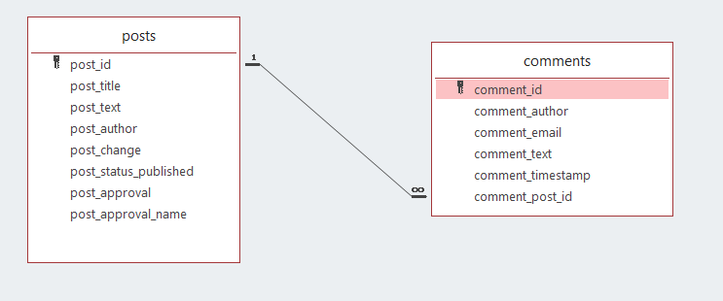

**Tables**

CREATE TABLE [dbo].[posts](

[post_id] [numeric](18, 0) IDENTITY(1,1) NOT NULL,

[post_title] [varchar](50) NULL,

[post_text] [varchar](max) NULL,

[post_author] [varchar](50) NULL,

[post_change] [datetime] NULL,

[post_status_published] [numeric](1, 0) NULL,

[post_approval] [datetime] NULL,

[post_approval_name] [varchar](50) NULL,

CONSTRAINT [PK_pots] PRIMARY KEY CLUSTERED

(

[post_id] ASC

))

CREATE TABLE [dbo].[comments](

[comment_id] [numeric](18, 0) IDENTITY(1,1) NOT NULL,

[comment_author] [varchar](50) NULL,

[comment_email] [varchar](50) NULL,

[comment_text] [varchar](500) NULL,

[comment_timestamp] [datetime] NULL,

[comment_post_id] [numeric](18, 0) NULL,

CONSTRAINT [PK_comments] PRIMARY KEY CLUSTERED

(

[comment_id] ASC

))