Emails:
Sending emails can save your documents and also allow you to open it from anywhere. To send an email you first need to be in an email app or email website(Gmail, outlook, yahoo, etc.). Once your in the app or website you will follow the following steps:
- For our school accounts you will need to be on Outlook or Microsoft website and log in using your school account email.
- Once logged in you will click “New Email”, and add the person that will receive the email in the “To” line. Example:
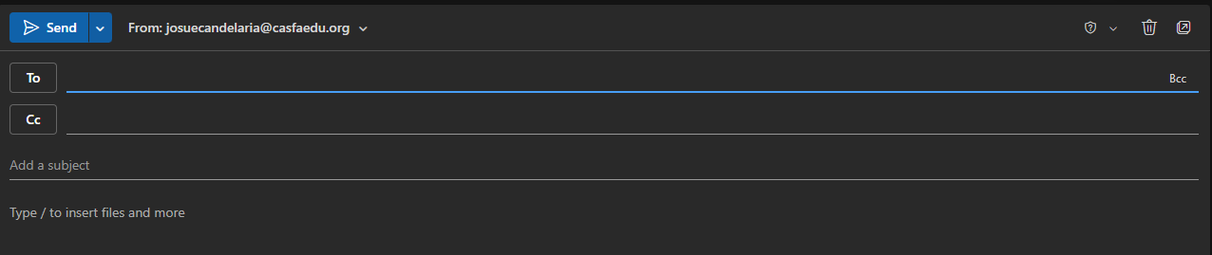

- Next you will go to “Insert” or Attach(Can look like a paperclip icon) and attach the file you are trying to send.
- In the “subject area” you can add a title to the email and in the bottom text box add any message you want to include in the email. (You can send emails without subject, message, or attachments)
Classwork: Send an email to the teacher with the subject “Test”

