TOMMY
The smart timekeeper for Toastmasters meetings
Project proposal · Hardware + software · Version 0.1 · October 2026

1. Summary
Tommy is a small physical device, paired with a phone app, that helps the Timer at a Toastmasters meeting do the job faster, more accurately and with less effort. It replaces the manual routine of coloured cards, a stopwatch and a paper log with one system that times each speaker, signals green, yellow and red lights that the whole room can see, records the exact speaking time, and produces the Timer's report automatically.
The goal is a product that other clubs will want to buy: reliable, easy to use in a real meeting, and visibly better than the traditional device (a button-and-LCD box).

2. The problem
- The Timer must juggle the stopwatch, the cards and the paper log while following a fast-moving agenda.
- Distraction is common: a speaker starts before the Timer presses Start, and the true time is lost.
- Guests in Table Topics are not on the agenda, so their names and times are written by hand.
- The Timer's report is assembled from scribbled notes and read out from memory.
- Existing devices have small displays, awkward buttons and no memory of the meeting.

3. The solution
Tommy has two parts that work together:
The device. A wedge-shaped desktop unit with two faces: a touchscreen for the Timer, and a large frosted light disc for the speaker that glows and flashes green, yellow and red.
The companion app. A web/mobile app that works as a remote control, scans the meeting agenda from a photo, and displays the final Timer's report.
The device keeps timing even if the phone disconnects. The phone adds convenience; it is never required for a speech to be timed.

3.1 Concept render
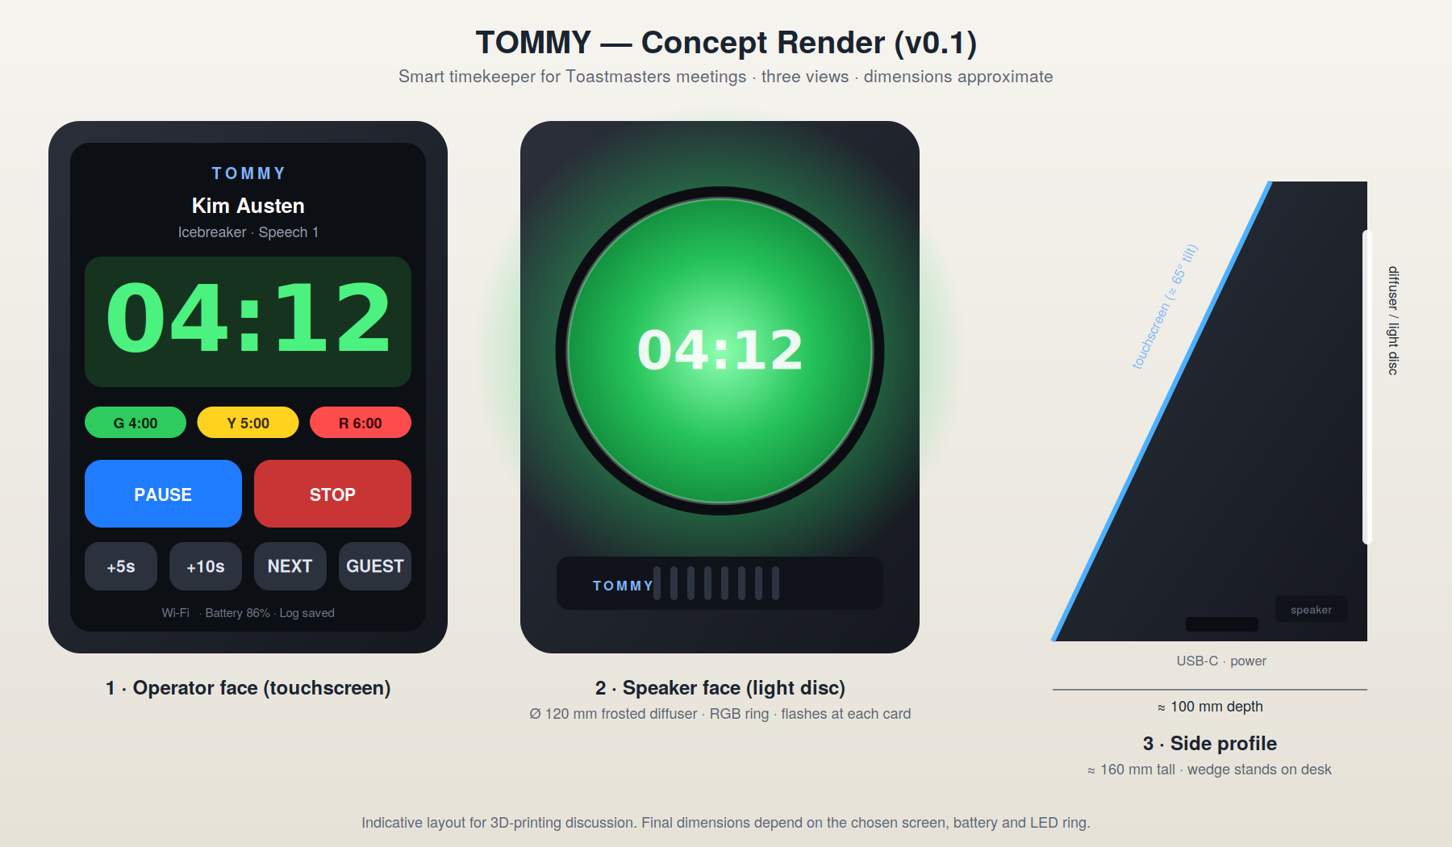
Figure 1. Operator face (left), speaker face (centre) and side profile (right). Dimensions are indicative and depend on the final components.

4. Key features

4.1 Core timing
- Preset roles with the official thresholds: Table Topics 1:00 / 1:30 / 2:00; Ice Breaker 4:00 / 5:00 / 6:00; Speech 5:00 / 6:00 / 7:00; Evaluation 2:00 / 2:30 / 3:00. All thresholds are editable.
- Green, yellow and red light on the speaker face, with a flash at each threshold, plus an optional sound or vibration.
- Optional disqualification mode: 30 seconds after red.
- Exact time stored when the Timer presses Stop (for example 7:45).

4.2 Catch-up and correction tools
- Time offset buttons (+5 s, +10 s, +30 s) so the Timer can start at the correct time when the speaker began before Start was pressed.
- Manual edit of any recorded time after the speech, with an audit note.
- Undo for accidental Start, Stop or Reset.

4.3 Agenda import
- Photograph the meeting agenda; the app reads roles, names and durations (OCR + AI) and builds the speaker queue.
- The Timer reviews and corrects the result before the meeting.
- The correct thresholds load automatically for each speaker.

4.4 Guests and Table Topics
- An Add guest button lets the Timer type or dictate a name in seconds.
- Names used before by the club are suggested to speed up entry.

4.5 Automatic Timer's report
- Every speech is logged: name, role, actual time, thresholds and within-time yes/no (rule configurable per club).
- When the Timer is called, the app shows a grouped summary by segment (Table Topics, speeches, evaluations), ready to read.
- Optional read-aloud mode: for example “Benjamin Grossier, 2 minutes 5 seconds.”
- Export to PDF in the format of the official Timer Log.

4.6 Personality and accessibility
- Short pre-recorded voice lines, such as “Hey, I’m Tommy, your Timer”, with a silent mode.
- Colour-blind friendly cues: flash patterns, on-screen text and vibration.
- Hybrid meetings: a shareable “virtual Tommy” screen for remote speakers.

5. How a meeting works
- Prepare. Before the meeting: the Timer photographs the agenda and confirms the speaker queue.
- Queue. Tommy shows the next speaker and loads the correct thresholds.
- Time. Start when the speaker begins; use +5 s / +10 s if Start was late.
- Signal. Lights change at each threshold. Stop records the exact time.
- Guests. Table Topics guests are added on the spot and timed the same way.
- Report. When called, the Timer reads or shows the generated report.

6. System architecture
Layer | Description
Device firmware | Timer state machine (ready, running, green, yellow, red, overtime), touch interface, LED control, audio, local storage of the meeting log.
Local connection | Tommy creates its own Wi-Fi access point so the phone connects directly. This avoids venue Wi-Fi that blocks device-to-device traffic. Bluetooth LE can be added later.
Companion app | Progressive web app for remote control, agenda import and report view. A native app can follow if Bluetooth is needed on iPhone.
Cloud (optional) | Agenda OCR/AI, club accounts, history and statistics, firmware updates. The core timing never depends on the cloud.

Design principle: the device is the source of truth for time. If the phone or network drops, nothing is lost.

7. Hardware components (prototype)
The list below is a starting point for discussion with the computer engineer. Prices are rough estimates in South African rand and must be verified with local suppliers.
Component | Purpose | Example | Est. cost (R)
Microcontroller with touchscreen | Main controller, Wi-Fi/Bluetooth, UI | ESP32-S3 board with 3.5–4.3 in capacitive display | 600 – 1,200
Addressable LED ring or strip | Speaker-facing light, visible from the back of a room | WS2812B ring, 24–60 LEDs | 100 – 250
Audio amplifier + speaker | Tommy’s voice and alerts | I2S amplifier (e.g. MAX98357A) + 3 W speaker | 150 – 300
Battery + charging | Cordless use during a 3-hour meeting | 2,000–3,000 mAh LiPo + USB-C charger board | 250 – 500
Vibration motor (optional) | Silent alert | Coin vibration motor | 30 – 80
Frosted acrylic diffuser | Even, bright light disc | Ø 100–120 mm, 3 mm | 100 – 250
Enclosure | Wedge body, stable on a table | 3D-printed or laser-cut | 200 – 500
Wiring, switch, connectors | Assembly | Misc. | 100 – 250
Estimated prototype total |  |  | ≈ 1,500 – 3,300

Open question for the engineer: is the ESP32-S3 the right choice for the display and LED load, and what power budget is needed for a 3-hour meeting with the display and LEDs on?

8. Software stack (proposed)
- Firmware: ESP32 (ESP-IDF or Arduino framework) with LVGL for the touch interface.
- Companion app: progressive web app (TypeScript), talking to the device over local Wi-Fi.
- Cloud services (later): agenda OCR/AI, account and club storage, export.
- Data: JSON meeting log stored on the device and mirrored on the phone.

9. Roadmap
Phase | Deliverable | Outcome
1 – Web app | Timer, speaker queue, guests, time offset, report | Used in a real meeting to validate the workflow
2 – Agenda import | Photo to speaker queue | Setup time per meeting under 2 minutes
3 – Prototype device | ESP32, touchscreen, LED ring on a bench | Working signal and timing hardware
4 – Enclosure | Two-face wedge, diffuser tested in a room | Visible from the back of the room
5 – Connected system | Local Wi-Fi link between device and phone | Remote control and live report
6 – Voice and polish | Voice lines, accessibility, PDF export | Pilot-ready unit
7 – Pilot | 3–10 units in several clubs | Feedback and purchase intent

10. Market and business
- Toastmasters clubs exist worldwide, and each meeting needs a timer.
- Possible model: hardware sold as a unit or kit, plus an optional subscription for agenda import, history and statistics.
- Validate first: confirm that at least five clubs would pay before investing in production.

Brand and permissions
The club president has given informal agreement to this project. Before any commercial sale, written permission should be obtained, and the Toastmasters name and logo must not be used on a sold product without authorisation from Toastmasters International or the district. The product name and branding should work independently (“Tommy”).

11. Risks
Risk | Mitigation
Poor visibility in bright or large rooms | Test diffuser and LED brightness in a real venue; allow a larger or second light unit.
Agenda OCR mistakes | Always show an editable review screen before the meeting.
Venue Wi-Fi restrictions | Tommy creates its own Wi-Fi; the device works with no network.
Battery runs out mid-meeting | Size the battery for 4 hours; show battery level; support USB-C power while in use.
Branding and licensing | Obtain written permission; keep an independent product brand.

12. Next steps
- Review. Review this proposal with the computer engineer and agree on the component list.
- Validate. Build and test the web app in a live meeting (no hardware cost).
- Prototype. Order prototype components and assemble the bench version.
- Enclosure. Design the enclosure for 3D printing using the concept render as the starting point.

