Sales & Operations · Framework Definition · v1 Draft
The Control Tower Framework
Five modules, each defined by one question a decision-maker actually asks during the month. Every module carries the same four layers — KPIs for what the position is, alerts for what needs attention, insights for what the pattern says, and actions for what to do about it, tested by simulation before it is committed. The modules are not independent dashboards: they form a closed loop, and the loop is the product.

BASIS  Discovery sessions, 21 Aug 2026 | TRACKS  Commercial & Credit · Sales & S&OP | STATUS  For review before build

1. The loop
Both tracks described their own segment of a single circulating problem. Month-end deal pressure lands on discount approval; approval delay pushes out retail; delayed retail delays the claim; the blocked claim exhausts the dealer’s funding; the funding block stops billing — and the volume that started the cycle is lost. No participant can currently see more than their own arc.
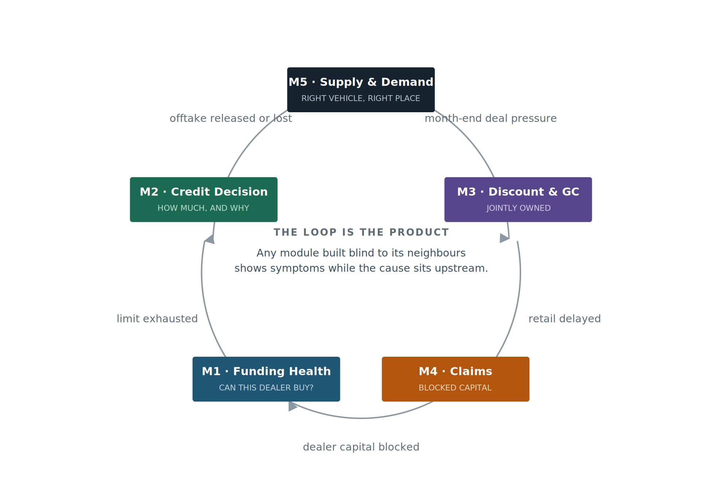
Read clockwise. The chain is causal, not sequential reporting — each arc is a delay that becomes someone else’s constraint.

2. Module map
Five modules over four shared objects, resolving upward into one number the business recognises: vehicles at risk against the plan.
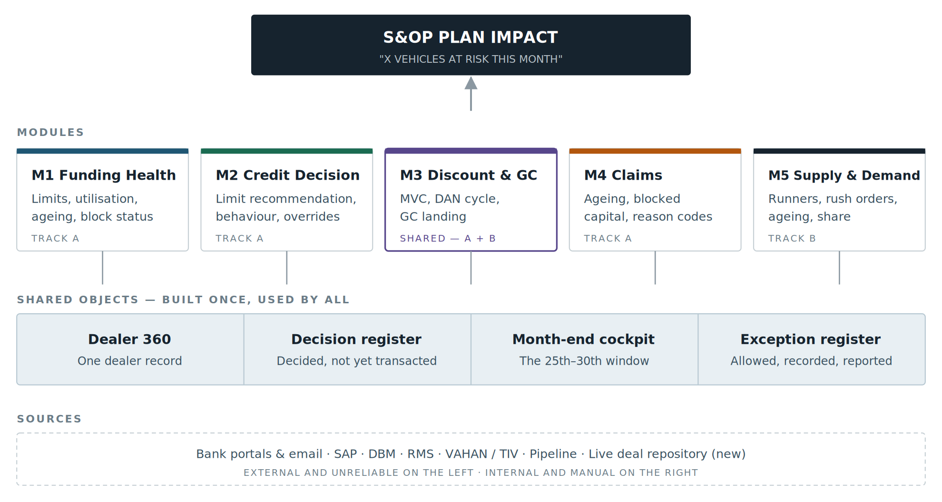

3. The modules
Each module states the question it answers, then its four layers. Targets and baselines are held separately in the KPI-per-persona workbook — this document defines what is measured, not yet the numbers.
M1 · Funding Health
Dealer Funding Health
Can this dealer take a vehicle today, and for how much longer?
Owner: Commercial & Credit | Refresh: intraday during month-end

Pain points today
▪ Limit and utilisation data arrives as per-bank emails, each in its own format at fixed frequency.
▪ No single view of a dealer across banks, verticals and systems
▪
▪ Blocks are discovered after the offtake is already lost. Information comes from banks on block and then it flows to SAP HANA
▪ Even under top-down, which bank to draw from stays a manual call
Sign off against ABP.

Key performance indicators
▪ Sanction limit, utilised and free limit.(How to confirm if he is not misusing). Can we get the bank to inform if he is using the funds to buy another vehicle brand?).  ▪ Limit utilisation % — dealer and portfolio  ▪ Fund deployment gap % ---  ▪ Dealers blocked — count and value | ▪ Dealers at risk within the tenor window  ▪ Stock ageing over 90 days — units and value  ▪ Vehicles at risk against plan

Alerts  ▪ Tenor breach approaching — T-15 days – Can we predict?  ▪ Utilisation crossing RAG threshold  ▪ Deployment gap beyond tolerance — timing or leakage  ▪ Dealer blocked → notify vertical with unit impact  ▪ Ageing over 90 days where a limit request is pending | Insights  ▪ Deployment gap trend per dealer  ▪ Exposure concentration by financier  ▪ Dealerwatch list - repeatedly at the tenor edge  ▪  Insights on who is providing better GM by better mix

Actions
▪ Trigger a limit review directly from the alert
▪

Replaces — per-bank email compilation and the 27th–28th spreadsheet. Delivers a single cross-vertical exposure view per dealer.

M2 · Credit Decision
Credit Decision Intelligence
How much limit should this dealer get, and can I defend it?
Owner: Commercial & Credit | Refresh: on request, with live consumption

Pain points today
▪ No formula or defensible logic for setting a limit — the number is judgement alone
▪ Dealer payment behaviour is captured nowhere, so risk cannot be evidenced
▪ Decided vs loaded vs consumed is not monitorable; portfolio aggregates do not reconcile
▪
▪ All are unsecured overrides are neither logged nor aggregated. there is a no collateral available. Dealer faltered? Data Analytics - - use to not issue the credit?
▪ Sales pressure on exceptions arrives with no data available to answer it
- There is no mechanism to monitor the performance against the credit limit.

Key performance indicators
▪ Decided vs loaded vs consumed vs free limit  ▪ Limit requested vs granted  ▪ Payment behaviour — committed vs actual days to pay | ▪ Unsecured overrides — count and value  ▪ Utilisation against granted limit  ▪ Credit decision turnaround time

Alerts  ▪ Limit request pending beyond SLA  ▪ Granted limit nearing exhaustion  ▪ Overrides breaching threshold within a period.. Highlighting to the executives.  ▪ Limit transfer executed without source reversal  ▪ Dealer entering red behaviour category | Insights  ▪ Dealer report card — behaviour, historical limit vs actual billing, ageing, override history  ▪ Dealers consistently granted more than they consume  ▪ Risk categorisation with contributing factors  Interest Vs CD..

Actions
▪ Simulate a proposed limit against exposure, ageing and behaviour before approving
▪ Issue a recommendation with a mandatory reason string
▪ Reallocate limit as a true move, with reversal enforced at source
▪

New measurement — payment behaviour exists in no system today. It must be constructed from email commitments and payment records, and everything defensible about the recommendation rests on it.

M5 · Supply & Demand
Supply & Demand Execution
Am I building and placing the right vehicles, in the right place, at the right time?
Owner: Sales vertical + Central planning | Refresh: mixed — see note

Pain points today
▪ Neither rush order nor indent reduction exists as a formal process
▪ Rush orders are raised with no pipeline entry; the dealer often cannot name the end customer
▪
▪ A rush order and a reduction for the same fort arrive on the same day, after the plant commitment has gone
▪ ~50% of strangers and repeaters built remain in stock; (need to verify)
▪ Allocation to RSM is manual with no underlying logic
▪ Market share analysis is a manual Excel-to-PPT chain; losses registered ~10 days late
▪ Marketing spend of ~₹1 crore a month is planned in Excel, with no ROI view
- The impact of accepted deals on the MVC/GC during month end is a challenge.

Key performance indicators
▪ Runner availability — weighted average  ▪ Rush order as % of committed supply  ▪ Committed supply adherence  ▪ Stranger rush order offtake  ▪ Ageing stock over 180 days | ▪ Strangers and repeaters built, still in stock  ▪ 1A vs 1B variation — runners only  ▪ Market share by state and district  ▪ Projected volume against plan

Alerts  ▪ Stranger rush order raised with a dry pipeline  ▪ Enquiry cluster matching aged stock — dealer or plant FG  ▪ Indent reduction against an existing plant commitment  ▪ Projected to land below plan  ▪ Runner availability below threshold on the 1st  ▪ Ageing crossing 180 days, or older model year | Insights  ▪ Placed vs supplied vs offtaken, by RSM  ▪ Why 40% of ageing is runner stock — open anomaly  ▪ Loss analysis — cases lost, to whom, top reasons  ▪ Winner and loser movement, drilled to district  ▪ MDM similar-fort mapping — what substitutes for what  ▪ Marketing spend against share gap

Actions
▪ Release, hold or alert a rush order at entry, with classification and pipeline shown
▪
▪ Trigger liquidation - When enquiries for a given FERT cluster above a threshold, match that demand against aged stock sitting at a dealer or in plant finished goods
▪ Move the Aging -- Adjust indent; initiate inter-dealer transfer
▪ Direct marketing spend to weak markets
MVC/Deal simulation — given a GC floor, which open deals to approve (repeat)

Cadence warning — runner availability is monthly by definition; rush order and ageing metrics are daily.

M3 · SHARED — TRACK A + B
Discount & Gross Contribution
What will GC land at, and which deals should I approve to hold it?
Owner: Finance (GC & Profitability) + Sales vertical | Refresh: daily, T−1 moving to T−2 hrs; monthly for offtake and GC bridge
Updated following the GC & Profitability session with Finance, 3 September 2026.

Pain points today
▪ In-month projected GC does not exist — Ayush: "that part is missing." Targets and actuals are tracked; the landing point is not
▪ Blocked on real-time material cost inflation — derived monthly from COPA on historical trend; needs plant finance participation
▪ Offtake discount is provisioned, not actual — P&L is struck on offtake while the discount reflection is retail-driven
▪ Approvers see this deal’s GC, not the cumulative effect on the month’s position
▪ No benchmark at approval time — approver cannot see last month’s average discount for that region
▪ Rolling 12-month FERT-wise NTP trend is manual Excel, on request
▪ Sharp NTP movements are investigated manually, after the fact
▪ Prior GC improvement targets (₹10–20k/vehicle) lapsed — never held against market reality.. Were there negative GC? What is the control – approval authority – which should be approved at the highest level – What threshold?

Key performance indicators  ▪ NTP and NTP variance — daily, chassis level, sliceable to FERT / MPG / model / segment / region  ▪ MVC (Marketing Variable Cost) variance — the discount movement  ▪ Net realisable value to VECV — NTP less dealer margin, cash discount, DSC, resale, telematics, financier incentives  ▪ GC actual vs BP target — monthly and YTD | ▪ Projected GC for the month (new)  ▪ GC bridge — price, discount, material inflation, technical changes, product mix  ▪ DAN approval cycle time and conversion

Alerts  ▪ Projected GC trending below BP target — before month close  ▪ Sharp NTP decline between two reporting points (the 25th-to-27th case)  ▪ Pipeline deal that would breach the GC floor if approved  ▪ Material cost inflation landing above forecast  ▪ Alert logic must be configurable, not hardcoded — parameters change month to month | Insights  ▪ GC movement decomposed — price, discount, inflation, technical change, mix  ▪ NTP parity across India 1 / India 2 / region / dealer type  ▪ Extraordinary events explaining a two-day GC swing  ▪ Rolling 12-month FERT-wise NTP trend, automated  ▪ DAN realisation — approved versus actually retailed

Actions
▪ Simulated GC at DAN approval — not just this deal’s GC, but the cumulative effect on the month’s landing (converges with Keshav’s identical ask)
▪ Show regional average discount benchmark at the point of approval
▪ Approve, counter or defer a deal against the projected landing position
▪ Reinstate GC improvement targets, checked at approval

What already exists
Chassis-level daily dump; Udaan Analytics daily NTP MIS; GC calculator already integrated into DAN approval; monthly GC bridge; BP targets at month / model / segment / vertical. Offtake automation ~10–15 days from completion, in parallel-run testing.
Build implication: M3 is smaller than originally scoped. The data granularity and the DAN-time GC calculator already exist — real scope is projection and surfacing, not construction. The single blocker is plant finance participation on real-time material cost inflation.

Definitions confirmed in session
MVC | Marketing Variable Cost — it is simply the discount, nothing more
NTP | Net Transaction Price = MRP − discount. The primary KPI, and the only element sales controls
NTP vs NRV | NTP is the price to customer; net realisable value to VECV is NTP less dealer margin, cash discount and all incentives. GC is built off NRV, not NTP
DAN | Deviation Approval Note — termed a deviation rather than a discount for Competition Act reasons

M4 · Claims
Claims & Blocked Capital
Whose money is stuck, for how long, and what is it costing downstream?
Owner: Commercial | Refresh: daily

Pain points today
▪ Claim cycle runs 30–100 days, with roughly 10% of retail value blocked
▪
▪ Registration papers depend on the customer; dealers often lodge 1–1.5 months after retail
▪ Money received is not reconciled invoice-by-invoice against offtake
▪ The downstream funding consequence of a claim delay is invisible to both tracks

Key performance indicators
▪ Blocked capital as % of retail value  ▪ Claims lodged vs not lodged, against retail  ▪ Approved / pending approval / pending concept | ▪ Days to clear — distribution, not average  ▪ Claim ageing buckets  ▪ Advance released vs balance pending

Alerts  ▪ Claim ageing past threshold  ▪ Blocked on a named document — bank statement, GSTR window, RC papers  ▪ Claim delay about to trigger a funding block — fires into M1  ▪ Dealer holding lodged-but-unsubmitted claims | Insights  ▪ Reason codes ranked — what actually blocks clearance  ▪ Dealers with chronic documentation lag  ▪ Blocked capital concentration by region and dealer  ▪ Correlation between claim delay and later limit exhaustion

Actions
▪ Escalate on the specific blocking document
▪ Flag to M1 where claim delay is becoming a funding risk
▪ Release balance payment on document receipt

Closes the loop. This is the module that feeds back into M1 — and the one neither track was watching.

4. Cross-functional
Only where a measure, alert or action genuinely spans modules. These are the items that fail if the modules are built as separate dashboards — everything else stays inside its module.
KPIs that span modules
M1 + M5 | Vehicles at risk against plan — the common language for every alert
M4 → M1 | Blocked capital converting into funding blocks
M3 + M5 | Projected GC landing against projected volume
M2 + M3 | Decision-to-transaction lag, across limits and deals

Alerts that cross
M4 → M1 | Claim delay about to exhaust a dealer’s limit
M1 → M5 | Dealer blocked — vertical notified with unit impact
M3 → M5 | Pending DANs will breach the GC floor if all convert
M5 → M2 | Rush order for a dealer with no funding headroom

Actions that cross
M3 + M5 | Defer a retail — GC protected, volume impact stated
M2 + M1 | Override granted with exposure simulated first
M5 + M1 | Liquidation directed to dealers with free limit

5. Shared objects
Built once. If these are duplicated per module, the modules will disagree with each other within a quarter.
Dealer 360  ALL MODULES | One dealer record — funding, stock, ageing, outstanding, payment behaviour, block status. Serves the credit decision and the “can this dealer even take the vehicle” question equally.
Decision register  M2 · M3 · M5 | Commitments made but not yet transacted — decided limits, live deals, placed indents. The object every simulation runs against, and the gap both tracks independently described.
Month-end cockpit  ALL MODULES | The 25th to 30th window, where both tracks are currently blind and where credit exceptions, DAN approvals, rush orders and deal negotiations all peak at once.
Exception register  M2 · M5 | Overrides, dry-pipeline rush orders, deferred retails. Allowed, recorded, attributed, reported — the mechanism that carries the weight a hard lock is not yet carrying.
Plan impact translator  ALL MODULES | Converts every alert into vehicles at risk. Without it each module speaks its own dialect, and leadership cannot compare a funding block against a supply shortfall.

6. Design principles
Carried directly from the sessions. Both rooms arrived at the first two independently, which is why they are stated once here rather than rediscovered per module.
01  Alert first, lock later  Allow the exception, record it, make it reportable. Hard locks only once the system has earned trust. | 02  Every number drills through  Both leaders rejected the aggregate on sight. A headline with no constituents will not be used.

03  Cadence follows definition  A monthly KPI shown daily is noise. State the refresh rate alongside every measure. | 04  Persona determines view  Same KPI, different formula and refresh by role. A VP wants the 5,000 units, not runner availability.

05  Reason strings are mandatory  A recommendation that cannot be defended in a room will not survive contact with one. | 06  Measure only what is controllable  Variation KPIs apply to runners; strangers are market-driven. Accountability without control is ignored.

7. Settle before building
Three decisions gate the rest
Each changes the shape of the build rather than its size. Deciding them late means rework, not delay.
1. Does the tower execute, or recommend and hand off? Whether actions write back to SAP and DBM determines integration effort, approval design and the audit position. Unresolved in both sessions.
2. Will the live deal repository actually be fed? It is manual by necessity. M3’s entire action layer rests on people entering deals during negotiation, and no incentive currently exists for them to do so.
3. Who sees the dealer risk category? One track will use it to argue for exposure, the other to argue against. Visibility is a deliberate choice, not a default.

Prepared from discovery session transcripts, 21 August 2026 · Commercial & Credit and Sales & S&OP tracks · All measures require source-system validation before use in specification.

