

Mulesoft Monitor
Specification
Version 0.2.201709

Author
Joaquin Osvaldo Rodriguez

Introduction
Mulesoft has requested the implementation of a software system, or application, as a final requirement for consideration in the job application process. The application is required to query and provide data about the Java virtual machine to third party application programming interfaces, or APIs, for queuing and visualizing data. Furthermore, the application must expose a RESTful interface, which can be managed via JMX.

Scope
This specification document is intended for engineers and managers evaluating the engineering process of Joaquin Rodriguez. It is designed to capture an analysis of requirements

Overview
This document is decomposed into Requirements, Design, and Implementation. The Requirements section specifies and analysis functional and non-functional requirements for the design of Monitor. Design specifies the architecture and system requirements imposed by design decisions. Implementation outlines guidance regarding installation, configuration, use, and maintenance of the application.

Requirements
Implement a Java application that queries Java Management Extensions, or JMX, for values corresponding to a specified list of attributes. Then format the attributes and values and send them to InfluxDB, a service that queues time-series data.

Function
ID | Statement | Priority | Status | Date
F01 | Must Query All SupportedJMXBean.java Class Enums | 0 | In Place | 20170923
F02 | Must listen on post 8080 for HTTP Requests | 0 | In Place | 20170924
F03 | Must Write JMXBean data to InfluxDB | 0 | In Place | 20170924

Interface
Interface requirements are systems that the application must interface with.

ID | Statement | Priority | Status | Date
I01 | Must interface with InfluxData InfluxDB | 0 | In Place | 20170923
I02 | Must depend on SupportedJMXBean.java Class | 0 | In Plaace | 20170924

InfluxData InfluxDB
InfluxDB is a time-series database that provides a RESTful interface for reading and writing data. Monitor must write data to InfluxDB with respect to time.

Grafana
Grafana is a web application that provides graphing capabilities for existing data source providers such InfluxDB. Grafana does not interface with Monitor. However, Grafana must be used to display data written to InfluxDB by Monitor.

SupportedJMXBean.java
A Java Enum Class written by Walter Poch. All of the Enum names correspond to values which can be obtained via JMX and stored in InfluxDB. Monitor must query values for all the Enum names declared in the Java class file.

Design
The design of Monitor is decomposed into Architecture and System. Architecture provides a view of Monitor that describes the implementation for engineers. System specifies software systems that are required for the implementation of Monitor that are based on design decisions.

Architecture
Monitor is composed of two threads which conform to different sides the client-server model. A Client thread is used to iteratively query and write data to an instance of InfluxDB.

Client
Monitor is composed of a Client thread

System
The following software systems are used in the implementation of Monitor.

Software

SpringBoot

Josvaldor Module
Module is a software system that provides out-of-the-box thread-safe communication multi-threaded modules, based on Linus modules.

Implementation
An implementation of Monitor is a usable instantiation of the application which can be provided to end-users for testing and production use. The following sections

Requirements
The implementation of Monitor is dependent on several software systems which must be installed and configured correctly to satisfy all applicable requirements.
Operating System | Ubuntu 16.04
Applications | Java Runtime Environment Version 8, Docker, Git

Guide
Guidance is provided for the implementation of Monitor to get started with data access and visualization quickly. This guide covers everything from where to get monitor to who can help you if you run into a maintenance issue with the application.

Distribution
The distribution of monitor is managed via Github.
$git clone https://github.com/josvaldor/monitor.git

Installation
The installation of Monitor is accompanied by the installation of Grafana and InfluxDB in Docker containers. This approach is adopted for ease of use in deployment.

Monitor
$ cd monitor
$ ./install.sh

Grafana
$ docker run -d --name=grafana -p 3000:3000 grafana/grafana

InfluxDB
$ docker run -d --name=influxdb -p 8086:8086 influxdb

Configuration

Grafana
InfluxDB Data Source
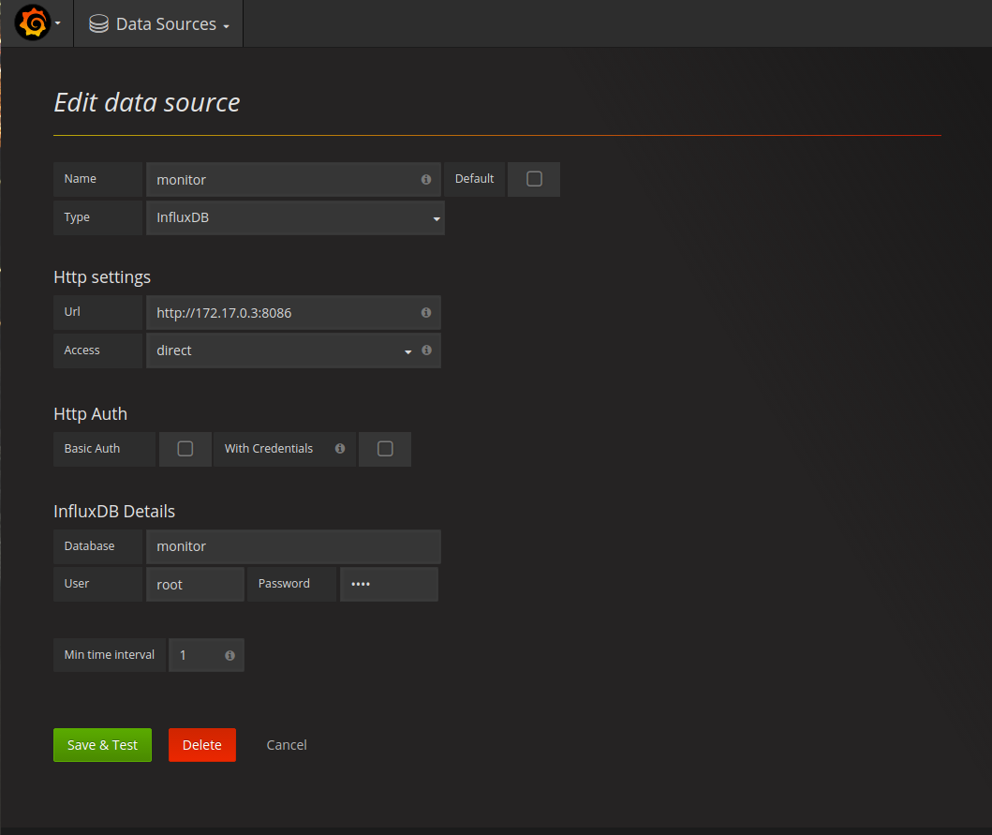

Use

Maintenance

