BASIC LINUX COMMANDS

AIM

To implement basic linux commands.

COMMANDS

Command 1 : pwd
pwd - print name of current/working directory
Syntax - pwd
Output :

Command 2 : ls
ls - list directory contents
Syntax – ls
Output :

Options :
-a, --all
do not ignore entries starting with .

-A, --almost-all
do not list implied . and ..

--author
with -l, print the author of each file

-b, --escape
print C-style escapes for nongraphic characters

--block-size=SIZE
with -l, scale sizes by SIZE when printing them; e.g., '--block- size=M'; see SIZE format below

-B, --ignore-backups
do not list implied entries ending with ~

-c with -lt: sort by, and show, ctime (time of last modification of file status information); with -l: show ctime and sort by
name; otherwise: sort by ctime, newest first

-C list entries by columns

--color[=WHEN]
colorize the output; WHEN can be 'always' (default if omitted), 'auto', or 'never'; more info below

-d, --directory
list directories themselves, not their contents

-D, --dired
generate output designed for Emacs' dired mode

-f do not sort, enable -aU, disable -ls --color

ect...

Command 3 : cd
cd - Used to go to a particular directory which is present in the current directory
Syntax - cd [Directory name] (to go the specified directory)
cd / (to go to root directory)
cd ~ (to go to home directory)
cd .. (to move to the parent directory of current directory)
Output :
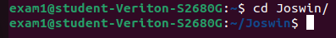

Command 4 : echo
echo - display a line of text
Syntax – echo “text to display”
Output :

Command 5 : mkdir
mkdir - make directories
Syntax – mkdir [directory name] (to make a specified directory)
Output :
Options :
-m, --mode=MODE
set file mode (as in chmod), not a=rwx - umask

-p, --parents
no error if existing, make parent directories as needed

-v, --verbose
print a message for each created directory

-Z set SELinux security context of each created directory to the default type

--context[=CTX]
like -Z, or if CTX is specified then set the SELinux or SMACK security context to CTX

--help display this help and exit

--version
output version information and exit

Command 6 : date
date - print or set the system date and time
Syntax – date
Output :
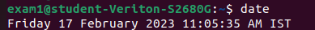

Command 7 : touch
touch - change file timestamps
Syntax – touch
Output :
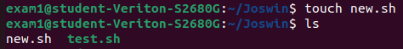

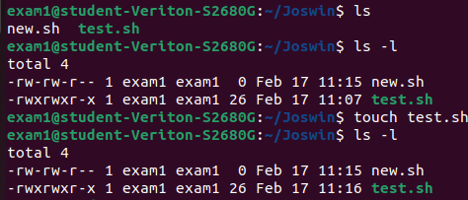

Command 8 : history
history - GNU History Library
Syntax – history
Output :
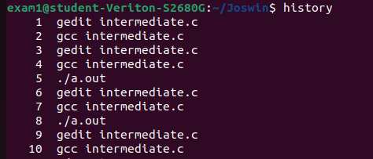

Command 9 : nano
nano - Nano's ANOther editor, inspired by Pico
Syntax – nano [file name]
Output :
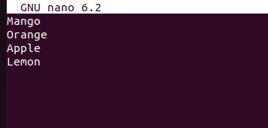

Command 10 : cat
cat - concatenate files and print on the standard output
Syntax - cat [file name]
- cat [file1 name] [file2 name]
Output :
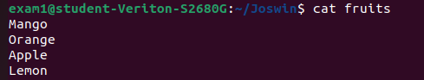

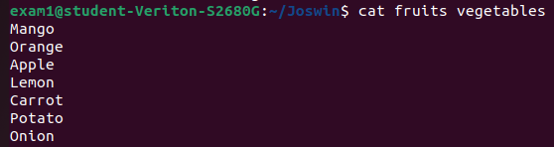

Command 11 : uname
uname - print system information
Syntax – uname
uname -a
Output :

Command 12 : whoami
whoami - print effective userid
Syntax – whoami
Output :

Command 13 : cp
cp - copy files and directories
Syntax – cp [source file name] [destination file name]
Output :
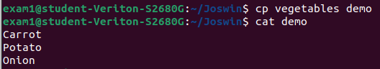

Command 14 : rm
rm - remove files or directories
Syntax – rm [file name]
Output :
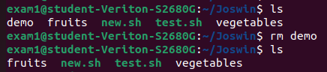

Command 15 : rmdir
rmdir - remove empty directories
Syntax – rmdir [directory name]
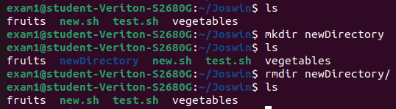

Command 16 : clear
clear - clear the terminal screen
Syntax – clear

Command 17 : man
man - an interface to the system reference manuals
Syntax – man [command name]
Output :
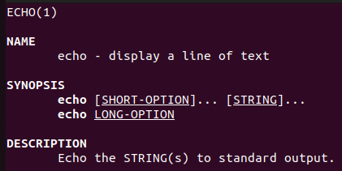

Command 17 : psudo (super user do)
psudo – If you want any command to be done with administrative or root privilages
Syntax – psudo [command name]

