SHELL PROGRAMMING

PROGRAM 1

echo Enter the name :
read name
echo Enter the semester :
read semester
echo Enter the batch :
read batch
echo Enter the roll number :
read rollno
echo Enter the registeration number :
read regno
echo "$name $semester $batch $rollno $regno"

OUTPUT
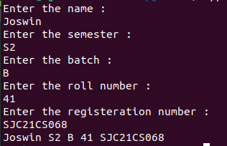

PROGRAM 2

echo Enter number one :
read num1
echo Enter number two :
read num2
echo $num1 + $num2 = $(($num1+$num2))

OUTPUT

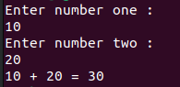

PROGRAM 3

echo Enter the first number :
read num1
echo Enter the second number :
read num2

if(($num1>$num2))
then
echo Biggest is $num1
else
echo Biggest is $num2
fi

OUTPUT

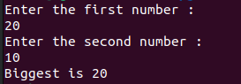

PROGRAM 4

echo Enter the limit :
read n

echo The first $n natural number is :
for((i=1; i<=n; i++))
do
echo $i
done

OUTPUT

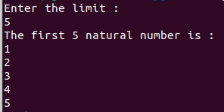

PROGRAM 5

echo Enter the number :
read n
fact=1

for((i=1; i<=n; i++))
do
fact=$((fact*i))
done

echo The factorial is $fact

OUTPUT

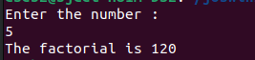

PROGRAM 6

echo Enter the limit
read n

a=0
b=1

echo The first $n fibonacci numbers :
for((i=1; i<=n; i++))
do
c=$((a+b))
echo $a
a=$b
b=$c
done

OUTPUT

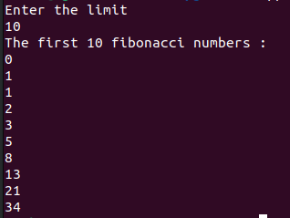

PROGRAM 7

echo "Enter the first number : "
read n1
echo "Enter the second number : "
read n2
echo "1) ADDITION
2) SUBTRACTION
3) MULTIPLICATION
4) DIVISION
Choose the operation : "
read op

case $op in
1) echo THE SUM IS $(($n1+$n2));;
2) echo THE DIFFERENCE IS $(($n1-$n2));;
3) echo THE PRODUCT IS $(($n1*$n2));;
4) echo THE QUOTIENT IS $(($n1/$n2));;
*) echo Wrong choice;;
esac

OUTPUT

