NBP REPORT

30 years of the Neighborhood Bird Project

June 2025

Table of Contents

GLOSSARY 3

Executive Summary 4

Neighborhood Bird Project 5

Parks 6

Carkeek Park 8

Cheasty Greenspace 10

Discovery Park 12

Genesee Park 14

Golden Gardens Park 16

Lake Forest Park 18

Lincoln Park: 20

Magnuson Park 22

Seward Park 23

Washington Park Arboretum 25

Species Spotlights 27

Anna’s Hummingbird 27

Dark-eyed Junco 27

Methods, Sources, Credits, and Acknowledgements 27

# Glossary

First-order Jackknife estimate of species richness

Shannon diversity index

Species richness

# Executive Summary

One page

# Neighborhood Bird Project

#### Birding with a Purpose

Seattle in 1994. Peak grunge and pre-tech.

2 page spread with map and information about each of the active NBP locations

## Parks

### Carkeek Park

Overview: Carkeek Park packs a lot of habitat diversity into a relatively small area. Mixed evergreen and deciduous forests with large trees protected from logging due to the steep topography of the ravines. Riparian corridors and wetlands that drain into Puget Sound. Carkeek has been surveyed continuously since the start of the NBP, with some disruption during emergency COVID response.

#### Diversity measures

Species richness

Shannon

->No significant trend detected

**Individual trends**

**Strongest increases**

**Strongest Declines**

#### Management conditions and challenges:

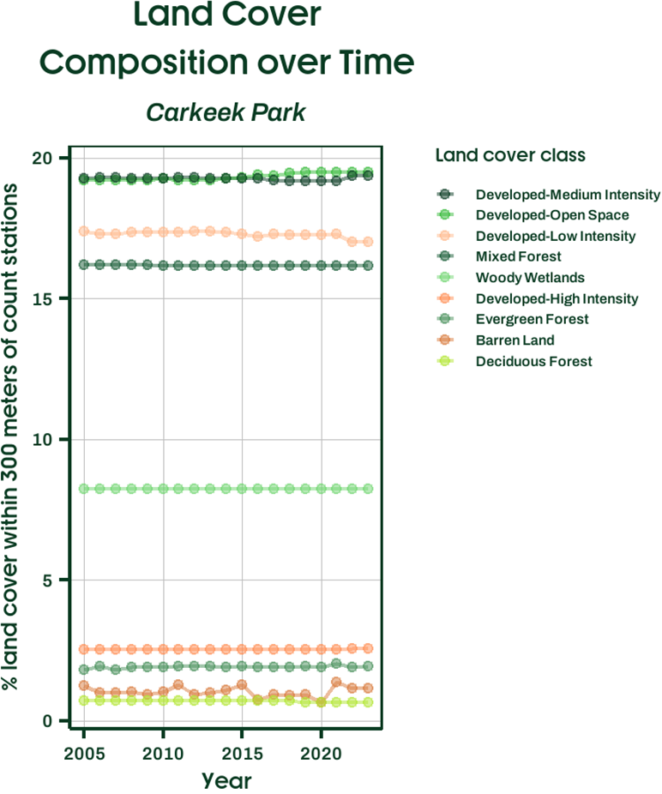

### Cheasty Greenspace

Feature:

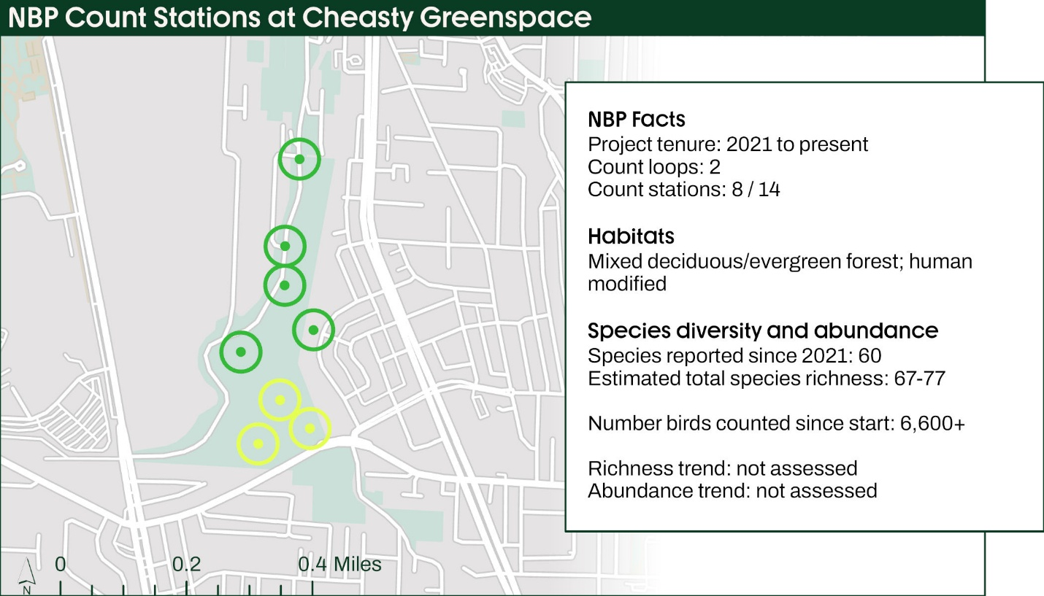

### Discovery Park

Feature: Ravens and Crows

Park area

Habitats

### Genesee Park

Feature:

Park area:

Habitats:

### Golden Gardens Park

Feature: Seabirds

Habitats: Evergreen forest; coasts; saltwater; urban

Golden Gardens is the longest running Neighborhood Bird Project site.

### Lake Forest Park

Feature: Backyard Birds

### Lincoln Park:

Park area:

Habitats: Forest; Woodlands; Coasts; Saltwater; Urban edges

### Magnuson Park

Feature: Wetland species

Local Extirpation of birds like bullock’s oriole.

### Seward Park

Feature: Forest birds

### Washington Park Arboretum

Park area:

Habitats: Mixed deciduous / evergreen forest;

## Species Spotlights

### Anna’s Hummingbird

### Dark-eyed Junco

Average monthly counts increased by 488%from 2005 to 2023.

Fastest growth occurred at Discovery Park and Golden Gardens.

# Methods, Sources, Credits, and Acknowledgements

Nick, Daniel, Joeseph

Birds Connect Seattle Science Committee: Peter Hodum, Ph.D; Paul Meijer, Ph.D., Melissa Mark, Ph.D; Jack DeLap, Ph.D.; Maya Groner, Ph.D

Birds Connect Seattle Conservation Committee: Jean Trent; Kersti Muul; Kim McCormick, Ph.D.; Emily Knudsen; Michele Murphy; Martha Baskin; Sandy Shettler; Melissa Mark, Ph.D.; Sara Rocero; Anna Vallery