# Modelling and Simulation of a Combined Cycle Power Plant

By

**Ale, T. O. 1 and Orukotan, A. S.2**

Electrical and Electronics Engineering Department

Federal University of Technology

Akure, Ondo State, Nigeria

1E-mail: [toale@futa.edu.ng](mailto:toale@futa.edu.ng) 2E-mail: [orukotanayomikun@yahoo.com](mailto:orukotanayomikun@yahoo.com)

1Phone number: +234803-368-1227 2Phone number: +2347061926514

# Abstract

Gas turbines are so important for the generation of electric power in Nigeria. Most interestingly, gas turbines can be used in a combined cycle mode. Critical to this, is the use of the heat content of the flue gas which is the major waste of the gas turbine. This paper therefore put forward a method and develops the model of a Combined Cycle Power Plant (CCPP) using MATLAB / Simulink. However, the Rowen’s model which serves as a bedrock to power system studies was modified to develop a gas turbine system while the steam turbine which is a part of CCPP was conversely modelled using the causal technique (transfer function derivations), and even the three term control designs were incorporated to the CCPP system to ensure stability and the results obtained will be adequately discussed later in this paper.

# Keywords:

# 1. Introduction

Over the years, the power sector in Nigeria has had to grapple with one of the prerequisite for any nation’s development, which is large availability of electric power. One of the cogent demand placed on it as a society is to increase electric power but it has been discovered that the demand for electricity is higher than its aggregate supply. No doubt, this is an economic imbalance that has remained in a state of disequilibrium. This paper is concerned with this unpleasant development and it therefore portends that industrial waste can be used to solve the problems of power in Nigeria. Hence, adopting the technology of Combined Cycle power system can become a necessary and sufficient remedy to power insufficiency and even unavailability in Nigeria. Therefore, the simulation of the CCPP is of utmost interest to be able to study the behaviour of the power system under various conditions.

# 2. Systematic Modelling of a Combined Cycle Power Plant

A combined cycle power plant is a combo of a brayton cycle and rankine cycle power plants. These two cycles combined in one single cycle (Single shaft) is used to produce more electric power compared to conventional gas turbines. Besides, the main components of a CCPP are the gas turbine, Heat Recovery Steam Generator (HRSG) and the steam turbine. However, the intention of this paper is to modify the widely labelled Rowen’s model as backbone for development of most CCPP models in recent years. Also, the transfer function of the HRSG will be derived and the other components that make up the rankine cycle power plant. In subsequent lines, the systematic modelling of a combined cycle power plant will be presented.

## 2.1 Gas Turbine Model

In general, Gas turbine power plant consists of four major components which are the Compressor, Combustion Chamber (CC), turbine and the generator. These components are highly important in the modelling of a Gas Turbine Power Plant (GTPP). As the modelling approach of this research work, static components which reflect the steady-state input-output relationships of fundamental physical variables were obtained by some detailed input-output analysis. In the work of Rowen, he modelled the GTPP with suitable transfer functions representing these components under some basic assumptions.

## 2.2 Modelling of Heat Recovery Steam Generator (HRSG)

An HRSG is sometimes referred to as a boiler. Boiler is a part of the power plant that generates super-heated steam. However, to model a boiler, two germane thing must be considered. First, it is expedient to realize the mathematical model which automatically represents a storing element, thereby inducing an important delay of the output signal. Second, the determination of the mathematical model of the boiler control system which, from the point of view of automation, is a chain of proportionally integrating and proportionally derivative elements with multiple delays and limitations.

However, considering the mass balance between the feed water flow rate and steam flow rate, the pressure variation process is described approximately through the differential equation as shown in equation 1:

$$Ta \frac{dPt}{dt}=Dq-D ; (1)$$

Where,

Dq is the Boiler Thermal Load,

D is the Steam Load and

Ta is the Accumulation Constant

To calculate the boiler inertia time, equation 2 is used

$$Tp=Ta\frac{Ptn}{Dmax} (2)$$

Hence, equation 2 becomes $Ta=Tp \frac{Dmax}{Ptn} ;$

Substituting Ta into equation 1 gives;

$$Tp \frac{Dmax}{Ptn} \frac{dPt}{dt}=Dq-D ; (3)$$

If these are used in per units related to the boiler nominal values, then, steam load,

$D=d and it becomes Pt and Dq=dq.$

Hence, the equation 3 becomes

$$Tp\frac{dPt}{dt}=dq-\dot{m_{t}}-Pt (4)$$

Where,

$dq$ is the boiler thermal load in per unit

$\dot{m_{t}}$ is the steam flow rate in per unit

Equation (4) allows the representation of the steam generator through a transfer function having a first order delay.

Introducing the operational operator, $s= \frac{d}{dt}$ the transfer function is given as equation 5

$$Hc=\frac{1}{1+s.Tp} (5)$$

For modern boilers, $Tp=\frac{125}{300}=0.42;$

$$∴Hc= \frac{1}{1+0.42s} (6)$$

## 2.3 Modelling of the Synchronous Generator

The intention of this section is to discuss the theoretical model of a synchronous generator appropriate for simulations in the time-domain and model-based control design. In modelling cases, it is assumed that all synchronous generators have the same representations. They only differ with respect to some model parameters. Therefore, since the round-rotor synchronous generator is a distinct case of a salient-pole rotor synchronous generator, the latter only will be treated for an arbitrary number of pole-pairs.

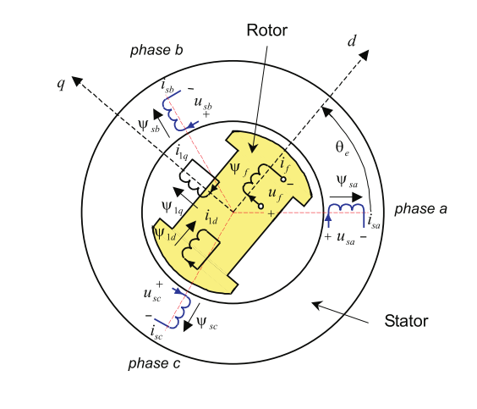

**Figure 2.1:** Schematic representation of an elementary three-phase, two pole synchronous generator

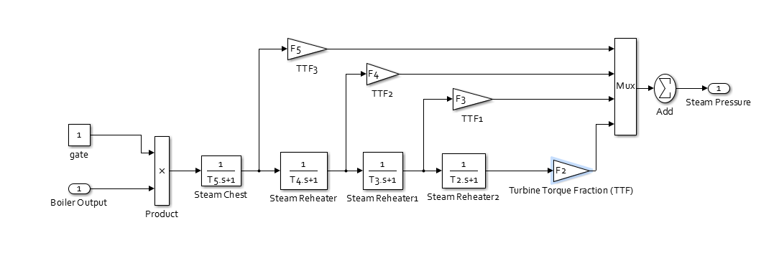

**Figure 2.2:** The Overall Steam Turbine System

Park (1933) postulated that the voltage equations of the ideal synchronous generator (linear magnetic circuit and stator windings are sinusoidal distributed along the stator circumference) in the $d_{q}$ reference frame are given by (generator sign convention are used for the stator circuits):

$$u_{d }={-R}_{s }i_{d}- ω_{e}ψ_{q}- \frac{d}{dt}ψ_{d } (2.5)$$

$$u_{q}= {-R}_{s }i_{q}+ ω_{e}ψ_{d}- \frac{d}{dt}ψ_{q } (2.6)$$

$$- u_{f}= {-R}_{f }i_{f}- \frac{d}{dt}ψ_{f } (2.7)$$

Where,

$$u_{d } is the direct-axis voltage \left[V\right]$$

$$R_{s }is the stator winding resistance \left[ Ω\right]$$

$$i_{d} is the direct-axis current \left[A\right]$$

$$ω_{e}= \frac{dθ_{e}}{dt} [rad/s]$$

$$=is the electrical angular frequency$$

$ψ_{q }i$*s the quadrature – axis winding flux [Vs]*

$$t is the time[s]$$

$$ψ_{d } is the direct-axis winding ﬂux [Vs]$$

$$u_{q} is the quadrature-axis voltage \left[V\right]$$

$$i_{q} is the quadrature-axis current [A]$$

$$u_{f} is the ﬁeld winding voltage \left[V\right]$$

$$R_{f }is the ﬁeld winding resistance [Ω]$$

$$i_{f} is the ﬁeldwinding current [A]$$

$$and ψ_{f } is the ﬁeld windingﬂux\left[Vs\right].$$

The equation (1), (2), (3) above are coupled via the fluxes and it also depends on the electrical angular frequency, $ω_{e}$. However, this in the large introduces non-linearities. The fluxes are shown below:

$$Φ_{d}\left(s\right)=L_{do}\left(s\right)I_{d}\left(s\right)+L_{dfo}\left(s\right)I_{f}\left(s\right) (2.8)$$

$$Φ_{f}\left(s\right)=L_{fdo}\left(s\right)I_{d}\left(s\right)+L_{fo}\left(s\right)I_{f}\left(s\right) ; (2.9)$$

$$Φ_{q}\left(s\right)=L_{q}\left(s\right)I_{q}\left(s\right) ; (2.10)$$

$$s is the laplace operator and$$

$$L_{do}\left(s\right), L_{fdo}\left(s\right)= L_{fo}\left(s\right), L_{dfo}\left(s\right), L_{q}\left(s\right)$$

*for $proper transferfunctions.$*

The dynamic behaviour of an ideal synchronous generator is described by the sets of equationsstated above and clearly expressed in the $d_{q }$ reference frame. In simulations carried out in the time-domain, it is convenient to rewrite the ﬁrst set of equations in the following form:

$$ψ_{d}= - \int{( u_{d}}+R_{s}i_{d}+ ω_{e}ψ_{q}) dt (2.11)$$

$$ψ_{q}= - \int{( u_{q}}+ R_{s}i_{q}- ω_{e}ψ_{d}) dt (2.12)$$

$$ψ_{f}=\int{(}u_{f}+ R_{f}i_{f}) dt (2.13)$$

Taking the ﬂuxes as state variables, the aforementioned rotor ﬂux equations can be suitably expressed as a matrix system as shown below:

$$\left[ \begin{matrix}Φ_{d} \\ Φ_{f}\end{matrix}\right]=\left[\begin{matrix}L_{do}\left(s\right) & L_{fdo}\left(s\right) \\ L_{fdo}\left(s\right) & L_{fo}\left(s\right)\end{matrix}\right] . \left[\begin{matrix}I_{d} \\ I_{f}\end{matrix}\right]$$

It is easy to show that the inverse transformation is in the form of:

$$\left[\begin{matrix}I_{d} \\ I_{f}\end{matrix}\right]= \left[\begin{matrix}L_{fo}\left(s\right) & -L_{fdo}\left(s\right) \\ L_{fdo}\left(s\right) & L_{do}\left(s\right)\end{matrix}\right] . \left[ \begin{matrix}Φ_{d} \\ Φ_{f}\end{matrix}\right]$$

Where:

$L_{fo}\left(s\right),$ $L_{fdo}\left(s\right), L_{do}\left(s\right) and L_{dfo}\left(s\right) are$

$$identical .$$

In line with the foregoing, for an ideal synchronous generator, the dynamic behaviour of its quadrature-axis is fully described by the transfer function.

$$Y_{d}\left(s\right)= -\left[\frac{I_{q} \left(s\right)}{u_{q}\left(s\right)}\right]=\left[\frac{1}{( R_{s }+s. Lq(s)}\right] (2.14)$$

For the identiﬁcation of $Y_{d}\left(s\right),$ knowledge of the quadrature axis voltage $u_{q}\left(t\right)$ and current $i_{q}\left(t\right)$ are both necessary and sufﬁcient.

Assuming: $R_{s}=1Ω and Lq=0.1 H;$

$$∴ Y_{d}\left(s\right)=\left[ \frac{1}{1+0.1 s}\right] 2.15)$$

## 2.4 Modelling of the steam Turbine

The steam turbine has four different stages, each stage modelled by a first-order transfer function. The first stage represents the steam chest while the three other stages represent either re-heaters or crossover piping. Moreover, Fractions F2 to F5 represented with gain blocks as shown in the diagram below are used to distribute the turbine power to the various shaft stages.

**Table 1:** The Steam Turbine Parameters and Values

|  |  |  |  |  |
| --- | --- | --- | --- | --- |
| $$Turbine Torque Fractions$$ | $$F_{2}$$ | $$F_{3}$$ | $$F_{4}$$ | $$F_{5}$$ |
| $$Fraction Values$$ | $$0.5$$ | $$0.5$$ | $$0.6$$ | $$0.8$$ |
| $$Steam Turbine Time Constant$$ | $$T_{2}$$ | $$T_{3}$$ | $$T_{4}$$ | $$T_{5}$$ |
| $$Constant Values (Seconds)$$ | $$0.3$$ | $$10$$ | $$10$$ | $$0.5$$ |

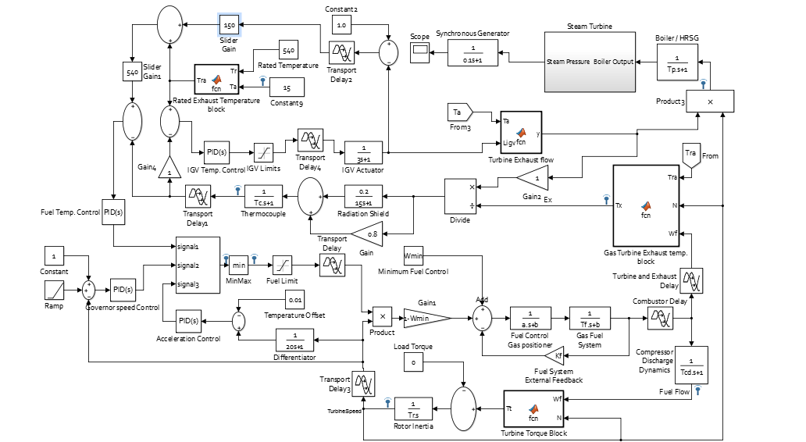

**Figure 2.3: The Combined Cycle Power Plant Model**

**Table 2:** Parameter Values for the Gas Turbine Model

|  |  |  |  |
| --- | --- | --- | --- |
| **Parameters** | **Description** | **Values** | **Unit** |
| $$a$$ | $$Valve Positioner Time Constant$$ | $$0.05$$ | $$Seconds$$ |
| $$b$$ | $$Fuel System Transfer function coefficient$$ | $$1$$ | ---------- |
| $$T_{f}$$ | $$Fuel system Time Constant$$ | $$0.4$$ | $$Seconds$$ |
| $$T_{r}$$ | $$Rotor Inertia Time Constant$$ | $$18.5$$ | $$Seconds$$ |
| $$T_{c}$$ | $$Thermocouple Time Constant$$ | $$2.5$$ | $$Seconds$$ |
| $$T_{cd}$$ | $$Compressor discharge volume time constant$$ | $$0.2$$ | $$Seconds$$ |
| $$K_{f}$$ | $$Fuel System External Feedback$$ | $$0$$ | $$pu$$ |
| $$W_{min}$$ | $$Minimum Fuel Flow$$ | $$0.23$$ | $$pu$$ |
| $$E_{CR}$$ | $$Combustor Reaction Time Delay$$ | $$0.01$$ | $$Seconds$$ |
| $$E_{TD}$$ | $$Turbine and Exhaust Delay$$ | $$0.04$$ | $$Seconds$$ |
| $$T_{TD}$$ | $$Transport Delay$$ | $$0.125$$ | $$Seconds$$ |
| $${Max}_{F}$$ | $$Fuel demand signal upper Limit$$ | $$1.0$$ | $$pu$$ |
| $${Min}_{F}$$ | $$Fuel demand signal lower Limit$$ | $$0.15$$ | $$pu$$ |
| $$IGVmax$$ | $$IGV demand signal upper limit$$ | $$1.2566$$ | $$pu$$ |
| $$IGVmin$$ | $$IGV demand signal lower limit$$ | $$0.6109$$ | $$pu$$ |
| $$T_{p}$$ | $$Boiler Inertia Time Constant$$ | $$0.42$$ | $$Seconds$$ |
| $$Tt$$ | $$Tt=[1.3 \left(Wf-0.23\right)+ 0.5 \left(1-N\right)$$ | --------- | ----------- |
| $$Tx$$ | $$Tx=\left[Tra-3.9 \left(1-Wf\right)+ 3.1 \left(1-N\right)\right]$$ | --------- | $$℃$$ |
| $$Tra$$ | $$Tra=Tr-0.6 \left(15-Ta\right)$$ | --------- | $$℃$$ |
| $$Wx$$ | $$Wx=N*\left[\frac{519}{\left(Ta+460\right)} \right]*{\left(Ligv\right)}^{0.2567}$$ | --------- |  |

# Source: Rowen’s Mathematical Analysis

# 3. Results & Discussion



**Figure 3.1:** The effect of Inlet Guide Vane (IGV) position on turbine speed

Air flow is regulated by the Inlet Guide Vanes (IGV) and is also a function of ambient air temperature, ambient pressure, and turbine speed. Apparent nonlinearity in the speed dependency of airflow was observed. On this graph dependency of airflow to the turbine speed and IGV angle was clearly seen.

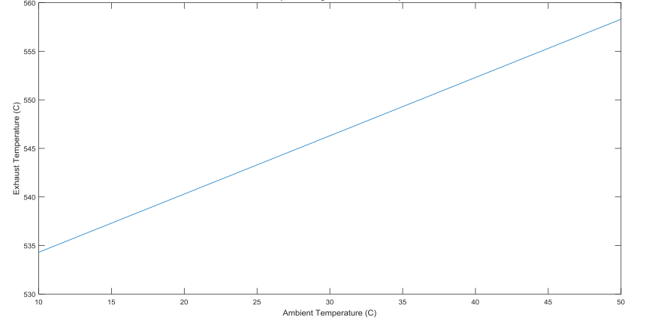

**Figure 3.2:** Ambient Temperature versus Exhaust Temperature

If there is one thing that will affect the efficiency of the modelled system, it depends greatly on the ambient conditions. From the result obtained, it shows that an increase in the ambient temperature of the system leads to a more proportionate increase in the exhaust temperature. In fact, the efficiency of the system is reduced at high ambient temperature.



**Figure 3.3:** The relationship between fuel flow and output power

From basic intuition, it is easy to say that output power of a gas turbine unit is directly proportional to input fuel flow and nothing else. This assumed claim was evidently proven from the apparent linearity between fuel flow and output power observed. Actually, the output power depends mainly on the fuel flow. Thus, increasing the fuel flow leads to a proportionate increase in the exhaust temperature.



**Figure 3.4:** The effect of temperature changes on Power output

The performance of the system is gravely affected by ambient conditions (Ambient temperature this time round). In any case, temperature changes in the system are very sensitive to little changes in flow rates of gas. Hence, the effect of ambient temperature changes cannot be over emphasized if the efficiency of the system is of utmost concern. However, from the graph obtained, the output power is highly dependent on the ambient temperature. From physical inspection, the graphical representation of the ambient temperature and power output relationship has a gradually reducing pattern. Indubitably, it implies that at a low ambient temperature, there is an increase in power output and vice-versa.

# 4. Conclusion

This paper has described how MATLAB / Simulink was used to model and simulate a Combined Cycle Power Plant (CCPP). It is therefore easy to conclude that the high performance of a combined cycle power plant is dependent on certain parameters which include ambient conditions, fuel flow, air flow etc. as discussed in the results and discussion section.

# References

Park, R. H. (1929, July). Two Reaction theory of synchronous machines, generalized method of analysis. *part I: In AIEE Transactions, 48*, pp. 716-730.

Park, R. H. (1933, June). Two Reaction Theory of synchronous machines, generalized method of analysis. *Part II: In AIEE Transactions, 52*, pp. 352-355.

Rowen, W. I. (1992). Simplified Mathematical Representation of single shaft gas turbines in mechanical drive service. *ASME Journal of Engineering for Power*, 1-7.