Real-time Embedded systems

Lab7 Running task monitoring

**Subject**: FreeRTOS Real Time Kernel project on Atmel SAM D21 board

**Description**:

This lab project reviews how to create tasks and gets information of created tasks.

1. Create two tasks, one is make LED on the board blink at a fixed rate; another task is to monitor the status of all running tasks.
2. Monitor task will display the running tasks information.

Please modify the stack size and priority of the two created tasks and record the updated display information on the Tera term.

Bonus points

1. Add another task to generate a 500 Hz periodic square waveform using the PB30.
2. Add another task to generate a two-tone siren that alternates between 250 Hz and 500 Hz with each tone lasting for 0.5 second using PB31 pin to drive a speaker.

Hints:

1. Create a “GCC C ASF Board Project” for the SAM D21 Xplained board as before.

Please note: The **BoardTypes** must be **Atmel.** There should be **only one** board that satisfies the board selection criteria as shown in the following figure.

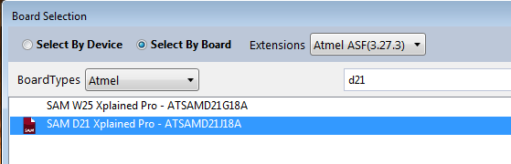

1. Use ASF Wizard to Add two library modules “Standard serial I/O (stdio)(driver)” and “FreeRTOS mini Real-Time Kernel (service) **8.0.1**” and then click Apply button to complete adding these two selected modules into the project.

Please note: use the latest 8.0.1 version of FreeRTOS from now on.

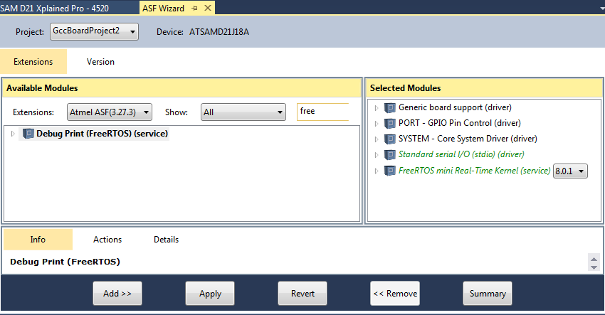

1. Modify FreeRTOSConfig.h file under the /config folder.

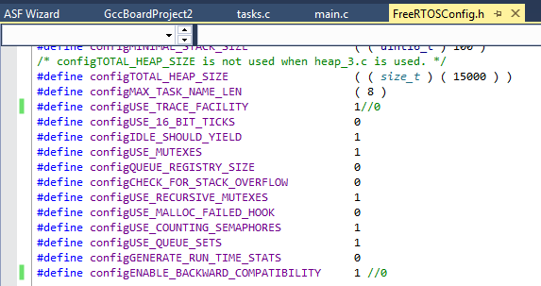

Add a macro definition *#define configUSE_STATS_FORMATTING_FUNCTIONS 1* as below.

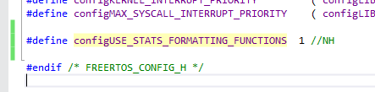

1. Remove the heap_1.c under the directory \src\ASF\thirdparty\freertos\freertos-8.0.1\Source\portable\MemMang with the new heap_3.c (available on D2L).

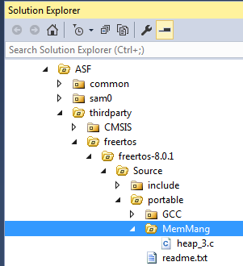

1. Overwrite the default main.c file with the the main_proj1.c (available on D2L).
2. Build the project and run.
3. From the Tera Terminal, you may observe the following output.

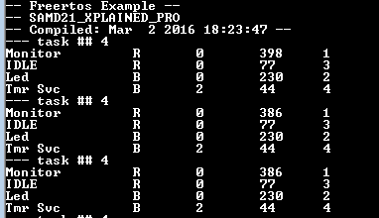

The 1st column – Task name; the 2nd column - State; then, the 3rd column - Priority; 4th column – Stack size; 5th column – thread ID number.

B – Blocked; R – Ready; D – Deleted; S - Suspended