Real-time Embedded systems

Lab8 FreeRTOS Demo on OLED1 Xplained Pro

Atmel Software Framework (ASF v3.27.3) provides four example projects for controlling OLED1 Xplained Pro.

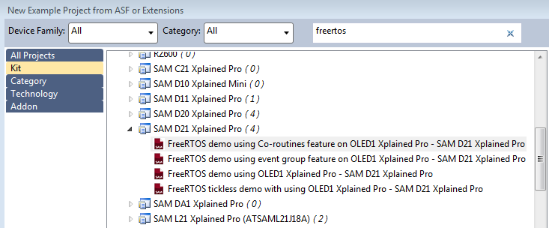

In this lab, please create one of these four example demo projects, build it, program the D21 board and start debugging.

Please note that OLED1 board should be connected to the Extension 3 of SAM D21.

Please perform following tasks:

1. Please read the source code, especially the C code with the main() function.
2. What tasks, resources and interrupts have been created and used in the demo project?
3. Please draw an overall control flow diagram of the program.
4. Please list a set of FreeRTOS API functions that have used in the project.
5. Please explain the transitions among different running modes; and give a description of each running mode.