Assignment 5 — Technical Analysis using R

Overview and setup
This package implements the nine requested technical indicators in separate base-R scripts. Open the folder in RStudio, run source("run_tests.R"), and review the printed console output. No technical-analysis packages are used. For real stock data, prepare a data frame with Date, Open, High, Low, Close, and Volume columns and pass the Close vector to each relevant function.

Implementation explanations

SMA
Computes the mean for every complete consecutive window; output length is n - period + 1.
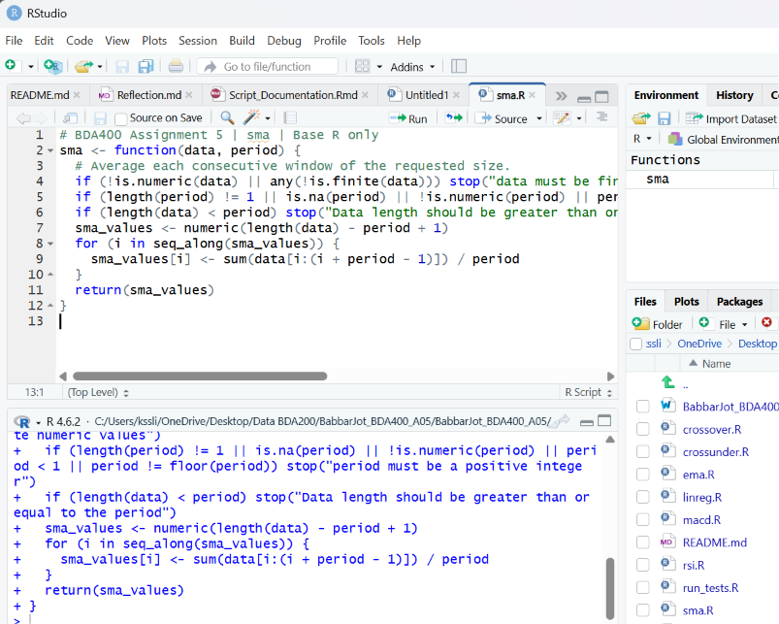

EMA
Starts from the first price, then applies multiplier 2/(period+1) recursively.
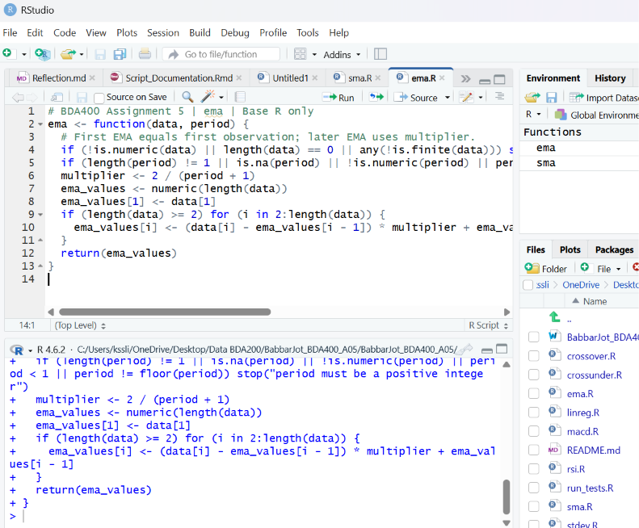

MACD
Subtracts long EMA from short EMA, calculates an EMA signal, and subtracts the signal to obtain the histogram.
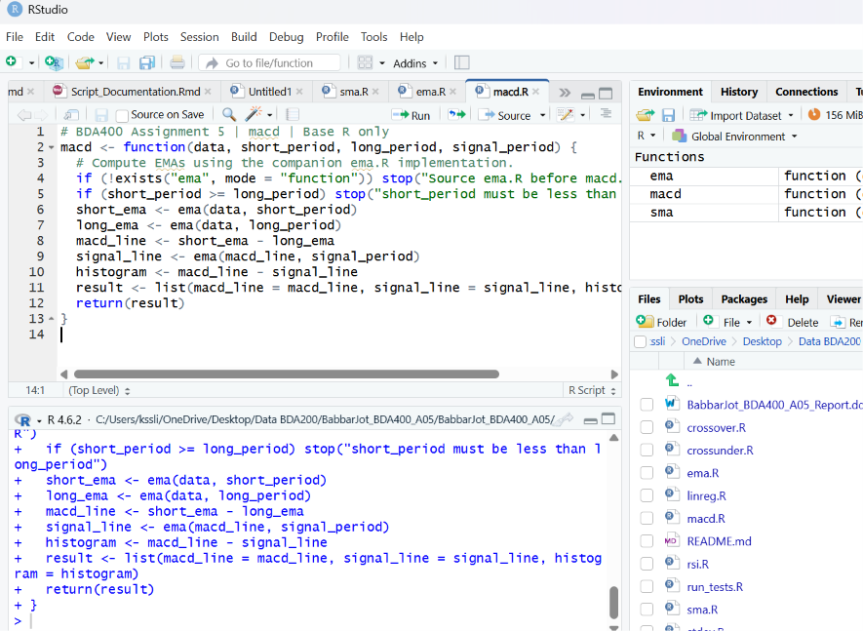

Population standard deviation
Calculates the mean squared deviation and its square root, dividing by n.
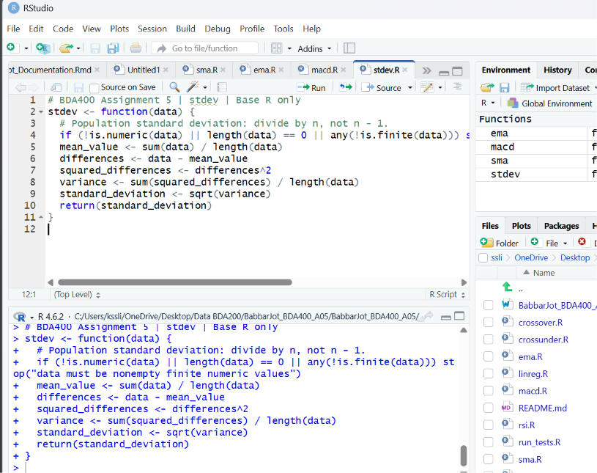

Linear regression
Fits a straight line to the selected recent window using slope = covariance numerator / sum of squared index deviations.
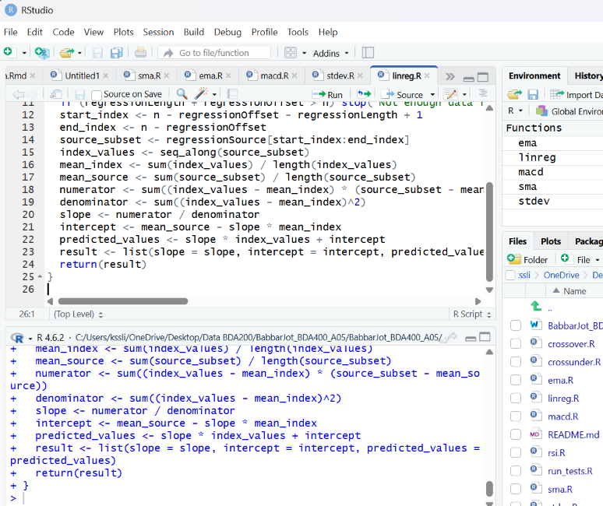

RSI
Separates gains and losses, seeds their averages, and updates them with Wilder smoothing.
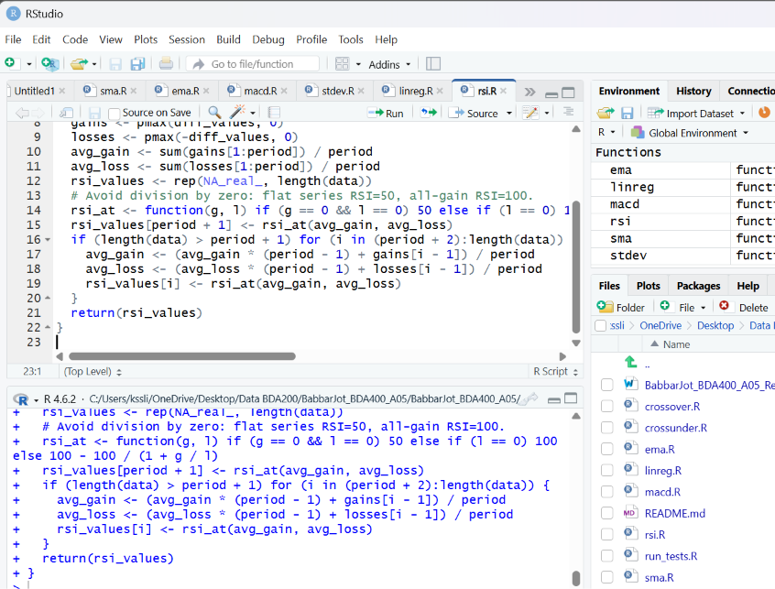

Stochastic RSI
Normalizes RSI within a rolling window, then smooths the result into K and D series.
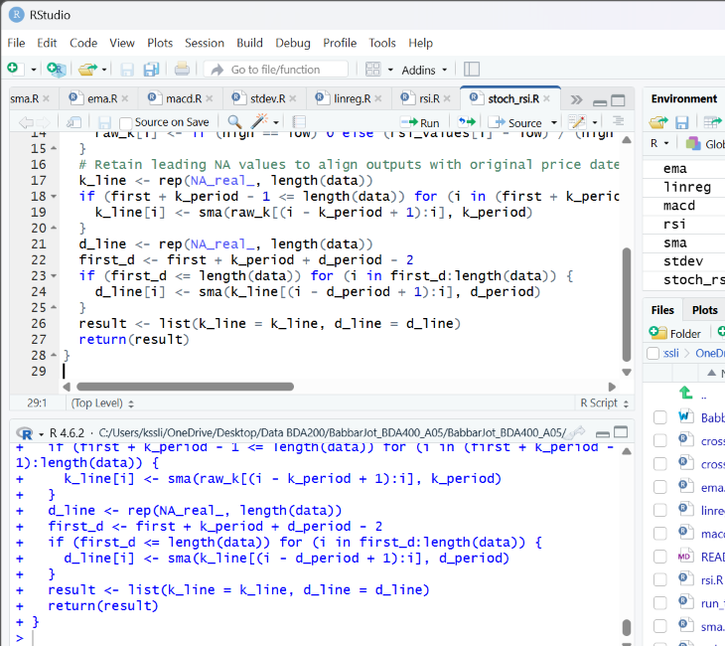

Crossover
Reports Up or Down when one series crosses another; otherwise None.
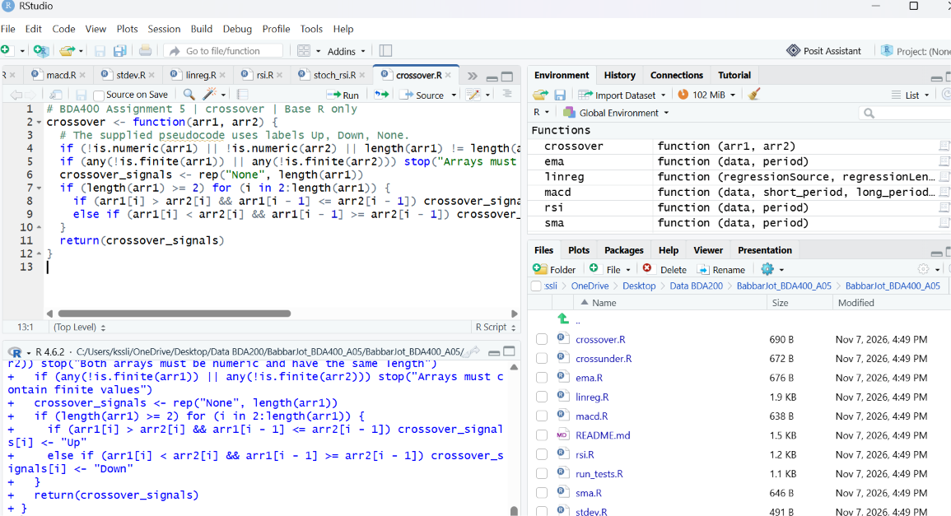

Crossunder
Reports True at downward crosses and False otherwise; first position is None.
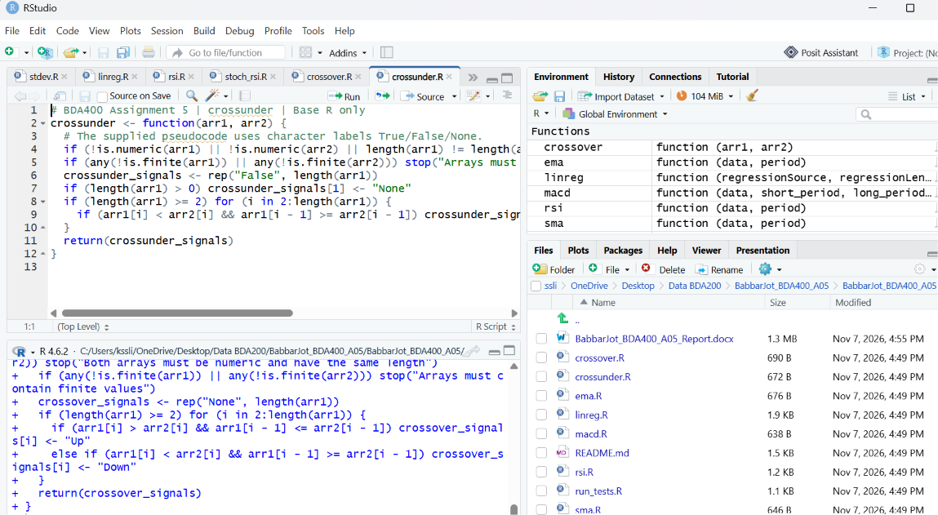

Testing and verification
The included run_tests.R uses synthetic vectors and stopifnot() assertions for expected outputs. These are test definitions, not a claim that RStudio has been executed. Run them and paste a screenshot or console log below. Compare population SD with sqrt(sum((x-mean(x))^2)/length(x)), not base sd(x).
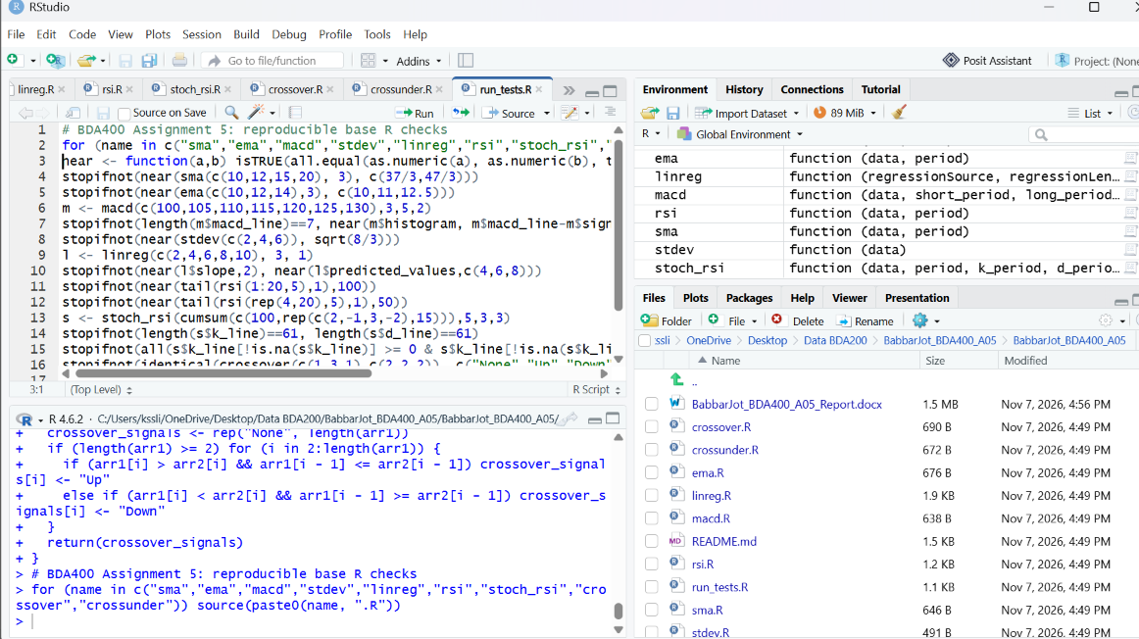

Important specification choices
The provided assignment contains inconsistencies: crossover prose describes booleans but pseudocode returns Up/Down/None; crossunder prose describes booleans but pseudocode returns True/False strings; the linear regression pseudocode has a window-index formula that does not preserve regressionLength for positive offsets; and the StochRSI example has too few observations for its 14-period RSI. The implementations follow the described calculation intent and named templates. Confirm any instructor-specific test expectations.

Repository and submission checklist
GitHub Link:

