Assignment 2 — Technical Analysis Using R
GitHub repository: https://github.com/[username]/TechnicalAnalysis
REPORT TEMPLATE — Complete each verification and replace screenshot placeholders with genuine captures from your own setup. Do not submit placeholders as completed evidence.

1. GitHub repository setup
Create a public or instructor-accessible repository named TechnicalAnalysis. Add an Assignment2 subfolder and upload the assignment files.
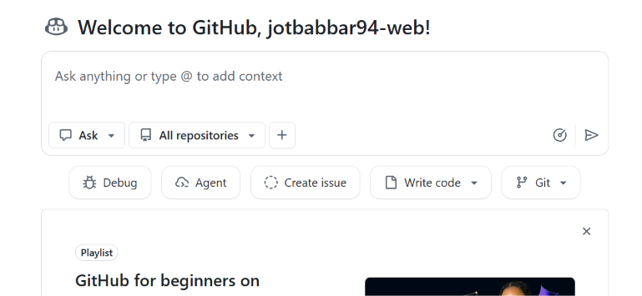
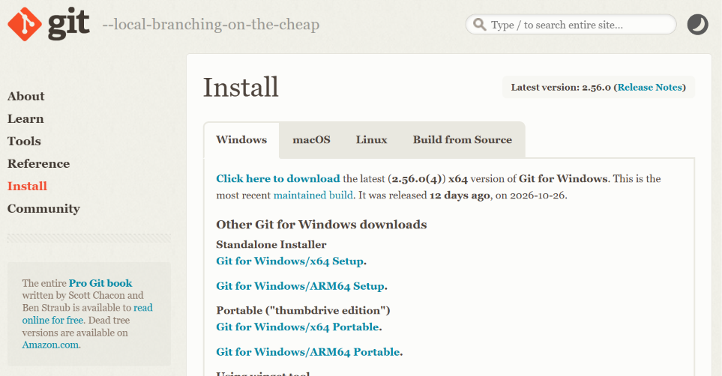
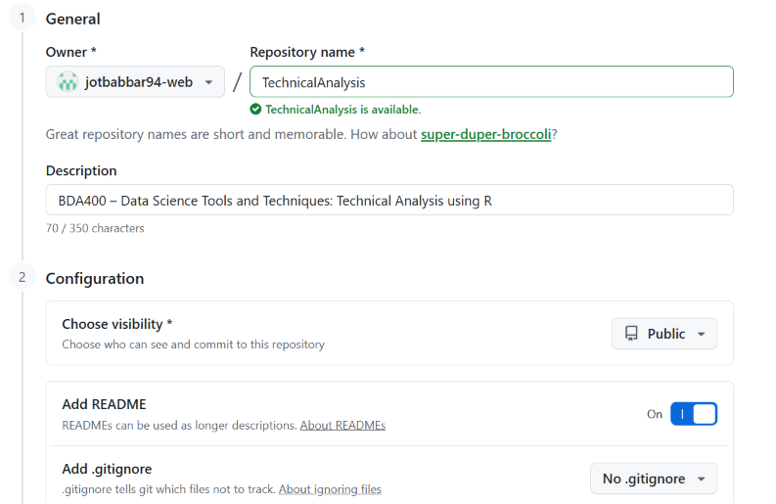

2. Install R and RStudio
Install R from CRAN and RStudio Desktop from Posit. Launch RStudio and record the R version using R.version.string.
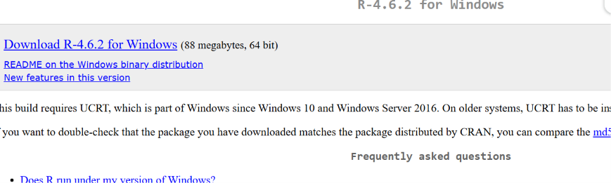
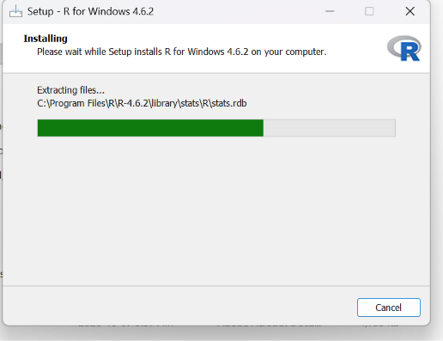
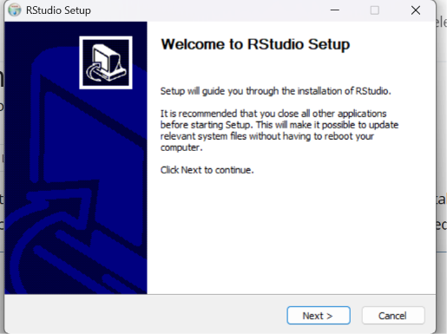

3. Install required packages
Run install.packages(c("quantmod", "TTR")) in the RStudio Console. Verify with packageVersion("quantmod") and packageVersion("TTR").

4. Configure portfolio
Create portfolio.txt with AAPL, MSFT and GOOGL, each on its own line. Set RStudio working directory to the Assignment2 folder; verify with getwd() and readLines("portfolio.txt").
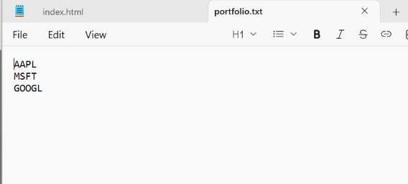

5. Import stock data
Source stock_functions.R, then call stocks <- load_stock_data("portfolio.txt"). Each ticker should be stored in its own data frame inside the named list stocks. Verify names(stocks), sapply(stocks, nrow), and head(stocks[["AAPL"]]).
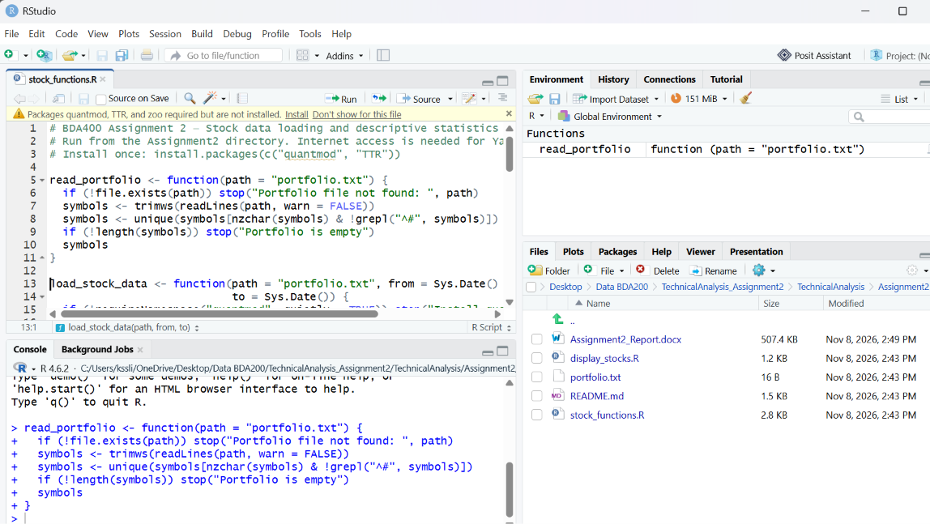

6. Calculate statistics
Run statistics <- summarize_portfolio(stocks); print(statistics). Explain that the summary uses closing prices and a 20-trading-day simple moving average. Independently verify one mean/median/SD using R base functions on a selected stock, and manually spot-check a small sample.
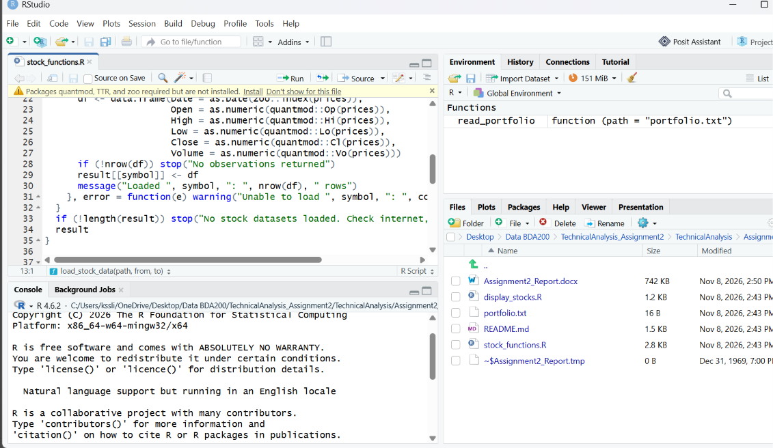

7. Display and visualize
Run source("display_stocks.R"). Capture the first/last six rows, summary output, RStudio Data Viewer, and at least one closing-price chart with the 20-day SMA.
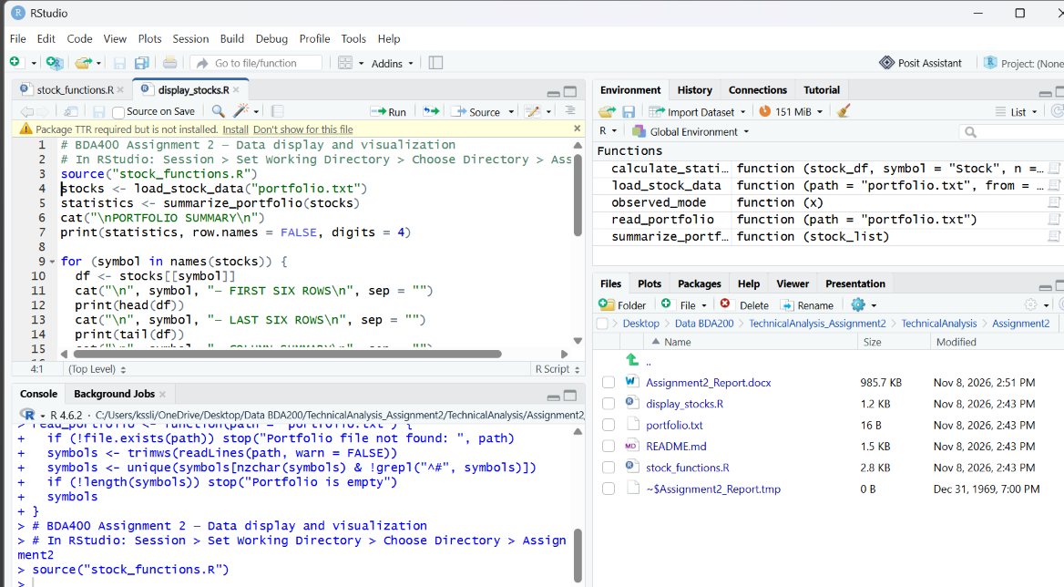

8. Results and observations
Fill in the actual date range, row counts, statistics, and chart observations after executing the script. Note any missing data or download failures.

9. Verification and troubleshooting
Record what you personally checked: package versions, file names, data row counts, independent statistics, charts, and GitHub preview. Include any errors encountered and how you resolved them.

10. Submission checklist
Confirm Assignment2 folder includes portfolio.txt, stock_functions.R, display_stocks.R, README.md and this completed report. Confirm repository URL is correct and files open in GitHub.

