Jot Flora G. Lorenzo

BSBA-FM191

Flowchart

A flowchart is a visual representation or diagram that shows a workflow or a process in sequential order. A flowchart can also be a representation of an algorithm, a step-by-step approach to explaining a task.

The flowchart shows the steps of a process as boxes of various kinds, and their order by connecting the boxes with arrows. They are wildly used in multiple fields to document, study, plan, improve and communicate often complex processes in clear, easy-to-understand diagrams.

Flow charts are an important tool for the improvement of processes. By providing a graphical representation, they help project teams to identify the different elements of a process and understand the interrelationships among the various steps.

Below are the following types of boxes and how they are used in a flowchart:

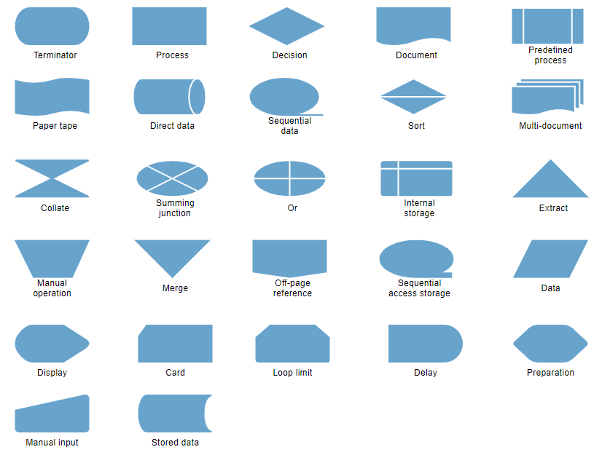

Example of flowchart:

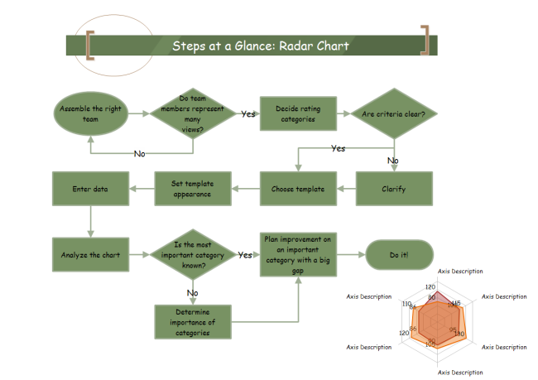

Sources:<https://www.edrawsoft.com/en/explain-algorithm-flowchart.html>

<https://www.visual-paradigm.com/tutorials/flowchart-tutorial/>

<https://www.inc.com/encyclopedia/flow-charts.html#targetText=Flow%20charts%20are%20an%20important,interrelationships%20among%20the%20various%20steps.>

Pseudocode

Pseudocode is a detailed yet readable description of what a computer program or algorithm must do. It is expressed in a formally-styled natural language rather than in a programming language. Pseudocode is sometimes used as a detailed step in the process of developing a program.

Pseudocode is an informal way of programming description that does not require any strict programming language syntax or underlying technology considerations. It is used for creating an outline or a rough draft of a program. Pseudocode summarizes a program’s flow, but excludes underlying details. It is important for system designers to write a pseudocode to ensure that programmers understand a software project's requirements and align code accordingly.

Example of pseudocode:

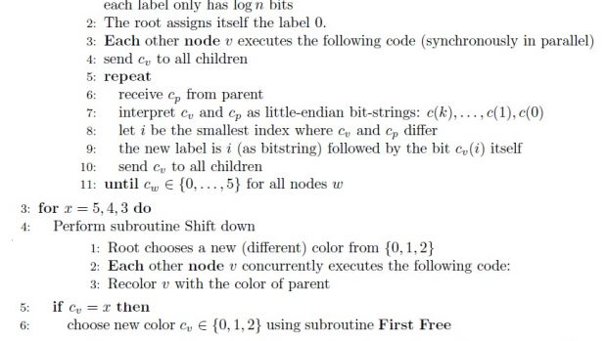

Sources: <https://whatis.techtarget.com/definition/pseudocode>

<https://economictimes.indiatimes.com/definition/pseudocode>