Jot Flora G. Lorenzo

BSBA-FM191

Adding Two Numbers

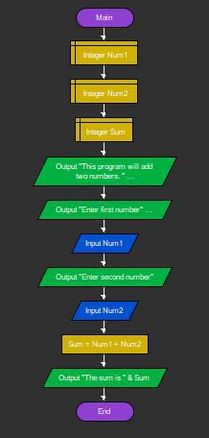

Area of a Circle

