ENVIRONMENTAl MONITORING SYSTEM

Objectives:

Ensure compliance with environmental regulations.Detect and respond to environmental threats.Determine the purpose of your monitoring system, such as tracking air quality, water Quality, weather conditions, or wildlife.

IOT DEPLOYMENTS:

Sensor Selection: Choose appropriate sensors for monitoring various environmental parameters such as temperature, humidity, air quality, water quality, soil moisture, and more. Select sensors that are compatible with IoT platforms.

Connectivity:

Ensure that your sensors are equipped with wireless communication capabilities, such as Wi-Fi, LoRa, NB-IoT, or cellular, to transmit data to a central IoT platform.

IoT Platform:

Deploy an IoT platform to receive, process, and store the sensor data. Popular platforms include AWS IoT, Azure IoT, Google Cloud IoT, and various open-source solutions.

Data Transmission:

Set up a reliable data transmission protocol to ensure data is securely sent to the IoT platform. This may involve MQTT, CoAP, HTTP, or other communication protocols.

Data Processing and Storage: Process incoming data to filter,

aggregate, and store it in a database. You may use cloud-based databases or on-premises solutions based on your requirements.

PLATFORM DEVELOPMENT:

Define Requirements:

Identify the specific environmental parameters you want to monitor (e.g., temperature, humidity, air quality, water quality, soil conditions).Determine the geographical scope and scale of your monitoring system.Sensor Integration:Select and integrate compatible sensors to measure the chosen environmental parameters.Ensure proper calibration and data accuracy for the sensors.

Connectivity:

Implement communication protocols (e.g., MQTT, HTTP, CoAP) to receive data from sensors.Support various wireless technologies (Wi-Fi, LoRa, cellular) for sensor connectivity.Data Ingestion:Develop a data ingestion pipeline to accept data from sensors and store it in a database or data lake.Consider real-time data streaming for immediate analysis.

Data Processing:

Implement data processing logic to filter, clean, and aggregate the incoming data.Apply algorithms for data quality assurance and anomaly detection

CODE:

Import random

Import time

Class EnvironmentalSensor:

Def __init__(self, location):

Self.location = location

Def collect_data(self):

Temperature = random.uniform(15, 30) # Simulated temperature data in °C

Humidity = random.uniform(30, 70) # Simulated humidity data in %

Air_quality = random.randint(0, 100) # Simulated air quality data (0-100 scale)

Return {

“Location”: self.location,

“Temperature (°C)”: temperature,

“Humidity (%)”: humidity,

“Air Quality”: air_quality,

}

Def main():

Sensor1 = EnvironmentalSensor(“Location A”)

Sensor2 = EnvironmentalSensor(“Location B”)

While True:

Data1 = sensor1.collect_data()

Data2 = sensor2.collect_data()

Print(“Sensor 1 Data:”

For key, value in data1.items(): Print(f”{key}: {value}”)

Print(“\nSensor 2 Data:”)

For key, value in data2.items():

Print(f”{key}: {value}”) Print(“\n” + “-“ * 30) Time.sleep(5) # Simulate data collection every 5 seconds

If __name__ == “__main__”:

Main()

DIAGRAM:

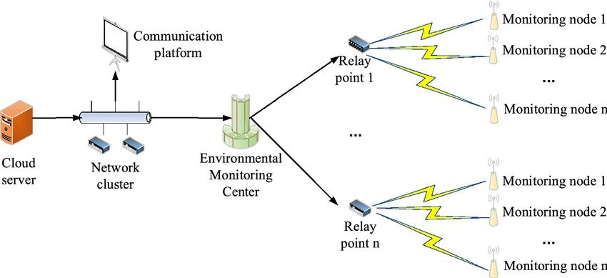

BENEFITS:

Safety and Well-Being:

Immediate Alerts: Visitors can receive real-time alerts about adverse weather conditions, natural disasters (e.g., storms, wildfires), or sudden environmental changes, helping them make informed decisions and stay safe.Air Quality Information: Real-time air quality data can alert visitors to high pollution levels, allowing them to take necessary precautions, especially for those with respiratory conditions.

Activity Planning:Weather Updates: Access to real-time weather information enables visitors to plan their outdoor activities more effectively, knowing if it’s a good day for hiking, picnicking, or other outdoor pursuits.

Temperature and Humidity: Knowing the current temperature and humidity levels helps visitors dress appropriately and avoid discomfort during their outdoor adventures.

Environmental Education:Learning Opportunities: Real-time data can enhance the educational aspect of parks by providing insights into the local ecosystem, wildlife behavior, and the impact of human activities on the environment.

Citizen Science: Visitors can contribute to environmental research by participating in data collection or monitoring programs, fostering a sense of responsibility for the environment.

Environmental Awareness:Environmental Health: Visitors gain a better understanding of the park’s environmental health, biodiversity, and sustainability efforts, encouraging a greater appreciation for conservation efforts.Real-Time Updates: Access to live data encourages visitors to connect with nature and become more aware of the dynamic changes in the environment.

Resource Management:Efficient Resource Allocation: Park staff can use real-time data to allocate resources effectively, such as deploying rangers to areas experiencing high visitor traffic or managing resources for environmental protection.Mitigating Overcrowding: Real-time data can help avoid overcrowding in popular outdoor areas, ensuring a more enjoyable experience for visitors.

Navigation and Access:Trail and Route Information: Visitors can access real-time trail conditions, water levels, and road closures, making it easier to plan their routes and navigate the park.

Accessibility: Real-time data can also benefit individuals with disabilities by providing information about accessible facilities and services.