PL SQL PROGRAMMING
Exercise 3: Stored Procedures

Scenario 1: The bank needs to process monthly interest for all savings accounts.
  - Question: Write a stored procedure ProcessMonthlyInterest that calculates and updates the balance of all savings accounts by applying an interest rate of 1% to the current balance.
QUERY
CREATE OR REPLACE PROCEDURE ProcessMonthlyInterest AS
v_new_balance NUMBER;
BEGIN
FOR acc IN (
SELECT AccountID, Balance
FROM Accounts
WHERE AccountType = 'Savings'
) LOOP
v_new_balance := acc.Balance * 1.01;
UPDATE Accounts
SET Balance = v_new_balance,
LastModified = SYSDATE
WHERE AccountID = acc.AccountID;
DBMS_OUTPUT.PUT_LINE('Updated AccountID ' || acc.AccountID || ' New Balance: ' ||
v_new_balance);
END LOOP;
END;
/
OUTPUT
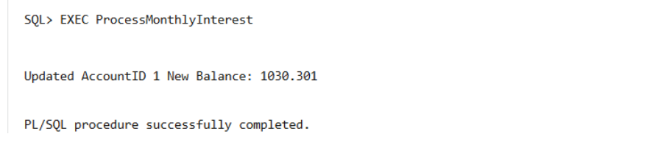

EXEC ProcessMonthlyInterest
Scenario 2: The bank wants to implement a bonus scheme for employees based on their performance.
  - Question: Write a stored procedure UpdateEmployeeBonus that updates the salary of employees in a given department by adding a bonus percentage passed as a parameter.
QUERY
CREATE OR REPLACE PROCEDURE UpdateEmployeeBonus (
p_department IN VARCHAR2,
p_bonus_percent IN NUMBER
) AS
BEGIN
FOR emp IN (
SELECT EmployeeID, Name, Salary
FROM Employees
WHERE Department = p_department
) LOOP
DECLARE
v_new_salary NUMBER;
BEGIN
v_new_salary := emp.Salary + (emp.Salary * p_bonus_percent / 100);
UPDATE Employees
SET Salary = v_new_salary
WHERE EmployeeID = emp.EmployeeID;
DBMS_OUTPUT.PUT_LINE(
'EmployeeID: ' || emp.EmployeeID ||
', Name: ' || emp.Name ||
', New Salary: ' || v_new_salary
);
END;
END LOOP;
END;
/
EXEC UpdateEmployeeBonus(‘IT’, 10);
OUTPUT
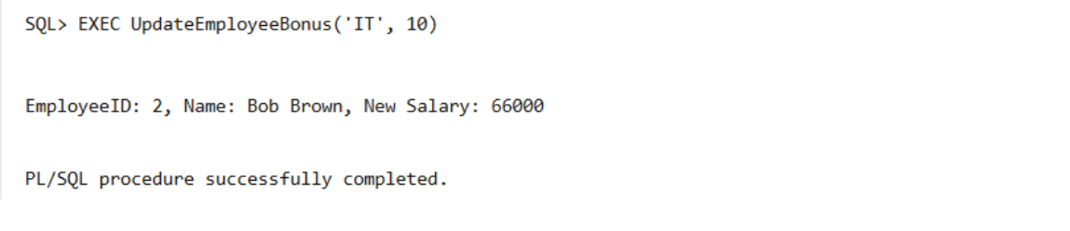

Scenario 3: Customers should be able to transfer funds between their accounts.
  - Question: Write a stored procedure TransferFunds that transfers a specified amount from one account to another, checking that the source account has sufficient balance before making the transfer.
QUERY
CREATE OR REPLACE PROCEDURE TransferFunds (
p_from_account_id IN NUMBER,
p_to_account_id IN NUMBER,
p_amount IN NUMBER) AS
v_from_balance NUMBER;
BEGIN
SELECT Balance INTO v_from_balance
FROM Accounts
WHERE AccountID = p_from_account_id;
IF v_from_balance < p_amount THEN
DBMS_OUTPUT.PUT_LINE('Insufficient balance. Transfer failed.');
RETURN;
END IF;
UPDATE Accounts
SET Balance = Balance - p_amount
WHERE AccountID = p_from_account_id;
UPDATE Accounts
SET Balance = Balance + p_amount
WHERE AccountID = p_to_account_id;
DBMS_OUTPUT.PUT_LINE('Transfer successful.');
END;
/
EXEC TransferFunds(1, 2, 200);
OUTPUT
