**BIG DATA ANALYSIS WITH IBM CLOUD DATABASES**

**PHASE 3: DEVELOPMENT PART 1**

**IBM DB2**

IBM DB2 is designed for managing and storing large volumes of data efficiently and securely. Db2 is used in a variety of industries and applications for various purposes. common uses of IBM Db2:

* Relational Database Management
* Enterprise Database
* Data Warehousing
* Application Development
* Mainframe Data Storage

**DATABASE SETUP:**

We have created an IBM Cloud account, and created the appropriate database service Db2, and had set up a database instance.

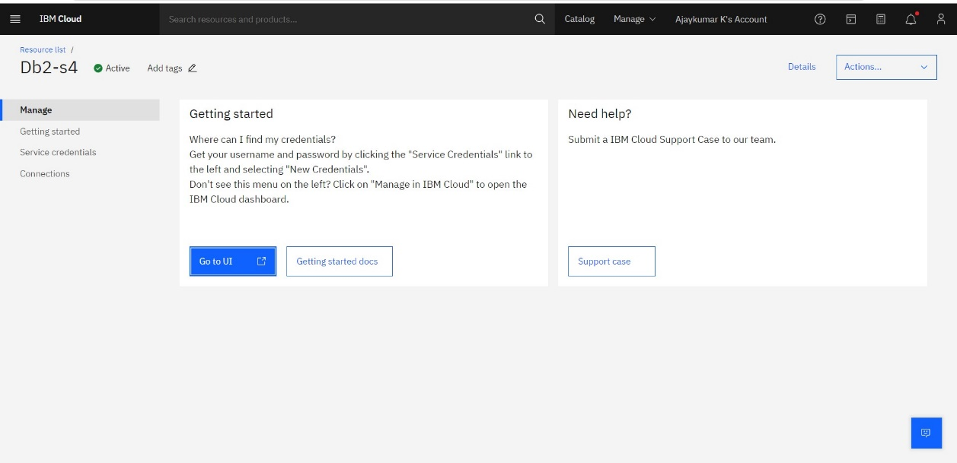

**LOADING THE DATASET:**

After creating the DB2 instance, we have created a table called AI in the database and loaded the dataset ‘all_ai_tool.csv’ in it.

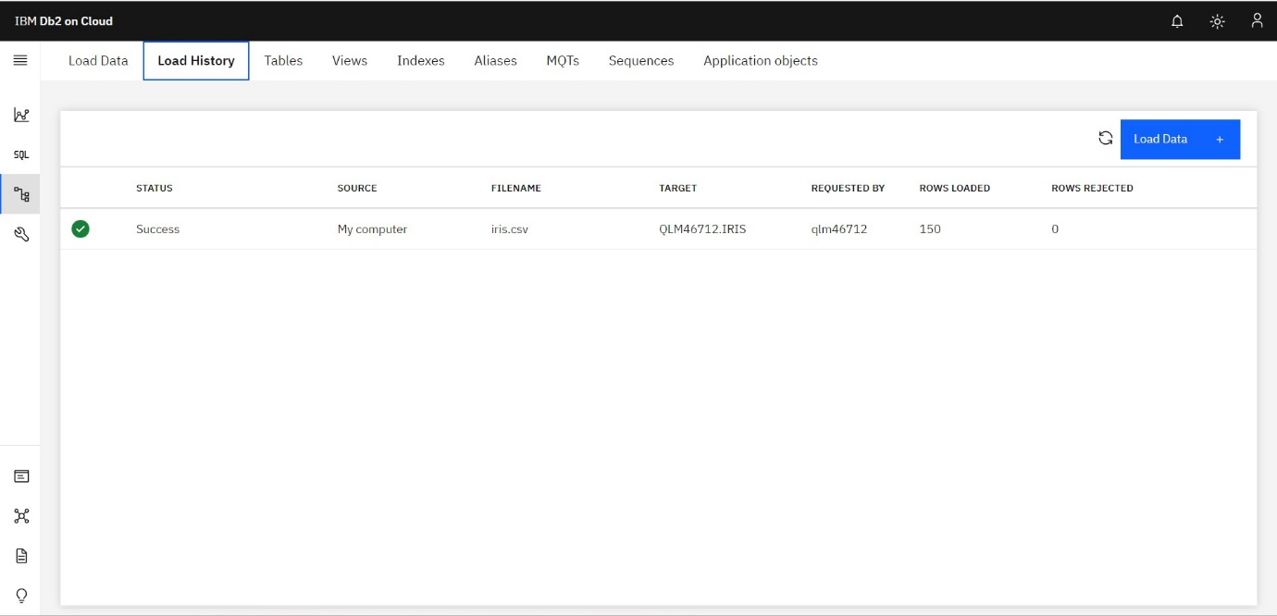

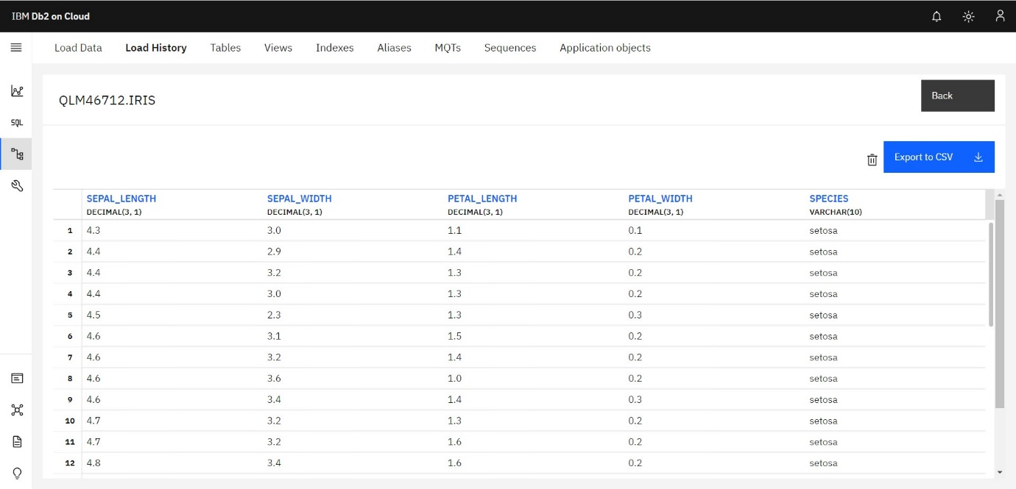

**EXECUTION:**

After adding the dataset ‘languages.csv’ to the database, we have executed some basic SQL queries to check whether the dataset is connected to the database correctly.

