**BIG DATA ANALYSIS WITH IBM CLOUD DATABASES**

**VISUALISATION WITH IBM WATSON STUDIO**

# IBM WATSON STUDIO

IBM Watson Studio is a comprehensive data science and machine learning platform offered by IBM. It is designed to help data scientists, developers, and other professionals collaborate and work on data analysis, machine learning, and artificial intelligence (AI) projects. Watson Studio provides a variety of tools and services to streamline the entire data science workflow, from data preparation to model deployment. Some of the key features of IBM Watson Studio are

* Data Preparation.
* Machine Learning Models.
* Model Deployment.
* Explainability.
* Data Catalog and Governance.

# WORKING WITH IBM WATSON STUDIO OBJECT STORAGE

Create a cloud object storage. Create a bucket named “iris.csv”. Drop the

“iris.csv” dataset in the bucket.

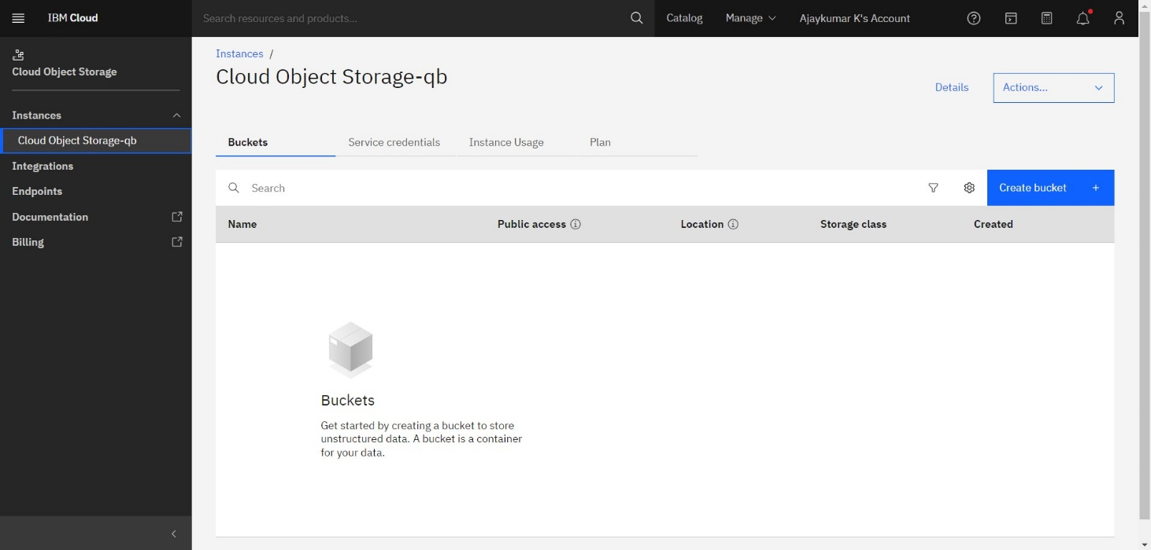

# LAUNCHING THE WATSON STUDIO

Launch the IBM Watsonx in Watson studio by providing our login credentials, and create a project called “iris”.

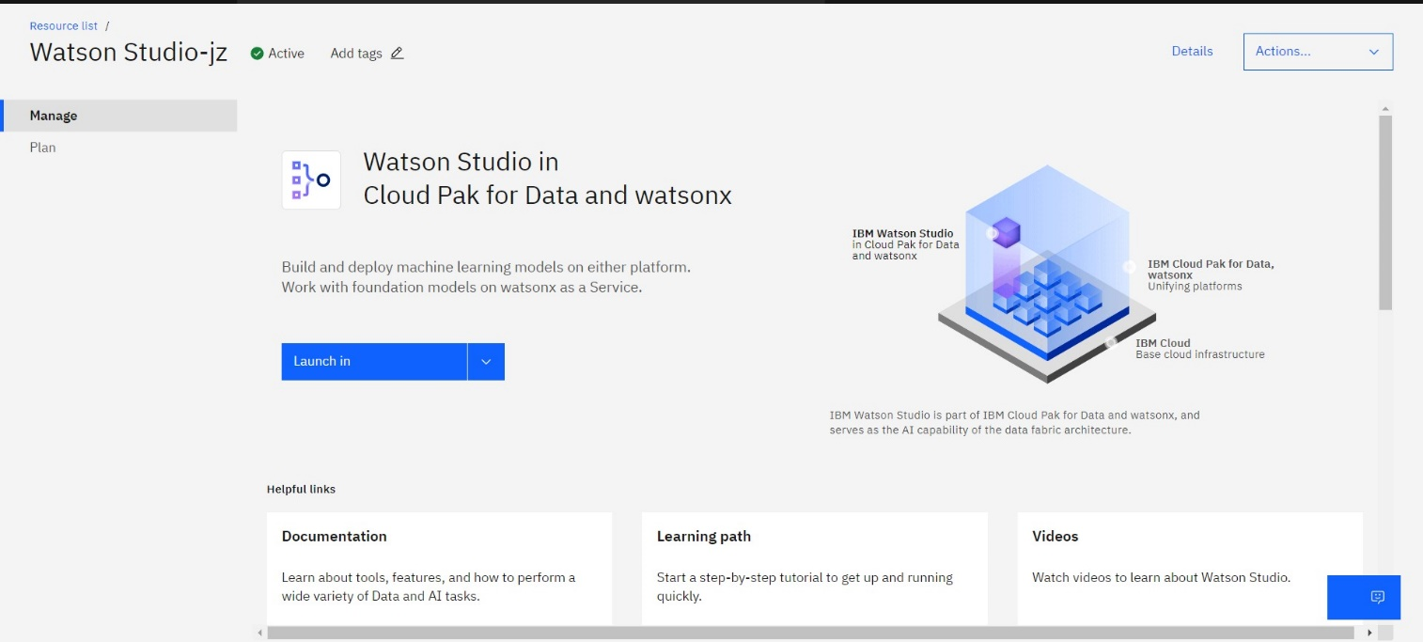

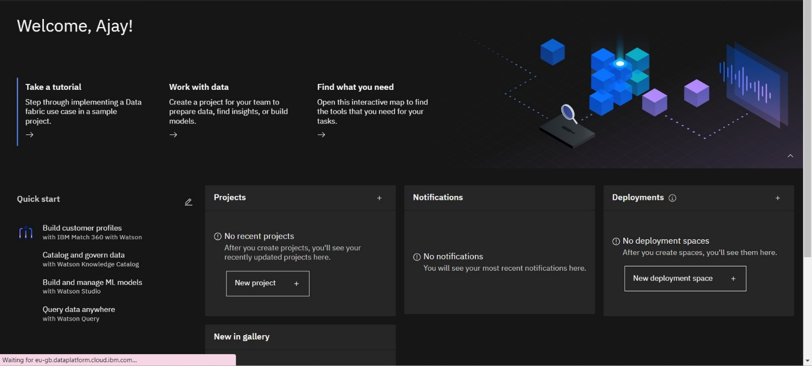

# DATABASE SETUP

Upload the dataset “iris.csv” in the asset section of the “AI-TOOL-Analysis” bucket in the Watson studio.

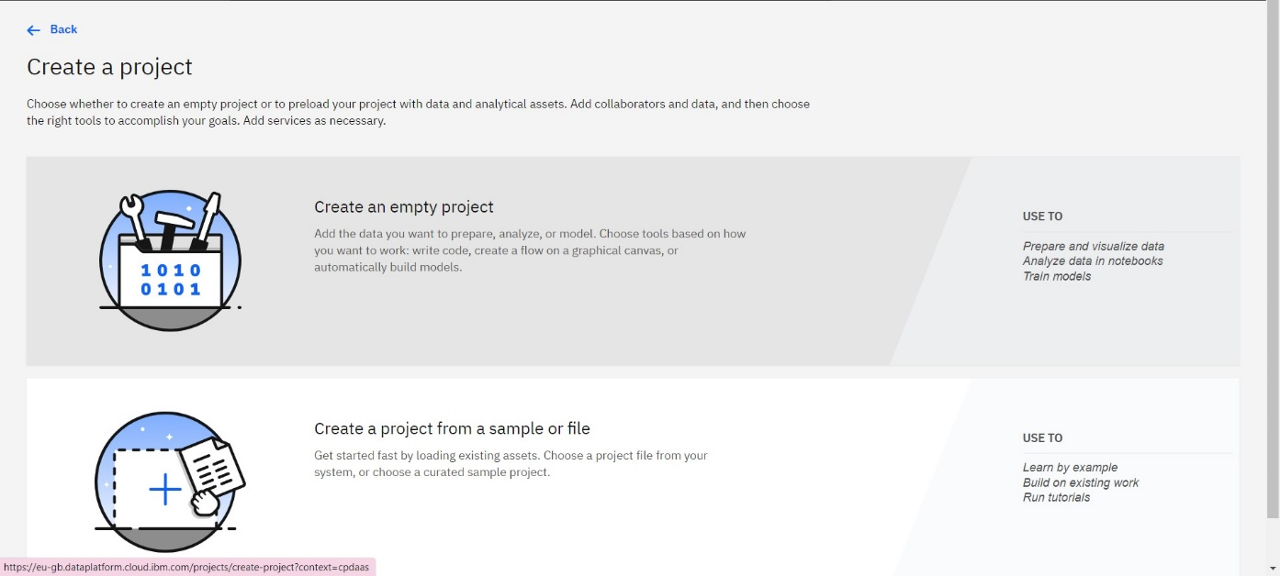

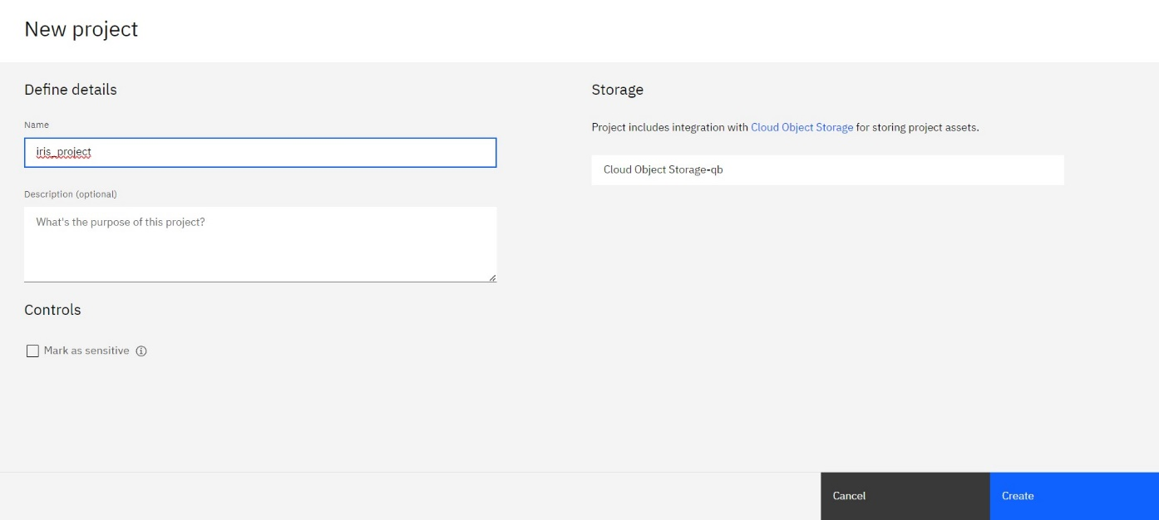

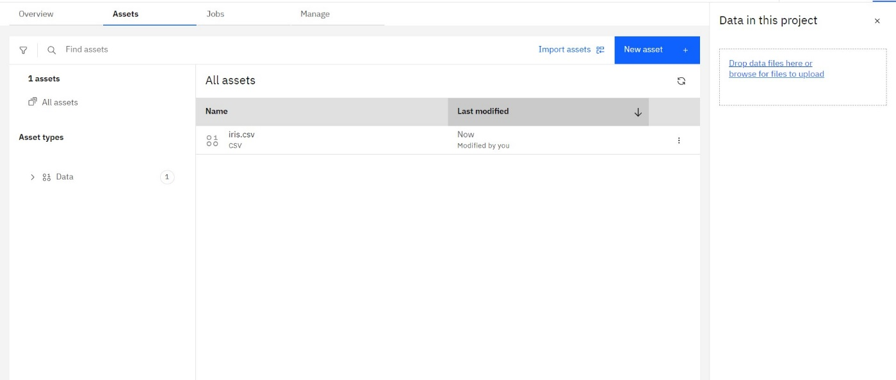

# VISUALIZING THE DATASET IN VARIOUS ASPECTS

1. Scatterplot

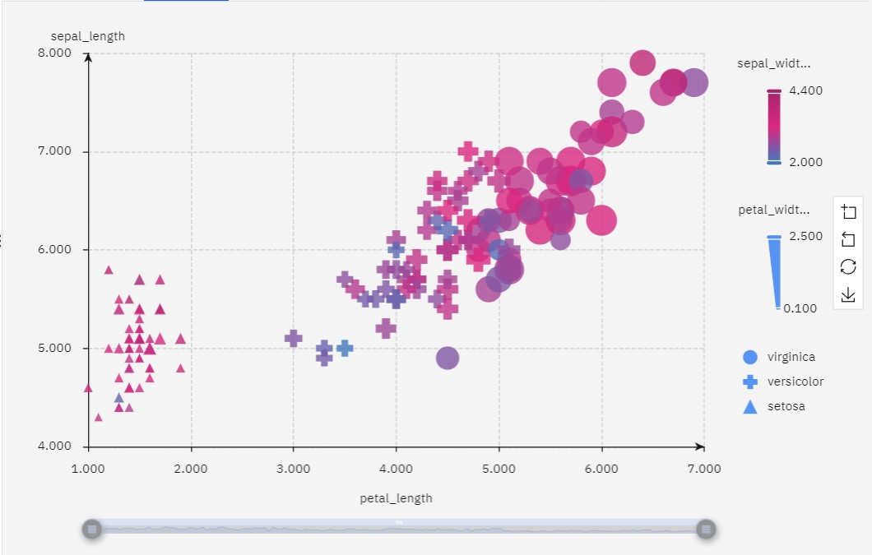

1. Piechart

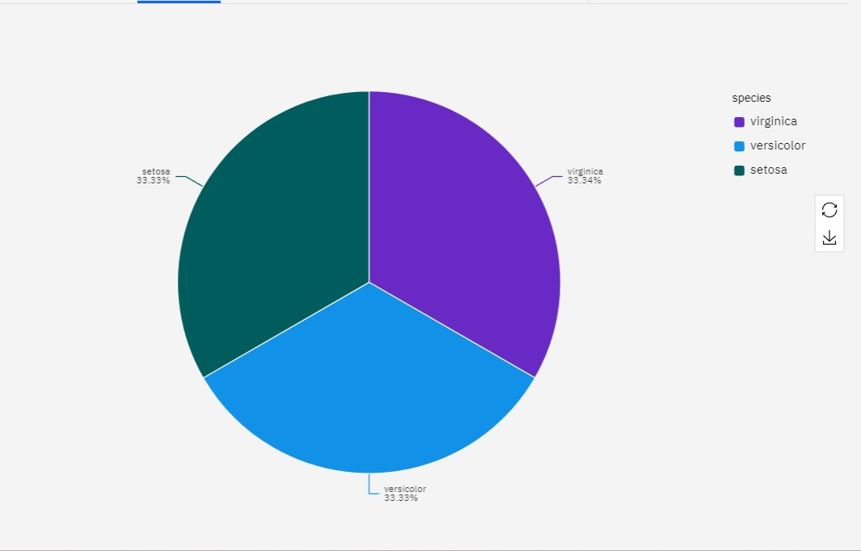

1. Histogram

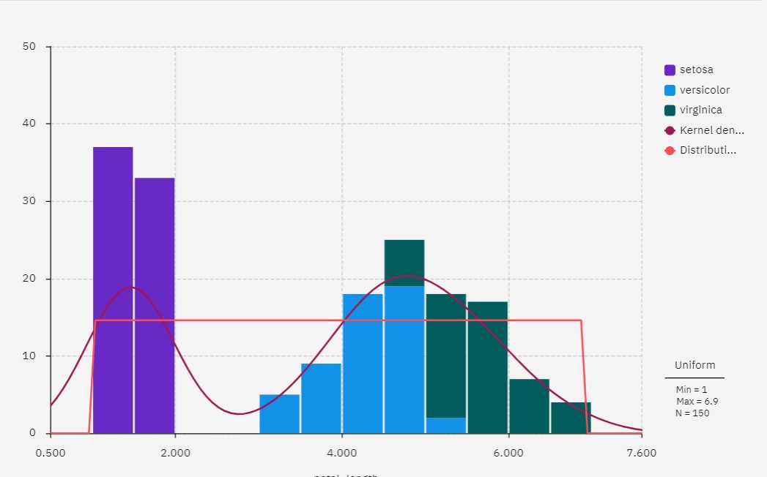

1. Bar graph

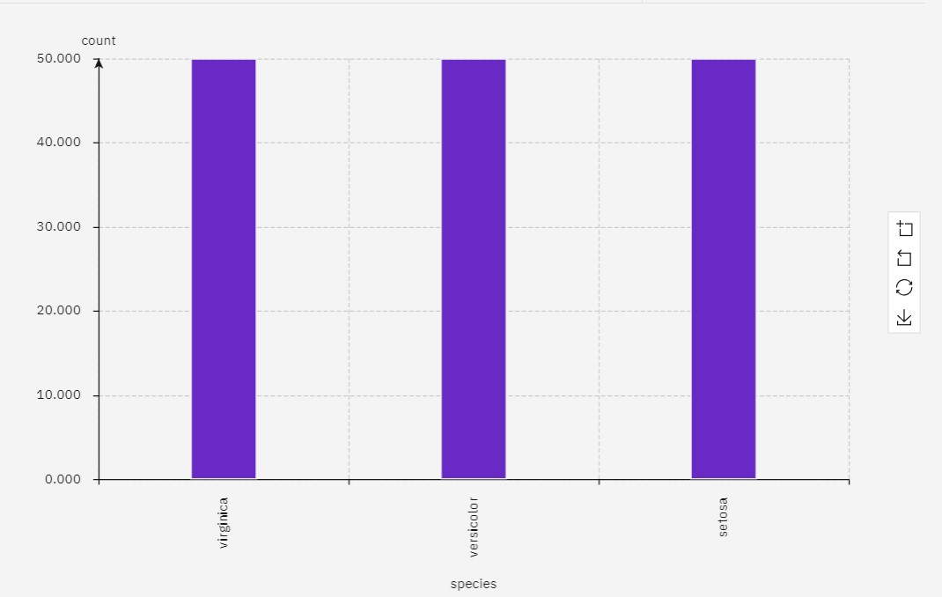

1. Line chart

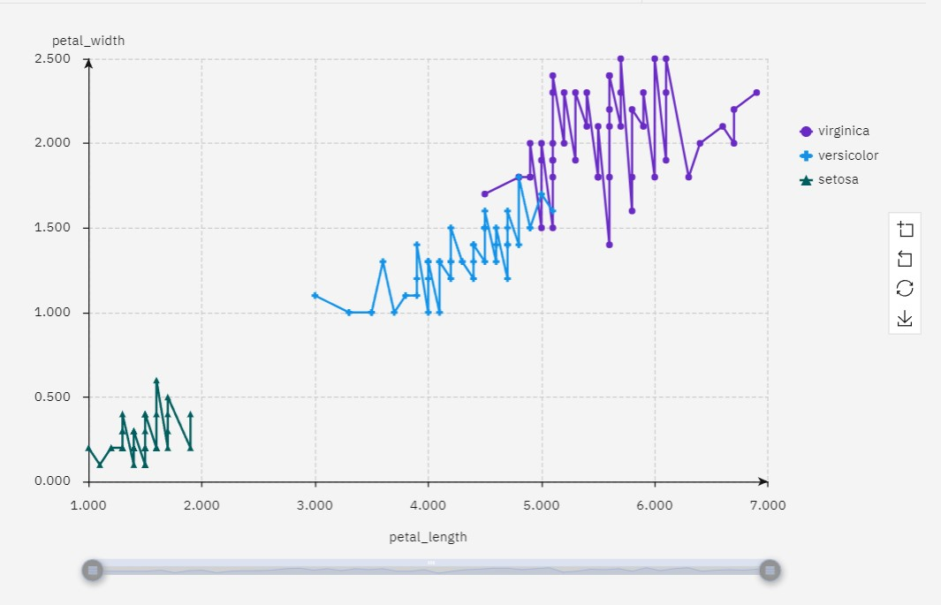

# MACHINE LEARNING ALGORITHMS

Machine learning algorithms are computational methods that enable computers to learn and make predictions or decisions without being explicitly programmed for a specific task. There are several types of machine learning algorithms, which can be broadly categorized into the following three groups

* Supervised Learning
* Unsupervised Learning
* Reinforcement Learning

In addition to these main categories, there are other specialized machine learning techniques and algorithms, including

* Semi-Supervised Learning
* Transfer Learning
* Time Series Analysis
* Anomaly Detection
* Ensemble Learning

**MACHINE LEARNIG MODELS WITH IBM WATSON**

## IMPORT DATA TO A PROJECT

Create a new project in IBM Watson Machine learning platform under IBM Watsonx for data in the launch in twisty.

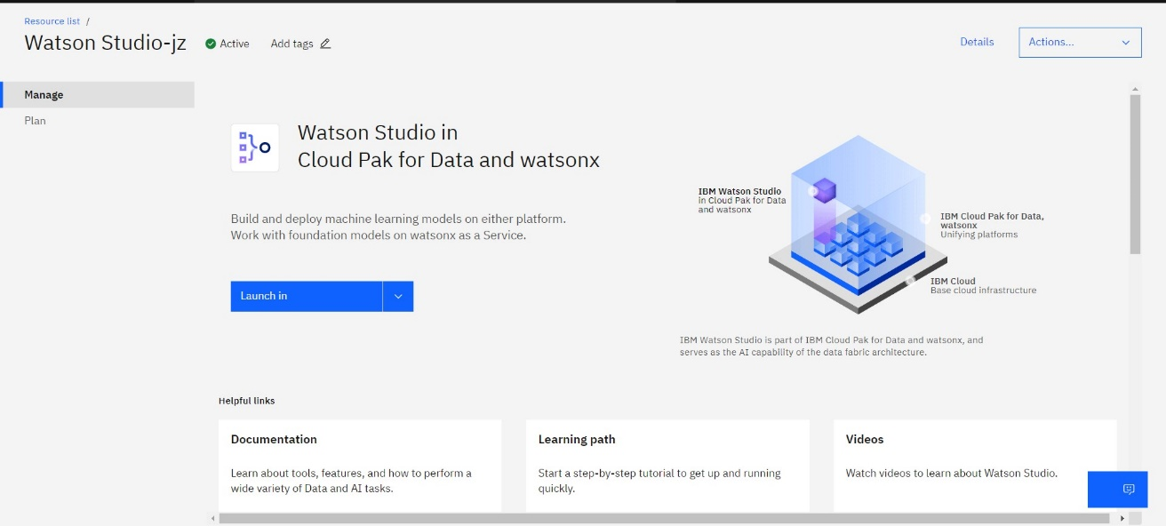

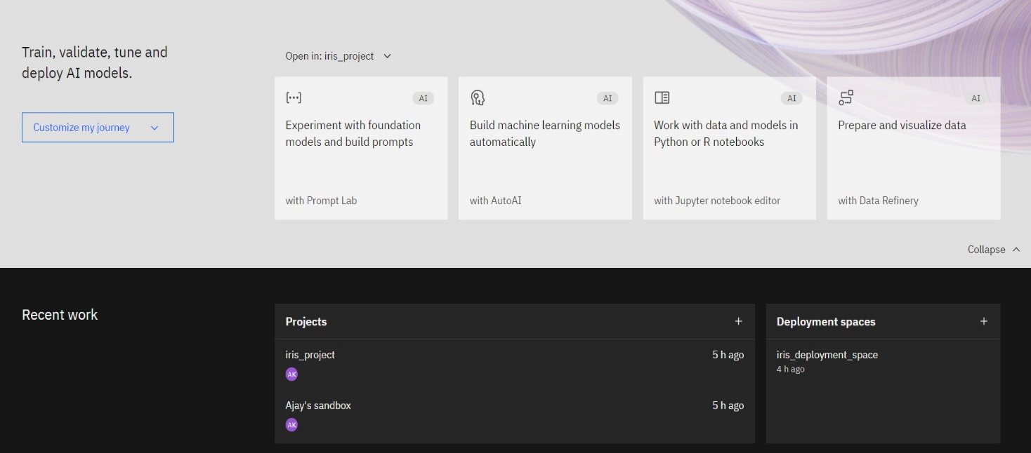

Upload the dataset “iris.csv” in the new project “iris_project”.

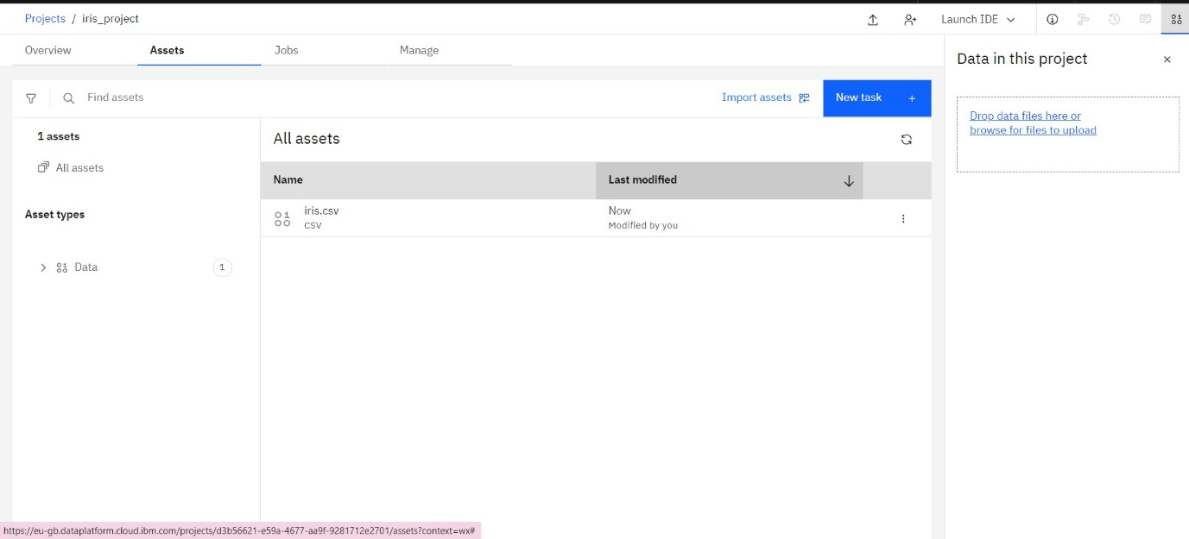

## ASSOCIATE THE MACHINE LEARNING SERVICE

Train the dataset with AutoAI tool and Associate the machine learning service within it.

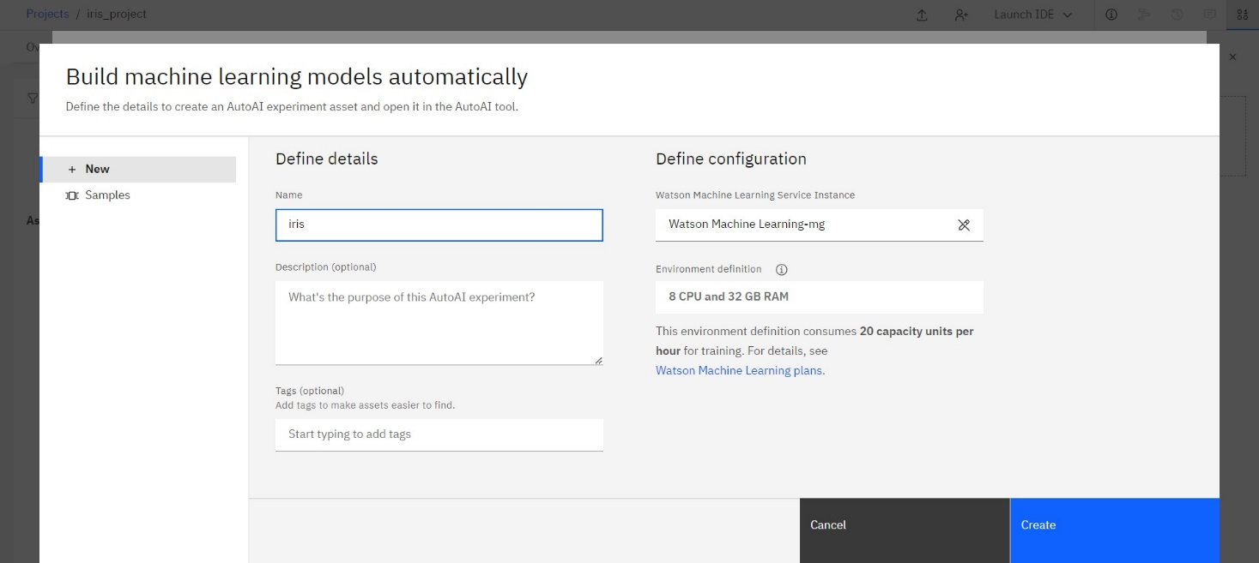

# BUILD A MACHINE LEARNING MODEL

Once the service is associated with our project, Build the model using AUTOAI tool. Drop the dataset “iris.csv” to train the data.

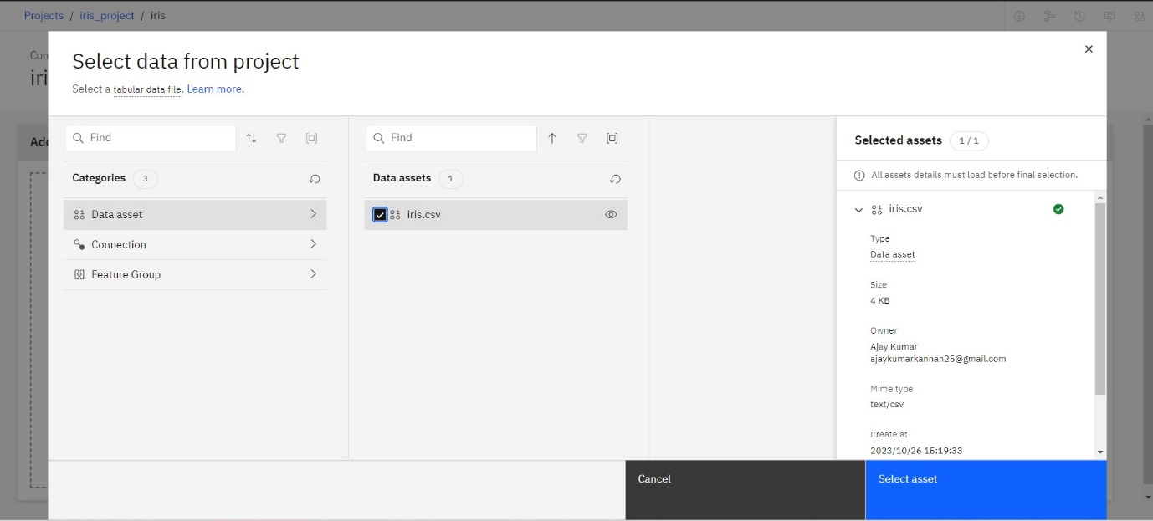

After adding the dataset, choose the column “Majority Category” to predict. Select the prediction type as “Multiple Classification” and Optimized for “Accuracy and runtime. Run the experiment.

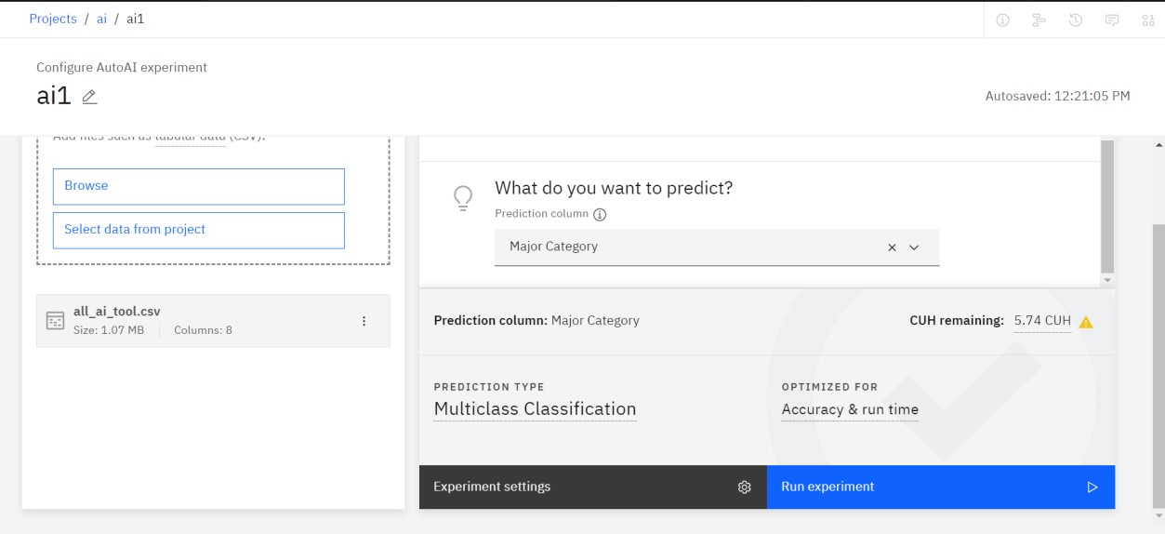

## RELATIONSHIP MAP

Processing the relationship map for the column “Major Category”

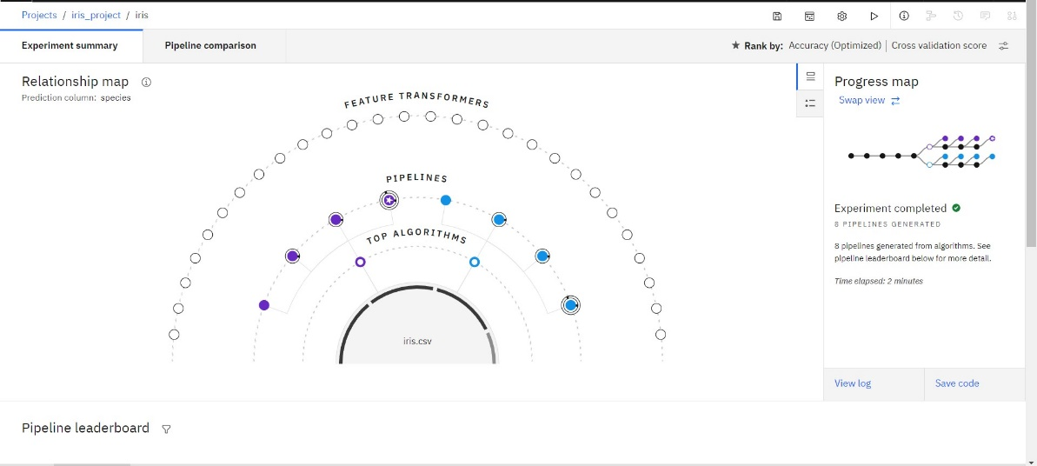

The complete relationship map

# Pipeline Leaderboard

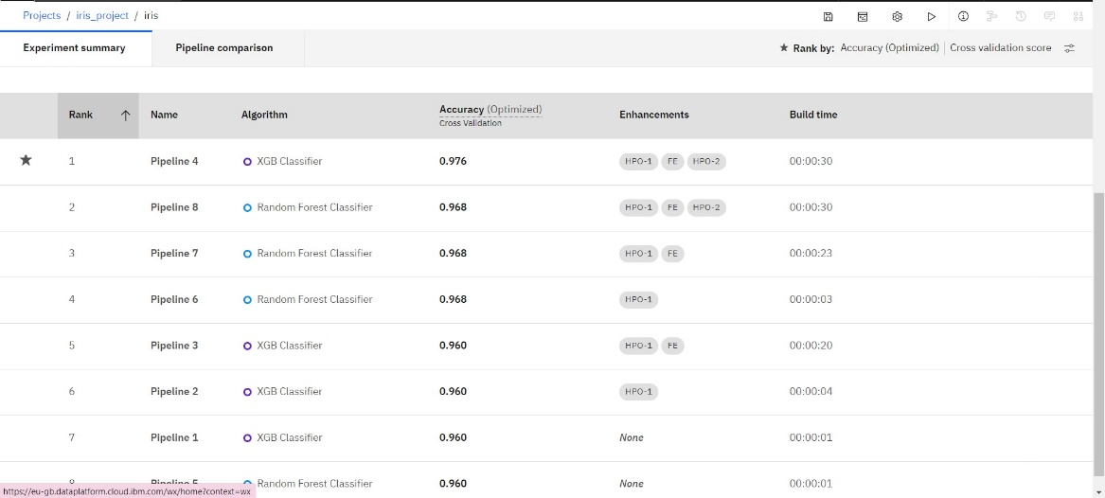

From the leader board, Select the algorithm which is ranked as 1. Save the algorithm and deploy the dataset.

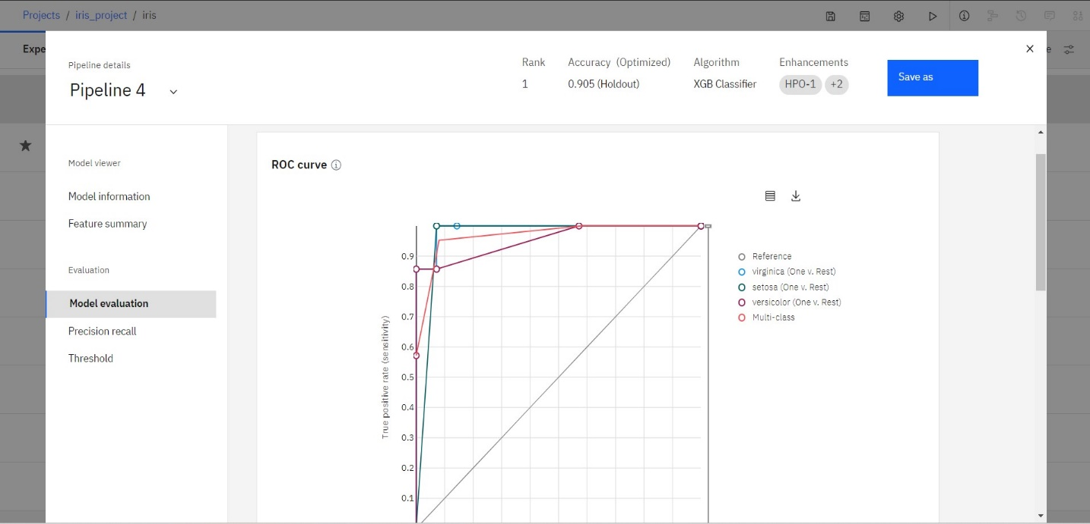

# Deployment Space:

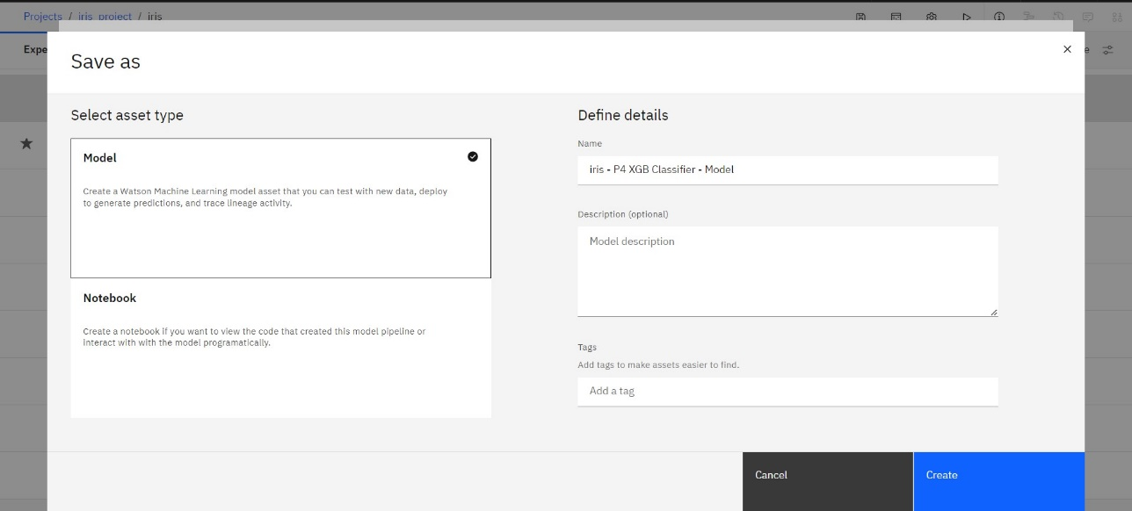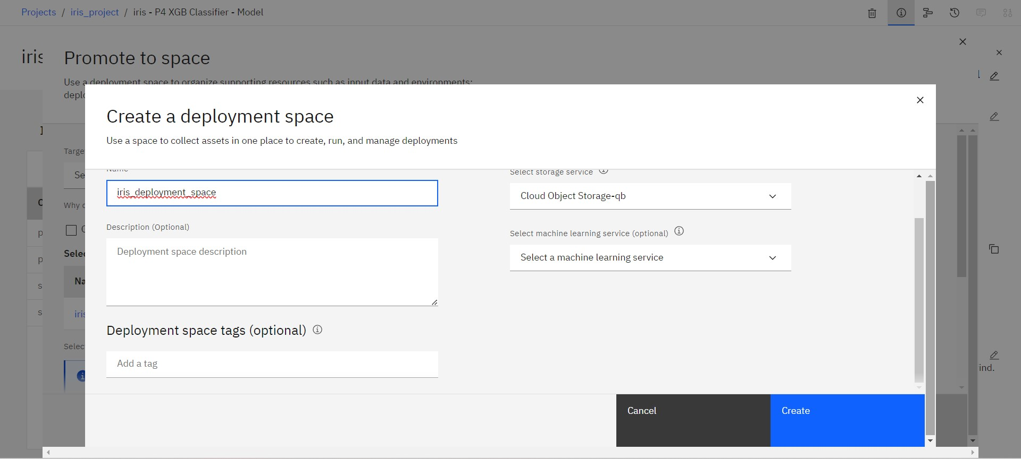

**DEPLOY AND TEST YOUR MODEL**

Open the deployment space created. Select the model and promote the deployment space

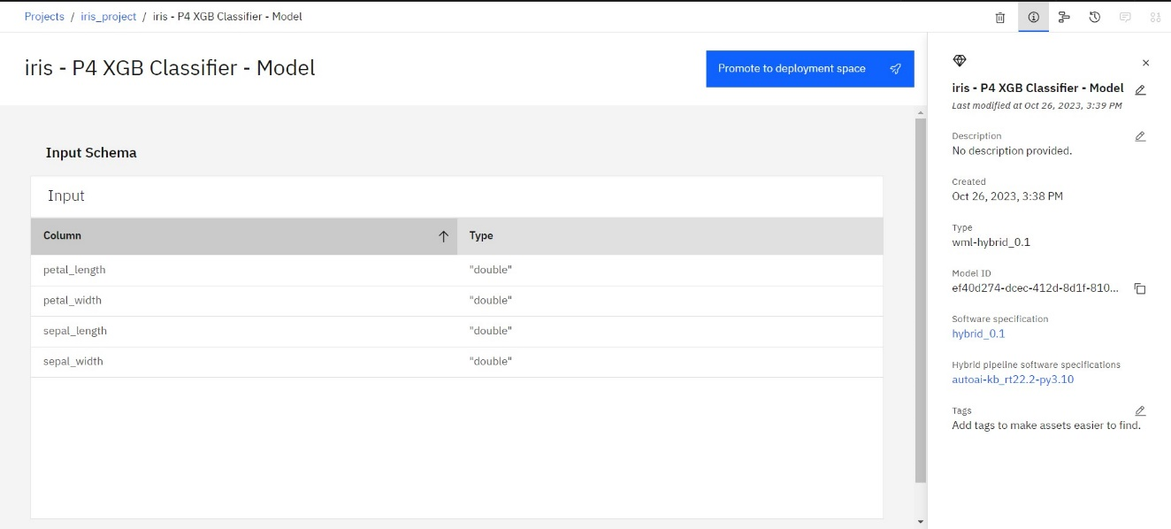

Promote it and find the predicted results by providing any two row of data from the dataset

