MYSQL (TASK2)

1.To find the address (location_ id, street_ address, city, state_ province, country_ name) of all the departments by using natural join.

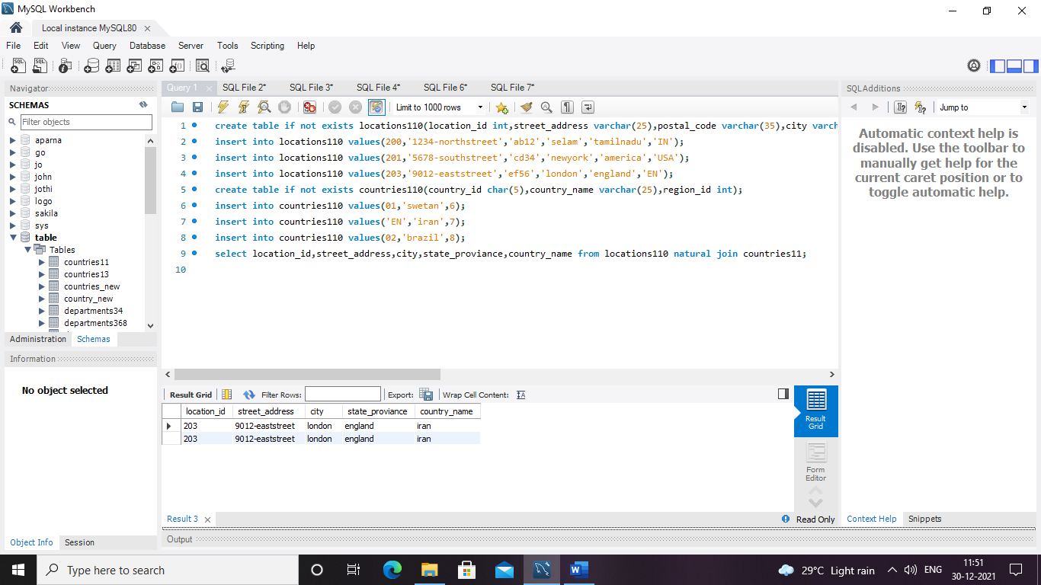

Output :

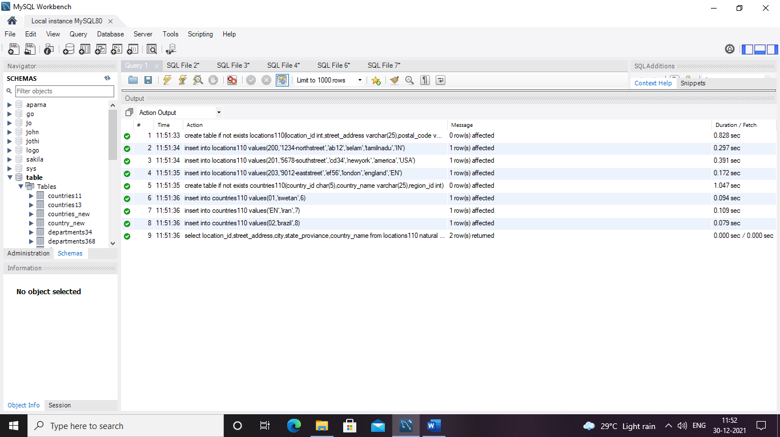

2. To find the name (first_ name, last_ name) department_ id and name of all the employees.

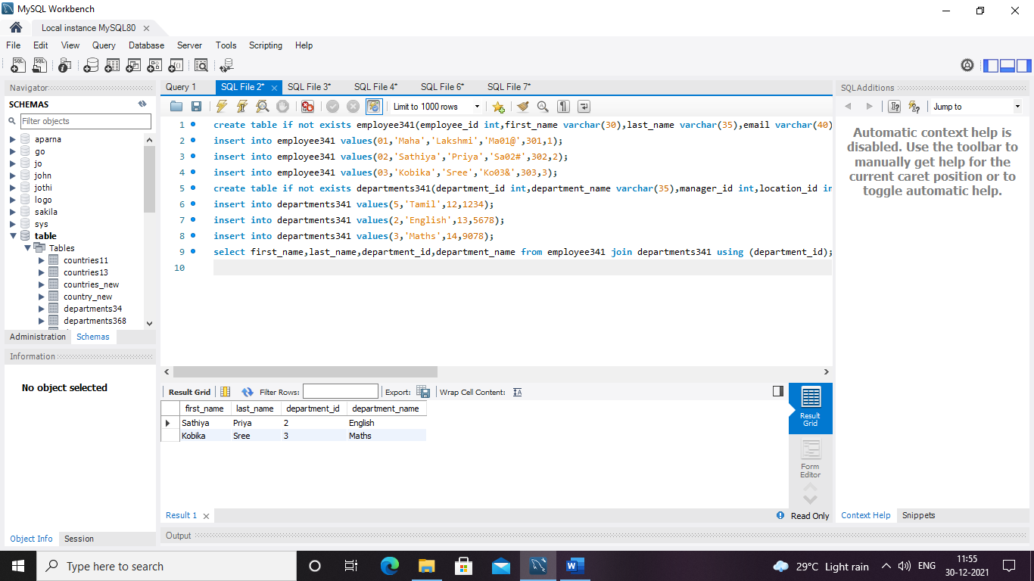 output:

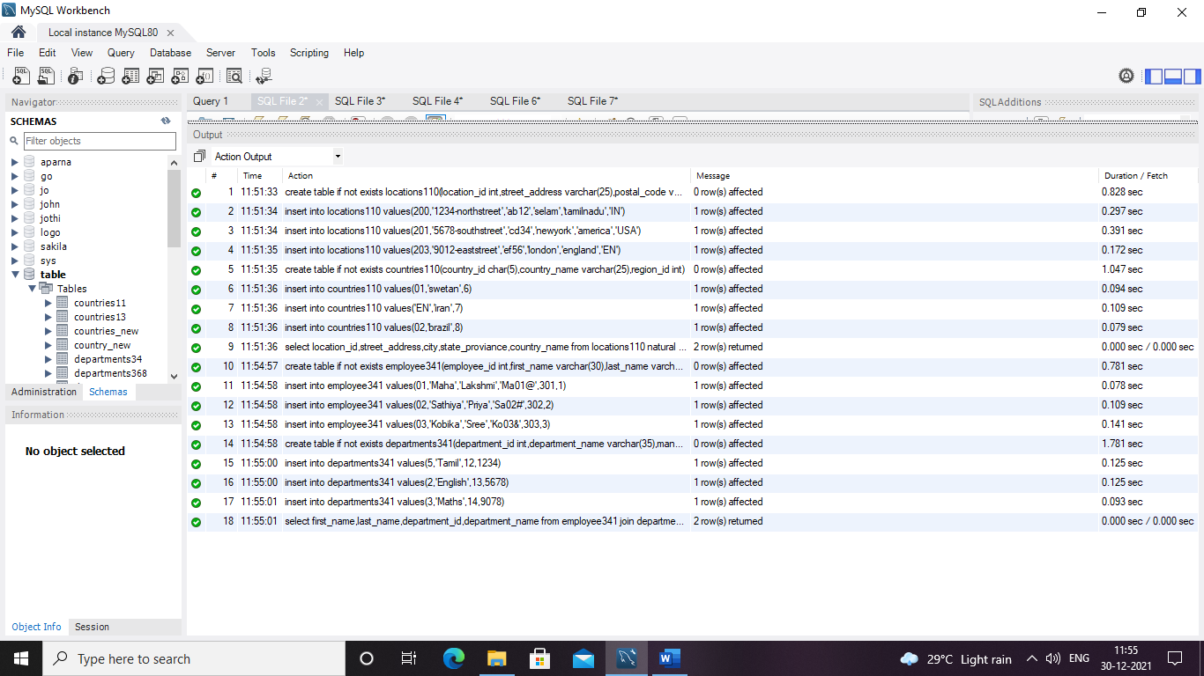

3.To find the name (first_ name, last_ name), job, department_ id and name of the employees who works in the London.

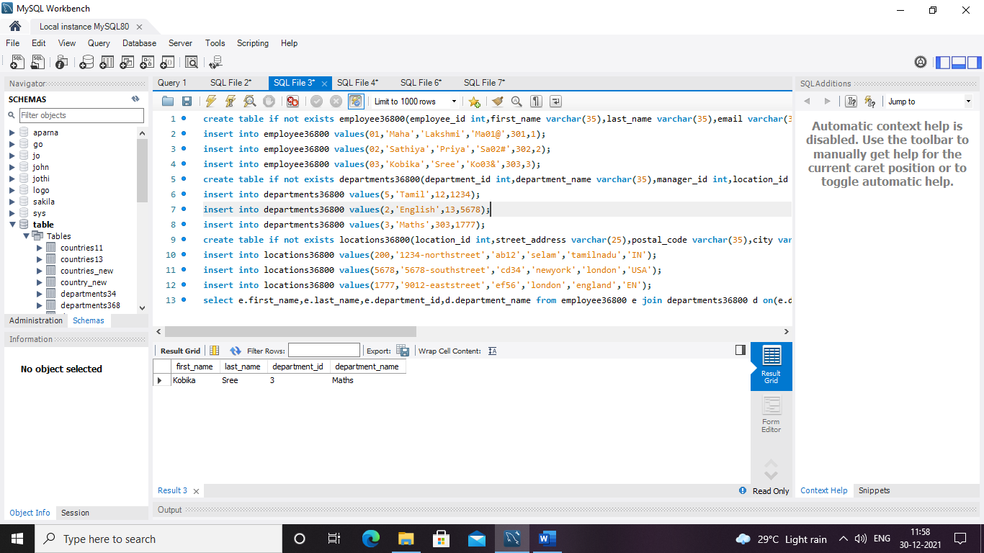

Output:

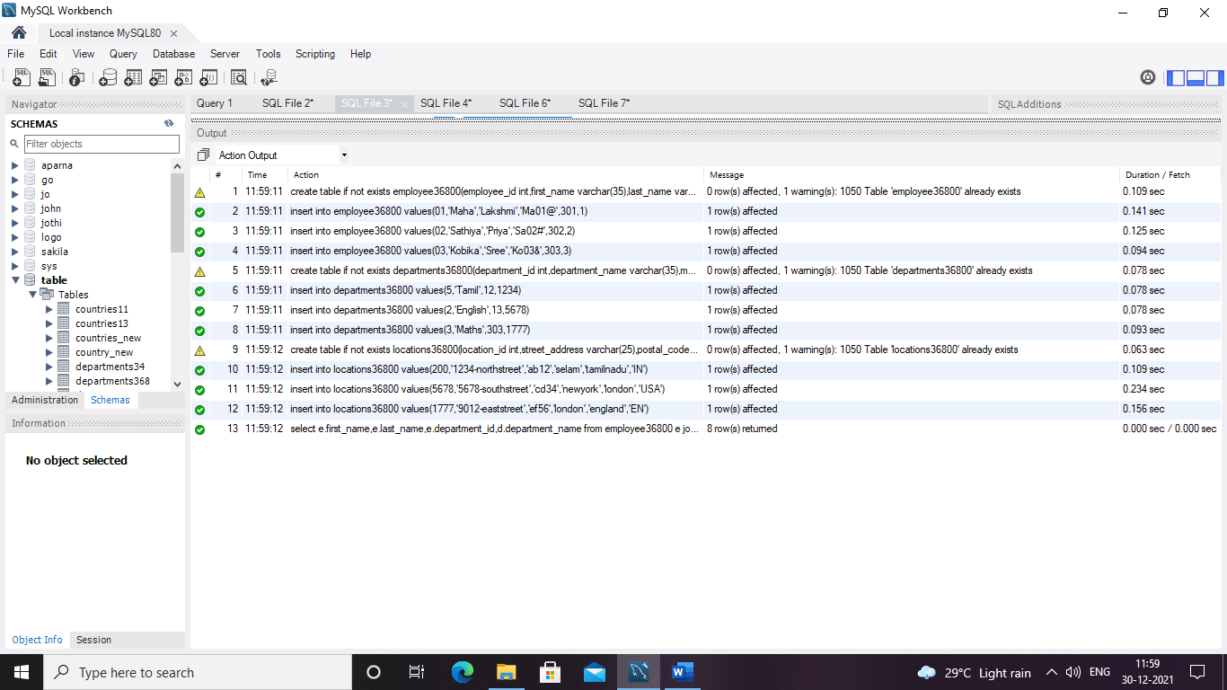

4. To find the name (first_ name, last_ name) and the salary of the employees who have a higher salary then the employee whose last_ name = ’ Priya ’.

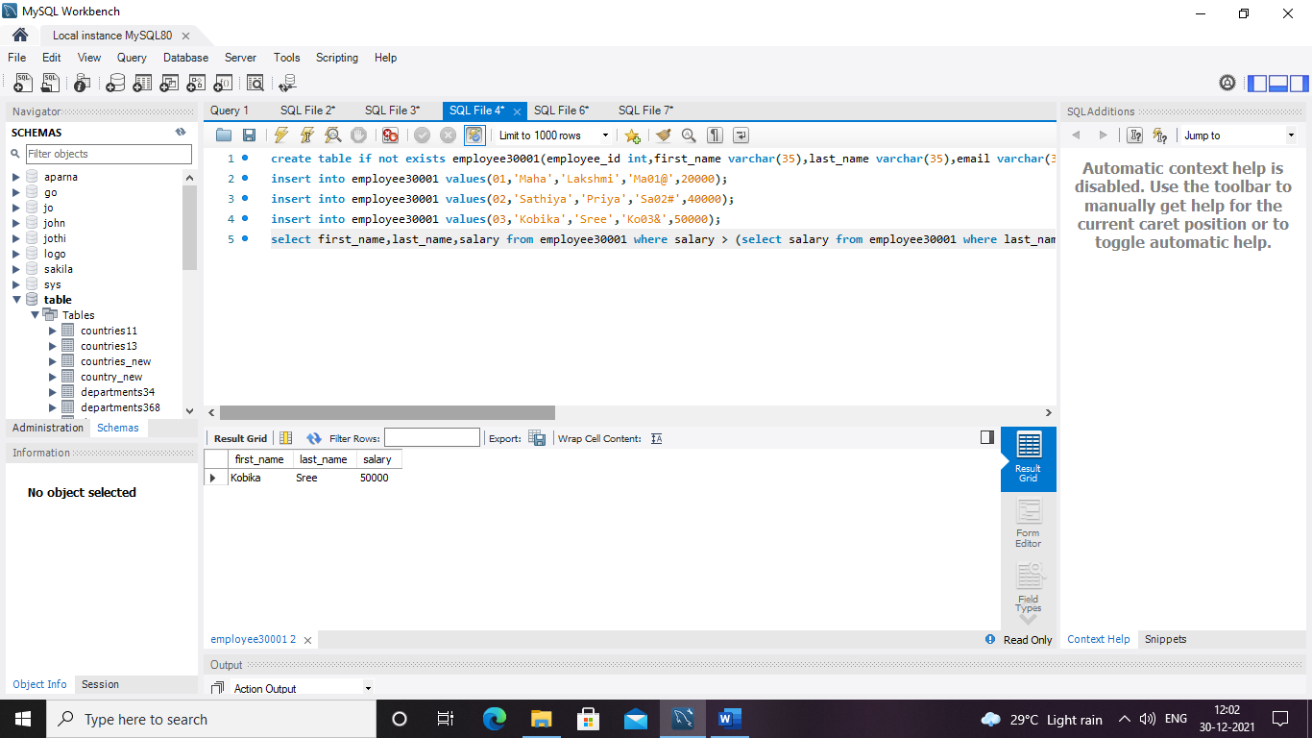

Output:

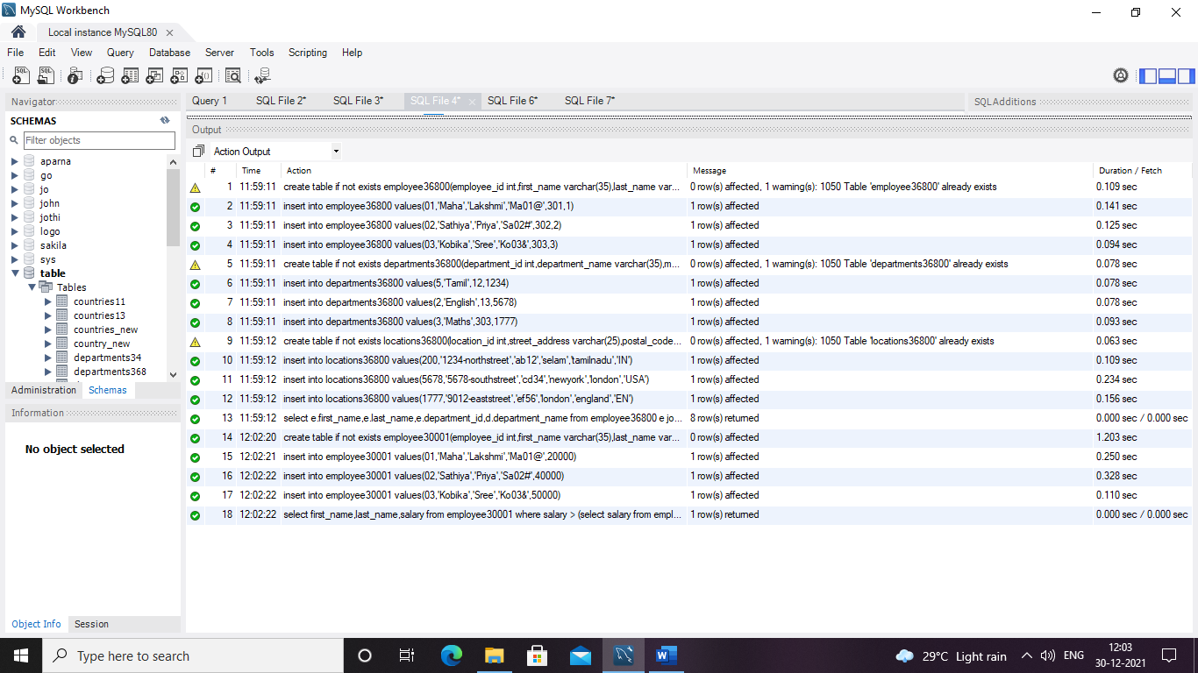

5. To find the name (first_ name, last_ name) of the employees who are managers.

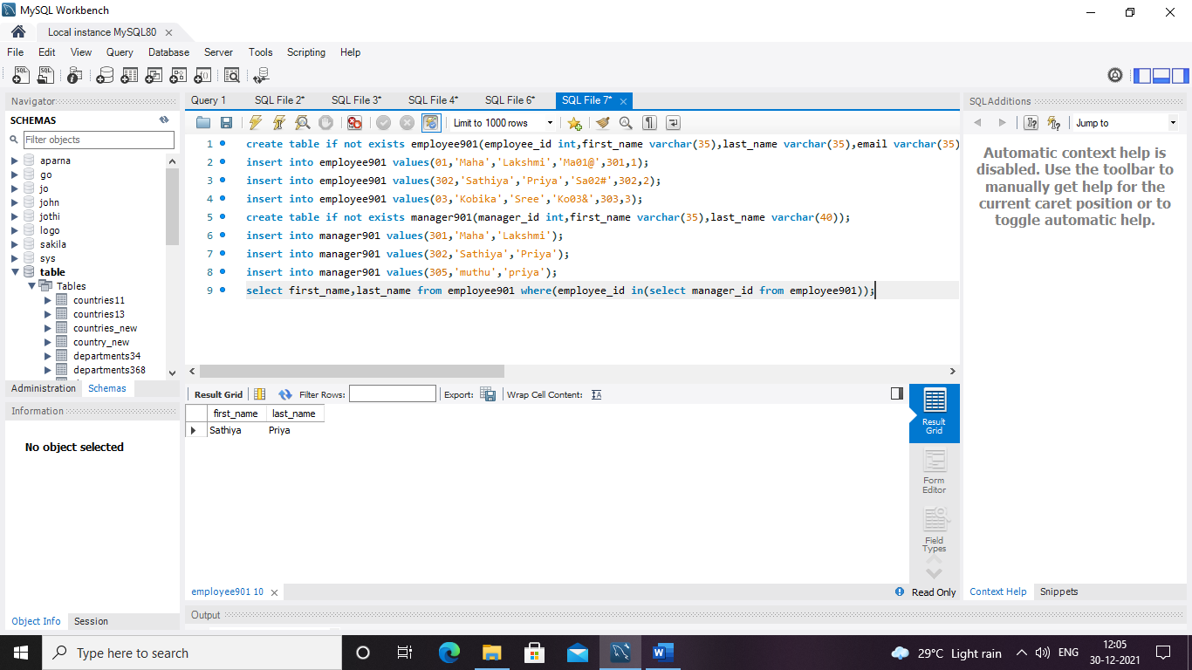

Output:

