https://drive.google.com/file/d/1aLdo6BUFojVKKdvxzM5lNbZ2bnlQ87jY/view?usp=drivesdk

CHAPTER-I

FRESH BITES CATERTING

INTRODUCTION :

**Catering is derived from the word 'cater' which means to provide or to take care of**. It refers to the service of food and beverages to the customers and has a deep relation with the hotel and tourism industry. It provides what is needed or required. The person or establishment provides food and drinks to customers.

Catering is **the process or business of preparing food and providing food services for clients at remote locations, such as hotels, restaurants, offices, concerts, and events**. Companies that offer food, drinks, and other services to various customers, typically for special occasions, make up the catering sector.

A catering professional may be responsible for planning a menu, setting up, or providing utensils and other equipment. Catering does not generally require a formal education, although having training or experience in food preparation, event planning, or business management might make a candidate stronger.

**A catering service makes and provides food and drinks for gatherings such as parties, weddings and business events**. The business will prepare a selection of refreshments — whether it's hors d'oeuvres or a three-course meal — for the party's guests. This menu is pre-approved by the person hiring the catering business.

There are many types of food, and their nutritional value varies. The main food sources are plants, which convert solar energy to the organic matter in photosynthesis, and animals, which feed on plants or other organisms. One of the objectives of catering is to **provide a high-quality meal for your client**.

Start with an attention-grabbing introduction. **Introduce yourself and explain why you are the best candidate for the role**. In the body of the letter, explain why you are the best fit for the job. Highlight your experience in catering management, as well as other relevant experience.

This is especially true if you're not used to cooking for large groups of people. A catering service can help you stay on track by providing a set menu and price ahead of time. This way, you'll know exactly how much your event will cost and you can budget accordingly.

PURPOSE OF FRESH BITES CATERING :

* We specialize in accomodating any/all food allergies and dietary restrictions! - We support small businesses and local spending, so the services we provide
* At Fresh Bites, we are on a mission to revolutionize the way people access nutritious food in today's fast-paced world . We understand the importance
* Fresh Bites Catering in Big Lake, AK is dedicated to catering events with superb meals made from the freshest produce.
* The major forms of modern-day transport catering are airline-catering, railways catering, ship catering and surface catering in coaches or buses which operate on long-distance routes.
* Business to Business Catering: such catering serves business customers such as event planners, office managers, administrators, sales professionals, etc.
* Consumer Catering: such catering services are provided to consumers for special occasions such as birthday parties, funerals, weddings, etc.

CHAPTER-2

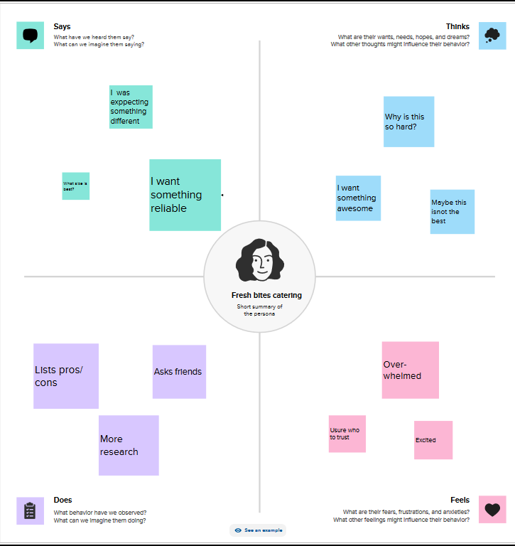EMPATHY MAP:

BRIN STORMING MAP:

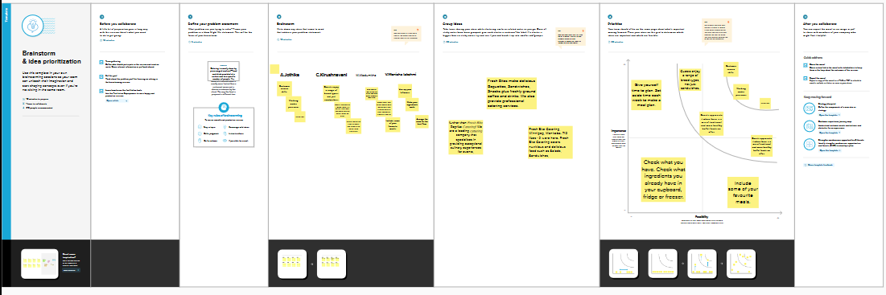

CHAPTER-3

PROFIT&LOSS: 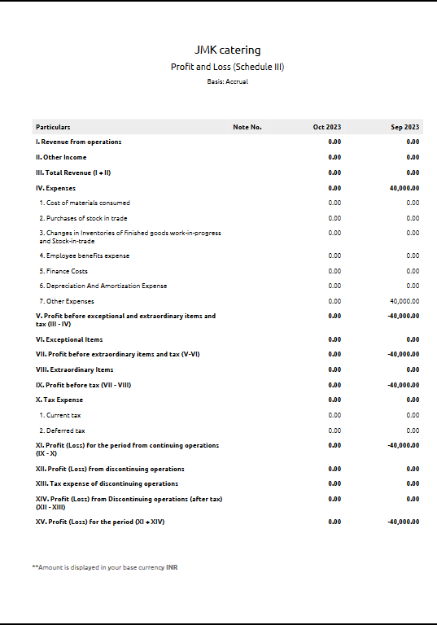

BALANCE SHEET:

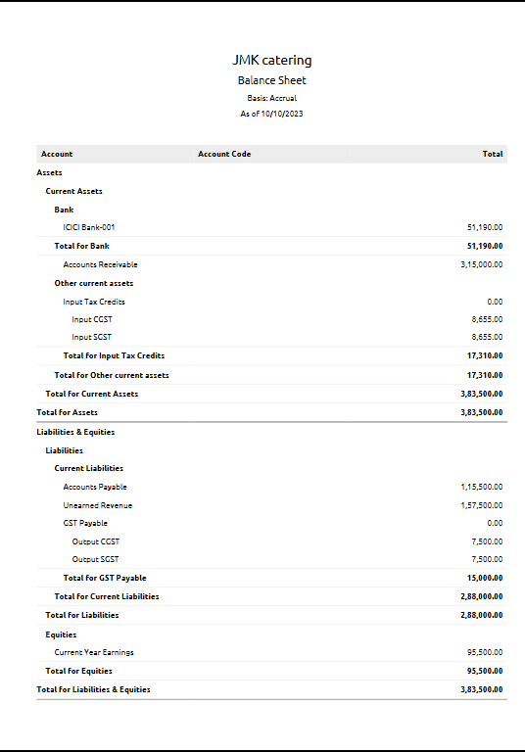

CHAPTER-4

ADVANTAGES OF FRESH BITES CATERING:

* You'll Have More Time to Take Care of Your Guests.
* Dietary Restrictions Can Become a Burden.
* You Can Sit Back, Relax, and Engage Your Guests.
* Catering Food Will Help You Throw an Amazing Party.
* The Pros and Cons of Going into Catering
* You can try new foods. ...
* You do not have to cook. ...
* You get to spend time with family and friends. ...
* It's easier to feed large parties. ...
* You can't tell what nutrients are in your dish.
* You can't control the way the dish is prepared.
* Budget Constraints. ...
* Specialised Diets.
* Brand Consistency.
* Waste Management.

DISADVANDAGES OF FRESH BITES CATERING:

* you'll have a lot of responsibility.
* you'll be extremely busy.
* you'll have a lot of stress.
* it'll be difficult in the beginning of your career.
* Potential for greater risk if costs not managed effectively.
* Non core business/lack of expertise.
* Increased senior management time required from organisation.
* Potential for greater liabilities in terms of employee costs, pensions etc.
* Property Damage. ...
* Food Spoilage. ...
* Worker Accidents. ...
* Equipment Malfunction. ...
* Transportation Accidents.

CHAPTER-5

APPLICATIONS:

Catering is the business of **providing food service at a remote site or a site such as a hotel, hospital, pub, aircraft, cruise ship, park, festival, filming location or film studio**.

A caterer **prepares, delivers and serves meals to diners at special events like weddings, anniversary parties or corporate meetings**. They start by meeting with a client to determine the scheduling, menu and pricing, and then develop a price estimate and a contract for the event.

**How to write a catering proposal in 6 easy steps**

* Step 1: Write a cover letter. ...
* Step 2: Include Your Menu Items & Cost. ...
* Step 3: Add Extra Charges (if any) ...
* Step 4: Total Quote. ...
* Step 5: Explain Your Policies. ...
* Step 6: Signature and Payment Information.
* What makes a good cater?

Great catering service also revolves around **good customer service** – being able to talk to the guests with courtesy and applying the necessary human relations skills possible. A caterer may prepare great meals, set up a good venue, and put some great decors and everything good.

A catering facility is best defined as **a food facility that plans, organizes, prepares or provides food and related services to on-premises or off-premises events from a fixed location**.

**One whose business is to provide food, supplies, and sometimes service at social gatherings**.

CHAPTER-6

CONCLUSION:

It is a service that **delivers, cooks and/or serves food on site at a client's location**. Options can range from full-service to mobile or industrial caterers so that providing food to guests is as easy as possible on the host or client.

Catering is **the activity of providing food and drink for a large number of people**, for example at weddings and parties.

CHAPTER-7

FUTURE SCOPE:

* Preparing and storing food safety before and during events.
* Setting up all tables and food service areas with chairs, linens and dishes.
* Serving food to guests at events.
* Cleaning up and tearing down the dining area by removing all tableware, linens, garbage and furniture.
* Make delicious food. This is a given! ...
* Ensure excellent customer service. ...
* Hone your ability to organize events. ...
* Keep Attire Professional. ...
* Ensure a sanitary environment. ...
* Offer competitive pricing. ...
* Keep profits high without sacrificing service. ...
* Develop excellent management skills.
* Executive Summary.
* Company Overview.
* Team and Management.
* Market and Opportunity.
* Business Operational Plan.
* Products and Services.
* Marketing Plan.
* Financial Projections.