

COLLEGE CODE:1123

COLLEGE NAME:SRI KRISHNA COLLEGE OF ENGINEERING

DEPARTMENT:COMPUTER SCIENCE

STUDENT NM-ID: E6c545e699da820aab041daa42ae5518

ROLL NO:112323104006

DATE:14.05.2025

**Completed the project named as**

**ARTIFICIAL INTELLIGENCE-POWEREDAUTONOMOUS VEHICLES AND ROBOTICS**

SUBMITTED BY,

1. S.JOTHIKA

TEAM MEMBERS:

2.M.ISHWARYA

3.M.DHANUSH

4.S.JAMES

5. P.DASPRAKASH

Phase 5: Project Demonstration & Documentation

Title: AI-Powered Autonomous Vehicles And Robotics

Abstract:

This project presents an AI-powered autonomous vehicle and robotics system capable of navigating environments, detecting obstacles, and making real-time decisions without human input. Using machine learning, sensors, and computer vision, the prototype demonstrates efficient, intelligent mobility—highlighting the potential of AI in robotics and self-driving technologies.

1.Project Demonstration

Overview:

The project demonstration showcases the key functionalities and real-time performance of the AI-powered autonomous vehicles and robotics system. It highlights how AI enables the system to perceive the environment, make decisions, and operate independently with minimal human intervention.

Demonstration Details:

• **Autonomous Navigation:** The vehicle successfully followed a designated path using AI algorithms and real-time sensor data.

• **Obstacle Detection and Avoidance:** Integrated sensors and AI enabled the system to detect and avoid static and dynamic obstacles.

• **Object Recognition:** The robotic unit identified and interacted with objects using computer vision techniques.

• **Task Execution:** The robot performed pre-programmed tasks such as picking up or moving objects with precision.

•  **Real-Time Decision Making:** AI models allowed the system to adapt to changing environments and make autonomous decisions.

Outcome:

The outcome demonstrated the practical potential of AI and robotics for applications in autonomous transportation, warehouse automation, and beyond.

2.Project Documentation

Overview:

The project documentation provides a complete record of the design, development, and implementation of the AI-powered autonomous vehicles and robotics system. It includes technical specifications, system architecture, development processes, and testing results. This documentation ensures clarity, supports future enhancements, and serves as a reference for developers, stakeholders, and researchers.

Documentation Sections:

• **System Architecture:** Diagrams and descriptions of hardware and software integration.

• **Technology Stack:** Details of AI models, programming languages, platforms, and hardware components used.

• **Development Process:** Step-by-step explanation of design, coding, testing, and integration.

• **Algorithms and Models:** Explanation of AI techniques used for navigation, object detection, and decision- making.

• **Testing & Validation:** Methods used to evaluate system performance and reliability.

Outcome:

This ensures the project can be maintained, scaled, or replicated in the future, and serves as a valuable resource for both technical teams and stakeholders.

3.Feedback and Final Adjustments

Overview:

This phase focuses on collecting feedback from testing, demonstrations, or stakeholders to identify areas for improvement. Based on the feedback received, final adjustments were made to enhance the system’s performance, usability, and reliability before final deployment or submission.

Steps:

• C**ollect Feedback:** Gathered input from users, testers, and stakeholders after the demonstration.

• **Analyze and Modify:** Reviewed the feedback, identified necessary improvements, and made technical or functional adjustments.

• **Test and Finalize:** Re-tested the system to ensure all changes were effective and the project was ready for final delivery.

Outcome:

Final adjustments ensured that the AI-powered autonomous vehicle and robotics system operated smoothly, met project goals, and was ready for deployment or presentation.

4.Final Project Report Submission

Overview:

The final project report compiles all aspects of the AI-powered autonomous vehicles and robotics project, including planning, development, demonstration, feedback, and final adjustments. It serves as a comprehensive document that reflects the entire project lifecycle, key findings, challenges faced, and solutions implemented, ensuring clarity and completeness for evaluation or future reference.

Report Sections:

• **Executive Summary:**Summarizes the project goals, development process, and key achievements.

• **Challenges & Solutions:**Identifies major issues faced and explains how they were effectively resolved.

• **Phase Breakdown:**Outlines key stages: planning, design, implementation, testing, and refinement.

• **Outcomes:**Highlights successful demonstration, system reliability, and future potential.

Outcome:

The final system performed reliably during testing, confirming its real-world applicability and potential for future development.

5.Project Handover and Future Works

Overview:

It also highlights potential areas for future development, improvements, and research based on the current system’s performance and limitations.

Handover Details:

• **Next Steps:** Suggestions for future work, including scaling the system to support more users, expanding AI capabilities, and implementing multilingual support, will be providing.

Outcome:

The AI-Powered Autonomous Vehicles And Robotics will be officially handed over, along with recommendations for future enhancements and guidelines for system maintenance.

**source code for phase3 in Artificial Intelligence Powered Autonomous Vehicles And Robotics**

<!DOCTYPE html>

<html lang="en">

<head>

<meta charset="UTF-8" />

<meta name="viewport" content="width=device-width, initial-scale=1.0"/>

<title>Autonomous Vehicles & Robotics</title>

<style>

body {

font-family: Arial, sans-serif;

margin: 0;

padding: 0;

background-color: #f8f9fa;

}

header {

background-color: #222;

color: white;

padding: 40px 20px;

text-align: center;

}

nav {

background-color: #333;

padding: 10px;

text-align: center;

}

nav a {

color: white;

text-decoration: none;

margin: 0 15px;

font-weight: bold;

}

.section {

padding: 40px 20px;

max-width: 1000px;

margin: auto;

}

.section h2 {

text-align: center;

margin-bottom: 20px;

}

.features {

display: flex;

flex-wrap: wrap;

gap: 20px;

justify-content: center;

}

.feature {

background: white;

padding: 20px;

border-radius: 8px;

box-shadow: 0 2px 10px rgba(0,0,0,0.1);

flex: 1 1 250px;

text-align: center;

}

footer {

background-color: #222;

color: white;

text-align: center;

padding: 20px;

}

</style>

</head>

<body>

<header>

<h1>Autonomous Vehicles & Robotics</h1>

<p>Innovating the Future of Mobility and Automation</p>

</header>

<nav>

<a href="#about">About</a>

<a href="#features">Features</a>

<a href="#contact">Contact</a>

</nav>

<div class="section" id="about">

<h2>About Us</h2>

<p>

We specialize in cutting-edge autonomous vehicle and robotics technology.

Our mission is to create safe, efficient, and intelligent solutions for transportation and automation challenges.

</p>

</div>

<div class="section" id="features">

<h2>Our Solutions</h2>

<div class="features">

<div class="feature">

<h3>Self-Driving Cars</h3>

<p>Advanced perception, decision-making, and navigation systems for urban and highway driving.</p>

</div>

<div class="feature">

<h3>Delivery Robots</h3>

<p>Autonomous ground robots designed to deliver goods efficiently and securely in cities and campuses.</p>

</div>

<div class="feature">

<h3>AI Integration</h3>

<p>State-of-the-art machine learning models for object detection, mapping, and environment understanding.</p>

</div>

</div>

</div>

<div class="section" id="contact">

<h2>Contact Us</h2>

<p>Email: info@autovehicles-robotics.com</p>

<p>Phone: +1 (123) 456-7890</p>

</div>

<footer>

<p>&copy; 2025 Autonomous Vehicles & Robotics. All rights reserved.</p>

</footer>

</body>

</html>

**SCREENSHOT FOR PHASE 3:**

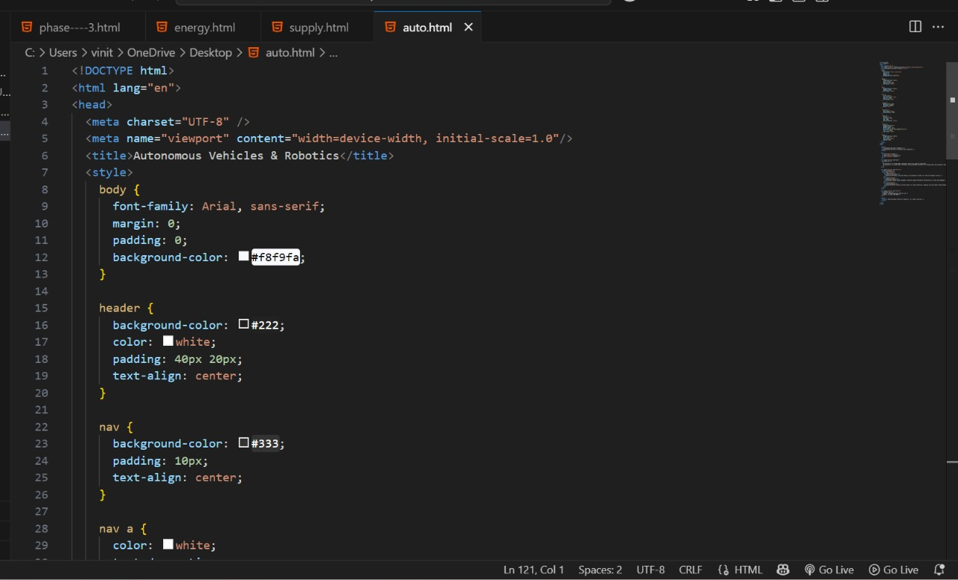

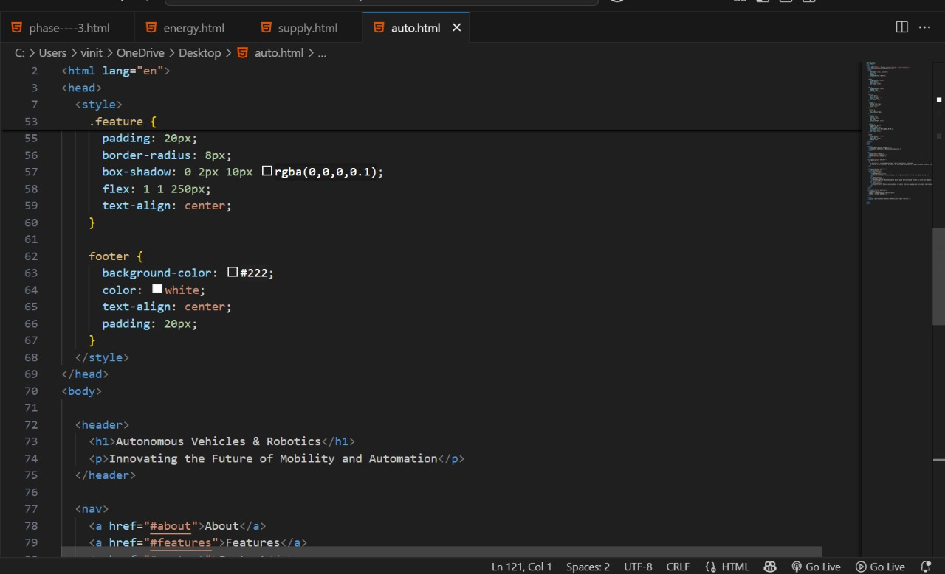

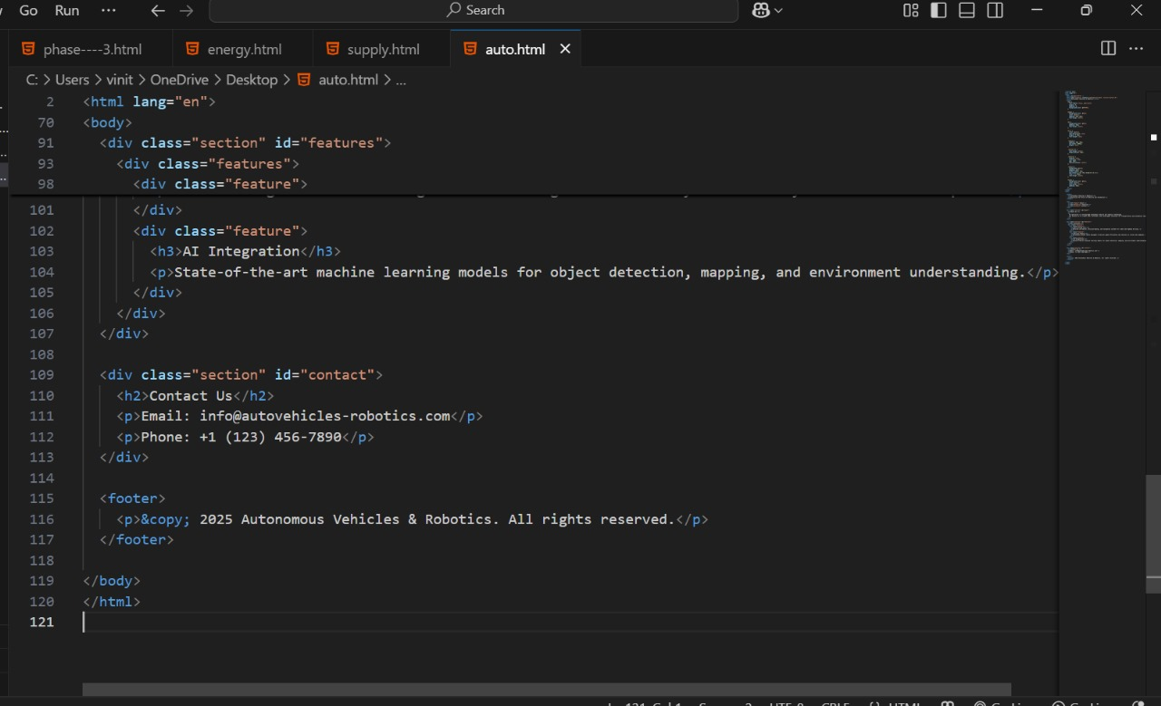

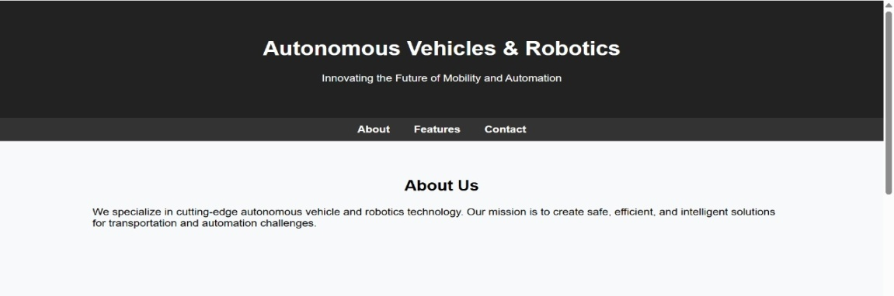

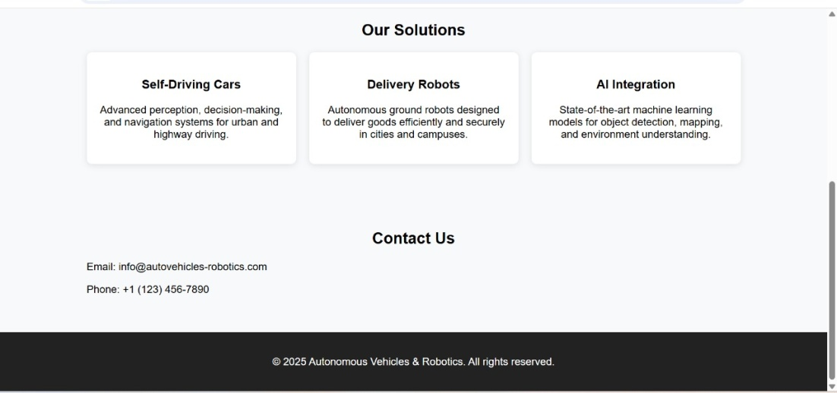

**Source code for phase 4 in artificial intelligence powered Autonomous Vehicles And Robotics**

**import math**

**import time**

**# Differential drive robot class**

**class DiffDriveRobot:**

**def _init_(self, x=0, y=0, theta=0):**

**self.x = x # Robot x position**

**self.y = y # Robot y position**

**self.theta = theta # Robot orientation (radians)**

**def move(self, v, w, dt):**

**# v: linear velocity, w: angular velocity, dt: time step**

**self.x += v * math.cos(self.theta) * dt**

**self.y += v * math.sin(self.theta) * dt**

**self.theta += w * dt**

**self.theta = self.theta % (2 * math.pi)**

**def get_position(self):**

**return (self.x, self.y, self.theta)**

**# Simple proportional controller to follow waypoints**

**def follow_path(robot, waypoints, dt=0.1):**

**K_linear = 1.0**

**K_angular = 4.0**

**for wp in waypoints:**

**while True:**

**x, y, theta = robot.get_position()**

**dx = wp[0] - x**

**dy = wp[1] - y**

**distance = math.hypot(dx, dy)**

**if distance < 0.05: # close enough to waypoint**

**break**

**path_angle = math.atan2(dy, dx)**

**angle_diff = path_angle - theta**

**# Normalize angle_diff to [-pi, pi]**

**angle_diff = (angle_diff + math.pi) % (2 * math.pi) - math.pi**

**v = K_linear * distance**

**w = K_angular * angle_diff**

**# Limit speeds**

**v = min(v, 0.5)**

**w = max(min(w, 1.0), -1.0)**

**robot.move(v, w, dt)**

**print(f"Robot position: x={robot.x:.2f}, y={robot.y:.2f}, theta={math.degrees(robot.theta):.1f}°")**

**time.sleep(dt)**

**# Example usage**

**robot = DiffDriveRobot()**

**# Define waypoints for the robot to follow**

**waypoints = [(1, 0), (1, 1), (0, 1), (0, 0)]**

**follow_path(robot, waypoints)**

**screenshot for phase 4:**

