RETAIL STORE PERFORMANCE

MINI PROJECT DOCUMENTATION

Presented by:
Uchinimakali Jothilakshii.B

Mini Project – Power BI & Excel
Tools Used: Excel | Power BI
2026

1. Project Overview and Objectives:
This project focuses on cleaning, transforming, and analyzing retail sales data using Excel and Power BI. The cleaned data is used to create interactive reports and a sales performance dashboard to understand sales, profit, store performance, and customer and order behavior.
The main objective of this project is to demonstrate data cleaning and transformation techniques in Excel and develop interactive Power BI visualizations. The project helps identify important business trends and performance patterns, enabling better understanding and data-driven decision-making.

2. Data Sources:
• Source: GitHub
• Dataset: Retail Sales Dataset
• Domain: Retail Sales and Business Performance
• Data Downloaded: 25 September 2026
• Purpose: The dataset was used to analyze sales, profit, store and manager performance, and customer and order behavior using Excel and Power BI.

3. Problem Statement:
• To analyze sales and profit performance across different product categories, stores, cities, and regions.
• To identify high-performing and low-performing stores and understand their contribution to overall business performance.
• To analyze customer and order behavior, including order status, payment methods, and customer ratings.

4. Attributes (Columns and Features) Details:
Attribute Name | Data Type | Description
Order ID | Text | Unique identification number for each order
Order Date | Date | Date on which the order was placed
Store Name | Text | Name of the store where the order was recorded
City | Text | City where the store is located
State | Text | State where the store is located
Region | Text | Region of the store
Store Manager | Text | Manager responsible for the store
Category | Text | Product category
Product Name | Text | Name of the product
Quantity | Whole Number | Number of units ordered
Unit Price | Decimal | Price of one unit of the product
Discount Percentage | Percentage | Discount percentage applied to the order
Discount Amount | Decimal | Amount of discount applied
Sales | Decimal | Total sales value of the order
Cost | Decimal | Cost associated with the order
Profit | Decimal | Profit or loss from the order
Profit Status | Text | Shows whether the order is Profit, Break-Even, or Loss
Discount Status | Text | Indicates the discount level applied to the order
Payment Method | Text | Payment method used by the customer
Order Status | Text | Current status of the order
Customer Rating | Decimal | Rating given by the customer
Rating Status | Text | Categorizes ratings as High Rating, Low Rating, or Not Rated

5. Tools and Technologies:
Excel
- Data cleaning and data transformation
- Handling missing values and duplicates
- Creating calculated fields
- Filtering and sorting data
- Creating pivot tables
Power BI
- Data import and preparation
- DAX calculations
- Data visualization
- Interactive report creation
- Interactive dashboard creation

6. Data Pre-processing (Excel and Power BI):
Excel Data Pre-processing
Data Cleaning and Transformation
- Removed duplicate records and handled missing values.
- Standardized data formats and created calculated fields.
- Filtered and sorted the data based on relevant fields, including date-based sorting.
Descriptive Summary
- Created a descriptive summary of Sales and Profit for initial analysis.
Pivot Table Analysis
- Sales and Profit by Category
- Category Sales and Cost Analysis
- Store Performance
- Order Status Analysis
- Payment Method Analysis
Power BI Data Pre-processing
- Transformed the data and changed the data types of the required fields

7. Data Modeling and DAX (Power BI):
Data Modeling
- The dataset contains a single table, so no separate data modeling or relationships were created.
Calculated and DAX Measure
- Created a Sales YTD measure using DAX to calculate year-to-date sales.
- Other KPI values such as Total Sales, Total Profit, Total Cost, Total Orders, Average Discount, and Average Profit were created using built-in aggregation options through drag-and-drop, without creating separate DAX measures.

8. Analysis and Visualization (Power BI Dashboard Features):
Analysis and Visualization
Created three separate Power BI reports based on different areas of the retail sales data:
- Sales and Profit Overview – Analyzed overall sales, profit, cost, orders, discounts, and sales trends.
- Store and Manager Performance – Analyzed store, manager, region, state, and city performance.
- Customer and Order Behavior – Analyzed order status, payment methods, customer ratings, and discount behavior.
Dashboard Features
- Created multiple visualizations based on the project objectives, including KPI cards, bar charts, column charts, line charts, pie/donut charts, scatter charts, and other relevant visuals.
- Used clear titles and labels for each visual to make the analysis easy to understand.
- Used filters and slicers to make the reports interactive.
- Added a navigation button to move between report pages.
- Created a consolidated Sales Performance Dashboard by combining the most important visuals from the three reports.
Consolidated Report and Dashboard
- Created a consolidated Sales Performance Dashboard to provide an overall view of retail sales performance.
Reports:
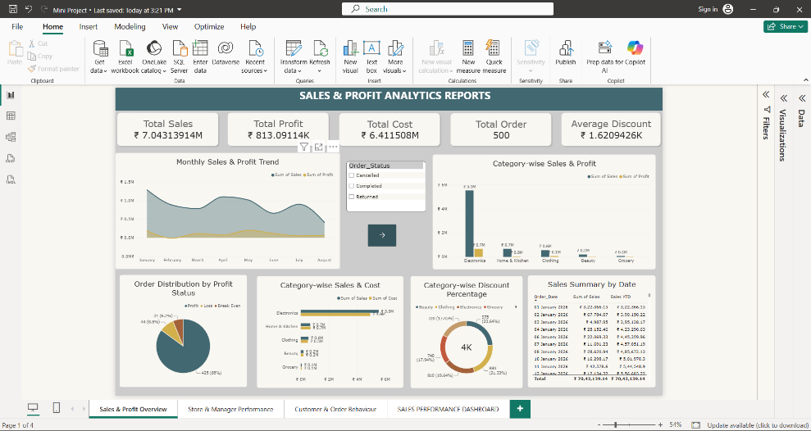

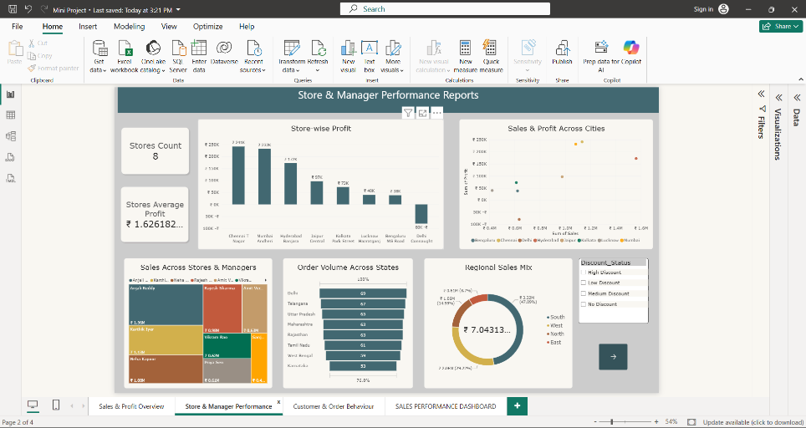
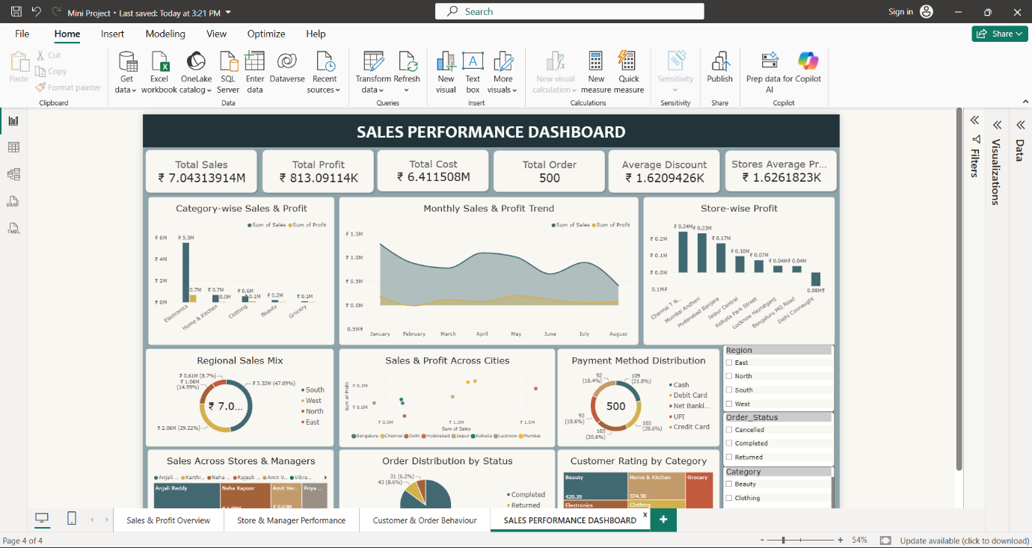
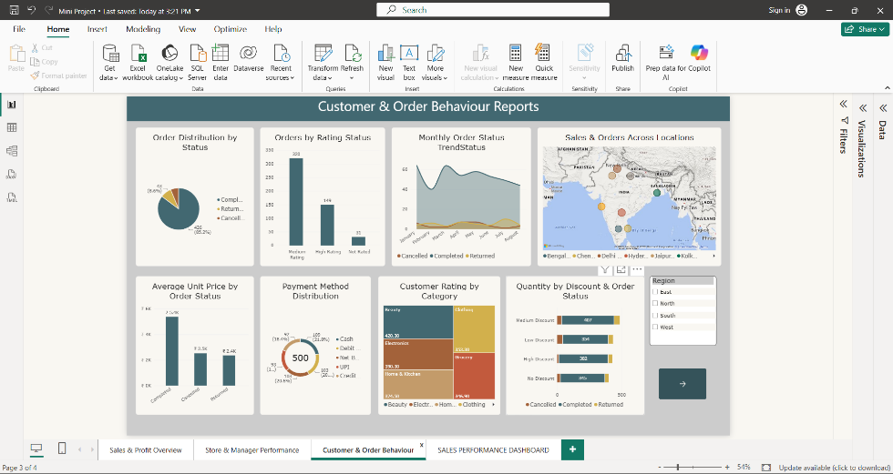

Dashboard:
9. Insights and Conclusions:
Key Findings
- Identified important trends and patterns in sales, profit, store performance, customer ratings, order status, and payment methods.
- Observed variations in sales and profit across different categories, stores, cities, and regions.
Analysis Insights
- Descriptive Analysis: Summarized sales, profit, cost, orders, discounts, customer ratings, and other key metrics using descriptive summaries, Pivot Tables, and Power BI visuals.
- Diagnostic Analysis: Compared different categories, stores, regions, order statuses, and payment methods to understand the factors contributing to differences in sales and profit.
- Predictive Analysis: Not performed in this project.
- Prescriptive Analysis: Not performed in this project.

10. Conclusion:
This project provided a complete approach to analyzing retail sales data using Excel and Power BI. Excel was used for data cleaning, transformation, descriptive analysis, and Pivot Table analysis, while Power BI was used to create interactive reports and a consolidated Sales Performance Dashboard. The project helped present retail sales and performance information in a clear and interactive way.

