CoreNLP - Standford

Standford NLP tools:
1. Parts of Speech (POS) tagger
2. Named Entity Recognizer (NER)
3. Parser
4. Coreference Resolution system
5. Sentiment analysis
6. Bootstrapped Pattern Learning
7. Open Information Extraction

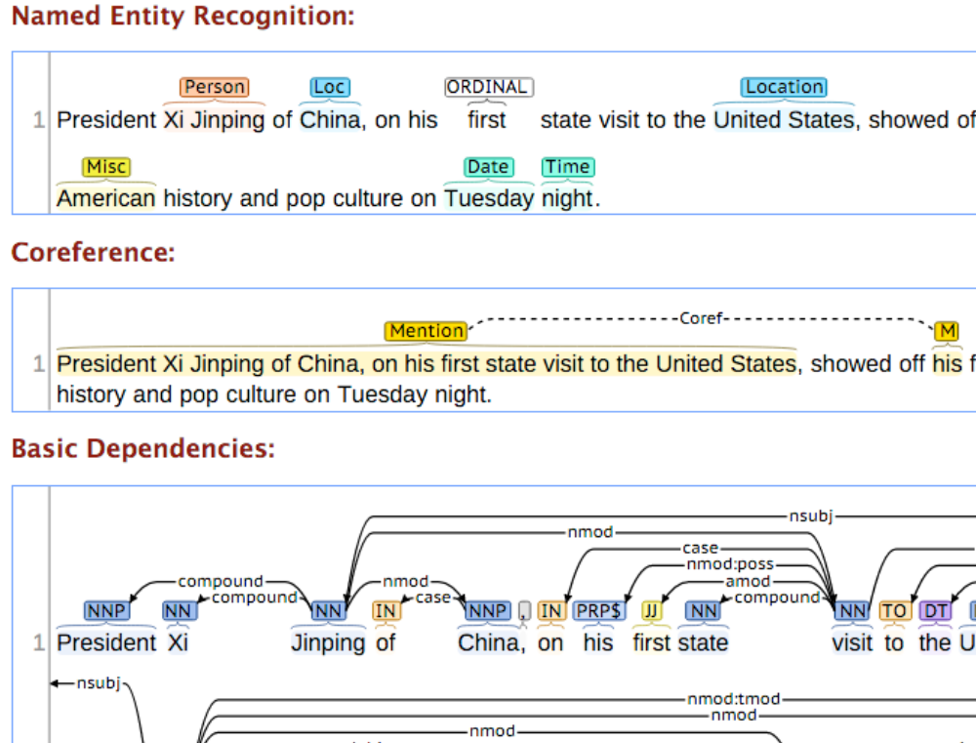
1. Parts-of-Speech Tagger
A Part-Of-Speech Tagger (POS Tagger) is a piece of software that reads text in some language and assigns parts of speech to each word (and other token), such as noun, verb, adjective, etc.,

