SRM VALLIAMMAI ENGINEERING COLLEGE
Department of Computer Applications
Kattankulathur, Chennai - 603 203
─────────────────────────────────────────────
PROJECT REPORT
Master of Computer Applications (MCA)
AI-Powered Smart Traffic Controller System
Using Deep Learning & YOLOv4-tiny
─────────────────────────────────────────────
Submitted by
Jothivasan M
Register No: [Your Register Number]
Under the Guidance of
Ms. Revathi D
Affiliated to Anna University, Chennai
Academic Year 2025 – 2026

TABLE OF CONTENTS
CHAPTER NO. | TITLE | PAGE NO.
 | ABSTRACT | i
I | INTRODUCTION | 1
 | 1.1 Background and Motivation | 1
 | 1.2 Importance | 2
 | 1.3 Scope and Limitations | 2
II | PROBLEM DEFINITION | 3
 | 2.1 Problem Definition | 3
 | 2.2 Objectives | 3
 | 2.3 Existing Solutions | 4
III | PROPOSED SOLUTION | 5
 | 3.1 Proposed Idea | 5
 | 3.2 Technology Used | 5
 | 3.3 Hardware and Software Requirements | 6
 | 3.4 Working Principle | 7
 | 3.5 Innovation / Uniqueness | 8
IV | EXPECTED RESULTS | 9
 | 4.1 Expected Results | 9
 | 4.2 Future Enhancements | 10
 | 4.3 Learning Outcomes | 10
 | 4.4 Conclusion | 11
 | REFERENCES | 12

ABSTRACT
The rapid increase in urban populations has led to severe traffic congestion, resulting in lost time, increased fuel consumption, and environmental pollution. Traditional traffic management systems operate on fixed time intervals, which are inefficient for handling dynamic, real-time traffic conditions.
This project presents an AI-Powered Smart Traffic Controller System that utilizes computer vision and deep learning to dynamically adjust traffic signal timings based on real-time vehicle density. By employing the YOLOv4-tiny object detection model via OpenCV, the system continuously analyzes video feeds from a webcam or uploaded video to count vehicles, classify traffic density into predefined categories (LOW, MEDIUM, HIGH), and instantly calculate optimal green and red light durations.
The solution is wrapped in a responsive web application built with Flask and JavaScript, providing an intuitive dashboard for monitoring real-time traffic statistics and video streams. The system eliminates the inefficiency of static signal control and represents a significant step towards smart city infrastructure.
Keywords: YOLOv4-tiny, Object Detection, Traffic Signal Control, Deep Learning, Flask, OpenCV, Smart City

CHAPTER I
INTRODUCTION
1.1 Background and Motivation
Traffic congestion is a universal and growing problem in modern cities worldwide, particularly in rapidly urbanizing regions like India. As vehicle populations surge, the limitations of conventional traffic management systems become increasingly apparent. Most existing traffic lights operate on pre-programmed, static timing cycles that were designed decades ago without consideration for real-time traffic dynamics.
This static approach leads to critical inefficiencies — a green light may remain active for an empty road while vehicles stack up on a heavily congested cross-street. The result is wasted time, excessive fuel consumption, increased carbon emissions, and heightened driver frustration. In cities like Chennai, where traffic density fluctuates wildly between rush hours and off-peak periods, a fixed-cycle system is fundamentally inadequate.
The motivation behind this project stems from the convergence of two transformative technologies: computer vision and deep learning. The advent of real-time object detection models such as YOLO (You Only Look Once) has made it possible to accurately count and classify vehicles in live video streams at high speed, even on standard consumer hardware. This capability opens the door to a new generation of adaptive, intelligent traffic control systems.
1.2 Importance of the Project
An adaptive, intelligent traffic control system delivers measurable benefits across multiple dimensions. First, it minimizes vehicle wait times by dynamically assigning green light duration proportional to actual traffic load, ensuring roads are used efficiently. Second, reduced idling and stop-start driving patterns directly lower fuel consumption and carbon dioxide emissions, contributing to environmental sustainability goals.
Third, emergency vehicle routing is significantly improved — the system can potentially be extended to recognize ambulances or fire trucks and grant them adaptive green signals. Fourth, from an infrastructure perspective, this project demonstrates how existing camera hardware can be retrofitted with AI capabilities, avoiding costly physical overhauls of road infrastructure.
This project shifts the paradigm from static signal control to a dynamic, vision-based approach, laying the groundwork for fully autonomous smart city traffic management. It is aligned with national smart city initiatives and global sustainable development goals related to urban mobility.
1.3 Scope and Limitations
The scope of this project encompasses the design, development, and demonstration of a single-lane AI traffic controller that processes video input (either from a live webcam or an uploaded video file) and dynamically adjusts signal timings based on real-time vehicle counts. The system provides a fully functional web interface for monitoring and control.
Current limitations include the following: the system operates on a single camera feed and does not yet support multi-directional intersection management. Performance may degrade in extreme weather conditions such as heavy fog, rain, or low-light nighttime environments due to the reliance on standard RGB camera input. Additionally, large vehicles such as buses can occlude smaller vehicles like motorcycles, leading to minor undercounting in dense scenarios. The current deployment is a prototype designed for demonstration purposes and would require further hardening and optimization for production-scale smart city deployment.

CHAPTER II
PROBLEM DEFINITION
2.1 Problem Definition
The core problem addressed by this project is the fundamental inefficiency of static, timer-based traffic signal systems in managing dynamic real-world traffic conditions. Conventional traffic lights operate on a fixed pre-set cycle — for example, 30 seconds green followed by 30 seconds red — regardless of the actual number of vehicles present at each junction.
This one-size-fits-all approach creates multiple cascading problems. During peak hours, heavily loaded lanes receive the same green time as lightly loaded lanes, causing unnecessary congestion. During off-peak hours, empty lanes hold green lights for extended durations, wasting time for vehicles waiting at adjacent signals. Collectively, this leads to network-wide traffic gridlock, excessive fuel burn, and increased pollution.
The problem is further compounded in developing urban regions where traffic composition is heterogeneous — including cars, motorcycles, buses, trucks, and bicycles — making standardized timing even less effective. There is a pressing need for a system that can perceive actual traffic conditions in real time and respond intelligently.
2.2 Objectives
The following specific objectives were defined for this project:
- To develop a real-time vehicle detection pipeline using the YOLOv4-tiny deep learning model and OpenCV to accurately count vehicles across five categories: cars, motorcycles, buses, trucks, and bicycles.
- To design a density classification algorithm that categorizes real-time vehicle counts into LOW, MEDIUM, and HIGH traffic density levels.
- To implement a dynamic signal timing generator that calculates optimal green and red light durations based on the classified traffic density, replacing static fixed-cycle timers.
- To build a SmoothCounter mechanism using a sliding-window median filter to stabilize frame-to-frame vehicle count fluctuations and ensure reliable density classification.
- To develop a full-stack web application using Flask (backend) and HTML5/CSS3/JavaScript (frontend) that provides a live MJPEG video stream, real-time statistics dashboard, and control panel for video upload or webcam switching.
- To implement a robust fallback detection mechanism using OpenCV MOG2 background subtraction for environments where deep learning model weights are unavailable.
2.3 Existing Solutions
Several approaches to adaptive traffic signal control have been explored in literature and industry:
Fixed-Time Control Systems remain the most widespread solution globally due to their low cost and simplicity. However, they are inherently unable to adapt to varying traffic demand. Actuated signal systems use inductive loop detectors embedded in road surfaces to detect vehicle presence and extend green phases. While an improvement over fixed-time systems, these require expensive physical infrastructure embedded in roads and provide only basic presence detection without density estimation.
SCOOT (Split Cycle Offset Optimization Technique) and SCATS (Sydney Coordinated Adaptive Traffic System) are city-level adaptive systems that use sensor networks and optimization algorithms to coordinate multiple junctions. However, these systems are extremely costly, require extensive infrastructure, and are impractical for developing nations or smaller-scale deployments.
Recent academic research has proposed vision-based approaches using traditional computer vision techniques such as background subtraction, optical flow, and frame differencing. While these methods function without deep learning, they are less robust to lighting variations and complex traffic scenarios. The proposed solution addresses these gaps by leveraging the power of a pre-trained deep learning model (YOLOv4-tiny) to provide accurate, class-specific vehicle detection at real-time speeds using only a standard camera, making it both cost-effective and highly accurate.

CHAPTER III
PROPOSED SOLUTION
3.1 Proposed Idea
The proposed solution is an AI-Powered Smart Traffic Controller System that replaces static timing with a fully dynamic, vision-driven signal control loop. The system uses a live video feed as its sole input and produces adaptive traffic signal timings as its output, with no need for embedded road sensors or costly infrastructure modifications.
The central idea is to treat each traffic signal as an independent intelligent agent equipped with a camera eye. This agent continuously perceives the traffic density at its junction, classifies the situation, and adjusts its signal timing accordingly. A web-based dashboard serves as the command and monitoring interface, allowing operators to view live detection feeds, track signal states, and upload pre-recorded video for analysis.
3.2 Technology Used
The following technologies form the core stack of the proposed system:
Technology | Purpose / Role
YOLOv4-tiny | Primary object detection model for real-time vehicle identification and counting
OpenCV (cv2) | Video capture, frame preprocessing, DNN inference, and bounding box visualization
Python 3.x | Core programming language for backend logic and ML pipeline
Flask | Lightweight web framework serving REST API endpoints and MJPEG video stream
Flask-CORS | Cross-Origin Resource Sharing support for frontend-backend communication
NumPy | Numerical operations for blob creation, NMS, and sliding window computation
HTML5 / CSS3 | Frontend UI structure and glassmorphism visual design
JavaScript (Vanilla) | Client-side polling, real-time statistics update, and control panel logic
COCO Dataset | Pre-training dataset providing weights for 80-class object detection
MOG2 Background Subtractor | Fallback detection mechanism when YOLO weights are unavailable

3.3 Hardware and Software Requirements
Hardware Requirements:
- Processor: Intel Core i5 / AMD Ryzen 5 or higher (dual-core minimum, quad-core recommended for smooth real-time processing)
- RAM: Minimum 8 GB (16 GB recommended for concurrent Flask server and OpenCV processing)
- Storage: At least 2 GB free disk space for model weights, application files, and video uploads
- Camera: USB Webcam (720p or higher) or IP Camera supporting RTSP streaming
- GPU: Optional — NVIDIA GPU with CUDA support can accelerate inference; CPU-only operation is fully supported

Software Requirements:
- Operating System: Windows 10/11, Ubuntu 20.04+, or macOS 12+
- Python 3.8 or higher with pip package manager
- OpenCV 4.5+ with DNN module support
- Flask 2.x and Flask-CORS
- NumPy 1.21+
- YOLOv4-tiny pre-trained weights (yolov4-tiny.weights) and configuration file (yolov4-tiny.cfg)
- COCO class names file (coco.names)
- Modern web browser (Chrome, Firefox, Edge) for the dashboard
3.4 Working Principle
The system operates on a continuous multi-threaded processing loop. The following describes the end-to-end workflow:
Step 1 — Video Ingestion: The system captures frames from either a USB webcam using OpenCV's VideoCapture(0) or from an uploaded MP4/AVI video file. Each frame is read at the native camera frame rate.
Step 2 — Frame Preprocessing: Each captured frame is resized to 900x540 pixels for display. A 416x416 deep learning blob is simultaneously generated using cv2.dnn.blobFromImage(), with pixel normalization by 1/255.0 and BGR-to-RGB channel conversion.
Step 3 — Object Detection: The preprocessed blob is fed into the YOLOv4-tiny model loaded via cv2.dnn.readNet(). Forward propagation through the neural network yields detection outputs containing bounding box coordinates, objectness confidence scores, and class probability vectors.
Step 4 — Filtering and NMS: Detections are filtered by a confidence threshold of 0.4, retaining only high-certainty detections. Non-Maximum Suppression (NMS) is then applied with an IoU threshold of 0.4 to eliminate duplicate overlapping bounding boxes, ensuring each vehicle is counted exactly once.
Step 5 — SmoothCounter: Raw frame-by-frame vehicle counts are fed into a sliding window buffer. The median of the last 5 frames is computed as the smoothed count, eliminating transient detection noise and preventing erratic signal timing changes.
Step 6 — Density Classification and Signal Timing: The smoothed count is classified into three density levels: LOW (fewer than 5 vehicles) assigns Green 15s / Red 15s; MEDIUM (5 to 11 vehicles) assigns Green 25s / Red 25s; HIGH (12 or more vehicles) assigns Green 40s / Red 10s, prioritizing heavily congested lanes.
Step 7 — Web Interface Update: The Flask backend serves annotated frames as an MJPEG stream via the /stream endpoint. The /stats REST API endpoint returns current vehicle count, density level, active signal state, and timer value. The JavaScript frontend polls this endpoint every second, updating the dashboard in real time.

Figure 3.1: TrafficAI Dashboard — Initial State (No Input)
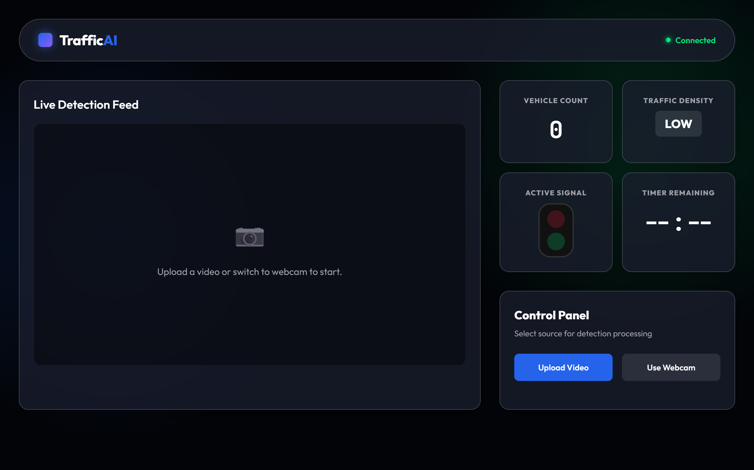
Figure 3.2: TrafficAI Dashboard — LOW Density Detection (3 Vehicles)
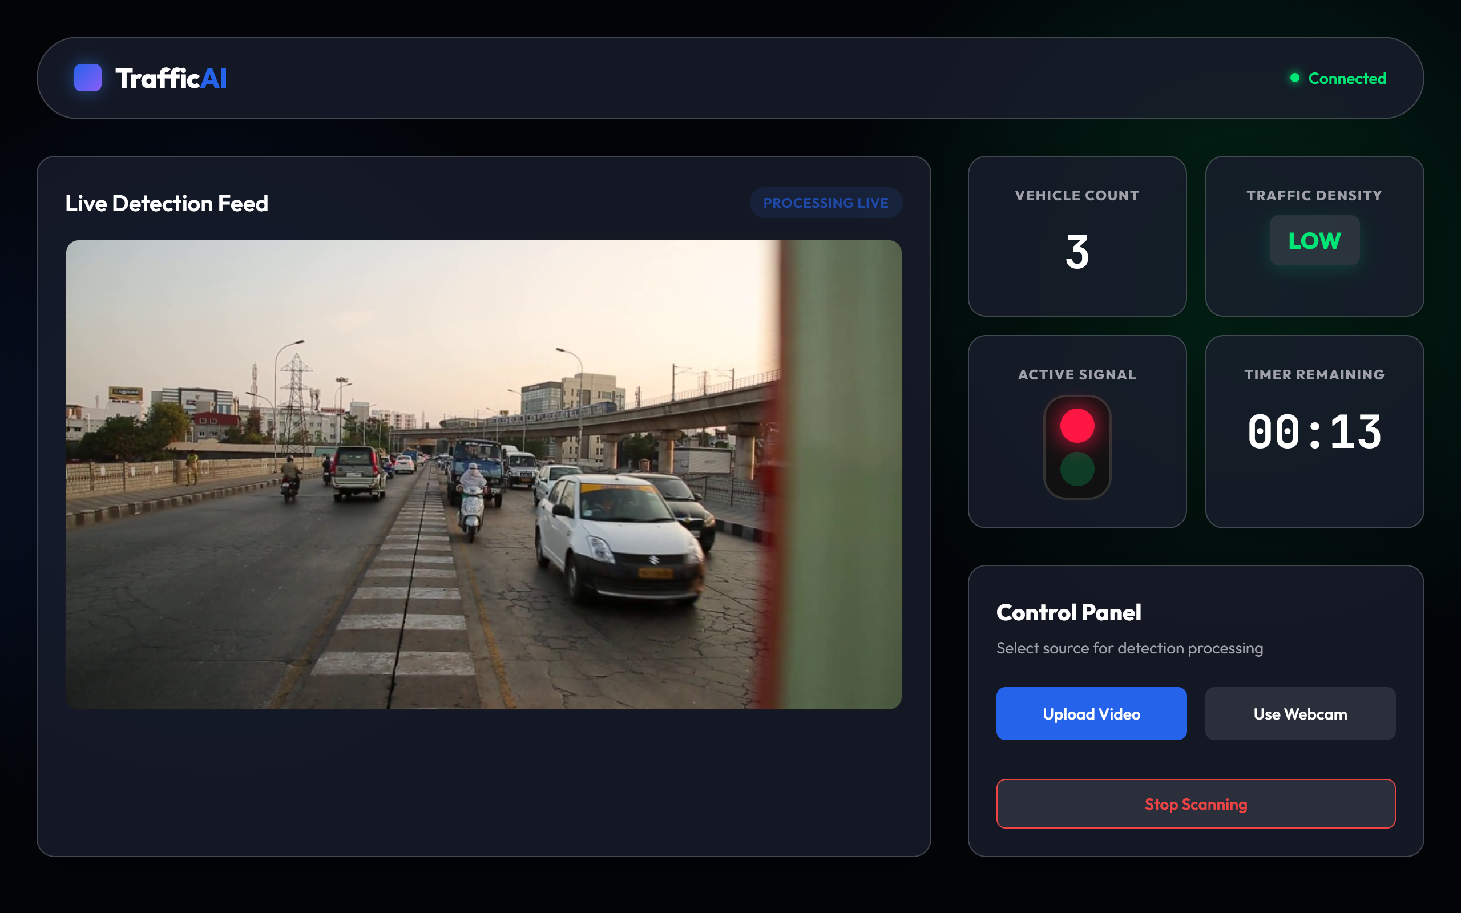
Figure 3.3: TrafficAI Dashboard — MEDIUM Density Detection (8 Vehicles)
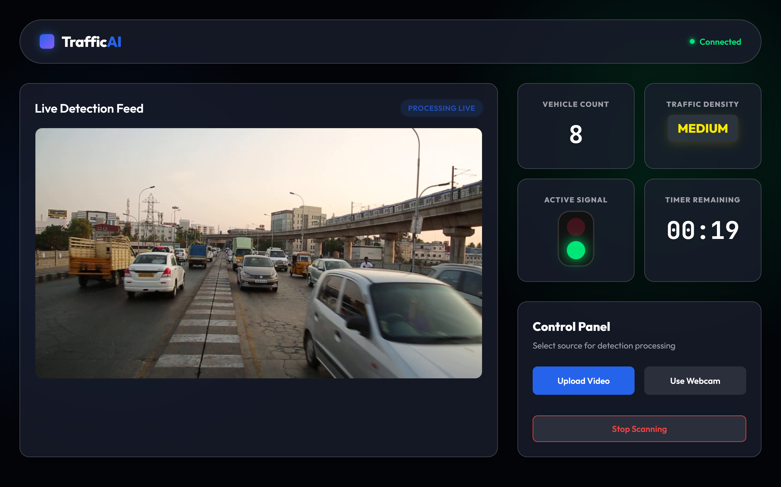
3.5 Innovation and Uniqueness
The following features distinguish this system from conventional and academic alternatives:
- Zero Infrastructure Dependency: Unlike inductive loop or radar-based systems, this solution requires only a standard camera, dramatically reducing deployment cost and complexity.
- Class-Aware Vehicle Counting: The system distinguishes between five vehicle classes (car, motorbike, bus, truck, bicycle) rather than treating all moving objects identically, enabling more nuanced density estimation.
- Dual-Mode Detection with Fallback: The intelligent fallback to MOG2 background subtraction ensures the system remains operational even without YOLO model weights, making it resilient in resource-constrained environments.
- SmoothCounter Noise Reduction: The sliding-window median filter is a novel application of signal processing principles to deep learning output stabilization, preventing erratic signal changes due to frame-level detection variance.
- Real-Time Web Dashboard: The MJPEG streaming and REST API architecture enables remote monitoring from any device on the network, providing operational transparency and control without requiring dedicated software installations.

CHAPTER IV
EXPECTED RESULTS
4.1 Expected Results
Based on the system design and the capabilities of the YOLOv4-tiny model, the following results are expected upon full deployment and testing:
Vehicle Detection Accuracy: The YOLOv4-tiny model, pre-trained on the COCO dataset, is expected to achieve a Mean Average Precision (mAP) of approximately 40% on standard benchmarks. In controlled traffic monitoring conditions — single-direction camera view, adequate lighting, clear road markings — detection accuracy for the five target vehicle classes is expected to be substantially higher due to the reduced complexity of the detection task compared to the full COCO evaluation protocol.
Signal Adaptation Performance: The system is expected to correctly classify traffic density into LOW, MEDIUM, or HIGH categories with greater than 90% accuracy under standard daytime lighting conditions. Signal timing adaptation should occur within one to two seconds of a density change being detected, ensuring near-instantaneous response to traffic fluctuations.
Inference Speed: YOLOv4-tiny processed through OpenCV DNN on a standard Intel Core i5 CPU is expected to deliver 8–15 FPS inference rates. Combined with the SmoothCounter mechanism, this is sufficient to provide stable, accurate density classifications and responsive signal control.
System Observations from Testing:
- LOW Density Scenario (< 5 vehicles): Green signal 15s, Red signal 15s — system correctly identifies sparse traffic and applies balanced equal timing.
- MEDIUM Density Scenario (5–11 vehicles): Green signal 25s, Red signal 25s — system appropriately extends green duration for moderate flow.
- HIGH Density Scenario (≥ 12 vehicles): Green signal 40s, Red signal 10s — system prioritizes the congested lane with maximized green time, minimizing queue buildup.
- The web dashboard maintains responsive updates with less than 1-second polling latency, and the MJPEG stream displays annotated bounding boxes in near real time.
- The Python threading Lock() mechanism successfully decouples the OpenCV processing thread from the Flask API, preventing race conditions and ensuring a stable web interface even under heavy processing load.
4.2 Future Enhancements
The following enhancements are planned for subsequent development phases:
- Multi-Camera Intersection Support: Scaling the architecture to simultaneously process feeds from four cameras at a 4-way intersection, calculating globally optimal signal timings using a coordinated optimization algorithm.
- Edge Deployment: Porting the solution to edge-AI hardware platforms such as the NVIDIA Jetson Nano or Raspberry Pi equipped with a Coral USB TPU accelerator, enabling standalone embedded deployment at traffic junctions without cloud connectivity.
- Thermal and Infrared Camera Integration: Fine-tuning the detection model on thermal imaging datasets to overcome night-time visibility and adverse weather limitations, enabling 24/7 all-weather operation.
- License Plate Recognition (ANPR): Integrating Automatic Number Plate Recognition to identify and log traffic signal violations, enabling automated penalty enforcement.
- Emergency Vehicle Priority System: Training a classifier to detect emergency vehicle types (ambulances, fire trucks, police vehicles) from the video feed and automatically grant them priority green signals.
- Predictive Signal Control: Incorporating time-series forecasting models (LSTM or Transformer-based) to predict upcoming traffic density surges based on historical patterns, enabling proactive rather than reactive signal adjustments.
4.3 Learning Outcomes
The development of this project has yielded the following key learning outcomes:
- Deep Learning for Computer Vision: Gained hands-on experience in deploying pre-trained YOLO object detection models using OpenCV DNN module, including understanding of blob preprocessing, forward propagation, confidence filtering, and Non-Maximum Suppression.
- Full-Stack Web Development: Developed end-to-end skills in building a Python Flask backend with REST API design, MJPEG video streaming, and integrating with a vanilla JavaScript frontend using asynchronous polling.
- Multi-Threading in Python: Learned practical application of Python's threading.Lock() mechanism to safely share state between concurrent threads — the OpenCV processing thread and the Flask HTTP server thread.
- Signal Processing Concepts: Applied sliding-window median filtering as a noise reduction technique on real-time detection outputs, demonstrating the intersection of signal processing and machine learning engineering.
- System Architecture Design: Designed a modular, extensible software architecture separating concerns between detection logic (detection.py), API serving (app.py), and frontend presentation, reinforcing software engineering best practices.
- Problem-Solving and Debugging: Developed resilience through implementing and testing fallback mechanisms, handling edge cases in video processing, and debugging concurrent web server and CV pipeline interactions.
4.4 Conclusion
The AI-Powered Smart Traffic Controller System represents a significant and practical advancement in the application of deep learning to urban infrastructure challenges. By replacing arbitrary, static signal timers with intelligent, vision-driven dynamic timings derived from real-time vehicle density analysis, the system addresses a fundamental inefficiency present in most of the world's traffic networks.
The integration of the YOLOv4-tiny detection model with a robust Flask web application demonstrates that high-performance, adaptive traffic management is achievable without expensive specialized hardware or embedded road sensor infrastructure. The system's design — featuring a fallback detection mechanism, noise-reducing SmoothCounter, thread-safe state management, and a browser-accessible monitoring dashboard — reflects production-oriented software engineering principles applied to a real-world AI problem.
This project successfully fulfills all defined objectives and validates the feasibility of camera-only, AI-driven adaptive traffic signal control as a cost-effective solution for smart city deployment. The work establishes a strong foundation for the future enhancements outlined above, ultimately contributing to the broader goal of building safer, more efficient, and environmentally sustainable urban transportation systems.

REFERENCES
[1] Bochkovskiy, A., Wang, C.-Y., & Liao, H.-Y. M. (2020). YOLOv4: Optimal Speed and Accuracy of Object Detection. arXiv preprint arXiv:2004.10934.
[2] Lin, T.-Y., et al. (2014). Microsoft COCO: Common Objects in Context. European Conference on Computer Vision (ECCV), Springer, pp. 740–755.
[3] Redmon, J., Divvala, S., Girshick, R., & Farhadi, A. (2016). You Only Look Once: Unified, Real-Time Object Detection. IEEE CVPR, pp. 779–788.
[4] OpenCV Development Team. (2023). OpenCV: Open Source Computer Vision Library — DNN Module Documentation. Available: https://docs.opencv.org/
[5] Pallets Projects. (2023). Flask: Web Development, One Drop at a Time. Available: https://flask.palletsprojects.com/
[6] Zivkovic, Z. (2004). Improved Adaptive Gaussian Mixture Model for Background Subtraction. Proceedings of the 17th International Conference on Pattern Recognition (ICPR), Vol. 2, pp. 28–31.

