use market;
DDL Commands
=============
//Create Table Supplier
CREATE TABLE Supplier (SID INT PRIMARY KEY, Sname VARCHAR(20), branch VARCHAR(30), city VARCHAR(20), phone VARCHAR(12)) ;

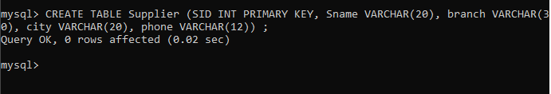

//Create Table Part
CREATE TABLE Part (PID INT PRIMARY KEY, Pname VARCHAR(30), color VARCHAR(20), price DECIMAL(10,2)) ;

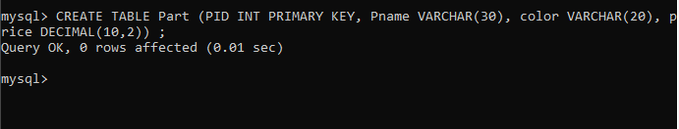

//Create Table Supplies
CREATE TABLE Supplies (SID INT, PID INT, qty INT, date_supplied DATE, FOREIGN KEY(SID) REFERENCES Supplier(SID), FOREIGN KEY(PID) REFERENCES Part(PID));

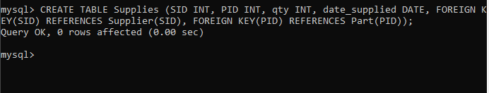

//Add Data To Tables

//Add Data To Supplier Table
Insert into Supplier values (1,’Arun Chris’,’Karimannoor’,’Thodupuzha’,9193672343);
Insert into Supplier values ( 2,’Albin Chris’,’Karimannoor’,’Kochi’,9192211367);
Insert into Supplier values ( 3,’Rahul Remesh’,’Thodupuzha’,’Thodupuzha’,9145456635);
Insert into Supplier values ( 4,’Mahesh Mathu’,’Vazhithala’,’Vazhithala’,919498755);
Insert into Supplier values (5,’Kevin Jomon’,’Vazhakulam’,’Muvattupuzha’,6758782684);

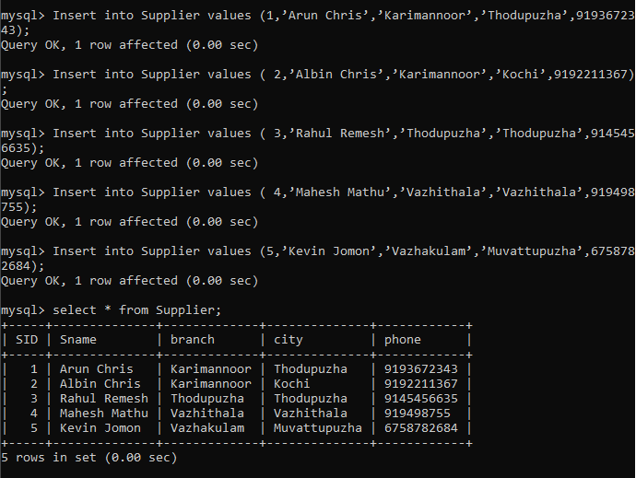

//Add Data To Part Table
Insert into Part values (1,’Phone’,’Black’,12000);
Insert into Part values (2,’Laptop’,’Silver’,55000);
Insert into Part values (3,’Watch’,’Black’,2000);
Insert into Part values (4,’Keybord’,’black’,500);
Insert into Part values (5,’Speaker’,’Blue’,1000);

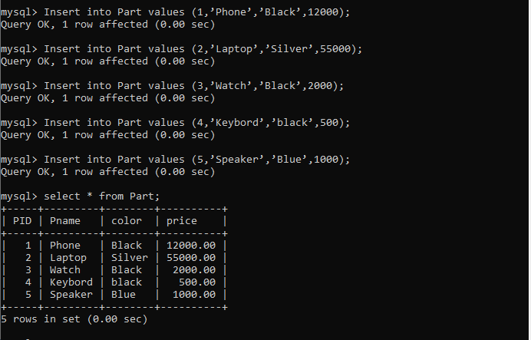

//Add Data To Supplies Table
Insert into Supplies values (1,2,15,’2003-02-03’);
Insert into Supplies values (2,3,18,’2005-09-04’);
Insert into Supplies values (3,4,10,’2010-07-12’);
Insert into Supplies values (4,5,56,’2026-09-01’);
Insert into Supplies values (5,1,21,’2026-09-01’);

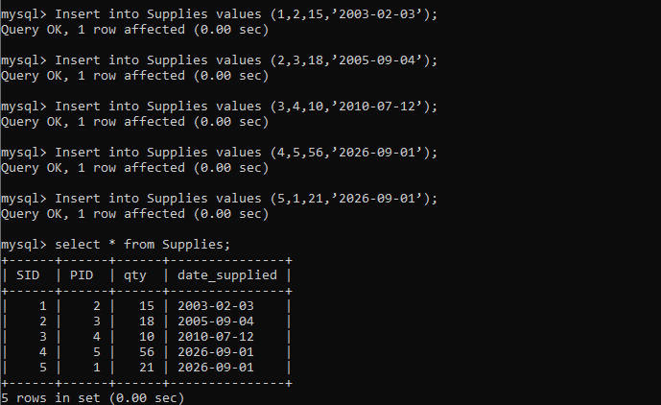

6.Add new Attribute ‘state’ to supplier table
ALTER TABLE Supplier ADD state VARCHAR(100);

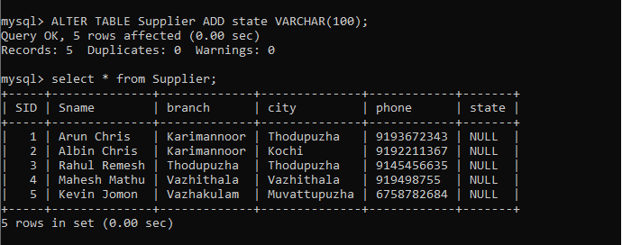

7.Remove attribute ‘city’ from supplier table
ALTER TABLE Supplier DROP COLUMN city;

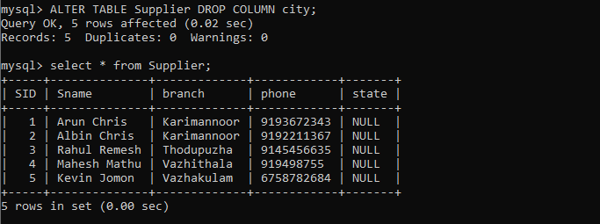

8.Modify the data type of ‘phone’ attribute
ALTER TABLE supplier MODIFY phone VARCHAR(20);

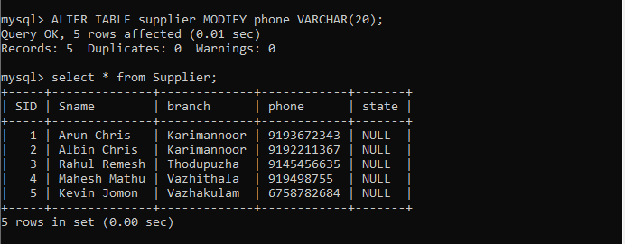
9.Change the name of attribute ‘city’ to ‘address’
ALTER TABLE Supplier ADD city VARCHAR(100);
ALTER TABLE Supplier RENAME COLUMN city TO address; //new
ALTER TABLE Supplier CHANGE COLUMN city address VARCHAR(20); //old command

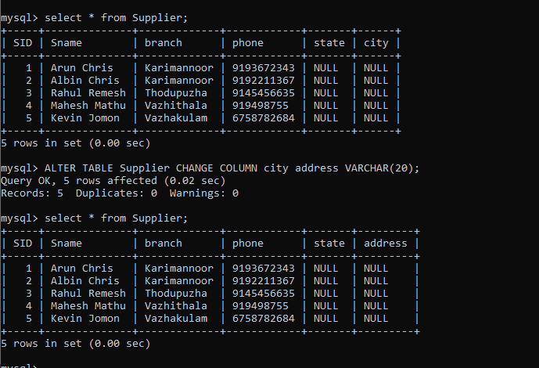

10.Change table name from ‘Supplier’ to ‘Sup’
RENAME TABLE Supplier TO Sup;

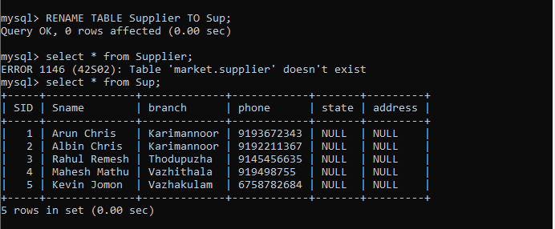

//Truncate contents of suppliers table
Truncate Table supplies;

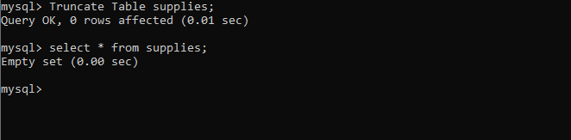

//Drop the Part table from the database
Drop table Part;

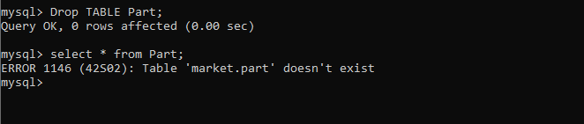

Queries with Constraints
Create the supplier table with Primary Key Constraint

CREATE TABLE Supplier (SID INT PRIMARY KEY, Sname VARCHAR(100), branch VARCHAR(50), city VARCHAR(50), phone VARCHAR(15));
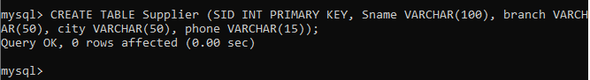

Create supplies table with Foreign key Constraint

CREATE TABLE Supplies (SID INT, PID INT, qty INT, date_supplied DATE,CONSTRAINT fk_sid FOREIGN KEY(SID) REFERENCES Supplier(SID), CONSTRAINT fk_pid FOREIGN KEY(PID) REFERENCES Part(PID));

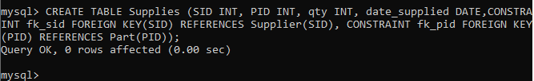

Create a part table with UNIQUE Constraint

CREATE TABLE Part (PID INT PRIMARY KEY, Pname VARCHAR(100) UNIQUE, color VARCHAR(50), price DECIMAL(10,2)) ;
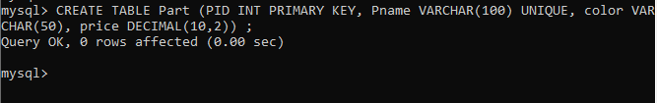

Create supplier Table with Check Constraints

CREATE TABLE Supplier (SID INT PRIMARY KEY, Sname VARCHAR(100), branch VARCHAR(50) CHECK (branch IN (“CSE”, “IT”,”ECE”,”ME”)), city VARCHAR(50), phone VARCHAR(15));
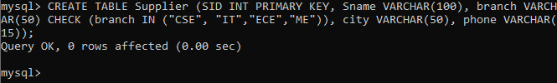

Create Supplier table with Default Constraint

CREATE TABLE Supplier (SID INT PRIMARY KEY, Sname VARCHAR(100), branch VARCHAR(50) DEFAULT “General”, city VARCHAR(50), phone VARCHAR(15));

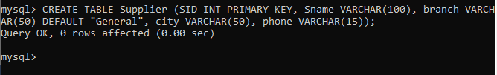

Queries on TCL
Create Savepoints

START TRANSACTION;
UPDATE Supplier SET city = “DELHI” WHERE SID = 5;
SAVEPOINT sp1;
UPDATE Supplier SET city = “KOLKATA” WHERE city = “DELHI”;

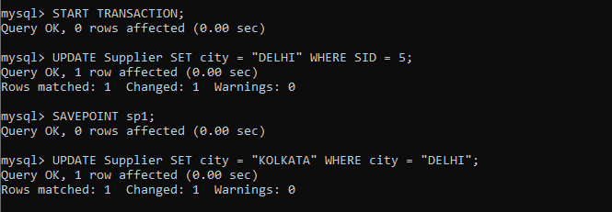
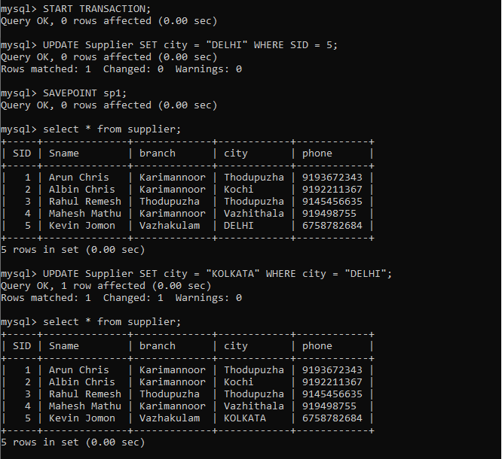
Rollback to SavePoints

ROLLBACK TO sp1;
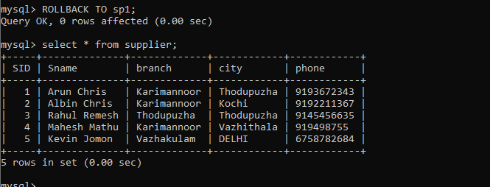

Use Commit to save on

COMMIT;
Aggregate Functions:
Find the minimum, maximum, average and sum of costs of parts

SELECT color, SUM(price) AS total_price FROM Part GROUP BY color;
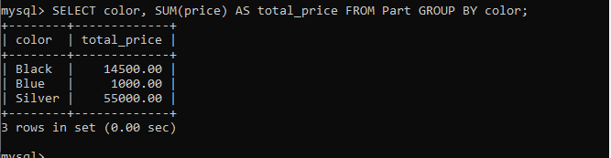

Count the total number of parts present

SELECT COUNT(*) FROM Part;
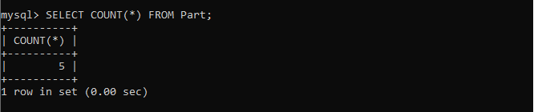

Retrieve the average cost of all parts supplied by ‘Mike’

SELECT AVG(p.price) FROM Supplies s JOIN Part p ON s.PID = p.PID JOIN Supplier sup ON s.SID = sup.SID Where sup.Sname=”Mike”;
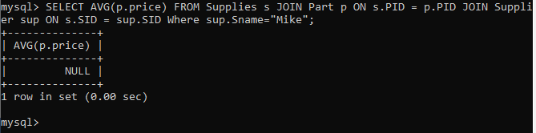

Queries on GROUP BY, HAVING AND ORDER BY Clauses
Display total price of parts of each color

SELECT color, SUM(price) AS total_price FROM Part GROUP BY color;
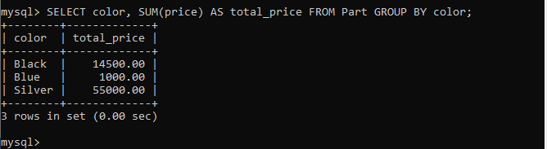

Find the branch and the number of suppliers in that branch for branches which
have more than 2 suppliers

SELECT branch, COUNT(*) AS supplier_count FROM Supplier GROUP BY branch HAVING COUNT(*)>2;
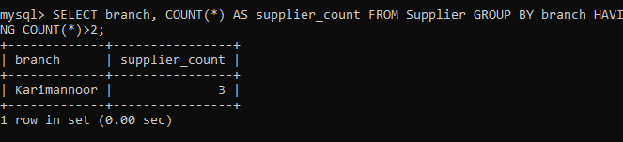

3. Find all parts sorted by pname in ascending order and cost in descending order

SELECT * FROM Part ORDER BY Pname ASC, price DESC;
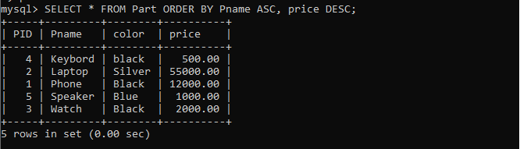
4. Find the branch and the number of suppliers in that branch
SELECT branch, COUNT(*) AS supplier_count FROM Supplier GROUP BY branch;
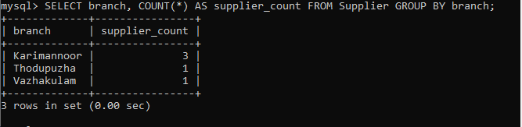
Queries on Analytical, Hierarchical, Recursive nature.
1. Find out the 5th highest earning employee details.
2. Which department has the highest number of employees with a salary above $80,000, and what percentage of employees in that department have a salary above $80,000
3. Retrieve employee table details using the hierarchy query and display that hierarchy path starting from the top level indicating if it is a leaf and there exists a cycle.
4. What is the average salary for employees in the top 2 departments with the highest average salary, and what is the hierarchy of departments and sub-departments for these top 2 departments?
5. Use recursion to retrieve the employee table and display the result in breadth first and depth first order.
6. Write a recursive query to show the equivalent of level, connect_by_root and
connect_by_path
7. Use recursion to retrieve the employee table and display the result in depth first order showing id, parent_id, level, root_id, path and leaf.

Queries on Operators
1. Find the pname, phoneno and cost of parts which have cost equal to or greater than 200

SELECT Pname, phone, price FROM Part WHERE Price>=200 AND price <=600;
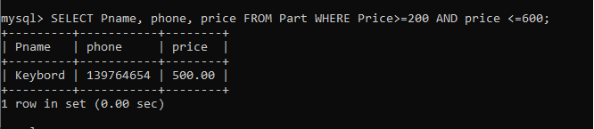
and less than or equal to 600.
2. Find the sname , SID and branch of suppliers who are in ‘local’ branch or ‘global’ branch

SELECT Sname, SID, branch FROM Supplier WHERE branch IN (“local”,”global”);
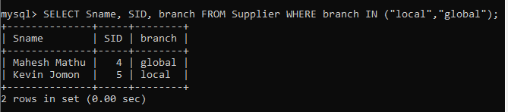
3. Find the pname, phoneno and cost of parts for which cost is between 200 and 600

SELECT Pname, phone, price FROM Part WHERE price BETWEEN 200 AND 600;
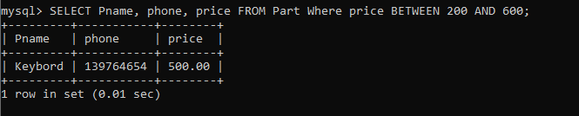
4. Find the pname and color of parts , which has the word ‘NET’ anywhere in its pname.

SELECT Pname, color FROM Part WHERE Pname LIKE "%NET%";
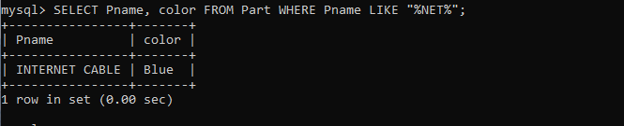

5. Find the PID and pname of parts with pname either ‘NUT’ or ‘BOLT’

SELECT PID, Pname FROM Part WHERE Pname In (“NUT”,”BOLT”);
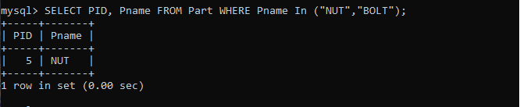
6. List the suppliers who supplied parts on ‘1st may2000’, ‘12 JAN 2021’ ,’17 dec 2000’
,’10 Jan 2021’

SELECT * FROM Supplies WHERE date_supplied IN (TO_DATE(“01-MAY-2000”,”DD-MON-YYYY”),TO_DATE(“12-JAN-2021”,”DD_MON-YYYY”), TO_DATE(“17-DEC-2000”,”DD_MON-YYYY”), TO_DATE(“10-JAN-2021”,”DD_MON-YYYY”));

7. Find all the distinct costs of parts

SELECT DISTINCT price FROM Part;
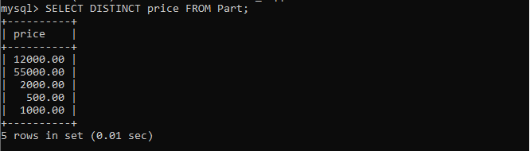
Join Operators
1. Perform Inner join on two tables

SELECT s.SID, s.Sname, sup.PID, sup.Qty FROM Supplier s INNER JOIN Supplies sup ON s.SID=sup.SID;
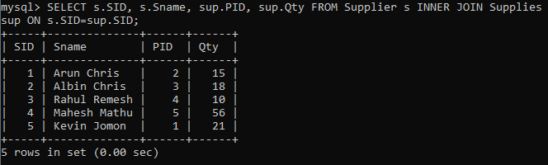
2. Perform Natural Join on two tables

SELECT * FROM Supplier NATURAL JOIN Supplies;
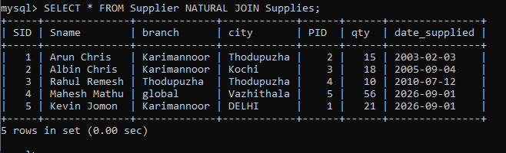
3. Perform Left Outer Join on tables

SELECT s.*, sup.PID FROM Supplier s LEFT OUTER JOIN Supplies sup ON s.SID=sup.SID;
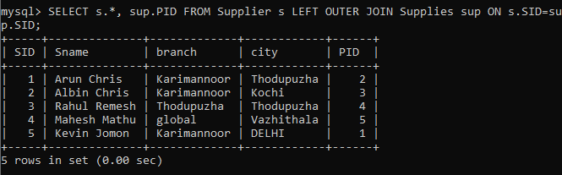
4. Perform Right Outer join on tables

SELECT s.*, sup.PID FROM Supplier s RIGHT OUTER JOIN Supplies sup ON s.SID=sup.SID;

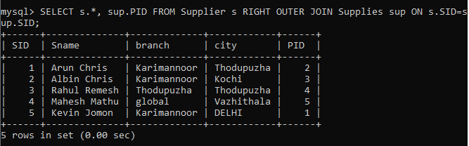

5. Perform Full Outer Join on tables

SELECT s.*, sup.PID FROM Supplier s LEFT OUTER JOIN Supplies sup ON s.SID=sup.SID UNION SELECT s.*, sup.PID FROM Supplier s RIGHT OUTER JOIN Supplies sup ON s.SID=sup.SID;
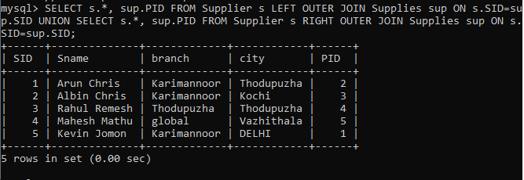

Set Theory Operators
1. Show the use of UNION operator with union compatibility

SELECT Sname FROM Supplier UNION SELECT Pname FROM Part;
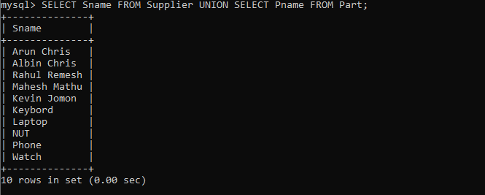
2. Show the use of intersect operator with union compatibility

SELECT Sname FROM Supplier INTERSECT SELECT Pname FROM Part;

3. Show the use of minus operator with union compatibility

4. Find the cartesian product of two tables

Queries on Set Theory Operators
1. List all parts except ‘NUT’ and ‘BOLT’ in ascending order of costs

2. display all parts that have not been supplied so far

3. To display the supplier names who have supplied ‘green’ part with cost 500 Rupees AND ‘red’ part with cost 400 Rupees.

4. To Display the name of suppliers who have supplied all parts that are ‘red’ in color.

MongoDB Queries
1. Create a collection and insert documents into it using insertOne() and insertMany()

2. Select all documents in collection

3. Find the count of all suppliers

4. Find all records that have city = ‘Delhi’

5. Retrieve all documents that have color equal to ‘red’ or ‘green’

6. Retrieve all documents where part_name is ‘P1’ or price is less than 200.

7. Update the record of ‘Geeta’ ,set city = ‘Bombay’ and phoneno = ‘11223344’

8. Delete all records where price is greater than 5000

9. Display only the name and city of the supplier

10. Sort all suppliers on city and display only the first two records.

