Answers to questions in

Lab 1: Filtering operations

Name: Mikel Zhobro  
Program:

**Instructions**: Complete the lab according to the instructions in the notes and respond to the questions stated below. Keep the answers short and focus on what is essential. Illustrate with figures only when explicitly requested.

Good luck!

**Question 1**: Repeat this exercise with the coordinates p and q set to (5, 9), (9, 5), (17, 9),

(17, 121), (5, 1) and (125, 1) respectively. What do you observe?

Answers:

We see sinus waves for the real and imaginary part .

**Question 2**: Explain how a position (p, q) in the Fourier domain will be projected as a sine wave in the spatial domain. Illustrate with a Matlab figure.

Answers:

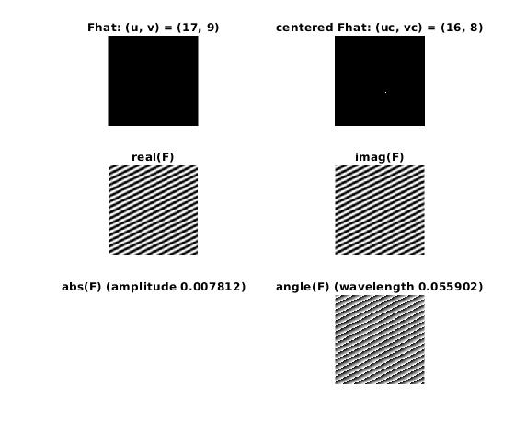

Figure 1.

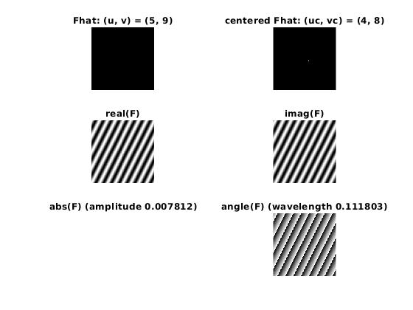

Figure 2.

Inverse Fourier transformation is dual to the Fourier transformation which translates a delta dirac to an exponential function with real and imaginary part having sinus form.

**Question 3**: How large is the amplitude? Write down the expression derived from Equation (4) in the notes. Complement the code (variable amplitude) accordingly.

Answers:

$a=\frac{1}{\sqrt{N∗M}}$

The amplitude is 1/N = 1/128, which is too completed accordingly in the code.

**Question 4**: How does the direction and length of the sine wave depend on p and q? Write down the explicit expression that can be found in the lecture notes. Complement the code (variable wavelength) accordingly.

Answers:

$ƛ=\frac{2π}{\left|\left|ω\right|\right|}=\frac{1}{\sqrt{u_{c}^{2}+v_{c}^{2}}}$

The sine waves spread in the direction from the coordinates center to the point [p,q] as shown in the images.

**Question 5**: What happens when we pass the point in the center and either p or q exceeds half the image size? Explain and illustrate graphically with Matlab!

Answers:

Discrete Fourier transformation treats both the image and its spectrum as periodical with interval N. In addition to that, for the spectrum, the following relation holds, Ƒ(N+x,N+x) = Ƒ(N-x,N-x), which allows the centering of the spectrum. The centering can be to performed with the *fftshift* function in Matlab.

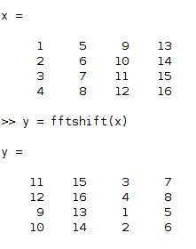

Figure 3. Centering operator

**Question 6**: What is the purpose of the instructions following the question *What is done by these instructions?* in the code?

Answers:

Centering. Normally the range [0,2π] is shown, but after centering we can see the range [-π, π] of the spectrum.

**Question 7**: Why are these Fourier spectra concentrated to the borders of the images? Can you give a mathematical interpretation? Hint: think of the frequencies in the source image and consider the resulting image as a Fourier transform applied to a 2D function. It might be easier to analyze each dimension separately!

Answers:   
F and G can be seen as 1D rect-functions in spatial space showing in x and y direction respectively. This correspond to si-functions in the corresponding directions on the frequency domain. Si functions spread from frequency zero and can be seen as decaying sin functions. Lastly, H is a linear combination of F and G which too corresponds to a linear combination in the Fourier domain.

**Question 8**: Why is the logarithm function applied?

Answers:

Normally the pixels of the spectrum are concentrated on the low range. The logarithm function redistributes the pixel concentration and so enhances the visibility.

To make sure that the log function doesn’t fail for 0 values, we add 1.

**Question 9**: What conclusions can be drawn regarding linearity? From your observations can you derive a mathematical expression in the general case?

Answers:   
Linear combination of images in spatial domain corresponds to linear combination of their Fourier transformations in frequency domain.

**Question 10**: Are there any other ways to compute the last image? Remember what multiplication in Fourier domain equals to in the spatial domain! Perform these alternative computations in practice.

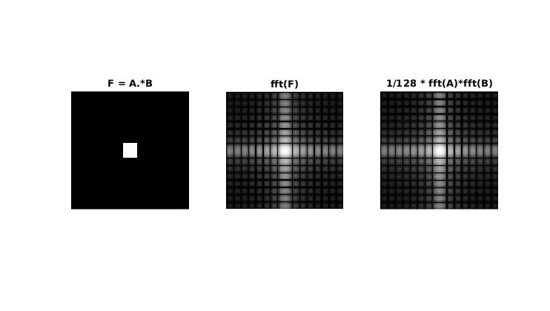

Answers:

Figure 4. Pointwise multiplication in spatial domain correspond to normal multiplication in frequency domain

A possible way is multiplying their Fourier transformations in Fourier domain and scaling it properly (1/128²).

If s(x,y) is a separable into a product s(x,y) = s_1(x)*s_2(y) the 2D-spectrium is the product of 1D Fourier transforms of s_1(x) and s_2(y). (in our case s_1 and s_2 are both rectangle functions.

**Question 11**: What conclusions can be drawn from comparing the results with those in the previous exercise? See how the source images have changed and analyze the effects of scaling.

Answers:

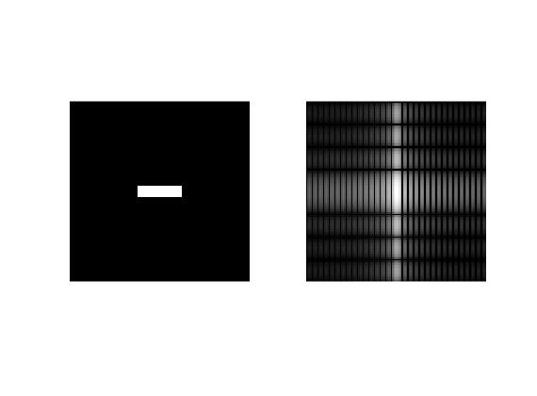

Figure 5. Scaling

In our case we have scaled the square by extending it in x direction and shortening it in y direction. In Fourier domain this corresponds to the opposite, i.e. stretching in y direction and shortening in x direction.

**Question 12**: What can be said about possible similarities and differences? Hint: think of the frequencies and how they are affected by the rotation.

Answers:

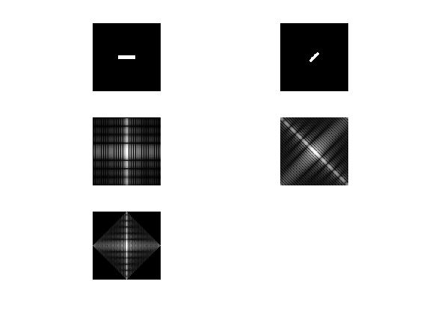

Figure 5. Rotation of image corresponds to rotation of its spectrum

We can conclude that rotation in spatial space corresponds to the same rotation in Fourier domain.

**Question 13**: What information is contained in the phase and in the magnitude of the Fourier transform?

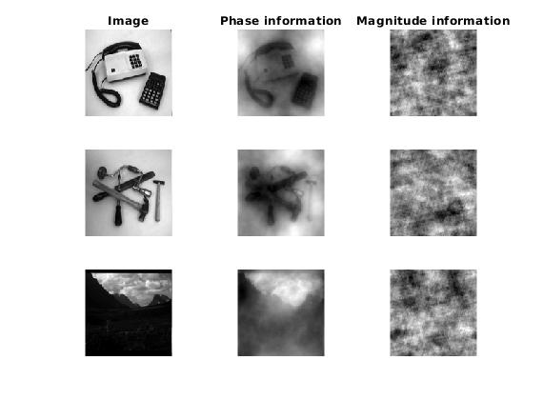Answers:

Figure 6.

We see that phase spectrum encodes the spatial relationship of the waveforms because we can still see the object even though the magnitude of the Fourier transform is changed, whereas the magnitude contains information about how large the waveforms are which is less important.

**Question 14**: Show the impulse response and variance for the above-mentioned t-values. What are the variances of your discretized Gaussian kernel for t = 0.1, 0.3, 1.0, 10.0 and

100.0?

Answers:

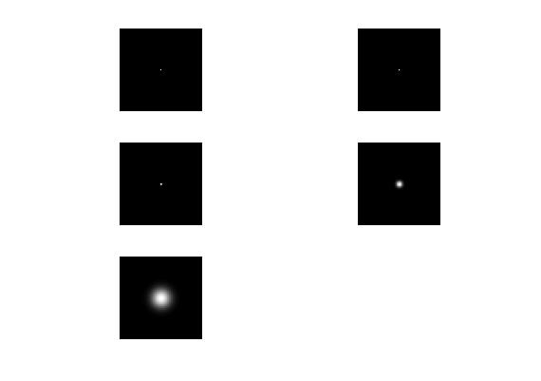

Figure 6. Impulse response of discretized Gaussian Filter

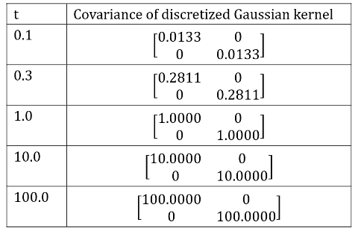

Figure 7. Covariances of Gaussian filters with different variance

**Question 15**: Are the results different from or similar to the estimated variance? How does the result correspond to the ideal continuous case? Lead: think of the relation between spatial and Fourier domains for different values of t.

Answers:

The variances for t bigger than 1 correspond to the ideal continuous case. Once t gets smaller than 1, the variances deteriorate. That is because Gaussian filters with small t cannot be captured pretty from the sampling.

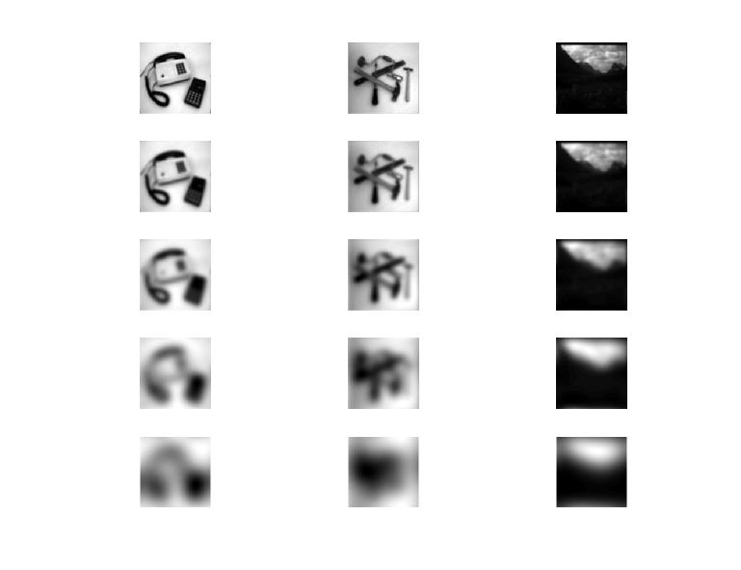**Question 16**: Convolve a couple of images with Gaussian functions of different variances (like t = 1.0, 4.0, 16.0, 64.0 and 256.0) and present your results. What effects can you observe?

Answers:

Figure 8. Gaussian filter with increasing variance

Images become more blur with increased variance. The reason for that is that the higher the variance the smaller the cut off frequency and the more high frequency components are cut off.

**Question 17**: What are the positive and negative effects for each type of filter? Describe what you observe and name the effects that you recognize. How do the results depend on the filter parameters? Illustrate with Matlab figure(s).

Answers:

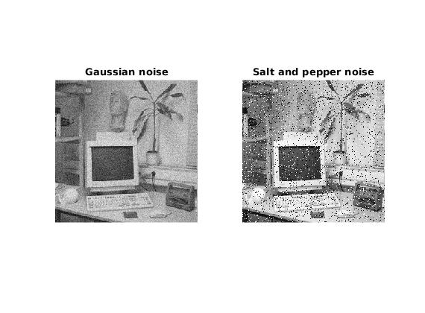

Figure 9. Noised images

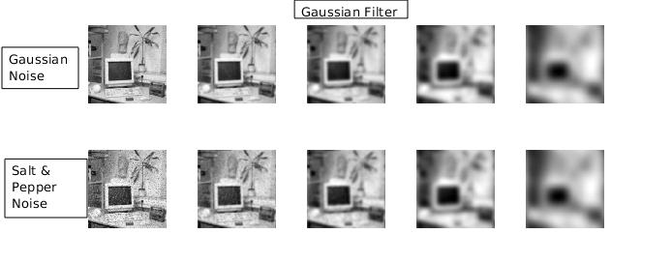

Figure 10.

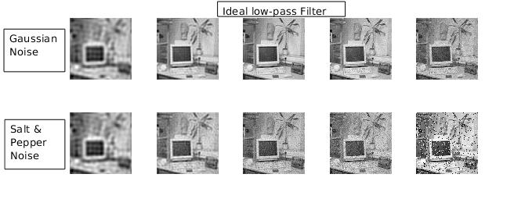

Figure 11.

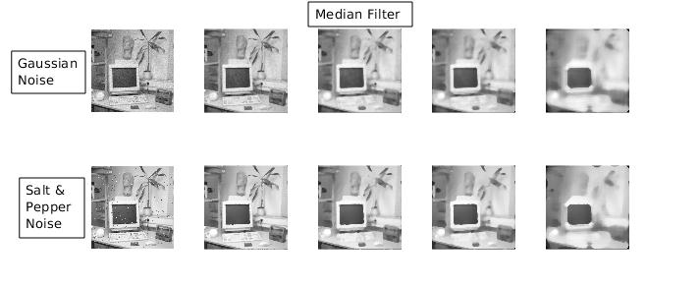

Figure 12.

Gaussian Filter:

* Advantages: very good smoothing, no sidelobes in both spatial and frequency domain, similar form in both domains
* Disadvantages: blurs the image when variance increases, salt and paper noise has more influence on the filtered image(considered as image pixels), worst attenuation of salt and paper noise

Median Filter:

* Advantages: impulses(salt noise) are removed, grey level plateaus and edges are preserved(transition between plateaus)
* Disadvantages: tend to generate somewhat unnatural looking of areas of constant intensity(sharpness loss), higher complexity

Ideal low-pass Filter:

* Advantages: easy to implement
* Disadvantages: no smoothing, just cut-off of high frequencies. Cannot smooth out impulses(salt and pepper noise ), ringing effects

**Question 18**: What conclusions can you draw from comparing the results of the respective methods?

Answers:  
Median Filter is the only filter that performs good in images with salt and pepper noise. It maintains edges and plateaus and attenuates the impulses. Both Gaussian and Ideal low-pass filters fail to attenuate salt and pepper noise. Main difference of Median Filter to Gaussian and Ideal low-pass Filters is that instead of averaging, it chooses the median which makes it an nonlinear filter compared to the two others which are linear.

**Question 19**: What effects do you observe when subsampling the original image and the smoothed variants? Illustrate both filters with the best results found for iteration i = 4.

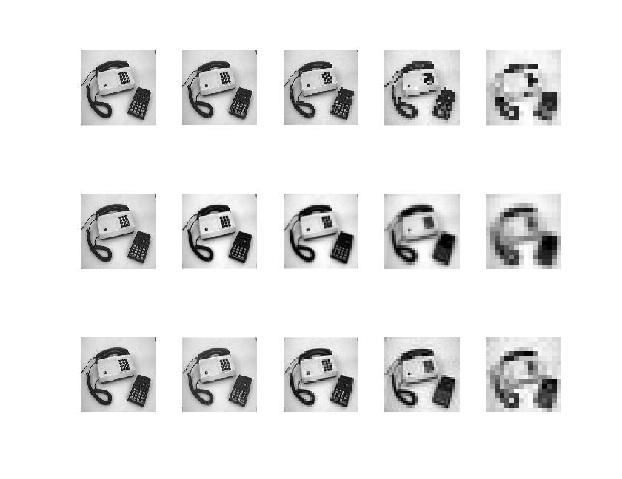Answers:

Figure 13. Subsampling, Gaussian Filtering & Subsampling, Low-pass Fitler & Subsampling

For i=4 it is hard to see any major differences. But we can notice that subsampling after smoothing with either Gaussian filter or ideal low-pass filter offers less artifacts and maintains more information from the image. This can be best noticed at i=2 or i=3

**Question 20**: What conclusions can you draw regarding the effects of smoothing when combined with subsampling? Hint: think in terms of frequencies and side effects.

Answers:

We can conclude that smoothing before subsampling helps loosing less information from the image. This can be explained by the Nyquist sampling theorem itself. A sampled image can be seen as a repeating spectrum in the frequency domain. Cutting off high frequencies by smoothing filters lowers maximal frequency of image and enables the repeating spectrum in frequency domain not to overlap itself and so prevents Aliasing and loss of information.