# Eclipse

|  |  |
| --- | --- |
| Shortcut | Description |
| Ctrl + 1 | Quickfix; shows potential fixes for warnings, errors or shows possible actions |
| Ctrl + Space | Content assist/ code completion |
| Ctrl + Q | Goes to the last edited position |
| Ctrl+ D | Deletes current line in the editor |
| Ctrl + Shift + O | Adjusts the imports statements in the current Java source file |
| Ctrl + 2, L or F | Assign statement to new local variable or field |
| Ctrl + Shift + T | Open Type Dialog |
| Ctrl + O | Shows quick outline of a class |
| Ctrl + F11 | Run last launched application |

# Math

|  |  |  |  |
| --- | --- | --- | --- |
| Exponents | Logs | Trig (ref. figure 1) | |
|  |  |  |  |
|  |  |  |  |

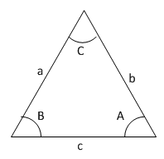Figure 1

|  |
| --- |
| Probability |
|  |
|  |
|  |