ENGINEERING ARTICLE · MINISTRY OF INVESTMENT
Intelligence that keeps its data at home
How the MISA Intelligence API answers company questions with a local model, so government data is never sent to a cloud provider, and how the whole system was brought into one deployable codebase.

What the system does
The MISA Intelligence API answers natural-language questions about companies, executives, sectors, and investment opportunities. A user asks something like “which German companies should we target for RHQ conversion” or “tell me about Temasek and what it means for MISA,” and the service returns a structured intelligence briefing grounded in a PostgreSQL database of around 254,000 company records. It is not a general chatbot. Every answer is built from the Ministry’s own data, with named programmes, real figures, and concrete engagement actions rather than generic prose.
Because that data is sensitive government material, the central design constraint is simple to state and hard to satisfy: the database rows and uploaded documents must never leave the machine. Everything else in the architecture follows from honouring that rule while still producing consultant-grade answers.

The core idea: keep grounded data local
The service runs two kinds of model call. A question-only call sees just the user text, for tasks like choosing which database filters to apply. A data-grounded call composes an answer from actual database rows or document passages. The residency router sends every data-grounded call to a local Llama 3.1 model running through Ollama on the host, so the sensitive content is composed on the machine and never transmitted. Question-only calls, and an optional path that sends only privacy-filtered fact cards with every internal field stripped, may use Azure OpenAI for higher narrative quality. A guard blocks any call that would send grounded data to a cloud model, so the boundary is enforced in code, not left to convention.

The journey of one request
The figure on the next page traces a single question from the browser to the answer. Each layer has one job, and the request passes through them in order.

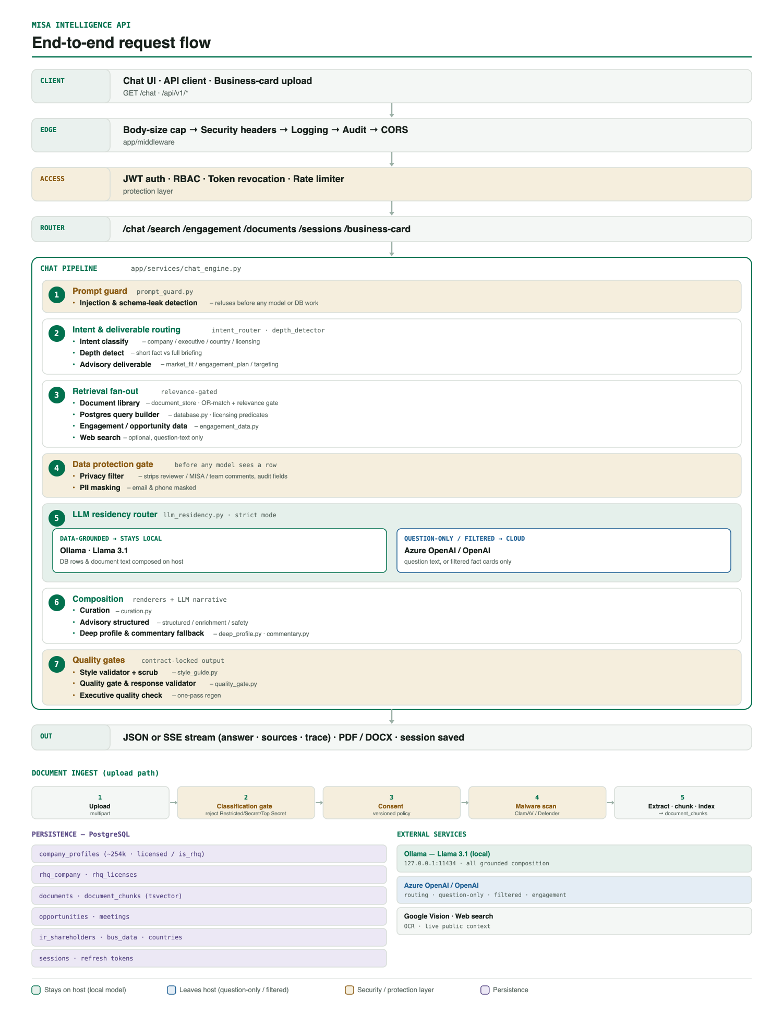
Figure 1. End-to-end request flow, the document ingest path, and the data stores.
A request first crosses the edge middleware: a body-size cap, security headers, request logging, an audit trail, and a CORS allowlist. It then reaches the access layer, where JWT authentication, role-based access, and a rate limiter decide whether the caller may proceed. Once past the routers, a chat question enters the pipeline that gives the system its character.
Inside the pipeline, a prompt guard runs first and refuses injection or schema-extraction attempts before any model or database work happens. Next the system reads the question intent and depth, and detects whether it is a specific advisory deliverable such as a market-fit assessment or an engagement plan. Retrieval then fans out in parallel across the document library, the Postgres query builder, and, when useful, a web search on the question text only.
Before any of that retrieved content reaches a model, it passes through the data protection gate. A privacy filter strips internal comment fields, reviewer notes, and audit metadata from every row, and a masking step redacts emails and phone numbers. Only then does the residency router choose the model: local for grounded content, cloud for question-only or filtered material. Composition assembles the briefing from deterministic renderers and the model narrative, and a final set of quality gates enforces the house style and structure before the answer streams back to the client.

Protecting the data at every step
Data protection is not a single feature but a set of layers the request cannot skip. Authentication and role-based access decide who may ask. The prompt guard stops attempts to make the model reveal its instructions or the database schema. The privacy filter guarantees that internal notes are removed before a model ever sees a row, which we verified directly: given a record full of reviewer and MISA comments, only the public fields survive. Masking removes personal contact details. And the residency router keeps the grounded content on the host. In production, a boot check refuses to start the service at all if authentication is disabled, the origin list is open, the malware scanner is off, or the interactive docs are exposed.

Handling uploaded documents safely
Documents follow their own path, shown along the bottom of the figure. Only Public documents may enter the library. The system detects the classification itself rather than trusting a label: it screens the text, the DOCX headers and footers, the filename, and the hidden properties that corporate classification tools write, catching Restricted, Secret, Top Secret, and Confidential markings in both English and Arabic. A marked file is rejected before anything is stored. Every upload also requires an accepted consent declaration, and each file is malware-scanned before its text is extracted, chunked, and indexed for retrieval.

Getting the answers right
A large part of the recent work was making the answers specific rather than generic. Each response type was regenerated live and graded against reference briefings for named anchors and real figures. That surfaced concrete defects, which were fixed: a document question that fell through to a generic country profile now retrieves the right passage regardless of phrasing; company lists that were sorted as text, placing a small restaurant above a multi-billion bank, are now ranked by true numeric revenue; the established briefing layout was restored across company, engagement, and targeting answers; and a grammar-safe scrub removes hollow adjectives so the prose stays concrete. The output quality gates hold this line on every answer.

One codebase, verified
The work spanned parallel efforts that had drifted into separate folders: one carried the local-model residency path, another carried the security and prompt improvements. These were merged, with careful reconciliation where both had touched the same files, into a single version-controlled repository that now holds every feature set with nothing lost. The full test suite passes at 1,119 tests with the linter clean, authentication tests are hermetic, and the production boot check enforces a safe configuration. The consolidated code is the canonical source, backed up on GitHub, with the deployment checklist shipped alongside it.
Repository: github.com/joudathashmi/chatbotollama21 Local Llama 3.1 and Azure OpenAI (privacy filtered).

